Changes to the Source Code:
- The first change I made to the source code for this drawing app (https://github.com/williammalone/Simple-HTML5-Drawing-App) is the implementation of a Command class and a Command Stack class:
  - 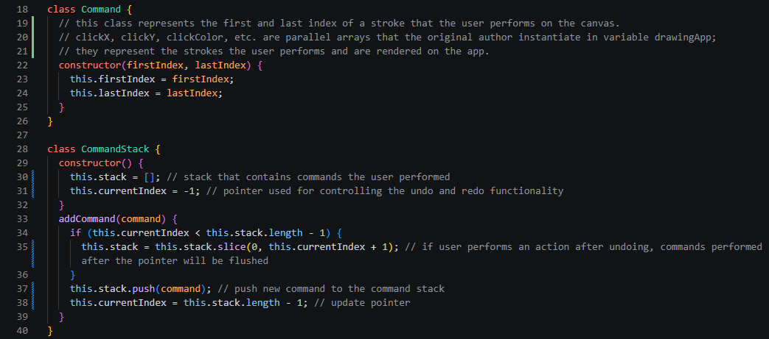
  - Stepping through the code reveals how original code author, William Mallone, stored each user’s stroke per frame. Mallone opted to use these parallel arrays to store the mouse’s X/Y coordinate, selected tool, brush color, brush size, and a Boolean flag checking if the user is moving the mouse:
    - 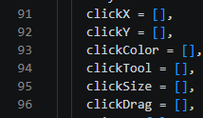
  - Since they’re parallel arrays, there is one index that can be used to iterate through all of them. I took advantage of this by making a “Command” class that stores the first and last index; the first index represents the frame that the user starts a stroke, and the last index is the final frame before the user releases the left mouse button.
  - In order to create a command stack that tracks the user’s stroke history, I made a “CommandStack” class that contains a stack holding instances of the Command class and a pointer, called “currentIndex”, that points to the current command that the user is set to (not necessarily the latest command, because the user could navigate the command stack using the undo or redo function).
  - The CommandStack class also has an “addCommand” method that accepts a command and pushes it to the top of the stack. If the currentIndex doesn’t point to the top of the stack, the stack is sliced from the bottom to the index that currentIndex is pointing to; the command is then pushed after the slice. The method also updates the CommandStack’s currentIndex to point to the top of the stack.
- Next, the undo and redo functions are instantiated:
  - 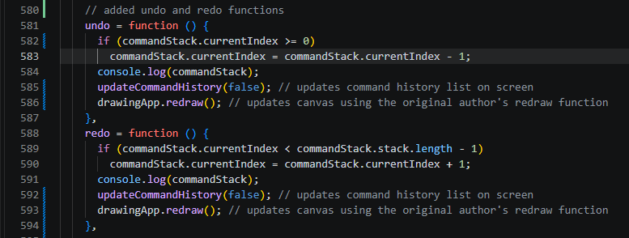
  - Depending on the bounds checking written in the conditional statement on line 583/589, the command stack’s pointer is incremented or decremented using the redo or undo functions respectively. The updateCommandHistory function is called immediately after:
    - 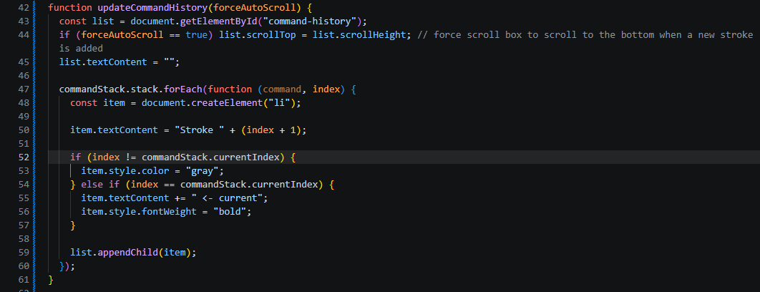
  - This function is responsible for updating the command history display on the app. The list is called on line 28 on the HTML file, along with the undo and redo buttons:
    - 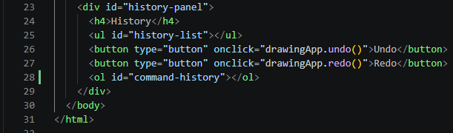
  - Here’s what the command history looks like on the web application:
    - 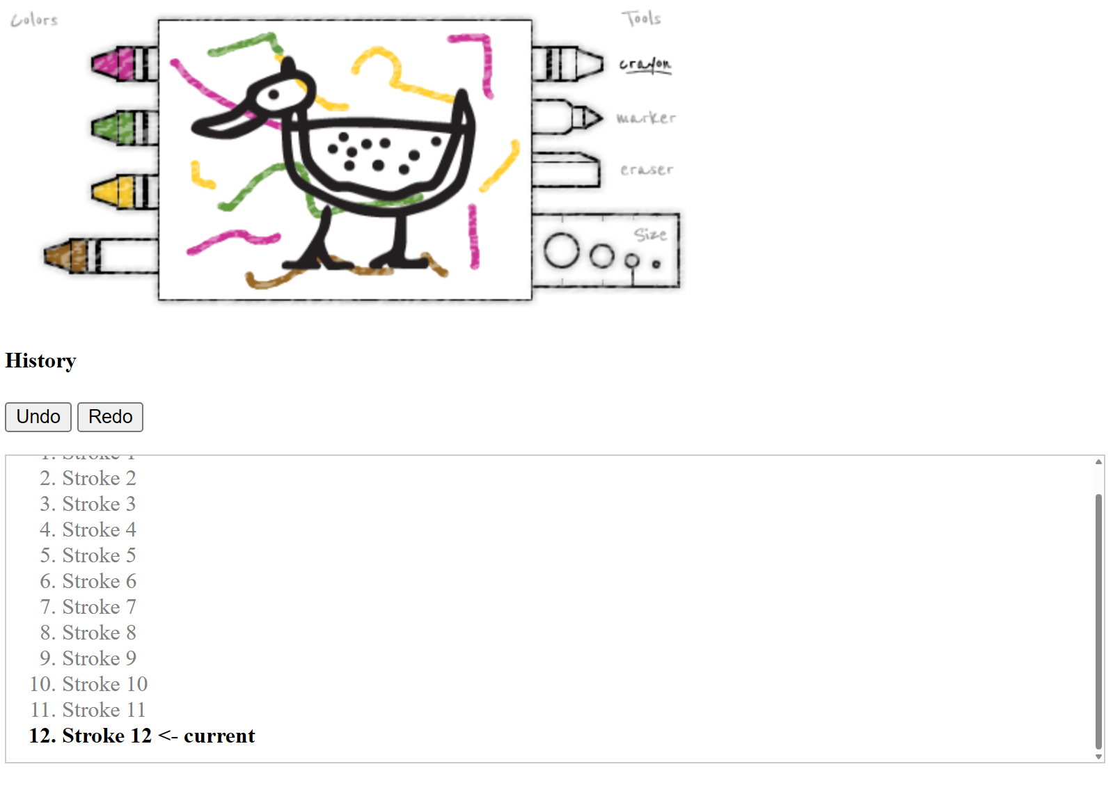
    - The command history is a scroll box, and when the user finishes a stroke on the canvas, it automatically scrolls to the bottom of the scroll box to display the current command that the user is on. When the user clicks on the undo or redo button, the canvas is updated and the pointer (AKA the “<- current” text) navigate up or down the list depending on what action the user takes:
    - 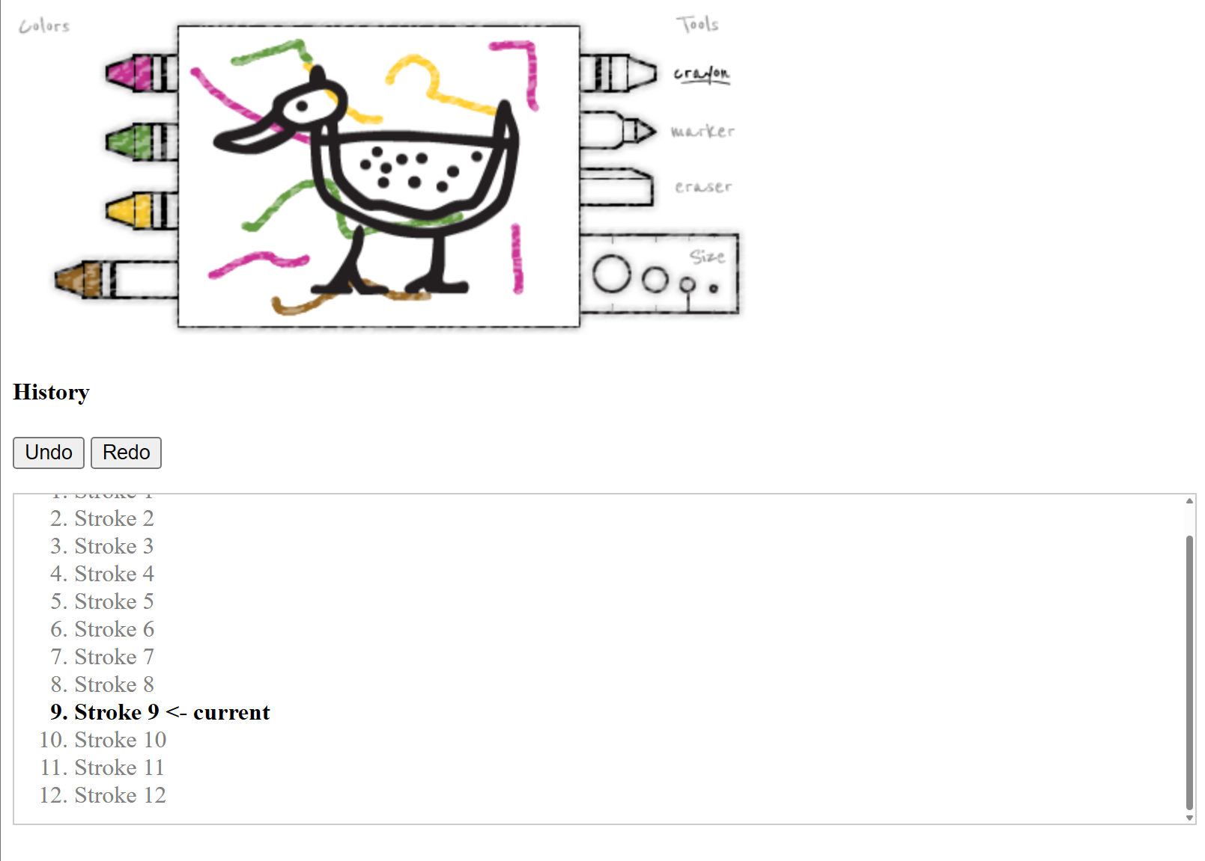
  - You may notice that the undo/redo functions end with a “drawingApp.redraw()” function. This function already existed in the original source code, though I made minor modifications to allow the undo/redo functions to update the canvas:
    - 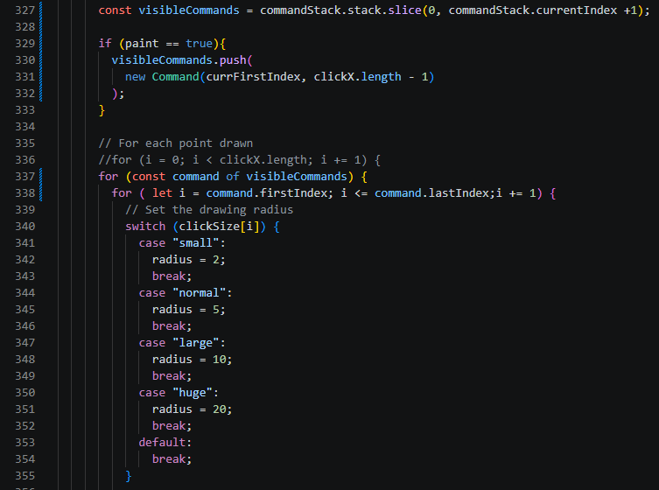
  - First, I added a “visibleCommands” stack that contains a slice of the commandStack that we want to have rendered on the canvas. If the “paint” Boolean variable is set to true, then any new commands that the user inputs are pushed to the stack; this allows the canvas to be actively updated while the user drags the mouse across it. The original for loop has been updated to accommodate the visibleCommands stack, and the canvas will only display clicks that are present within the visibleCommands stack.
  - Since the command stack’s currentIndex variable is updated when you run undo/redo, the canvas will update with the current commands since the undo/redo functions call the redraw function.
  - Also, since the eraser tool is essentially a white marker, it is also tracked within the command stack.
- There was an edge case that the application would count tool selections as a command. As such, there are redundant commands on the stack that don’t update the canvas at all. However, the user could also press and hold on a tool, and then drag the mouse onto the canvas in which that command would need to be accounted for. Thus, I updated the drag and release function as shown:
  - 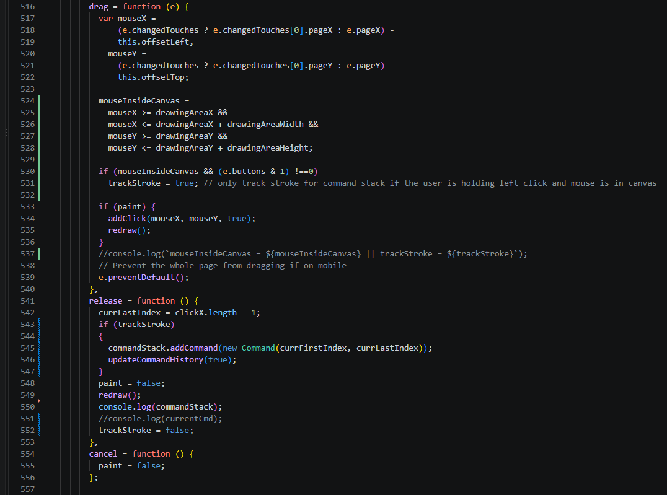
  - Lines 524-528 utilize a Boolean variable called “mouseInsideCanvas” that is true if the mouse is inside the canvas. Lines 530-531 also controls the traceStroke Boolean variable that signals lines 543-547 to add the command to the stack if the variable is set to true. This means that if the user has their mouse inside the canvas and they are hold the left mouse button, then once they release the button, that command is allowed onto the command stack.

Potential Future Implementations:
- Future implementations may include the following:
  - Garbage collection, better memory management
    - Considering that the parallel arrays and the command stack can, in theory, hold a finite number of strokes, there’s the possibility of excessive drawing on the canvas may cause a stack overflow. Perhaps implementing a system that purges distant commands in the history or strokes on the canvas that are no longer visible could alleviate this vulnerability.
  - Use of parallel arrays
    - It was a minor inconvenience, but it was a little challenging to decipher the original source code due to the use of parallel arrays. Perhaps Mallone felt that the overhead from implementing a Stroke class was not worth it, and utilizing parallel arrays could be marginally more efficient. However, it made the underlying code base harder to understand.
  - Nested for-loop starting on lines 336
    - My usage of the nested for-loop on the redraw function could theoretically hinder performance and useability of the software for the end-user if they performed a large amount of commands. Perhaps if I was to revisit this code in the future, I could find a more efficient way to render just the used commands onto the canvas.

Generative AI Usage Disclosure:
- The implementation of the undo and redo functionality, as well as the Command and CommandStack classes, were all written by me.
- OpenAI’s Codex was used for quickly understanding the source code, assisting in getting the command history to render onto the web application, and generating the README markdown file.

