Using El Niño Southern Oscillation (ENSO) Cycle as a Predictor for Dengue Transmission in Iquitos Peru

Sophia Drewry

2021-10-29

# 1 Summary/Abstract

# 2 Background

Since the start of the 20th century, dengue fever and dengue hemoragic fever have caused a significant burden in many parts of the world. According to the WHO, dengue incidence has increased 30-fold in the past 50 years (WHO, 2012). Environmental impacts on the breeding patterns and overall population of dengue’s primary host, the aedes Aegypti mosquito can be the suspected cause of this increase incidence. Factors such as rapid urbanization, change in weather and conditions, and poor sanitation contribute to the population growth of such Aedes vectors (Medlock & Leach, 2015). Dengue has 4 main serotypes, all of which have been found to circulate in South America. The country of Peru has experienced intermittent dengue outbreaks, some lasting as log as 10 years(Stoddard et al., 2014).It is also important to note that aedes Aegypti can also carry other arboviral diseases such as Zika, Chikungunya and West Nile, all of which are endemic to Peru to a smaller porportion. The city of Iquitos is conveniently located in close proximity to Nanay, Itaya, and Amazon Rivers and has a detailed dengue surveillance program set up with the Peruvian Ministry of Health and the U.S. Naval Medical Research Unit(Stoddard et al., 2014). Iquitos proximity to the ocean and higher altitude make this city ideal to study large scale weather phenomena on an urban level. The El Niño Southern Oscillation (ENSO) cycle has been shown to impact climate and ecology around the world. Its effect on infectious diseases transmission across South America has only been studied as isolated incidences or as general patterns on a limited geographic span. Climate data is important factor when studying zoonotic diseases and their geographic range. Waterborne and vector borne diseases usually see a spike in incidence rates when the host specie’s life cycle, habitat or breeding habits are altered, for this paper the Aedes aegypti mosquito host will be studied. The Aedes aegypti mosquito is the carrier of diseases found in south America such as dengue, Zika, West Nile virus, Chikungunya, and Venezuelan equine encephalitis (VEE). Dengue is the most prevalent arboviral disease in south America. **Cite this The impact of temperature and weather patterns has been shown to affect aedes Aegypti habitat and population dynamics. While as of 2021, dengue is mainly found in tropical and subtropical regions, studies have predicted that by 2050 southern United States and coastal eastern China and Japan will be at risk of endemic dengue transmission due to global climate change (Messina et al., 2019).

**Cite this ### ENSO and Vector Population Other countries such as India and Australia have been able to create predictive models, showing that a change in mean SOI values and rainfall variables are associated with either an increase or decrease of dengue incidence 3 months later Hu, Clements, Williams, & Tong (2010).

# 3 Description of data and data source

## 3.1 NOAA Data

El Niño and La Niña weather phenomena is measured as a function of the Southern Oscillation Index (SOI) and Sea Surface Temperature (SST). Both negative and positive SOI & SST values coincide abnormally warm and ocean waters across the eastern tropical & southern Pacific as well as change in air pressure. Other measures of outcomes of El Niño and La Niña episodes are ocean salinity, ocean temperature, ambient temperature, rainfall. SOI, SST and ENSO data for the years of 2001-2009 is publicly available and obtained from the National Oceanic and Atmospheric Administration(NOAA)

Our primary region of interest is 3.4, however in some cases data from region 4 is a better indicator for landfall values. For this reason, some variables will have both region 3.4 and 4 as predictors. If data from region 4 is used, it will be noted.

!(nino-regions.gif)

## 3.2 Dengue Forecasting Project Data

Weekly dengue reported cases from 2001-2009 in Iquitos, Peru is obtained from the Dengue Forecasting Project partnership with CDC and NOAA. Since dengue incidence data was reported from serological tests, serotype(DENV1-4) is included. This publicly available dataset also includes yearly population and monthly average rainfall data as well.

## 3.3 Questions/Hypotheses to be addressed

With the data I have chosen, I am looking to see if the El Niño and La Niña weather phenomena can be used as a predictor of arboviral disease transmission, specifically dengue in Iquitos, Peru.

# 4 Methods and Results

## 4.1 Data import and cleaning

Data cleaning consisted of combining all NOAA data sets into one larger set. This was done by converting all dates into numerical forms across each platform as well as adding additional week numbers. It’s important to note that the dengue data sets count incidents both weekly and by the physical date. This season in which the weeks are counted are not done by traditional year (starting in Janurary) but by Peruvian dengue seasons, starting in May. For this reason I chose to join all data sets using the physical date at the beginning of each week (month-day-year). Each data set was trimmed to match the original range of the dengue data set given.

## 4.2 Exploratory analysis

Initial exploratory data analysis was done on individual data sets after cleaning. Once sets were merged, addition descriptive table and models were produced. With the exploratory date analysis, one of the main goals when looking at the ecological data was to understand the interaction between the NOAA variables, SOI, SST and ENSO classification. This is done in the following chart. As mentioned previously both region 4 and 3.4 included in the data set because both are deemed as appropriate indicators of SST for the coastal Atlantic region. Each differ slightly but both are used for predicting patterns on the South American Coast (cite source)

SOI values follow do not follow an obvious pattern of either region 4 and 3.4 SST value as pictured in Figure 4.1 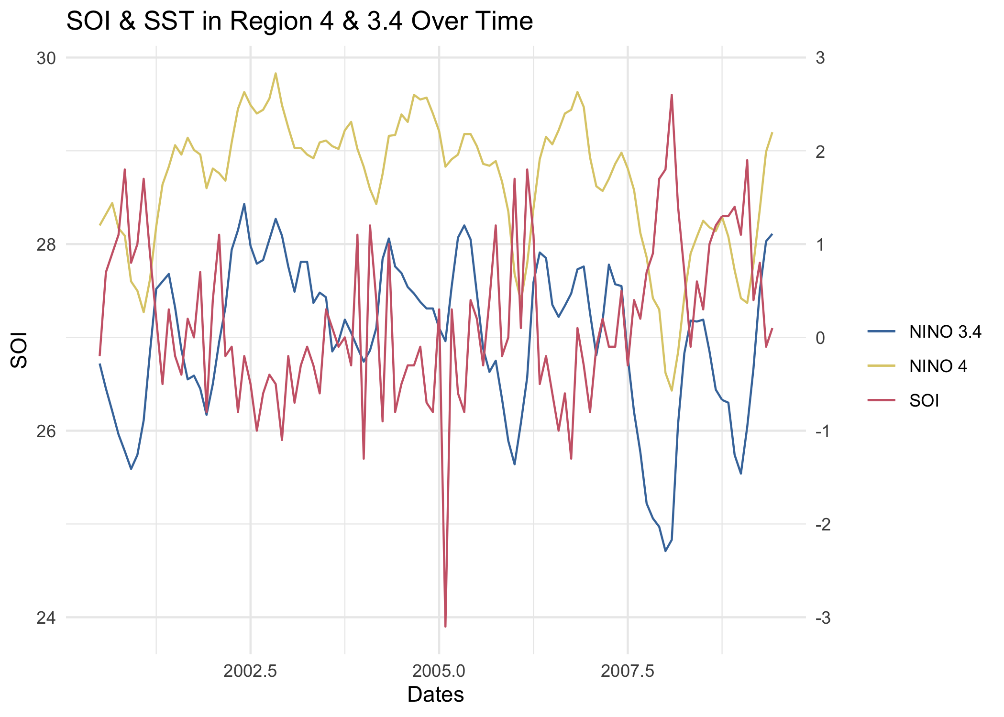 After running a General Linear Model, region 3.4 was choosen for the final model as it is the best predictor of dengue cases.

Figure 4.2 is a visualization of El Niño and La Niña occurrences. ENSO values coded red are El Niño and values coded blue are La Niña. These are the official classifications done by NOAA using various climate indicies and are not as sensitive of an indicator. 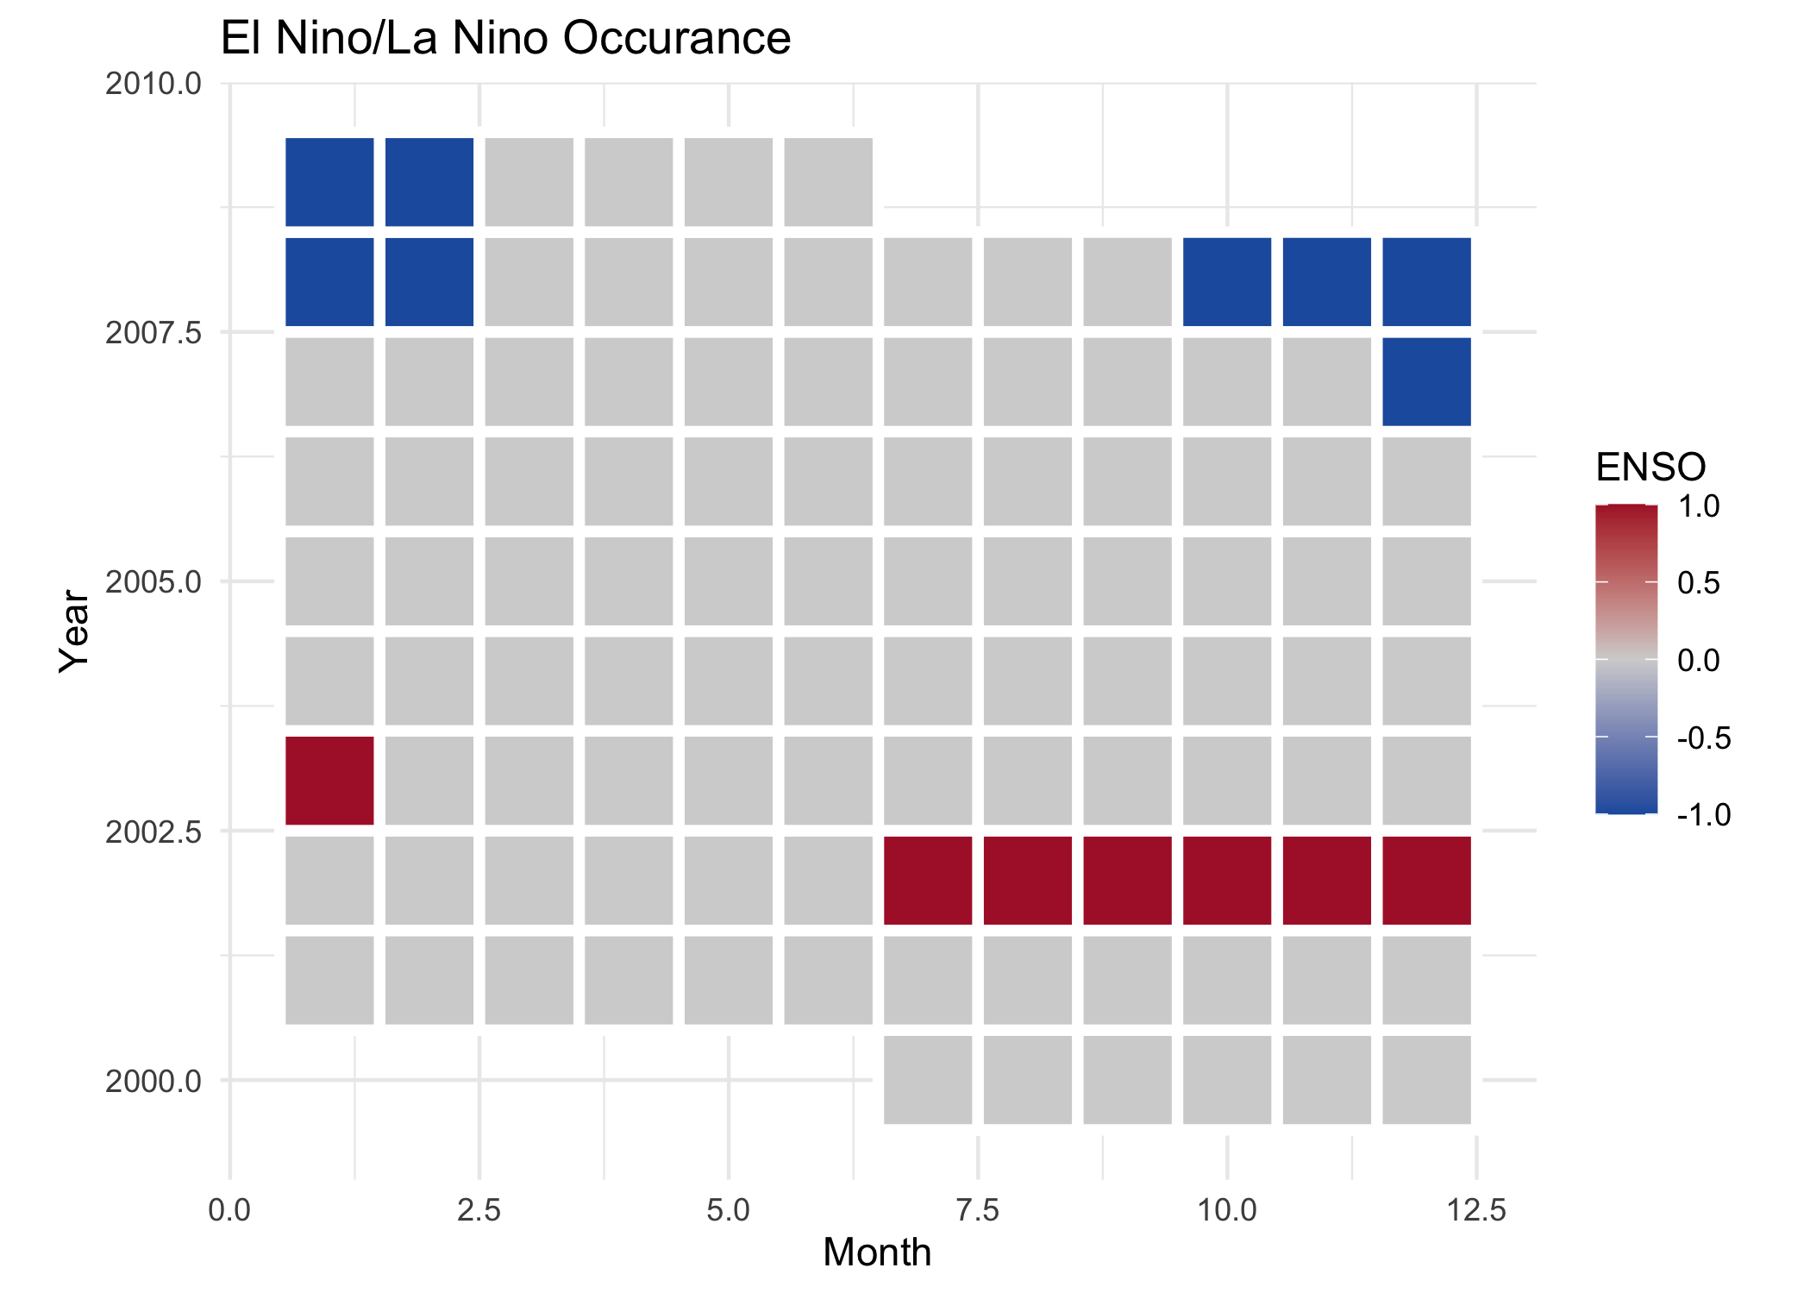

Dengue incidence in Iquitos Peru is represented in the following 3 graphs. Since all cases are reported via labortory testing, serotyping can be done. Figure 4.3 show this distribution. Note the introduction of DENV-4 around 2008. 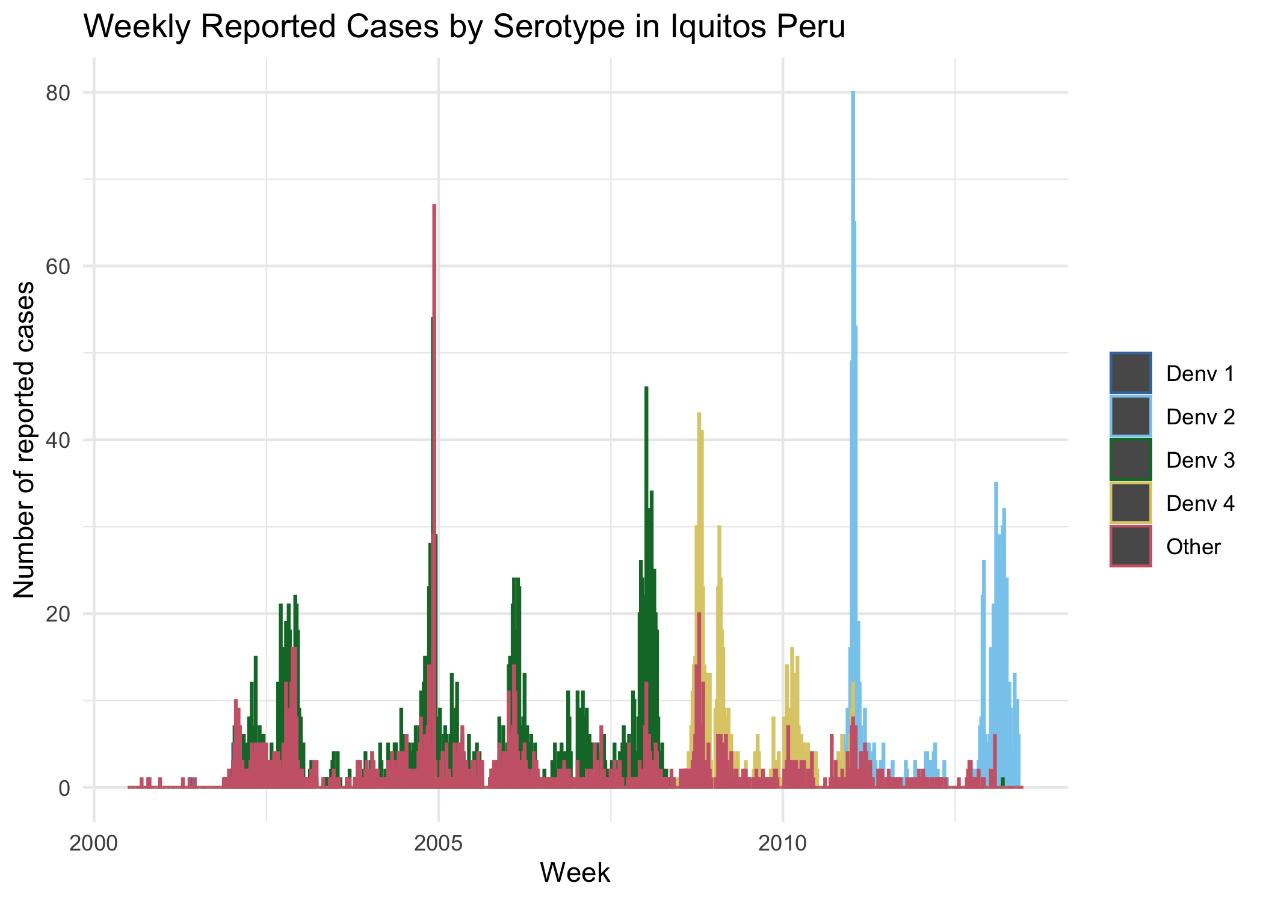 This table 4.1 summarized the data above.

Table 4.1: Table1.RDS.

| x |
| --- |
| /Users/sophiadrewry/Documents/School/Fall 2021/MADA/SophiaDrewry-MADA-project/results/exploratoryfigures/Table1.RDS |

Cumulative incidence of reported dengue infection by year is shown in the following graph. Figure 4.4 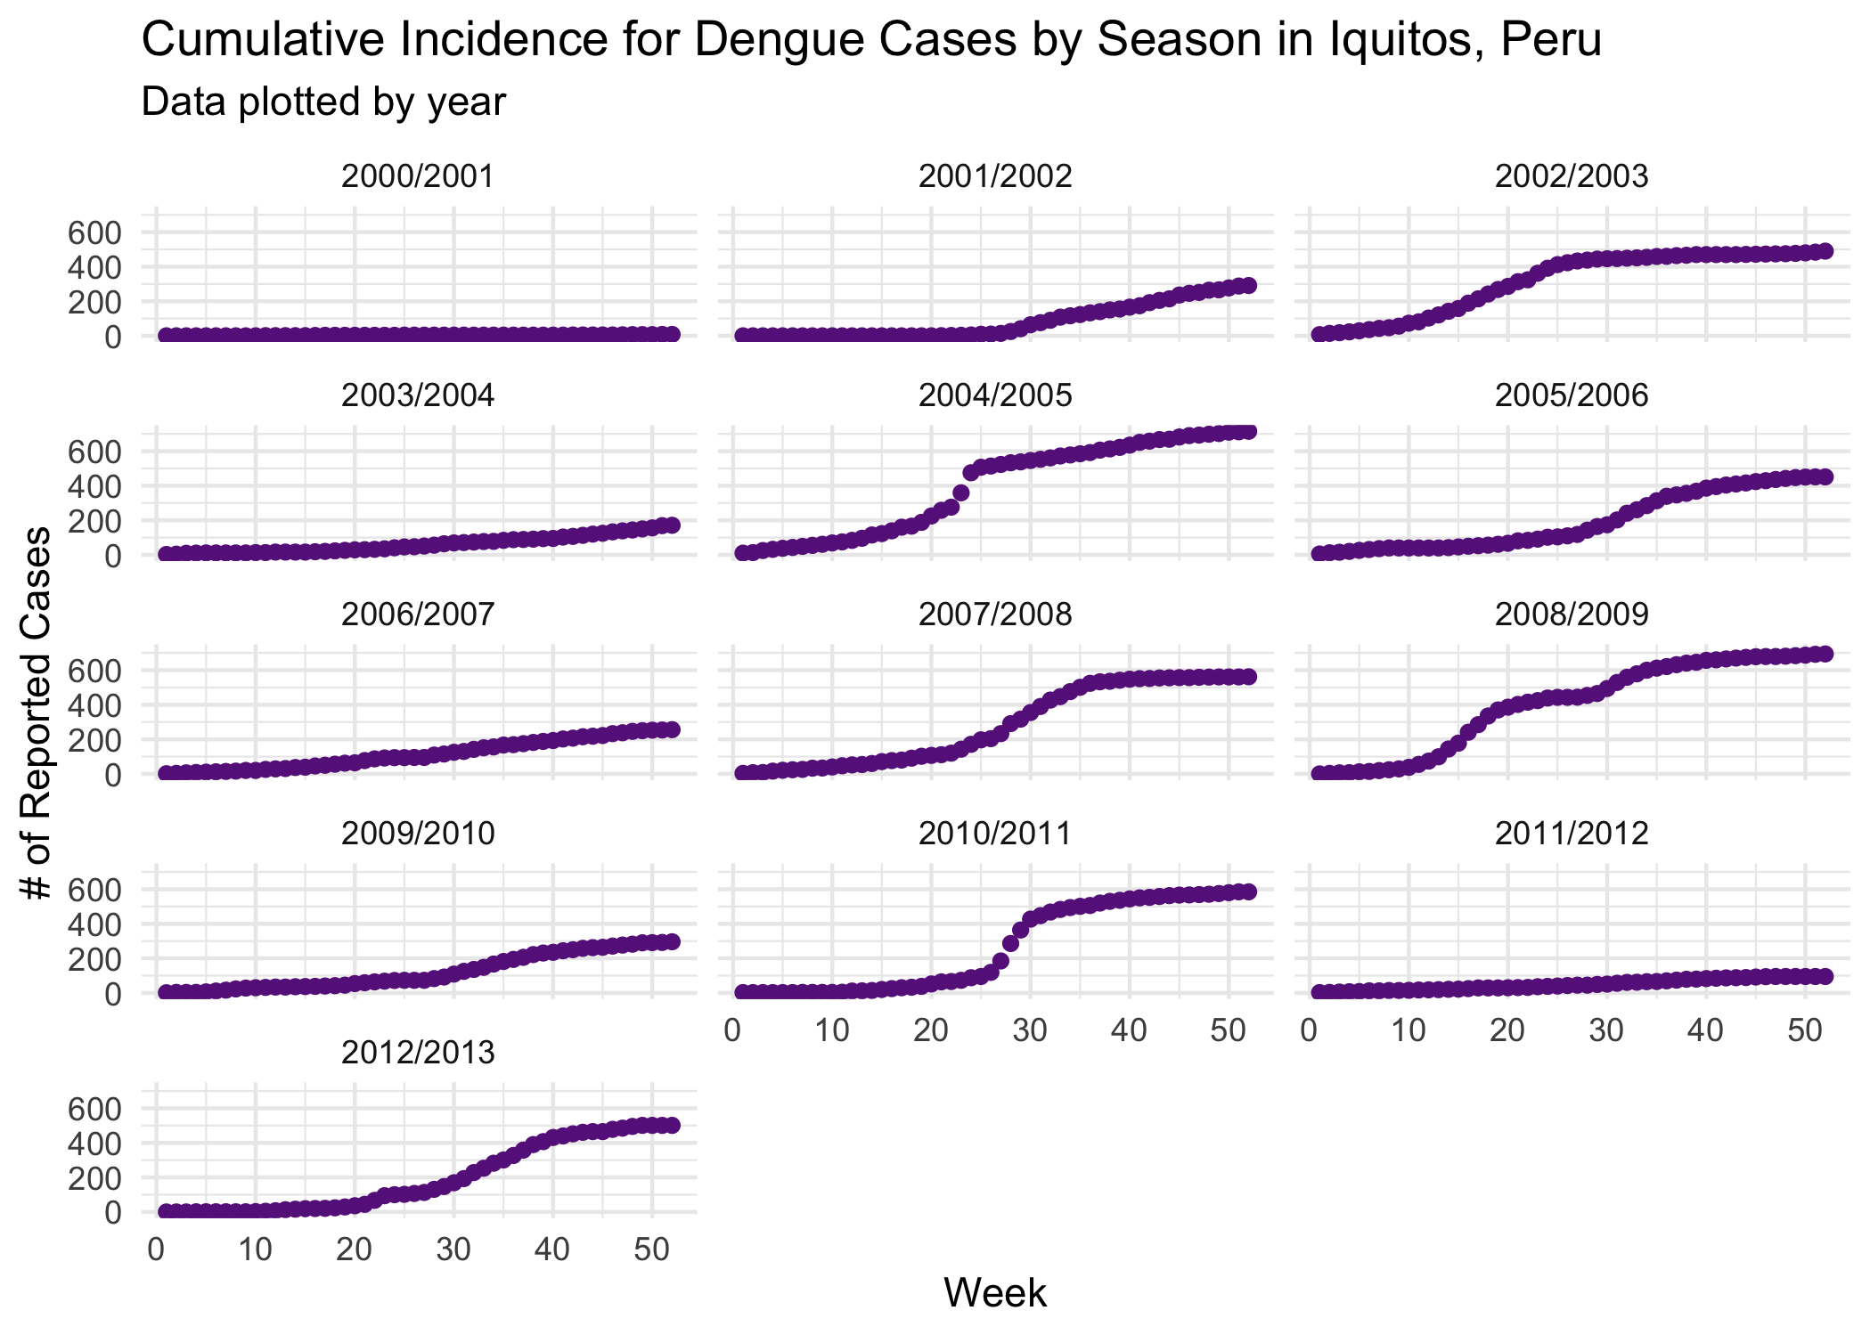

## 4.3 Full analysis

# 5 Discussion

## 5.1 Summary and Interpretation

*Summarize what you did, what you found and what it means.*

## 5.2 Strengths and Limitations

*Discuss what you perceive as strengths and limitations of your analysis.*

## 5.3 Conclusions

*What are the main take-home messages?*

*Include citations in your Rmd file using bibtex, the list of references will automatically be placed at the end*

This paper (**Leek2015a?**) discusses types of analyses.

Note that this cited reference will show up at the end of the document, the reference formatting is determined by the CSL file specified in the YAML header. Many more style files for almost any journal [are available](https://www.zotero.org/styles). You also specify the location of your bibtex reference file in the YAML. You can call your reference file anything you like, I just used the generic word references.bib but giving it a more descriptive name is probably better.

# References

Earnest, A., Tan, S., & Wilder-Smith, A. (2012). Meteorological factors and el nino southern oscillation are independently associated with dengue infections. *Epidemiology & Infection*, *140*(7), 1244–1251.

Hu, W., Clements, A., Williams, G., & Tong, S. (2010). Dengue fever and el nino/southern oscillation in queensland, australia: A time series predictive model. *Occupational and Environmental Medicine*, *67*(5), 307–311.

Medlock, J. M., & Leach, S. A. (2015). Effect of climate change on vector-borne disease risk in the UK. *The Lancet Infectious Diseases*, *15*(6), 721–730.

Messina, J. P., Brady, O. J., Golding, N., Kraemer, M. U., Wint, G. W., Ray, S. E., … others. (2019). The current and future global distribution and population at risk of dengue. *Nature Microbiology*, *4*(9), 1508–1515.

Stoddard, S. T., Wearing, H. J., Reiner Jr, R. C., Morrison, A. C., Astete, H., Vilcarromero, S., … others. (2014). Long-term and seasonal dynamics of dengue in iquitos, peru. *PLoS Neglected Tropical Diseases*, *8*(7), e3003.

WHO. (2012). Global strategy for dengue prevention and control 2012–2020. *WHO Library Cataloguing-in-Publication Data, Switzerland*.