Individual Assignment

November 22, 2024

WEBSITE: staples.ca

**Class Diagram**

**Create Account**

|  |  |  |  |
| --- | --- | --- | --- |
| Use Case Name | **Create Account** | | |
| Triggering Event | The customer clicks on “Create an Account” button | | |
| Brief Description | Enables a new user to register on Staples.ca by providing the necessary information | | |
| Actors | Owner | | |
| Related Use Cases |  | | |
| Preconditions | The user has opened the main menu | | |
| Post Conditions | User’s account is saved to the database. | | |
| Flow of activities | Actor | | System |
|  | 1. | Request to create account | Prompts for customer’s first and last name, email, password |
| 2. | Enter customer’s name, email and password | Verifies that first and last name, email and password have been entered. Creates a unique customer identifier, Displays the customer’s information. Prompts to save. |
| 3. | Choose to create account | Saves the account.  Returns to main menu |
| Exception Conditions | * Email Already Registered * Customer chooses to cancel | | |

**Create Order**

|  |  |  |  |
| --- | --- | --- | --- |
| Use Case Name | **Create Order** | | |
| Triggering Event | The customer selects items to purchase and clicks the “Checkout” button | | |
| Brief Description | User finalizes a purchase(s) by selecting items, providing delivery details and complete payment | | |
| Actors | Owner | | |
| Related Use Cases |  | | |
| Preconditions | Items are added to the shopping cart | | |
| Post Conditions | The order is successfully created | | |
| Flow of activities | Actor | | System |
|  | 1. | Request to Checkout | Displays items and adds selected items |
| 2. | Proceed to click “Checkout” | Verifies the product details in cart. Creating a unique orderID |
| 3. | Choose your shipping method (pickup or delivery) | Validates the address and displays available shipping options. |
| 4. | Proceed to payment | Verifying data once again and choosing the customers preferred payment type |
|  | 5. | Confirms order | Confirms order, saving information and going back to main menu |
| Exception Conditions | * Out of Stock item | | |

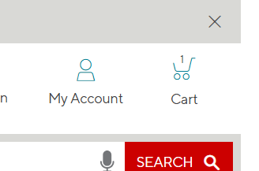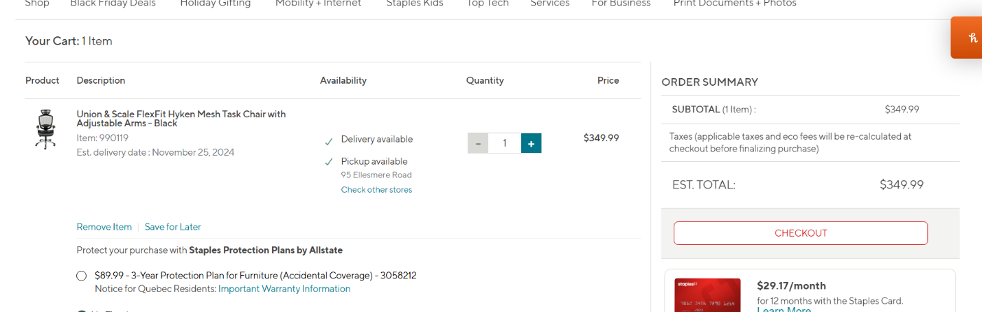

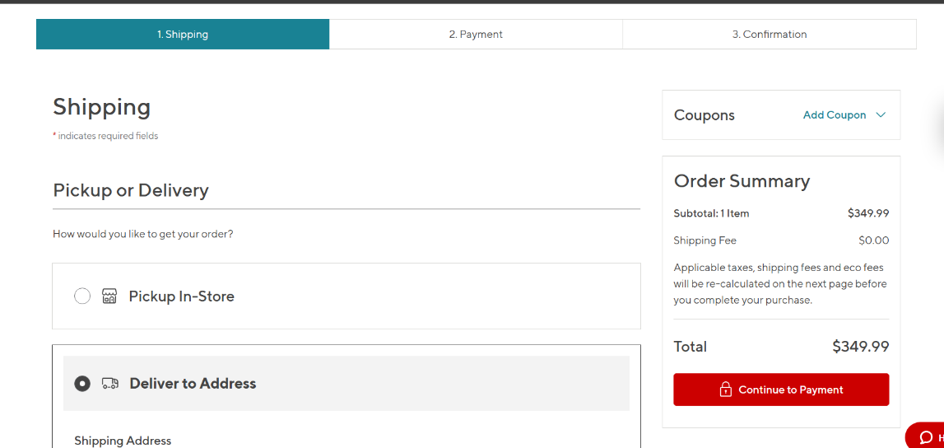

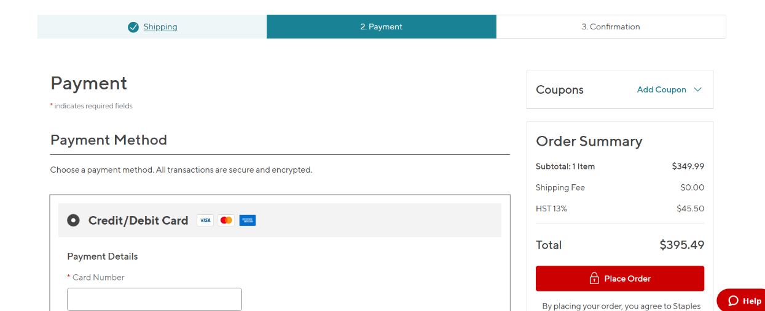

**Why?**

For my individual assignment, I have chosen Staples.ca because I used to frequently use Staples.ca since it has many products available for purchase ranging from office supplies for home, office, etc, to those specifically meant for businesses. The site is designed very well with links to all kinds of items like office supplies, electronics, furniture, and everything you can think of. The main reason for choosing Staples is the company’s magnificent record of service, courtesy, and quick deliverance. Such ethical procedures should be captured in this task as in this paper so that roles are clearly spaced and understood within the system that will be governed by the system under consideration. Simply clicking on enter doesn’t look breezy after visiting www.staples.ca. The interface is optimized for smartphones, tablets and desktops, which has increased access for most users.

**What do you like?**

One of the features of Staples.ca that I find most appealing is the fact that its design is neat and uncluttered, thus making it easy to navigate. Thanks to the clear and structured layout of the horizontal menu, where a user can find links to categories of particular interest or to special offers almost instantly, the e-commerce website of Staples does not have to operate without additional resources. One of the strengths of Staples.com is the effectiveness of its search system, which does not overload users with irrelevant information, returning instant results with ease. Furthermore, the website also includes fitting images and detailed product descriptions with user reviews to aid the users in making the correct purchases or in attaining information. Staples.ca is also great with their Create Account section as it’s just offering one form to fill, and your account is instantly created.

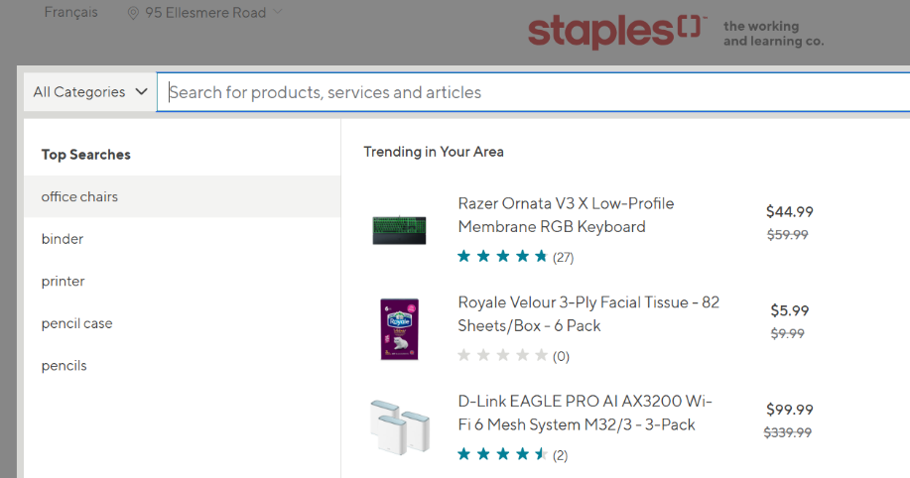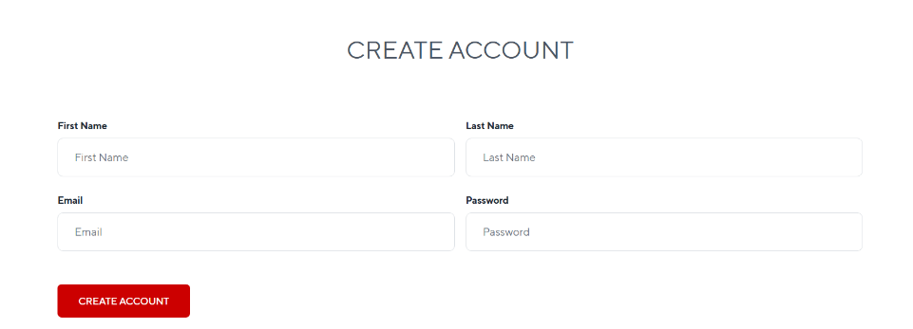

**What would you change?**

In my opinion Staples.ca is quite a pleasing site, however, there are some elements that can be improved. For example, it would be great to improve the mobile experience across all devices. Although the website works perfectly well on computers, some features on mobile tend to be a bit uneasy to navigate. A customer support system with the use of live chat would also improve the level of user experience by giving support to users whose matters are urgent as opposed to waiting for an email response or a phone call. In fact, if alterations were made to Staples.ca, it would be more efficient and customer friendly.