Inventory Lab – Julia Marchenko – 138820238

October 11, 2024

**Class Diagram**

**CreateProductInformation**

**QueryProductsbyProductType**

**CreatePurchase**

**QueryPurchases**

**get**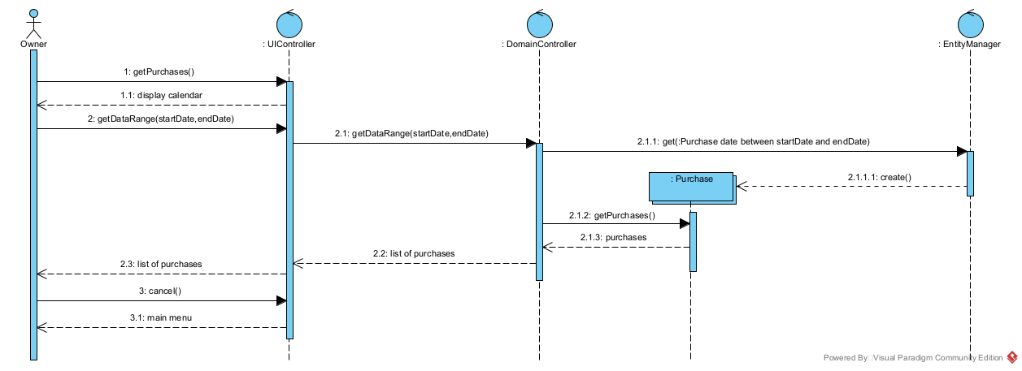

**Code**

Purchase.h

class Purchase {

private:

    int identifier;

    float purchaseTotal;

    float tax;

    float extendedPrice;

    int quantity;

    string date;

    Supplier supplier;

    Receipt receipt;

    Product product;

public:

    Purchase();

    void create();

    void setDate(const string& date);

    void setDescription(const string& description);

    void setAmount(float amount);

    void setID(int ID);

   vector<Purchase> getPurchases() const;

};

Product.h

class Product {

private:

    int productID;

    string name;

    string description;

    float price;

    int identifier;

    string ingredients;

    string precautions;

    string location;

    ProductType productType;

public:

    Product();

    void setProductID(int id);

    void setName(const string& name);

    void setDescription(const string& description);

    void setPrice(float price);

    void setIngredients(const string& ingredients);

    void setPrecautions(const string& precautions);

    void setLocation(const string& location);

    int getProductID() const;

    std::string getName() const;

    float getPrice() const;

};

Supplier.h

class Supplier {

private:

    int supplierID;

    string name;

    string phone;

    string email;

    string address;

public:

    Supplier();

    void setSupplierID(int id);

    void setName(const string& name);

    void setPhone(const string& phone);

    void setEmail(const string& email);

    void setAddress(const string& address);

    int getSupplierID() const;

    string getName() const;

};

Reciept.h

class Receipt {

private:

    string location;

    string date;

public:

    Receipt();

    void setLocation(const string& location);

    void setDate(const string& date);

    string getLocation() const;

    string getDate() const;

};

ProductType.h

class ProductType {

private:

    int productTypeID;

    string productTypeDesc;

public:

    ProductType();

    void setProductTypeID(int id);

    void setProductTypeDesc(const string& description);

    int getProductTypeID() const;

    string getProductTypeDesc() const;

};

UIController.h

public class UIController {

    addProduct()

    getProducts()

    addPurchases()

    getPurchases()

    selectProductTypes()

    enterProduct(name,description,identifier,ingredients,precautions)

    enterProduct(price,quantity)

    enterPurchases(date,reciept,supplierID)

    getDataRange(startDate,endDate)

    cancel()

    save()

}

DomainController.h

public class DomainController {

   float calculate()

   float calculate(price*quantity)

   float calculate(extendedPrice+tax)

   int identifier()

   getProductTypes()

   getProducts()

   getSupplier()

   enterPurchase(date,receipt,supplierID)

   selectProductTypes()

   enterProduct(name,description,identifier,ingredients,precautions)

   enterProduct(price,quantity)

   save()

   getDataRange(startDate,endDate)

}

EntityManager.h

public class EntityManager {

    persist(object)

    get(class,selection)

}