Figure 1. Variability MINT scores by group.

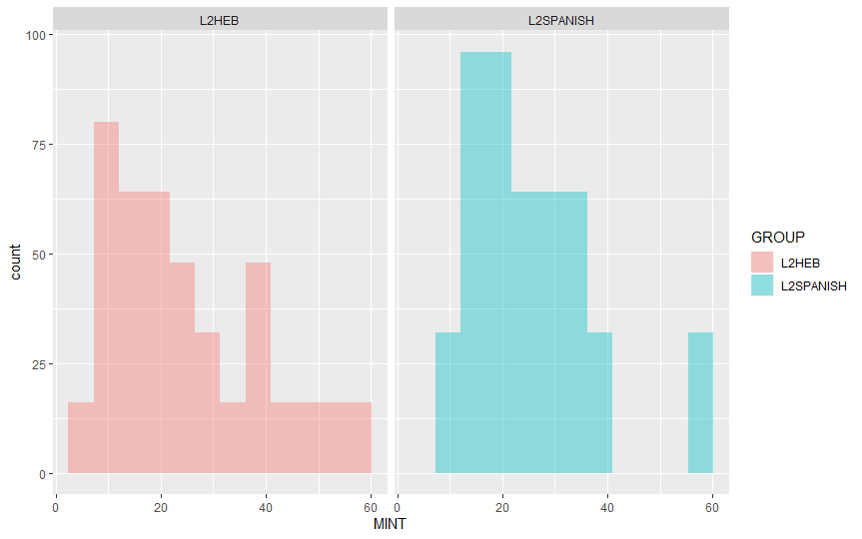

Figure 3. Agreement elicited production task (EPT) experimental trial in each target language.

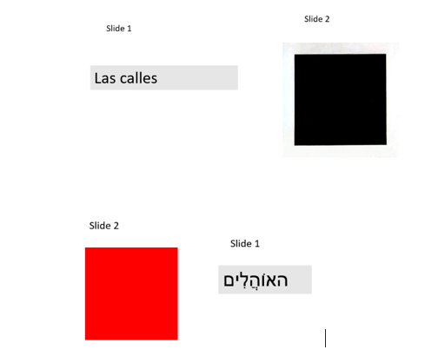

Figure 4. Proportion of accurate response by frequency condition across groups in EPT results.

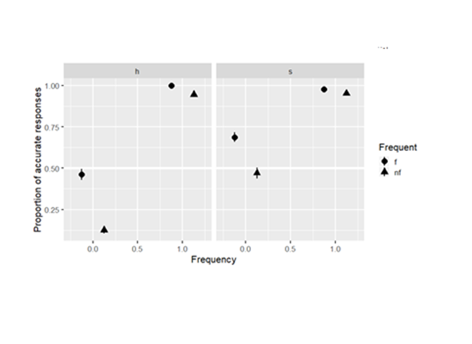

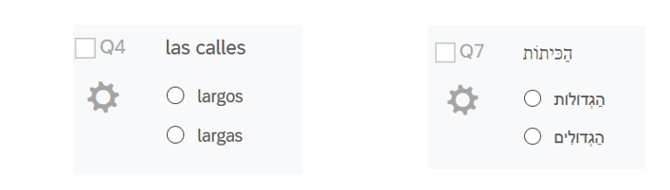Figure 5. FCT experimental tasks in each target language.

Figure 6. Proportion of accurate responses by frequency condition in FCT task