US.Level.Only.Total.OPEX.KDA

Jason Marshall

August 9, 2018

library(forecast)  
library(tidyquant)

## Loading required package: lubridate

##   
## Attaching package: 'lubridate'

## The following object is masked from 'package:base':  
##   
## date

## Loading required package: PerformanceAnalytics

## Loading required package: xts

## Loading required package: zoo

##   
## Attaching package: 'zoo'

## The following objects are masked from 'package:base':  
##   
## as.Date, as.Date.numeric

##   
## Attaching package: 'PerformanceAnalytics'

## The following object is masked from 'package:graphics':  
##   
## legend

## Loading required package: quantmod

## Loading required package: TTR

## Version 0.4-0 included new data defaults. See ?getSymbols.

## Loading required package: tidyverse

## -- Attaching packages --------

## v ggplot2 2.2.1 v purrr 0.2.4  
## v tibble 1.4.2 v dplyr 0.7.4  
## v tidyr 0.8.0 v stringr 1.2.0  
## v readr 1.1.1 v forcats 0.2.0

## -- Conflicts -----------------  
## x lubridate::as.difftime() masks base::as.difftime()  
## x lubridate::date() masks base::date()  
## x dplyr::filter() masks stats::filter()  
## x dplyr::first() masks xts::first()  
## x lubridate::intersect() masks base::intersect()  
## x dplyr::lag() masks stats::lag()  
## x dplyr::last() masks xts::last()  
## x lubridate::setdiff() masks base::setdiff()  
## x lubridate::union() masks base::union()

##   
## Attaching package: 'tidyquant'

## The following object is masked from 'package:dplyr':  
##   
## as_tibble

## The following object is masked from 'package:tibble':  
##   
## as_tibble

library(timetk)  
library(sweep)  
library(tidyverse)  
library(broom)  
library(timeDate)

##   
## Attaching package: 'timeDate'

## The following objects are masked from 'package:PerformanceAnalytics':  
##   
## kurtosis, skewness

library(reshape2)

##   
## Attaching package: 'reshape2'

## The following object is masked from 'package:tidyr':  
##   
## smiths

library(data.table)

##   
## Attaching package: 'data.table'

## The following objects are masked from 'package:reshape2':  
##   
## dcast, melt

## The following objects are masked from 'package:dplyr':  
##   
## between, first, last

## The following object is masked from 'package:purrr':  
##   
## transpose

## The following objects are masked from 'package:xts':  
##   
## first, last

## The following objects are masked from 'package:lubridate':  
##   
## hour, isoweek, mday, minute, month, quarter, second, wday,  
## week, yday, year

library(readr)  
library(DataExplorer)  
library(Hmisc)

## Loading required package: lattice

## Loading required package: survival

## Loading required package: Formula

##   
## Attaching package: 'Hmisc'

## The following objects are masked from 'package:dplyr':  
##   
## src, summarize

## The following object is masked from 'package:quantmod':  
##   
## Lag

## The following objects are masked from 'package:base':  
##   
## format.pval, units

library(caret)

##   
## Attaching package: 'caret'

## The following object is masked from 'package:survival':  
##   
## cluster

## The following object is masked from 'package:purrr':  
##   
## lift

library(quantreg)

## Loading required package: SparseM

##   
## Attaching package: 'SparseM'

## The following object is masked from 'package:base':  
##   
## backsolve

##   
## Attaching package: 'quantreg'

## The following object is masked from 'package:Hmisc':  
##   
## latex

## The following object is masked from 'package:survival':  
##   
## untangle.specials

library(GGally)

##   
## Attaching package: 'GGally'

## The following object is masked from 'package:dplyr':  
##   
## nasa

#############################################  
#union regional expense data into one dataset  
#############################################  
# #load expense data  
# dataset.1 <- read_csv("Y:/Sharepoint Projects/Jason Marshall/R_Projects/OPEX_Forecasting/Data/OpEx Expenses v2 - South.csv",  
# col_types = cols(Amount = col_number()))  
#   
# dataset.2 <- read_csv("Y:/Sharepoint Projects/Jason Marshall/R_Projects/OPEX_Forecasting/Data/OpEx Expenses v2 - US.csv",  
# col_types = cols(Amount = col_number()))  
#   
# dataset.3 <- read_csv("Y:/Sharepoint Projects/Jason Marshall/R_Projects/OPEX_Forecasting/Data/OpEx Expenses v2 - WCBT.csv",  
# col_types = cols(Amount = col_number()))  
#   
# dataset.4 <- read_csv("Y:/Sharepoint Projects/Jason Marshall/R_Projects/OPEX_Forecasting/Data/OpEx Expenses v2 - West.csv",  
# col_types = cols(Amount = col_number()))  
#   
# dataset.5 <- read_csv("Y:/Sharepoint Projects/Jason Marshall/R_Projects/OPEX_Forecasting/Data/OpEx Expenses v2 - CCBT.csv",  
# col_types = cols(Amount = col_number()))  
#   
# dataset.6 <- read_csv("Y:/Sharepoint Projects/Jason Marshall/R_Projects/OPEX_Forecasting/Data/OpEx Expenses v2 - East.csv",  
# col_types = cols(Amount = col_number()))  
#   
# dataset.7 <- read_csv("Y:/Sharepoint Projects/Jason Marshall/R_Projects/OPEX_Forecasting/Data/OpEx Expenses v2 - ECBT.csv",  
# col_types = cols(Amount = col_number()))  
#   
# #combine both datasets  
# comb.dataset <- bind_rows(dataset.1, dataset.2, dataset.3, dataset.4, dataset.5, dataset.6, dataset.7)  
#   
# #fill NA  
# comb.dataset$Amount <- replace_na(comb.dataset$Amount, replace = 0)  
#   
# #make unique col names  
# colsNamesShelf <-colnames(comb.dataset)  
# dataset_col_names <- make.names(colsNamesShelf, unique = TRUE)  
# colnames(comb.dataset) <- dataset_col_names  
#   
# #add date column  
# comb.dataset <- comb.dataset %>%  
# mutate(day.holder = 01) %>%  
# mutate(date.holder = paste(Year, Acct.Per, day.holder, sep = "-"))  
#   
# #set date.holder as date  
# comb.dataset$date.holder <- as.Date(comb.dataset$date.holder)  
#   
# #get last day of the month  
# comb.dataset$Date <- as.Date(timeDate::timeLastDayInMonth(comb.dataset$date.holder))  
#   
# #write to disk  
# write.csv(comb.dataset,"Y:/Sharepoint Projects/Jason Marshall/R_Projects/OPEX_Forecasting/Data/US.opex.test.full.csv")  
  
####################################################################################  
expense.dataset <- read_csv("Y:/Sharepoint Projects/Jason Marshall/R_Projects/OPEX_Forecasting/Data/US.opex.test.full.csv")

## Warning: Missing column names filled in: 'X1' [1]

## Parsed with column specification:  
## cols(  
## X1 = col_integer(),  
## GL.Level = col_character(),  
## Summary.Account = col_character(),  
## Parent.Account = col_character(),  
## Account = col_character(),  
## Geography = col_character(),  
## Region = col_character(),  
## Division = col_character(),  
## Period = col_character(),  
## Acct.Per = col_integer(),  
## Year = col_integer(),  
## Currency = col_character(),  
## Amount = col_integer(),  
## day.holder = col_integer(),  
## date.holder = col_date(format = ""),  
## Date = col_date(format = "")  
## )

## Warning in rbind(names(probs), probs_f): number of columns of result is not  
## a multiple of vector length (arg 1)

## Warning: 32 parsing failures.  
## row # A tibble: 5 x 5 col row col expected actual file expected <int> <chr> <chr> <chr> <chr> actual 1 1005 Amount no trailing characters e+05 'Y:/Sharepoint Projects/Jaso~ file 2 15347 Amount no trailing characters e+05 'Y:/Sharepoint Projects/Jaso~ row 3 17619 Amount no trailing characters e+05 'Y:/Sharepoint Projects/Jaso~ col 4 30257 Amount no trailing characters e+05 'Y:/Sharepoint Projects/Jaso~ expected 5 35440 Amount no trailing characters e+05 'Y:/Sharepoint Projects/Jaso~  
## ... ................. ... .......................................................................... ........ .......................................................................... ...... .......................................................................... .... .......................................................................... ... .......................................................................... ... .......................................................................... ........ ..........................................................................  
## See problems(...) for more details.

#change strings to factors  
expense.dataset <- expense.dataset %>% mutate_if(is.character, as.factor)

#agregate data to yearly  
#transaction granularity = division level by parent account (not lower level account for this version)  
expense.dataset.panel.total <- dcast(setDT(expense.dataset), formula = Geography + Region + Division ~ Year + Parent.Account, value.var = c('Amount'), fun.aggregate = sum)  
  
#remove larger expense dataset  
rm(expense.dataset)  
#############split pannel by year to help EDA###########  
# year.values <- unique(expense.dataset$Year)  
# for (i in year.values){  
# #print(i)  
# #filter dataframe  
# filtered.df <- expense.dataset %>%   
# filter(Year == i)  
#   
# #create new dataset  
# assign(paste("expense.dataset", i, sep = "."),  
# #create wide/panel version  
# dcast(setDT(filtered.df),   
# formula = Geography + Region + Division ~ Year + Parent.Account,   
# value.var = c('Amount'),   
# fun.aggregate = sum))  
# }

#load sales data  
sales.dataset <- read_csv("Y:/Sharepoint Projects/Jason Marshall/R_Projects/OPEX_Forecasting/Data/US_Region_Division_Added_Only_NA_Item_Sales_chopdown_test a557ef9eb.csv")

## Parsed with column specification:  
## cols(  
## `Invoice Date` = col_character(),  
## Region = col_character(),  
## `Region Number` = col_integer(),  
## Division = col_character(),  
## `Divsion Number` = col_integer(),  
## `GL Shelf` = col_character(),  
## `Net Sales` = col_number(),  
## `Total Margin` = col_number()  
## )

#make unique col names  
colsNamesShelf <-colnames(sales.dataset)  
dataset_col_names <- make.names(colsNamesShelf, unique = TRUE)  
colnames(sales.dataset) <- dataset_col_names  
  
#edit date format   
sales.dataset$Invoice.Date <- as.Date(sales.dataset$Invoice.Date, format = '%B %d, %Y')  
  
#change invoice date to last month of the year for monthly sum and join with expense data  
sales.dataset$Invoice.Date <- timeLastDayInMonth(sales.dataset$Invoice.Date)   
  
#change to character to facilitate group_by below  
sales.dataset$Invoice.Date <- as.character(sales.dataset$Invoice.Date)  
   
#create summarized version of sales data by month  
sales.dataset <- sales.dataset %>%   
 group_by(Invoice.Date, Region, Region.Number, Division, Divsion.Number, GL.Shelf) %>%  
 summarise(Net.Sales = sum(Net.Sales), Total.Margin = sum(Total.Margin))

#create panel data#######################  
  
#add month year data  
sales.dataset.panel <- sales.dataset %>%  
 mutate(YEAR = year(Invoice.Date)) %>%  
 mutate(MONTH = month(Invoice.Date))  
  
#use setDATATABLE to generate long dataset   
sales.dataset.panel <- dcast(setDT(sales.dataset.panel),   
 formula = Region + Region.Number + Division + Divsion.Number ~ YEAR + GL.Shelf,   
 value.var = c('Net.Sales', 'Total.Margin'),   
 fun.aggregate = sum)  
  
#create yearly total columns  
sales.dataset.panel <- sales.dataset.panel %>%   
 mutate(Net.Sales_TOTAL.2014 = rowSums(select(., starts_with("Net.Sales_2014")))) %>%  
 mutate(Net.Sales_TOTAL.2015 = rowSums(select(., starts_with("Net.Sales_2015")))) %>%  
 mutate(Net.Sales_TOTAL.2016 = rowSums(select(., starts_with("Net.Sales_2016")))) %>%  
 mutate(Net.Sales_TOTAL.2017 = rowSums(select(., starts_with("Net.Sales_2017")))) %>%  
 mutate(Net.Sales_TOTAL.2018 = rowSums(select(., starts_with("Net.Sales_2018")))) %>%  
 mutate(TOTAL.MARGIN.2014 = rowSums(select(., starts_with("Total.Margin_2014")))) %>%  
 mutate(TOTAL.MARGIN.2015 = rowSums(select(., starts_with("Total.Margin_2015")))) %>%  
 mutate(TOTAL.MARGIN.2016 = rowSums(select(., starts_with("Total.Margin_2016")))) %>%  
 mutate(TOTAL.MARGIN.2017 = rowSums(select(., starts_with("Total.Margin_2017")))) %>%  
 mutate(TOTAL.MARGIN.2018 = rowSums(select(., starts_with("Total.Margin_2018"))))  
  
#add timeseries data  
#sales.dataset.panel <- sales.dataset.panel %>%  
# mutate(day.holder = 01) %>%  
# mutate(date.holder = paste(YEAR, Acct.Per, day.holder, sep = "-"))  
  
#set date.holder as date   
#sales.dataset.panel$date.holder <- as.Date(sales.dataset.panel$date.holder)   
  
#get last day of the month  
#sales.dataset.panel$Date <- as.Date(timeDate::timeLastDayInMonth(sales.dataset.panel$date.holder))

#convert to character  
#to facilitate join on division name (not optimal)  
expense.dataset.panel.total$Division <- as.character(expense.dataset.panel.total$Division)  
#convert to upper case  
expense.dataset.panel.total$Division <- toupper(expense.dataset.panel.total$Division)   
  
#replace spaces with "." in division (for sales and expense data)  
expense.dataset.panel.total$Division <- gsub("\\ ", ".", expense.dataset.panel.total$Division)  
sales.dataset.panel$Division <- gsub("\\ ", ".", sales.dataset.panel$Division)  
  
#join expense and sales data  
comb.sales.exp.data <- inner_join(sales.dataset.panel, expense.dataset.panel.total,   
 by = "Division")  
  
#convert categorical to factor  
comb.sales.exp.data[,c("Region.x", "Division", "Region.y", "Geography")] <-   
 lapply(comb.sales.exp.data[,c("Region.x", "Division", "Region.y", "Geography")], factor)  
  
#drop larger raw sales data set  
rm(sales.dataset)  
  
#write to disc for power BI  
#write.csv(comb.sales.exp.data, "Y:/Sharepoint Projects/Jason Marshall/R_Projects/OPEX_Forecasting/Results/Exploratory.Data.Analysis/comb.dataset.csv")

# #2014 pairs plot  
# #net sales  
# comb.sales.exp.data %>% select(., contains("Net.Sales_2014")) %>%  
# ggpairs()  
# #total margin  
# comb.sales.exp.data %>% select(., contains("Total.Margin_2014")) %>%  
# ggpairs()  
#   
#   
# #2015 pairs plot  
# #net sales  
# comb.sales.exp.data %>% select(., contains("Net.Sales_2015")) %>%  
# ggpairs()  
# #total margin  
# comb.sales.exp.data %>% select(., contains("Total.Margin_2015")) %>%  
# ggpairs()  
#   
#   
# #2016 pairs plot  
# #net sales  
# comb.sales.exp.data %>% select(., contains("Net.Sales_2016")) %>%  
# ggpairs()  
# #total margin  
# comb.sales.exp.data %>% select(., contains("Total.Margin_2016")) %>%  
# ggpairs()  
#   
#   
# #2017 pairs plot  
# #net sales  
# comb.sales.exp.data %>% select(., contains("Net.Sales_2017")) %>%  
# ggpairs()  
# #total margin  
# comb.sales.exp.data %>% select(., contains("Total.Margin_2017")) %>%  
# ggpairs()  
#   
#   
# #2018 pairs plot  
# #net sales  
# comb.sales.exp.data %>% select(., contains("Net.Sales_2018")) %>%  
# ggpairs()  
# #total margin  
# comb.sales.exp.data %>% select(., contains("Total.Margin_2018")) %>%  
# ggpairs()

summary(comb.sales.exp.data)

## Region.x Region.Number Division   
## CENTRAL CORNBELT: 9 Min. : 250.0 FLORIDA : 2   
## EASTERN : 7 1st Qu.: 298.0 NEBRASKA : 2   
## EASTERN CORNBELT:10 Median : 400.0 NORTHEAST : 2   
## SOUTH : 8 Mean : 792.9 ALABAMA : 1   
## WEST : 7 3rd Qu.: 531.0 CENTRAL.CORNBELT.ADMIN : 1   
## WESTERN CORNBELT:10 Max. :3157.0 CENTRAL.CORNBELT.DC.DIVISION: 1   
## NA's :2 (Other) :42   
## Divsion.Number Net.Sales_2014_APPL Net.Sales_2014_CHEM  
## Min. : 1.00 Min. : -11740 Min. : 0   
## 1st Qu.: 54.00 1st Qu.: 1666973 1st Qu.: 34706666   
## Median : 68.00 Median : 4908854 Median : 57842091   
## Mean : 64.71 Mean : 4929339 Mean : 65853756   
## 3rd Qu.: 86.00 3rd Qu.: 8461021 3rd Qu.: 79289492   
## Max. :124.00 Max. :13146544 Max. :422331114   
## NA's :2   
## Net.Sales_2014_FERT Net.Sales_2014_OTHE Net.Sales_2014_SEED  
## Min. : 0 Min. : 0 Min. : 0   
## 1st Qu.: 36653396 1st Qu.: 324110 1st Qu.: 4636789   
## Median : 66597977 Median : 1475126 Median : 21279843   
## Mean : 63851829 Mean : 2435402 Mean : 23202697   
## 3rd Qu.: 95543171 3rd Qu.: 3471712 3rd Qu.: 32850611   
## Max. :182842148 Max. :15082995 Max. :127833773   
##   
## Net.Sales_2015_APPL Net.Sales_2015_CHEM Net.Sales_2015_FERT  
## Min. : -5482 Min. : 0 Min. : 0   
## 1st Qu.: 1638446 1st Qu.: 34942502 1st Qu.: 35141749   
## Median : 5297097 Median : 56903707 Median : 62907104   
## Mean : 5118250 Mean : 66947061 Mean : 63425646   
## 3rd Qu.: 8486965 3rd Qu.: 87500144 3rd Qu.: 92146438   
## Max. :14086485 Max. :405870246 Max. :188028109   
##   
## Net.Sales_2015_OTHE Net.Sales_2015_SEED Net.Sales_2016_APPL  
## Min. : 0 Min. : 0 Min. : -64870   
## 1st Qu.: 310743 1st Qu.: 3926655 1st Qu.: 1586402   
## Median : 1540968 Median : 21745280 Median : 5398352   
## Mean : 2531345 Mean : 23000486 Mean : 5231504   
## 3rd Qu.: 3642049 3rd Qu.: 32653948 3rd Qu.: 8522245   
## Max. :16668981 Max. :119197555 Max. :14497807   
##   
## Net.Sales_2016_CHEM Net.Sales_2016_FERT Net.Sales_2016_OTHE  
## Min. : 0 Min. : 0 Min. : 0   
## 1st Qu.: 35447738 1st Qu.: 29363320 1st Qu.: 261968   
## Median : 58585486 Median : 56218701 Median : 1600742   
## Mean : 66779128 Mean : 54969290 Mean : 2589026   
## 3rd Qu.: 87168027 3rd Qu.: 75715006 3rd Qu.: 3777971   
## Max. :386635805 Max. :162023993 Max. :16941240   
##   
## Net.Sales_2016_SEED Net.Sales_2017_APPL Net.Sales_2017_CHEM  
## Min. : 0 Min. : 0 Min. : 0   
## 1st Qu.: 3993133 1st Qu.: 1586978 1st Qu.: 38150703   
## Median : 21716808 Median : 5875063 Median : 62745467   
## Mean : 23894476 Mean : 5493877 Mean : 71538970   
## 3rd Qu.: 33437025 3rd Qu.: 9244111 3rd Qu.: 91003575   
## Max. :122550618 Max. :14337003 Max. :447061555   
##   
## Net.Sales_2017_FERT Net.Sales_2017_OTHE Net.Sales_2017_SEED  
## Min. : 0 Min. : 0 Min. : 0   
## 1st Qu.: 25571121 1st Qu.: 157358 1st Qu.: 5111529   
## Median : 55202577 Median : 1716933 Median : 22726769   
## Mean : 53541714 Mean : 2627888 Mean : 25505368   
## 3rd Qu.: 75142968 3rd Qu.: 4386266 3rd Qu.: 32720603   
## Max. :158604969 Max. :16926803 Max. :115911137   
##   
## Net.Sales_2018_APPL Net.Sales_2018_CHEM Net.Sales_2018_FERT  
## Min. : -16976 Min. : 0 Min. : 0   
## 1st Qu.: 875529 1st Qu.: 28877964 1st Qu.: 21905140   
## Median :3156634 Median : 42940741 Median : 37861468   
## Mean :3097969 Mean : 47254502 Mean : 39986803   
## 3rd Qu.:5014428 3rd Qu.: 61734461 3rd Qu.: 57349672   
## Max. :8067270 Max. :236259483 Max. :119962494   
##   
## Net.Sales_2018_OTHE Net.Sales_2018_SEED Total.Margin_2014_APPL  
## Min. : 0 Min. : 0 Min. : -11740   
## 1st Qu.: 88529 1st Qu.: 2763029 1st Qu.: 1666973   
## Median : 360517 Median : 22965256 Median : 4908854   
## Mean :1353733 Mean : 24515288 Mean : 4929339   
## 3rd Qu.:1668600 3rd Qu.: 31990300 3rd Qu.: 8461021   
## Max. :8675916 Max. :120725065 Max. :13146544   
##   
## Total.Margin_2014_CHEM Total.Margin_2014_FERT Total.Margin_2014_OTHE  
## Min. : 0 Min. : 0 Min. : -39797   
## 1st Qu.: 6059358 1st Qu.: 4245052 1st Qu.: 76268   
## Median :13116464 Median : 8771044 Median : 445759   
## Mean :12674123 Mean : 9892553 Mean : 594634   
## 3rd Qu.:16183005 3rd Qu.:15252315 3rd Qu.: 757806   
## Max. :43890536 Max. :36113807 Max. :2949413   
##   
## Total.Margin_2014_SEED Total.Margin_2015_APPL Total.Margin_2015_CHEM  
## Min. : 0 Min. : -5482 Min. : 0   
## 1st Qu.: 713205 1st Qu.: 1638446 1st Qu.: 6954502   
## Median : 2297055 Median : 5297097 Median :12900119   
## Mean : 3315621 Mean : 5118250 Mean :12805289   
## 3rd Qu.: 4128621 3rd Qu.: 8486965 3rd Qu.:16755124   
## Max. :20622334 Max. :14086485 Max. :46200599   
##   
## Total.Margin_2015_FERT Total.Margin_2015_OTHE Total.Margin_2015_SEED  
## Min. : 0 Min. : 0 Min. : 0   
## 1st Qu.: 4005047 1st Qu.: 102828 1st Qu.: 348494   
## Median : 8260105 Median : 366655 Median : 2642428   
## Mean : 9666591 Mean : 566847 Mean : 3067003   
## 3rd Qu.:13655513 3rd Qu.: 868945 3rd Qu.: 3359684   
## Max. :37203844 Max. :3415457 Max. :18216123   
##   
## Total.Margin_2016_APPL Total.Margin_2016_CHEM Total.Margin_2016_FERT  
## Min. : -64870 Min. : 0 Min. : 0   
## 1st Qu.: 1586402 1st Qu.: 7469797 1st Qu.: 3954050   
## Median : 5398352 Median :12725430 Median : 7738089   
## Mean : 5231504 Mean :12633479 Mean : 9421672   
## 3rd Qu.: 8522245 3rd Qu.:16385400 3rd Qu.:13227852   
## Max. :14497807 Max. :50207697 Max. :34666275   
##   
## Total.Margin_2016_OTHE Total.Margin_2016_SEED Total.Margin_2017_APPL  
## Min. :-246355 Min. : 0 Min. : 0   
## 1st Qu.: 46546 1st Qu.: 527529 1st Qu.: 1586978   
## Median : 401474 Median : 2665012 Median : 5875063   
## Mean : 560467 Mean : 3083704 Mean : 5493877   
## 3rd Qu.: 827158 3rd Qu.: 4202205 3rd Qu.: 9244111   
## Max. :3528066 Max. :12821211 Max. :14337003   
##   
## Total.Margin_2017_CHEM Total.Margin_2017_FERT Total.Margin_2017_OTHE  
## Min. : 0 Min. : 0 Min. : -51681   
## 1st Qu.: 7945959 1st Qu.: 3520723 1st Qu.: 63776   
## Median :13239210 Median : 8866238 Median : 326330   
## Mean :13166401 Mean : 9732501 Mean : 617477   
## 3rd Qu.:17577373 3rd Qu.:13494355 3rd Qu.: 917561   
## Max. :47924509 Max. :36649684 Max. :3780627   
##   
## Total.Margin_2017_SEED Total.Margin_2018_APPL Total.Margin_2018_CHEM  
## Min. : 0 Min. : -16976 Min. : 0   
## 1st Qu.: 449989 1st Qu.: 875529 1st Qu.: 3679305   
## Median : 2851691 Median :3156634 Median : 8281118   
## Mean : 3427475 Mean :3097969 Mean : 7827706   
## 3rd Qu.: 4176866 3rd Qu.:5014428 3rd Qu.:10671004   
## Max. :17970017 Max. :8067270 Max. :26032523   
##   
## Total.Margin_2018_FERT Total.Margin_2018_OTHE Total.Margin_2018_SEED  
## Min. : 0 Min. : -25245 Min. : -4379   
## 1st Qu.: 3057359 1st Qu.: 24174 1st Qu.: 233430   
## Median : 6438870 Median : 171026 Median : 2389771   
## Mean : 6901398 Mean : 304329 Mean : 2780754   
## 3rd Qu.:10131350 3rd Qu.: 395439 3rd Qu.: 3642486   
## Max. :28587604 Max. :1990347 Max. :16183772   
##   
## Net.Sales_TOTAL.2014 Net.Sales_TOTAL.2015 Net.Sales_TOTAL.2016  
## Min. : 0 Min. : -2780 Min. : 0   
## 1st Qu.: 93618923 1st Qu.:121293814 1st Qu.:109678659   
## Median :171806623 Median :167387199 Median :157803404   
## Mean :160273022 Mean :161022788 Mean :153463424   
## 3rd Qu.:204330977 3rd Qu.:201132464 3rd Qu.:191681720   
## Max. :445577191 Max. :421005148 Max. :416563576   
##   
## Net.Sales_TOTAL.2017 Net.Sales_TOTAL.2018 TOTAL.MARGIN.2014   
## Min. : 0 Min. : 0 Min. : 0   
## 1st Qu.:112433353 1st Qu.: 77848946 1st Qu.:21347126   
## Median :166885595 Median :121699561 Median :32518504   
## Mean :158707818 Mean :116208296 Mean :31406270   
## 3rd Qu.:195360832 3rd Qu.:152406584 3rd Qu.:44438232   
## Max. :480809273 Max. :344087245 Max. :89018070   
##   
## TOTAL.MARGIN.2015 TOTAL.MARGIN.2016 TOTAL.MARGIN.2017   
## Min. : -2780 Min. : 0 Min. : 0   
## 1st Qu.:20175988 1st Qu.:17105948 1st Qu.:18140103   
## Median :31230778 Median :32650243 Median :32882621   
## Mean :31223980 Mean :30930825 Mean :32437731   
## 3rd Qu.:41821278 3rd Qu.:40694437 3rd Qu.:42446813   
## Max. :87029822 Max. :95768342 Max. :94021628   
##   
## TOTAL.MARGIN.2018 Geography Region.y   
## Min. : 0 United States:51 Central Cornbelt: 9   
## 1st Qu.:10553734 Eastern : 7   
## Median :21421760 Eastern Cornbelt:10   
## Mean :20912155 South : 8   
## 3rd Qu.:28444741 West : 7   
## Max. :63857553 Western Cornbelt:10   
##   
## 2013_ADMIN_CHARGE 2013_BAD_DEBT 2013_BURDEN 2013_DEPR_AMORT   
## Min. :-1491039 Min. :-2141607 Min. : 142828 Min. : 282   
## 1st Qu.: 812832 1st Qu.: -96798 1st Qu.:1679963 1st Qu.: 926064   
## Median : 1506060 Median : -158 Median :2665516 Median :2049468   
## Mean : 1265936 Mean : -41424 Mean :2629529 Mean :2308897   
## 3rd Qu.: 1788030 3rd Qu.: 43900 3rd Qu.:3315260 3rd Qu.:2803548   
## Max. : 3649200 Max. : 1903656 Max. :8142296 Max. :8519800   
##   
## 2013_EMPLOYEE_EXPENSE 2013_ENVMNTL_SAFETY_EXP 2013_ERL_ARO_EXP  
## Min. : 7498 Min. : 430 Min. :0   
## 1st Qu.: 259475 1st Qu.: 48893 1st Qu.:0   
## Median : 368855 Median : 84541 Median :0   
## Mean : 396077 Mean :126820 Mean :0   
## 3rd Qu.: 492137 3rd Qu.:124979 3rd Qu.:0   
## Max. :1091852 Max. :719351 Max. :0   
##   
## 2013_FX_GAIN_LOSS 2013_GA_EXPENSES 2013_HOURLY WAGES 2013_INC_EXP_OTHER  
## Min. :0 Min. :0 Min. : 0 Min. :-838007   
## 1st Qu.:0 1st Qu.:0 1st Qu.:1858884 1st Qu.: 0   
## Median :0 Median :0 Median :3014177 Median : 0   
## Mean :0 Mean :0 Mean :3100208 Mean : -22451   
## 3rd Qu.:0 3rd Qu.:0 3rd Qu.:4109433 3rd Qu.: 0   
## Max. :0 Max. :0 Max. :9015536 Max. : 14787   
##   
## 2013_INCENTIVE 2013_INSURANCE_PREMIUMS 2013_INTERBRANCH_CHRG  
## Min. : 20000 Min. :-470759 Min. :-4538426   
## 1st Qu.:1543432 1st Qu.: 217026 1st Qu.: -11439   
## Median :2205610 Median : 407094 Median : 141764   
## Mean :2246436 Mean : 358592 Mean : 115232   
## 3rd Qu.:2743476 3rd Qu.: 476808 3rd Qu.: 574420   
## Max. :6775618 Max. : 991084 Max. : 2342618   
## NA's :4   
## 2013_INTEREST_INCOME 2013_LESS_DEPR_AMORT_EXP 2013_LESS_GA_EXP  
## Min. :-2980232 Min. :0 Min. :0   
## 1st Qu.:-1205165 1st Qu.:0 1st Qu.:0   
## Median : -807577 Median :0 Median :0   
## Mean : -878018 Mean :0 Mean :0   
## 3rd Qu.: -390347 3rd Qu.:0 3rd Qu.:0   
## Max. : 690279 Max. :0 Max. :0   
##   
## 2013_LESS_OTHER_EXP 2013_LOSS_DAMAGE_CLAIMS 2013_MAINTENANCE   
## Min. :-4680778 Min. :-621918 Min. : 2704   
## 1st Qu.:-1179210 1st Qu.: 32849 1st Qu.: 664406   
## Median : -316136 Median : 133021 Median :1305621   
## Mean : -851678 Mean : 182400 Mean :1275207   
## 3rd Qu.: -27624 3rd Qu.: 286580 3rd Qu.:1758077   
## Max. : 110363 Max. : 940936 Max. :2772000   
##   
## 2013_MARKETING 2013_OFFICE_EXPENSE 2013_OTHER EXPENSES   
## Min. : 1857 Min. : 42422 Min. :-1139214.0   
## 1st Qu.: 82796 1st Qu.: 399671 1st Qu.: 877.5   
## Median :185390 Median : 575201 Median : 52451.0   
## Mean :207088 Mean : 561161 Mean : 10684.9   
## 3rd Qu.:268739 3rd Qu.: 710291 3rd Qu.: 96115.5   
## Max. :669292 Max. :1447778 Max. : 409195.0   
##   
## 2013_OUTSIDE_SERVICES 2013_OVERTIME 2013_RENTAL   
## Min. : -1849 Min. : 0 Min. : 37918   
## 1st Qu.: 502690 1st Qu.: 456939 1st Qu.: 988532   
## Median : 981273 Median : 825893 Median :1698345   
## Mean :1056490 Mean : 929762 Mean :1716442   
## 3rd Qu.:1398020 3rd Qu.:1174149 3rd Qu.:2317946   
## Max. :5701298 Max. :4222205 Max. :5050168   
##   
## 2013_RETIRE_GAIN_LOSS 2013_ROLLING_STOCK 2013_SALARIES   
## Min. :-284435 Min. : 33201 Min. : 68661   
## 1st Qu.: -83522 1st Qu.:1979013 1st Qu.: 2767276   
## Median : -10751 Median :3294828 Median : 3758301   
## Mean : -38408 Mean :3161449 Mean : 3799607   
## 3rd Qu.: 0 3rd Qu.:4244826 3rd Qu.: 4684560   
## Max. : 158188 Max. :8513493 Max. :11488912   
##   
## 2013_TAXES_LICENSES 2013_UTILITIES 2014_ADMIN_CHARGE   
## Min. : 1167 Min. : 0 Min. :-1401372   
## 1st Qu.: 241968 1st Qu.:196038 1st Qu.: 768906   
## Median : 416522 Median :272140 Median : 1406700   
## Mean : 512977 Mean :279855 Mean : 1241594   
## 3rd Qu.: 682138 3rd Qu.:360470 3rd Qu.: 1710499   
## Max. :1955567 Max. :614924 Max. : 3364356   
##   
## 2014_BAD_DEBT 2014_BURDEN 2014_DEPR_AMORT   
## Min. :-1142346 Min. : 101691 Min. : 2903   
## 1st Qu.: 0 1st Qu.:1761417 1st Qu.:1245392   
## Median : 40257 Median :2691604 Median :2244194   
## Mean : 395198 Mean :2662265 Mean :2550895   
## 3rd Qu.: 411832 3rd Qu.:3343654 3rd Qu.:3350749   
## Max. : 7470158 Max. :8297300 Max. :7819289   
##   
## 2014_EMPLOYEE_EXPENSE 2014_ENVMNTL_SAFETY_EXP 2014_ERL_ARO_EXP  
## Min. : 6540 Min. : 188 Min. :0   
## 1st Qu.: 291865 1st Qu.: 47642 1st Qu.:0   
## Median : 386476 Median : 79568 Median :0   
## Mean : 437877 Mean :110072 Mean :0   
## 3rd Qu.: 548472 3rd Qu.:121172 3rd Qu.:0   
## Max. :1273567 Max. :702075 Max. :0   
##   
## 2014_FX_GAIN_LOSS 2014_GA_EXPENSES 2014_HOURLY WAGES 2014_INC_EXP_OTHER  
## Min. :0 Min. :0 Min. : 0 Min. :-879846   
## 1st Qu.:0 1st Qu.:0 1st Qu.:2046177 1st Qu.: 0   
## Median :0 Median :0 Median :3038521 Median : 0   
## Mean :0 Mean :0 Mean :3212616 Mean : -19165   
## 3rd Qu.:0 3rd Qu.:0 3rd Qu.:4191790 3rd Qu.: 0   
## Max. :0 Max. :0 Max. :9744252 Max. : 26723   
##   
## 2014_INCENTIVE 2014_INSURANCE_PREMIUMS 2014_INTERBRANCH_CHRG  
## Min. : -7205 Min. :-125688 Min. :-3989630   
## 1st Qu.:1326460 1st Qu.: 212797 1st Qu.: 7769   
## Median :1959030 Median : 378780 Median : 201964   
## Mean :1991291 Mean : 370332 Mean : 107372   
## 3rd Qu.:2527560 3rd Qu.: 459626 3rd Qu.: 599446   
## Max. :7767832 Max. :1034092 Max. : 2217976   
## NA's :4   
## 2014_INTEREST_INCOME 2014_LESS_DEPR_AMORT_EXP 2014_LESS_GA_EXP  
## Min. :-2788795 Min. :0 Min. :0   
## 1st Qu.:-1109801 1st Qu.:0 1st Qu.:0   
## Median : -627509 Median :0 Median :0   
## Mean : -817928 Mean :0 Mean :0   
## 3rd Qu.: -433498 3rd Qu.:0 3rd Qu.:0   
## Max. : 580 Max. :0 Max. :0   
##   
## 2014_LESS_OTHER_EXP 2014_LOSS_DAMAGE_CLAIMS 2014_MAINTENANCE   
## Min. :-5009197 Min. :-223345 Min. : 76   
## 1st Qu.:-1342389 1st Qu.: 66460 1st Qu.: 669075   
## Median : -281354 Median : 162788 Median :1146206   
## Mean : -873027 Mean : 189833 Mean :1171780   
## 3rd Qu.: -13654 3rd Qu.: 261417 3rd Qu.:1732786   
## Max. : 217118 Max. : 955872 Max. :2837997   
##   
## 2014_MARKETING 2014_OFFICE_EXPENSE 2014_OTHER EXPENSES  
## Min. :-14337 Min. : 30085 Min. :-1171462   
## 1st Qu.: 90639 1st Qu.: 379206 1st Qu.: -1492   
## Median :201736 Median : 546683 Median : 28133   
## Mean :234157 Mean : 549226 Mean : -7953   
## 3rd Qu.:308635 3rd Qu.: 681203 3rd Qu.: 80969   
## Max. :719604 Max. :1528704 Max. : 438547   
##   
## 2014_OUTSIDE_SERVICES 2014_OVERTIME 2014_RENTAL   
## Min. : 4881 Min. : 0 Min. : 34169   
## 1st Qu.: 591351 1st Qu.: 509781 1st Qu.:1203706   
## Median : 894515 Median : 879619 Median :1493616   
## Mean :1059488 Mean : 957581 Mean :1640734   
## 3rd Qu.:1394042 3rd Qu.:1209560 3rd Qu.:2212595   
## Max. :5416927 Max. :4644002 Max. :4687079   
##   
## 2014_RETIRE_GAIN_LOSS 2014_ROLLING_STOCK 2014_SALARIES   
## Min. :-375545 Min. : 13317 Min. : 70196   
## 1st Qu.: -80751 1st Qu.:2187866 1st Qu.: 2922515   
## Median : -19729 Median :3347236 Median : 3933352   
## Mean : -38263 Mean :3196755 Mean : 3978259   
## 3rd Qu.: 0 3rd Qu.:4197519 3rd Qu.: 4953386   
## Max. : 461744 Max. :8205894 Max. :11547099   
## NA's :1   
## 2014_TAXES_LICENSES 2014_UTILITIES 2015_ADMIN_CHARGE   
## Min. : -2795 Min. : 0 Min. :-1478031   
## 1st Qu.: 243533 1st Qu.:227180 1st Qu.: 940491   
## Median : 406730 Median :314149 Median : 1416053   
## Mean : 508010 Mean :312310 Mean : 1247457   
## 3rd Qu.: 663970 3rd Qu.:417558 3rd Qu.: 1645062   
## Max. :1695855 Max. :680606 Max. : 3322560   
##   
## 2015_BAD_DEBT 2015_BURDEN 2015_DEPR_AMORT   
## Min. :-1745163 Min. : 77945 Min. : 3870   
## 1st Qu.: -14398 1st Qu.:2028440 1st Qu.:1157848   
## Median : 90335 Median :2969861 Median :2306373   
## Mean : 647538 Mean :2856259 Mean :2451819   
## 3rd Qu.: 603938 3rd Qu.:3527563 3rd Qu.:3095782   
## Max. :11089783 Max. :8867120 Max. :8992674   
##   
## 2015_EMPLOYEE_EXPENSE 2015_ENVMNTL_SAFETY_EXP 2015_ERL_ARO_EXP  
## Min. : 9485 Min. : 2007 Min. :0   
## 1st Qu.: 249014 1st Qu.: 69512 1st Qu.:0   
## Median : 333100 Median :117596 Median :0   
## Mean : 405376 Mean :139284 Mean :0   
## 3rd Qu.: 500556 3rd Qu.:154324 3rd Qu.:0   
## Max. :1218954 Max. :675438 Max. :0   
##   
## 2015_FX_GAIN_LOSS 2015_GA_EXPENSES 2015_HOURLY WAGES 2015_INC_EXP_OTHER  
## Min. : 0.000 Min. :0 Min. : 12816 Min. :-658293   
## 1st Qu.: 0.000 1st Qu.:0 1st Qu.: 2115306 1st Qu.: 0   
## Median : 0.000 Median :0 Median : 3455731 Median : 0   
## Mean : 1.961 Mean :0 Mean : 3358991 Mean : -15892   
## 3rd Qu.: 0.000 3rd Qu.:0 3rd Qu.: 4374944 3rd Qu.: 0   
## Max. :100.000 Max. :0 Max. :10088139 Max. : 0   
##   
## 2015_INCENTIVE 2015_INSURANCE_PREMIUMS 2015_INTERBRANCH_CHRG  
## Min. : 0 Min. :-117588 Min. :-5173933   
## 1st Qu.:1100126 1st Qu.: 299990 1st Qu.: 57762   
## Median :1844569 Median : 381996 Median : 194904   
## Mean :1852559 Mean : 397969 Mean : 91657   
## 3rd Qu.:2226098 3rd Qu.: 475942 3rd Qu.: 406258   
## Max. :7348462 Max. :1242343 Max. : 1179012   
## NA's :6   
## 2015_INTEREST_INCOME 2015_LESS_DEPR_AMORT_EXP 2015_LESS_GA_EXP   
## Min. :-3044889 Min. :0 Min. : 0.000   
## 1st Qu.:-1312307 1st Qu.:0 1st Qu.: 0.000   
## Median : -733264 Median :0 Median : 0.000   
## Mean : -920389 Mean :0 Mean : 5.745   
## 3rd Qu.: -430869 3rd Qu.:0 3rd Qu.: 0.000   
## Max. : 253934 Max. :0 Max. :293.000   
##   
## 2015_LESS_OTHER_EXP 2015_LOSS_DAMAGE_CLAIMS 2015_MAINTENANCE   
## Min. :-6956467 Min. :-498616 Min. : 12884   
## 1st Qu.:-1326484 1st Qu.: 34723 1st Qu.: 645345   
## Median : -206553 Median : 121352 Median :1205829   
## Mean : -896626 Mean : 282988 Mean :1163879   
## 3rd Qu.: -32598 3rd Qu.: 320403 3rd Qu.:1545253   
## Max. : 878209 Max. :2895420 Max. :2462427   
##   
## 2015_MARKETING 2015_OFFICE_EXPENSE 2015_OTHER EXPENSES   
## Min. : 3145 Min. : 34071 Min. :-1235212.0   
## 1st Qu.:111946 1st Qu.: 430862 1st Qu.: -15384.5   
## Median :231610 Median : 533402 Median : 8356.0   
## Mean :259836 Mean : 561727 Mean : 596.6   
## 3rd Qu.:337595 3rd Qu.: 683080 3rd Qu.: 51755.5   
## Max. :787887 Max. :1488354 Max. : 529620.0   
##   
## 2015_OUTSIDE_SERVICES 2015_OVERTIME 2015_RENTAL   
## Min. : 2767 Min. : 0 Min. : 9417   
## 1st Qu.: 591390 1st Qu.: 544375 1st Qu.: 920980   
## Median : 841825 Median : 846960 Median :1424189   
## Mean :1078781 Mean : 979177 Mean :1457783   
## 3rd Qu.:1557008 3rd Qu.:1105004 3rd Qu.:1899443   
## Max. :5764666 Max. :5132750 Max. :4312441   
##   
## 2015_RETIRE_GAIN_LOSS 2015_ROLLING_STOCK 2015_SALARIES   
## Min. :-1083392 Min. : 19692 Min. : 70494   
## 1st Qu.: -66048 1st Qu.:1857576 1st Qu.: 3166986   
## Median : -1602 Median :2775307 Median : 4371102   
## Mean : -45726 Mean :2780858 Mean : 4215479   
## 3rd Qu.: 2183 3rd Qu.:3508851 3rd Qu.: 5248556   
## Max. : 158583 Max. :8179248 Max. :11604850   
##   
## 2015_TAXES_LICENSES 2015_UTILITIES 2016_ADMIN_CHARGE   
## Min. : -85147 Min. : 158 Min. :-1685056   
## 1st Qu.: 259342 1st Qu.:222172 1st Qu.: 972006   
## Median : 389676 Median :304771 Median : 1290456   
## Mean : 516406 Mean :311458 Mean : 1238918   
## 3rd Qu.: 638378 3rd Qu.:387361 3rd Qu.: 1554534   
## Max. :2028537 Max. :680787 Max. : 3262369   
##   
## 2016_BAD_DEBT 2016_BURDEN 2016_DEPR_AMORT   
## Min. :-1855106 Min. : 23222 Min. : 407   
## 1st Qu.: -46514 1st Qu.:2036657 1st Qu.:1355761   
## Median : 97870 Median :2989616 Median :2506591   
## Mean : 645150 Mean :2893400 Mean :2825087   
## 3rd Qu.: 602351 3rd Qu.:3667071 3rd Qu.:3676677   
## Max. : 8111146 Max. :9448923 Max. :9543263   
##   
## 2016_EMPLOYEE_EXPENSE 2016_ENVMNTL_SAFETY_EXP 2016_ERL_ARO_EXP  
## Min. : 175 Min. : 106 Min. :0   
## 1st Qu.: 267316 1st Qu.: 67208 1st Qu.:0   
## Median : 340496 Median :109959 Median :0   
## Mean : 390941 Mean :130330 Mean :0   
## 3rd Qu.: 453585 3rd Qu.:149962 3rd Qu.:0   
## Max. :1196682 Max. :696998 Max. :0   
##   
## 2016_FX_GAIN_LOSS 2016_GA_EXPENSES 2016_HOURLY WAGES 2016_INC_EXP_OTHER  
## Min. :0 Min. :0 Min. : -3 Min. :-592516   
## 1st Qu.:0 1st Qu.:0 1st Qu.: 2200324 1st Qu.: -47937   
## Median :0 Median :0 Median : 3460507 Median : -10037   
## Mean :0 Mean :0 Mean : 3453816 Mean : -40544   
## 3rd Qu.:0 3rd Qu.:0 3rd Qu.: 4467980 3rd Qu.: -295   
## Max. :0 Max. :0 Max. :10979339 Max. : 159424   
##   
## 2016_INCENTIVE 2016_INSURANCE_PREMIUMS 2016_INTERBRANCH_CHRG  
## Min. : 0 Min. : 0 Min. :-5656011   
## 1st Qu.:1295921 1st Qu.: 274246 1st Qu.: 4678   
## Median :1858428 Median : 360378 Median : 127837   
## Mean :2040745 Mean : 380975 Mean : 46630   
## 3rd Qu.:2528588 3rd Qu.: 437692 3rd Qu.: 353197   
## Max. :8099812 Max. :1152734 Max. : 1392033   
## NA's :3   
## 2016_INTEREST_INCOME 2016_LESS_DEPR_AMORT_EXP 2016_LESS_GA_EXP  
## Min. :-3676040 Min. :0 Min. :-92   
## 1st Qu.:-1244202 1st Qu.:0 1st Qu.: 0   
## Median : -719629 Median :0 Median : 0   
## Mean : -972744 Mean :0 Mean : -3   
## 3rd Qu.: -490001 3rd Qu.:0 3rd Qu.: 0   
## Max. : 4000 Max. :0 Max. : 0   
##   
## 2016_LESS_OTHER_EXP 2016_LOSS_DAMAGE_CLAIMS 2016_MAINTENANCE   
## Min. :-6888878 Min. :-551514 Min. : 619   
## 1st Qu.:-1157697 1st Qu.: 36731 1st Qu.: 603431   
## Median : -285806 Median : 87892 Median :1123041   
## Mean : -923332 Mean : 146179 Mean :1079570   
## 3rd Qu.: -19404 3rd Qu.: 238025 3rd Qu.:1443657   
## Max. : 213116 Max. :1095913 Max. :3152530   
##   
## 2016_MARKETING 2016_OFFICE_EXPENSE 2016_OTHER EXPENSES  
## Min. : 15 Min. : 900 Min. :-1167464   
## 1st Qu.: 79426 1st Qu.: 400100 1st Qu.: 16   
## Median :203550 Median : 580911 Median : 27689   
## Mean :232789 Mean : 584707 Mean : 26988   
## 3rd Qu.:280909 3rd Qu.: 732253 3rd Qu.: 79914   
## Max. :822761 Max. :1649241 Max. : 600008   
##   
## 2016_OUTSIDE_SERVICES 2016_OVERTIME 2016_RENTAL   
## Min. : 105 Min. : 0 Min. : 11144   
## 1st Qu.: 559100 1st Qu.: 541348 1st Qu.: 926072   
## Median : 811665 Median : 871803 Median :1475406   
## Mean :1097989 Mean :1007499 Mean :1470645   
## 3rd Qu.:1291136 3rd Qu.:1115002 3rd Qu.:1765442   
## Max. :6503399 Max. :5702616 Max. :5270484   
##   
## 2016_RETIRE_GAIN_LOSS 2016_ROLLING_STOCK 2016_SALARIES   
## Min. :-869074 Min. : 0 Min. : 241   
## 1st Qu.:-137638 1st Qu.:1857944 1st Qu.: 2986101   
## Median : -22598 Median :2671739 Median : 4345172   
## Mean :-105885 Mean :2683598 Mean : 4232754   
## 3rd Qu.: 0 3rd Qu.:3296388 3rd Qu.: 5466370   
## Max. : 81287 Max. :8372021 Max. :12860394   
##   
## 2016_TAXES_LICENSES 2016_UTILITIES 2017_ADMIN_CHARGE   
## Min. : 94 Min. : 82 Min. :-1590480   
## 1st Qu.: 232344 1st Qu.:235112 1st Qu.: 956274   
## Median : 436386 Median :295893 Median : 1182072   
## Mean : 586424 Mean :293245 Mean : 1172547   
## 3rd Qu.: 780083 3rd Qu.:368184 3rd Qu.: 1478448   
## Max. :2195982 Max. :726870 Max. : 3092904   
##   
## 2017_BAD_DEBT 2017_BURDEN 2017_DEPR_AMORT   
## Min. :-2456242 Min. : 0 Min. : 0   
## 1st Qu.: -79239 1st Qu.:2196942 1st Qu.:1539370   
## Median : 70614 Median :2982152 Median :2805586   
## Mean : 445546 Mean :3049921 Mean :3163797   
## 3rd Qu.: 552974 3rd Qu.:3739116 3rd Qu.:4247462   
## Max. : 7304946 Max. :9724282 Max. :9505817   
##   
## 2017_EMPLOYEE_EXPENSE 2017_ENVMNTL_SAFETY_EXP 2017_ERL_ARO_EXP  
## Min. : 0 Min. :-72969 Min. :0   
## 1st Qu.: 261843 1st Qu.: 75331 1st Qu.:0   
## Median : 362992 Median :110017 Median :0   
## Mean : 410031 Mean :130388 Mean :0   
## 3rd Qu.: 500740 3rd Qu.:156108 3rd Qu.:0   
## Max. :1331112 Max. :740647 Max. :0   
##   
## 2017_FX_GAIN_LOSS 2017_GA_EXPENSES 2017_HOURLY WAGES 2017_INC_EXP_OTHER   
## Min. : 0.00 Min. :0 Min. : 0 Min. :-666880.0   
## 1st Qu.: 0.00 1st Qu.:0 1st Qu.: 2176896 1st Qu.: -46124.0   
## Median : 0.00 Median :0 Median : 3676552 Median : -3805.0   
## Mean : 76.04 Mean :0 Mean : 3647881 Mean : -39025.8   
## 3rd Qu.: 0.00 3rd Qu.:0 3rd Qu.: 4576494 3rd Qu.: -934.5   
## Max. :3878.00 Max. :0 Max. :11695042 Max. : 215202.0   
##   
## 2017_INCENTIVE 2017_INSURANCE_PREMIUMS 2017_INTERBRANCH_CHRG  
## Min. : -5323 Min. : 0 Min. :-5710688   
## 1st Qu.:1476735 1st Qu.: 277853 1st Qu.: -55   
## Median :1866902 Median : 328121 Median : 164538   
## Mean :2140840 Mean : 382794 Mean : 83116   
## 3rd Qu.:2429937 3rd Qu.: 459006 3rd Qu.: 530268   
## Max. :9006234 Max. :1116273 Max. : 1341488   
## NA's :2   
## 2017_INTEREST_INCOME 2017_LESS_DEPR_AMORT_EXP 2017_LESS_GA_EXP  
## Min. :-2667054 Min. :0 Min. :0   
## 1st Qu.:-1157784 1st Qu.:0 1st Qu.:0   
## Median : -754108 Median :0 Median :0   
## Mean : -842511 Mean :0 Mean :0   
## 3rd Qu.: -394546 3rd Qu.:0 3rd Qu.:0   
## Max. : 111001 Max. :0 Max. :0   
## NA's :1   
## 2017_LESS_OTHER_EXP 2017_LOSS_DAMAGE_CLAIMS 2017_MAINTENANCE   
## Min. :-6252684 Min. :-1454891 Min. : -217   
## 1st Qu.:-1418487 1st Qu.: 43688 1st Qu.: 688319   
## Median : -327872 Median : 115445 Median :1094405   
## Mean : -964332 Mean : 125069 Mean :1097240   
## 3rd Qu.: -4394 3rd Qu.: 187038 3rd Qu.:1481303   
## Max. : 352377 Max. : 867585 Max. :2689814   
##   
## 2017_MARKETING 2017_OFFICE_EXPENSE 2017_OTHER EXPENSES  
## Min. : -3686 Min. : 0 Min. :-1408001   
## 1st Qu.: 90406 1st Qu.: 366022 1st Qu.: -4052   
## Median :200319 Median : 552528 Median : 3428   
## Mean :222685 Mean : 551339 Mean : -32769   
## 3rd Qu.:297740 3rd Qu.: 637622 3rd Qu.: 20254   
## Max. :801229 Max. :1539667 Max. : 193437   
##   
## 2017_OUTSIDE_SERVICES 2017_OVERTIME 2017_RENTAL   
## Min. : 1635 Min. : 0 Min. : 257   
## 1st Qu.: 704762 1st Qu.: 586268 1st Qu.: 980751   
## Median :1149145 Median : 866965 Median :1596886   
## Mean :1274427 Mean :1051745 Mean :1708539   
## 3rd Qu.:1608714 3rd Qu.:1258074 3rd Qu.:2035434   
## Max. :5990549 Max. :6219366 Max. :4828759   
##   
## 2017_RETIRE_GAIN_LOSS 2017_ROLLING_STOCK 2017_SALARIES   
## Min. :-665045 Min. : -32 Min. : 0   
## 1st Qu.:-130725 1st Qu.:2109598 1st Qu.: 3050326   
## Median : -57470 Median :2908499 Median : 4570147   
## Mean :-112772 Mean :2922472 Mean : 4410478   
## 3rd Qu.: 0 3rd Qu.:3838147 3rd Qu.: 5837763   
## Max. : 102528 Max. :8695337 Max. :13067569   
##   
## 2017_TAXES_LICENSES 2017_UTILITIES 2018_ADMIN_CHARGE 2018_BAD_DEBT   
## Min. : -91499 Min. : -3600 Min. :-869652 Min. :-1132229   
## 1st Qu.: 270096 1st Qu.:259151 1st Qu.: 571751 1st Qu.: -202421   
## Median : 555966 Median :349583 Median : 730788 Median : -20919   
## Mean : 590838 Mean :335730 Mean : 700322 Mean : -25053   
## 3rd Qu.: 684826 3rd Qu.:425330 3rd Qu.: 948615 3rd Qu.: 44698   
## Max. :2084122 Max. :702265 Max. :2032092 Max. : 1837198   
##   
## 2018_BURDEN 2018_DEPR_AMORT 2018_EMPLOYEE_EXPENSE  
## Min. : 0 Min. : 0 Min. : 0   
## 1st Qu.:1123998 1st Qu.: 850396 1st Qu.:148067   
## Median :1698898 Median :1566875 Median :191411   
## Mean :1762174 Mean :1627012 Mean :225235   
## 3rd Qu.:2277688 3rd Qu.:2333792 3rd Qu.:275060   
## Max. :5327208 Max. :4662093 Max. :632351   
##   
## 2018_ENVMNTL_SAFETY_EXP 2018_ERL_ARO_EXP 2018_FX_GAIN_LOSS  
## Min. : 0 Min. :0 Min. :0   
## 1st Qu.: 40000 1st Qu.:0 1st Qu.:0   
## Median : 60703 Median :0 Median :0   
## Mean : 66784 Mean :0 Mean :0   
## 3rd Qu.: 87710 3rd Qu.:0 3rd Qu.:0   
## Max. :294647 Max. :0 Max. :0   
##   
## 2018_GA_EXPENSES 2018_HOURLY WAGES 2018_INC_EXP_OTHER 2018_INCENTIVE   
## Min. :0 Min. : 0 Min. :-610525 Min. : 0   
## 1st Qu.:0 1st Qu.:1169393 1st Qu.: -28870 1st Qu.: 699667   
## Median :0 Median :1918749 Median : -7197 Median :1204626   
## Mean :0 Mean :1936477 Mean : -27771 Mean :1263834   
## 3rd Qu.:0 3rd Qu.:2507968 3rd Qu.: -1482 3rd Qu.:1648550   
## Max. :0 Max. :5923205 Max. : 41761 Max. :3899233   
## NA's :2   
## 2018_INSURANCE_PREMIUMS 2018_INTERBRANCH_CHRG 2018_INTEREST_INCOME  
## Min. : 0 Min. :-4490600 Min. :-677386   
## 1st Qu.:139506 1st Qu.: 1290 1st Qu.:-121566   
## Median :175772 Median : 78762 Median : -20737   
## Mean :195852 Mean : 48331 Mean : 162951   
## 3rd Qu.:230658 3rd Qu.: 326548 3rd Qu.: 50638   
## Max. :539200 Max. : 1103289 Max. :8037376   
##   
## 2018_LESS_DEPR_AMORT_EXP 2018_LESS_GA_EXP 2018_LESS_OTHER_EXP  
## Min. :0 Min. : 0.000 Min. :-4667797   
## 1st Qu.:0 1st Qu.: 0.000 1st Qu.: -911112   
## Median :0 Median : 0.000 Median : -259991   
## Mean :0 Mean : 4.843 Mean : -721962   
## 3rd Qu.:0 3rd Qu.: 0.000 3rd Qu.: -5944   
## Max. :0 Max. :247.000 Max. : 158426   
##   
## 2018_LOSS_DAMAGE_CLAIMS 2018_MAINTENANCE 2018_MARKETING   
## Min. :-471081 Min. : 0 Min. : 0   
## 1st Qu.: 9960 1st Qu.: 428074 1st Qu.: 56267   
## Median : 36508 Median : 615990 Median : 82420   
## Mean : 59935 Mean : 661454 Mean : 97794   
## 3rd Qu.: 110684 3rd Qu.: 896571 3rd Qu.:121933   
## Max. : 646907 Max. :1927475 Max. :438143   
##   
## 2018_OFFICE_EXPENSE 2018_OTHER EXPENSES 2018_OUTSIDE_SERVICES  
## Min. : 0 Min. :-877181 Min. : 425   
## 1st Qu.:202062 1st Qu.: 0 1st Qu.: 493194   
## Median :289620 Median : 5611 Median : 700748   
## Mean :298721 Mean : -6270 Mean : 858993   
## 3rd Qu.:374529 3rd Qu.: 23619 3rd Qu.: 952118   
## Max. :808900 Max. : 159023 Max. :4495835   
##   
## 2018_OVERTIME 2018_RENTAL 2018_RETIRE_GAIN_LOSS  
## Min. : 0 Min. : -53 Min. :-507316   
## 1st Qu.: 341200 1st Qu.: 525634 1st Qu.: -87969   
## Median : 615816 Median : 718406 Median : -9050   
## Mean : 678447 Mean : 896225 Mean : -15983   
## 3rd Qu.: 834553 3rd Qu.:1254601 3rd Qu.: 0   
## Max. :2958292 Max. :2449025 Max. : 534727   
##   
## 2018_ROLLING_STOCK 2018_SALARIES 2018_TAXES_LICENSES 2018_UTILITIES   
## Min. : 0 Min. : 0 Min. :-117271 Min. : 0   
## 1st Qu.:1199916 1st Qu.:1570026 1st Qu.: 148875 1st Qu.:132353   
## Median :1799836 Median :2334214 Median : 304372 Median :197403   
## Mean :1849562 Mean :2289119 Mean : 348704 Mean :192595   
## 3rd Qu.:2446126 3rd Qu.:2948957 3rd Qu.: 502727 3rd Qu.:245124   
## Max. :4641610 Max. :6559275 Max. :1146348 Max. :422172   
##

Unupervised #####################################

library("KernSmooth")

## KernSmooth 2.23 loaded  
## Copyright M. P. Wand 1997-2009

# smoothScatter(x = comb.sales.exp.data$Net.Sales_2017_CHEM, y = comb.sales.exp.data$Net.Sales_2017_FERT)  
# smoothScatter(x = comb.sales.exp.data$`2017_ROLLING_STOCK`, y = comb.sales.exp.data$Net.Sales_2017_FERT)  
# smoothScatter(x = comb.sales.exp.data$`2017_ROLLING_STOCK`, y = comb.sales.exp.data$Net.Sales_2017_CHEM)  
#   
#   
# smoothScatter(x = comb.sales.exp.data$Net.Sales_2017_CHEM, y = comb.sales.exp.data$Net.Sales_2017_SEED)  
# smoothScatter(x = comb.sales.exp.data$Net.Sales_2017_CHEM, y = comb.sales.exp.data$Net.Sales_2017_SEED)  
# smoothScatter(x = comb.sales.exp.data$Net.Sales_2017_CHEM, y = comb.sales.exp.data$Net.Sales_2017_SEED)  
# smoothScatter(x = comb.sales.exp.data$Net.Sales_2017_CHEM, y = comb.sales.exp.data$Net.Sales_2017_SEED)

# #cluster libs  
# library(factoextra)  
# library(NbClust)  
#   
# #cluster Divisions based on chem/Seed  
# fviz_nbclust(comb.sales.exp.data[,c(21,24)],  
# kmeans, method = "wss") +  
# labs(subtitle = "Elbow method")  
#   
# # Silhouette method  
# #plot silhouette score of different cluster numbers  
# fviz_nbclust(comb.sales.exp.data[,c(21,24)], kmeans, method = "silhouette") +  
# labs(subtitle = "Silhouette method")  
#   
# #plot of model with clusters highlighted  
# mod_df_clust <- eclust(comb.sales.exp.data[,c(21,24)],  
# FUNcluster = "kmeans",  
# k = 2, graph = TRUE, hc_metric = "euclidean")  
#   
# #total silh score  
# #silinfo$avg.width  
# fviz_silhouette(mod_df_clust, palette = "jco",   
# ggtheme = theme_classic())

regresion testing ############

#2017 data set   
data.2017 <- comb.sales.exp.data %>%   
 select(., contains("2017"))  
  
#cut down to just sales data and expense data  
data.2017.net.sales.xvar <- data.2017[,c(11, 13:43)]  
# data.2017.CHEMsales.xvar <- data.2017[,c(2, 13:43)]  
# data.2017.FERTsales.xvar <- data.2017[,c(3, 13:43)]  
# data.2017.SEEDsales.xvar <- data.2017[,c(5, 13:43)]

tau <- tau <- seq(from = .20, to = .80, by = .2)  
tau.50 <- 0.50  
  
#data.2017[,c(13:43)]  
cols <- colnames(data.2017.net.sales.xvar[,-1])  
  
#quantile regression (Median)  
for (i in cols){  
 scat.plot <- ggplot(aes(x = Net.Sales_TOTAL.2017, y = data.2017.net.sales.xvar[,i]), data = data.2017) +   
 geom_point() +   
 #geom_smooth(method = "lm") +  
 geom_quantile(quantiles = 0.5) +   
 ggtitle(paste("2017 Net Sales vs ", i, sep = " "))  
 print(scat.plot)  
}

## Smoothing formula not specified. Using: y ~ x

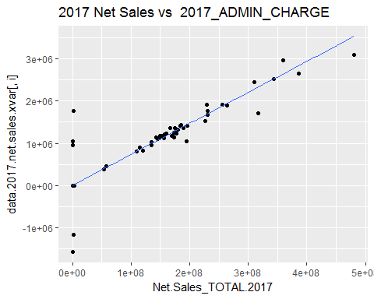

## Smoothing formula not specified. Using: y ~ x

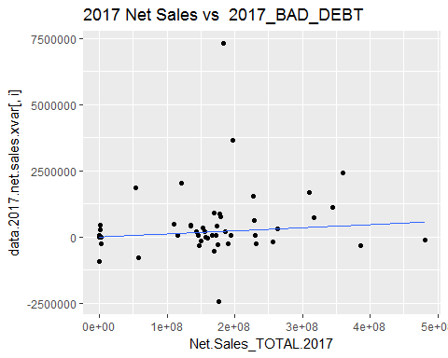

## Smoothing formula not specified. Using: y ~ x

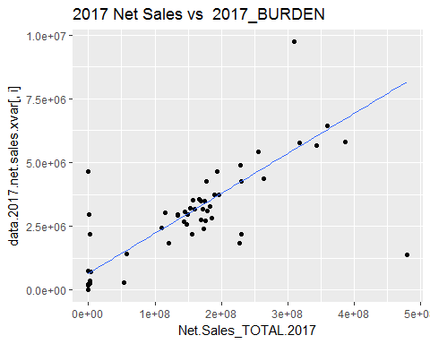

## Smoothing formula not specified. Using: y ~ x

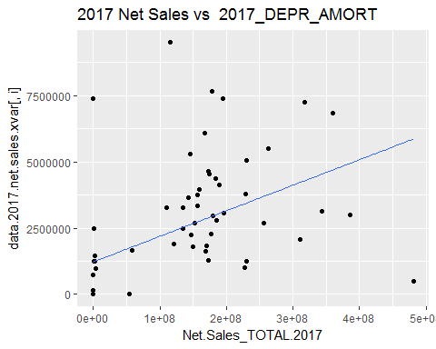

## Smoothing formula not specified. Using: y ~ x

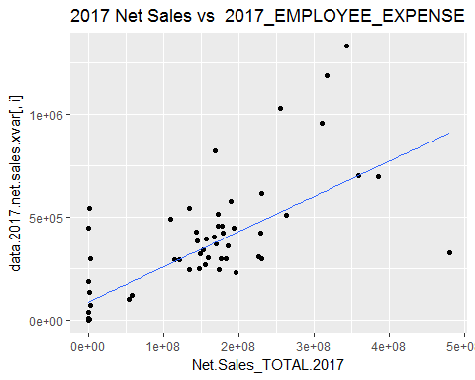

## Smoothing formula not specified. Using: y ~ x

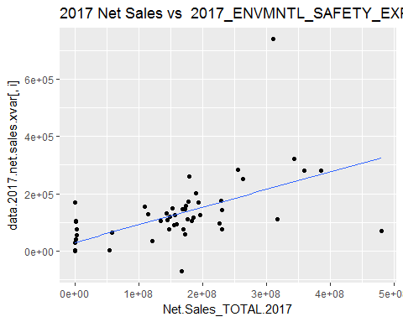

## Smoothing formula not specified. Using: y ~ x

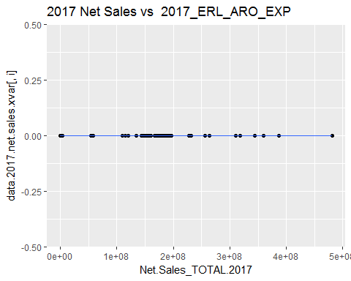

## Smoothing formula not specified. Using: y ~ x

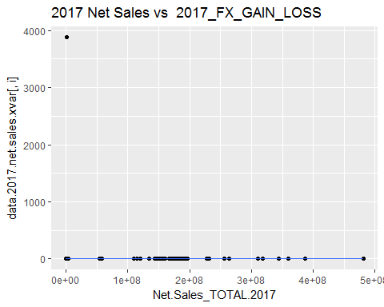

## Smoothing formula not specified. Using: y ~ x

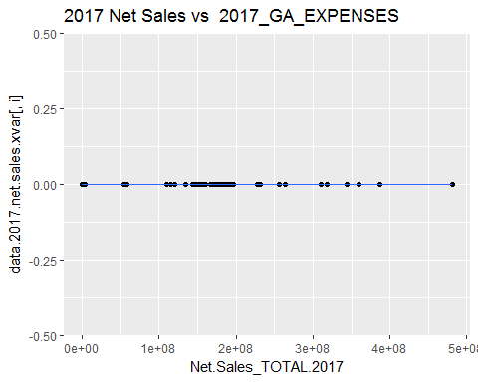

## Smoothing formula not specified. Using: y ~ x

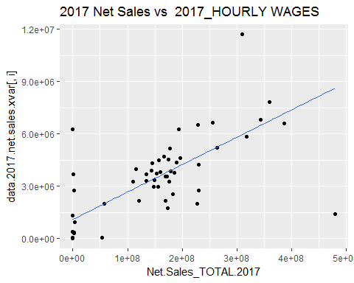

## Smoothing formula not specified. Using: y ~ x

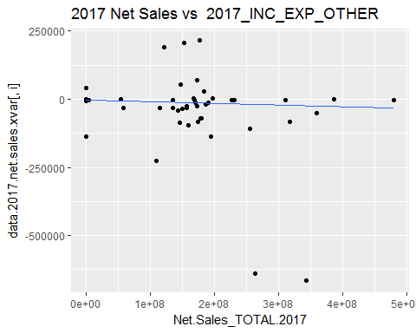

## Warning: Removed 2 rows containing non-finite values (stat_quantile).

## Smoothing formula not specified. Using: y ~ x

## Warning: Removed 2 rows containing missing values (geom_point).

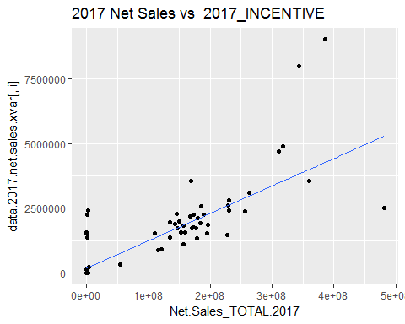

## Smoothing formula not specified. Using: y ~ x

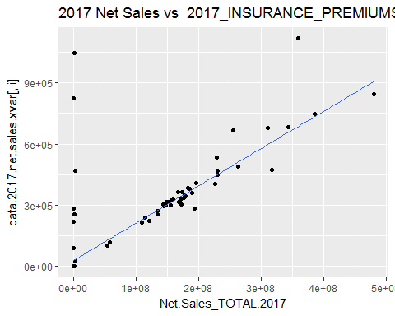

## Smoothing formula not specified. Using: y ~ x

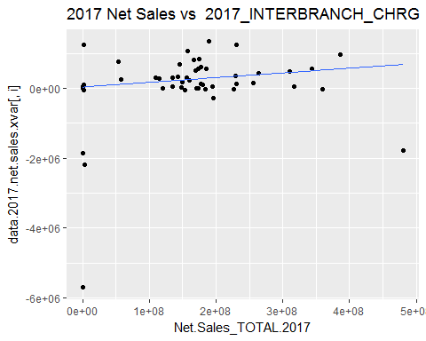

## Warning: Removed 1 rows containing non-finite values (stat_quantile).

## Smoothing formula not specified. Using: y ~ x

## Warning: Removed 1 rows containing missing values (geom_point).

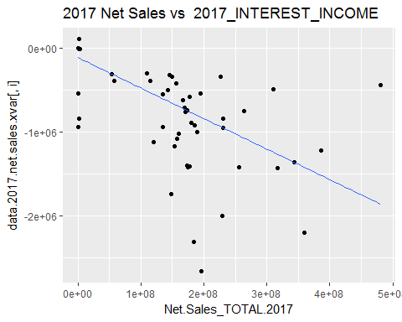

## Smoothing formula not specified. Using: y ~ x

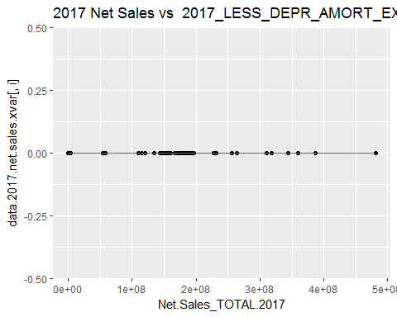

## Smoothing formula not specified. Using: y ~ x

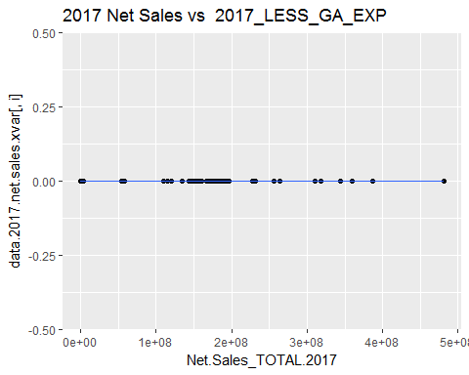

## Smoothing formula not specified. Using: y ~ x

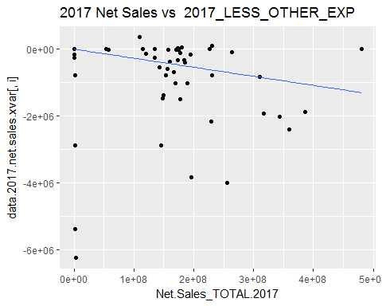

## Smoothing formula not specified. Using: y ~ x

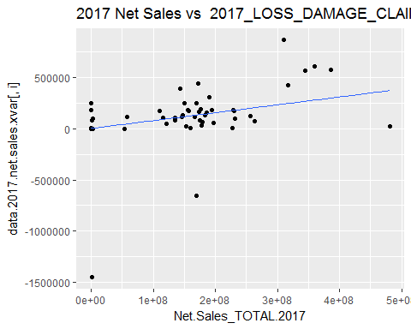

## Smoothing formula not specified. Using: y ~ x

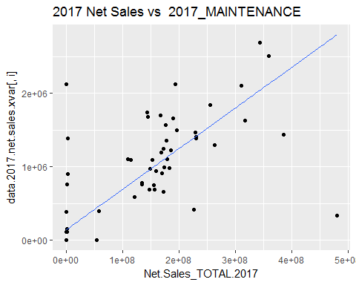

## Smoothing formula not specified. Using: y ~ x

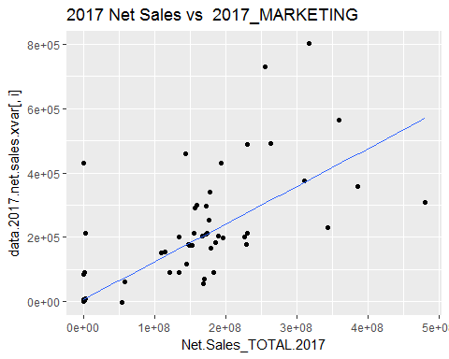

## Smoothing formula not specified. Using: y ~ x

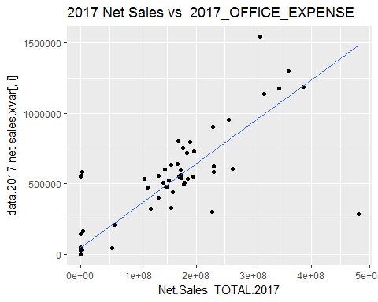

## Smoothing formula not specified. Using: y ~ x

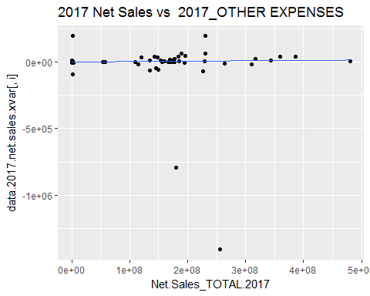

## Smoothing formula not specified. Using: y ~ x

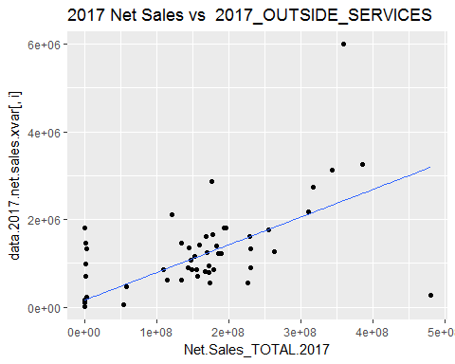

## Smoothing formula not specified. Using: y ~ x

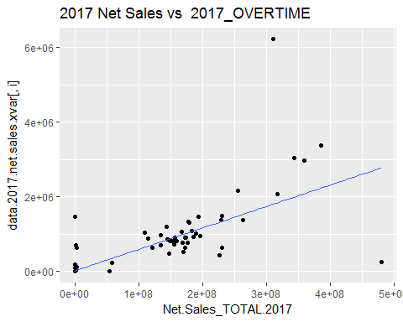

## Smoothing formula not specified. Using: y ~ x

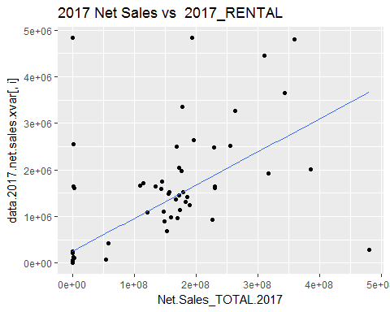

## Smoothing formula not specified. Using: y ~ x

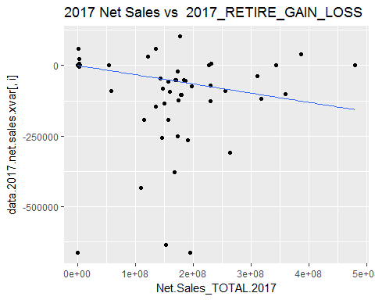

## Smoothing formula not specified. Using: y ~ x

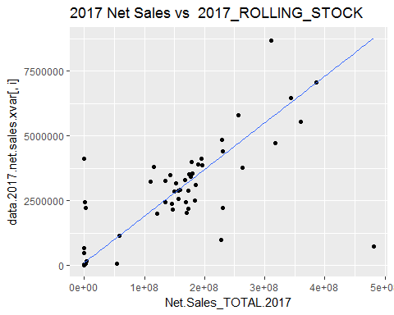

## Smoothing formula not specified. Using: y ~ x

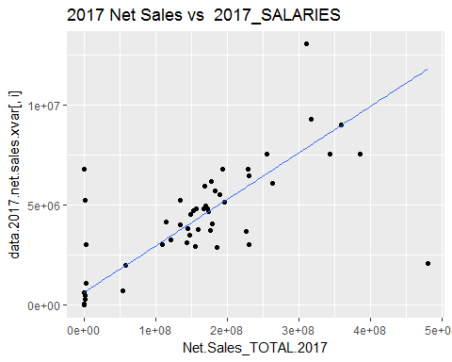

## Smoothing formula not specified. Using: y ~ x

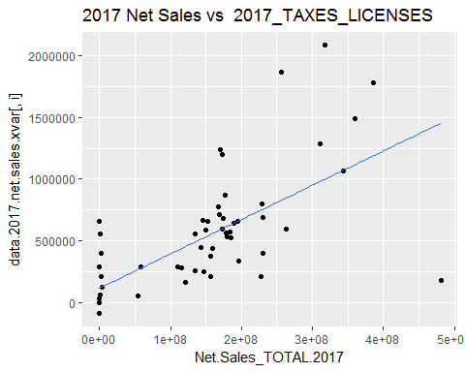

## Smoothing formula not specified. Using: y ~ x

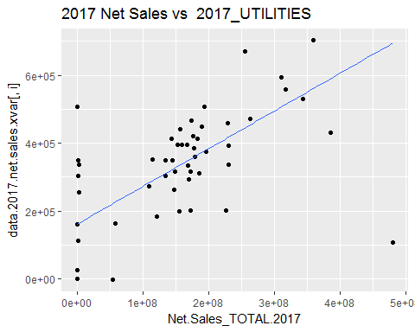

#loess regression model  
for (i in cols){  
 scat.plot <- ggplot(aes(x = Net.Sales_TOTAL.2017, y = data.2017.net.sales.xvar[,i]), data = data.2017) +   
 geom_point() +   
 geom_smooth(method = "loess") +  
 ggtitle(paste("2017 Net Sales vs ", i, sep = " "))  
 print(scat.plot)  
}

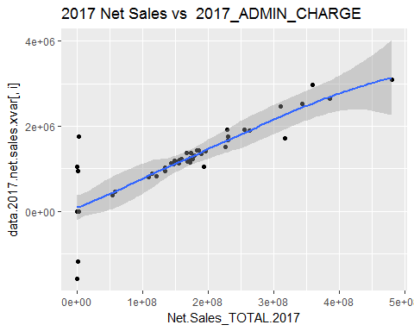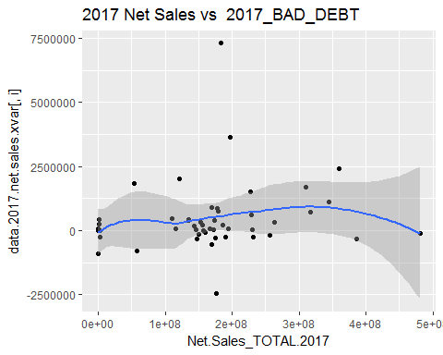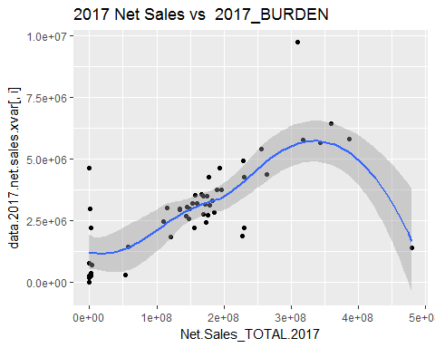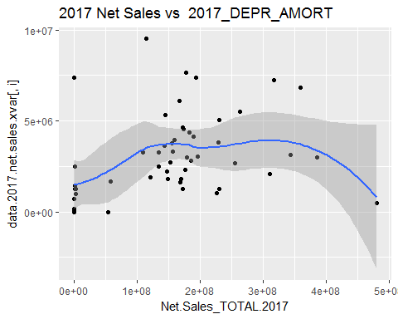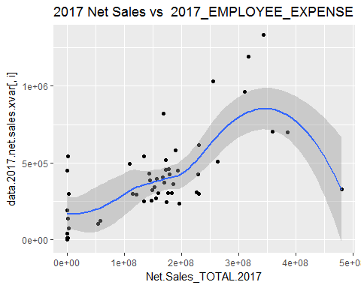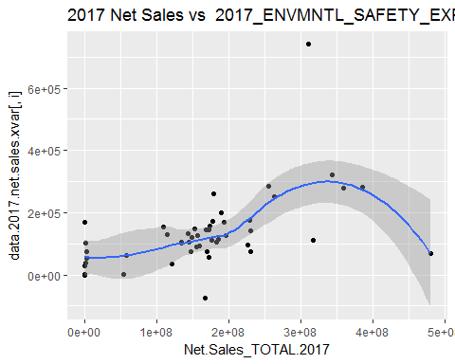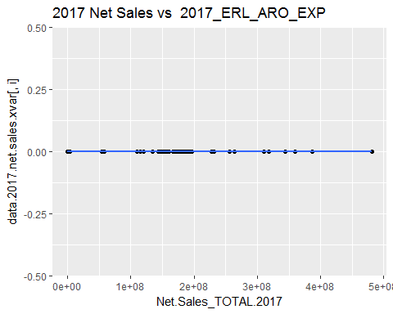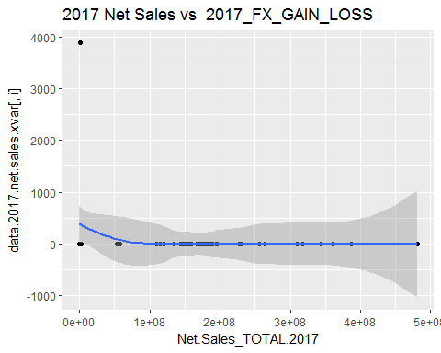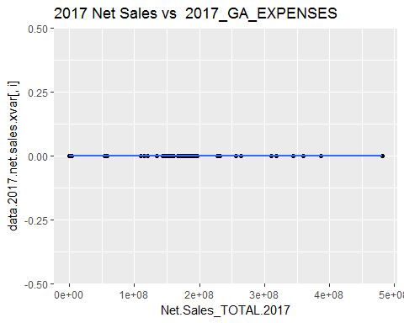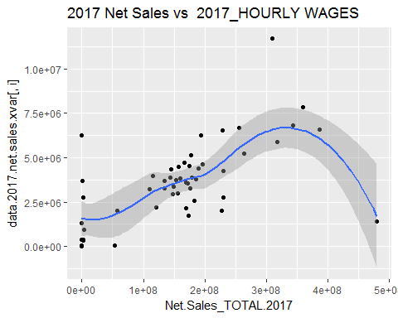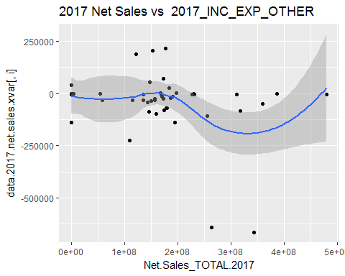

## Warning: Removed 2 rows containing non-finite values (stat_smooth).

## Warning: Removed 2 rows containing missing values (geom_point).

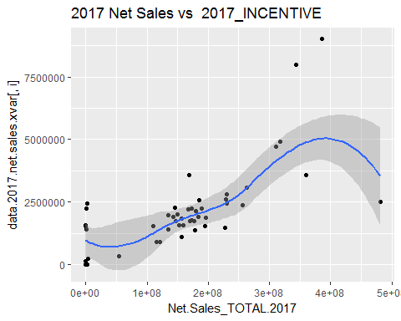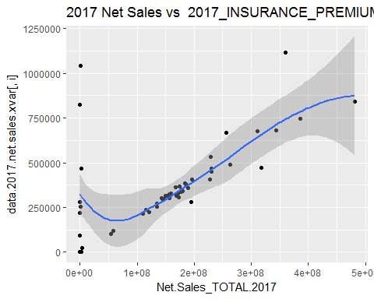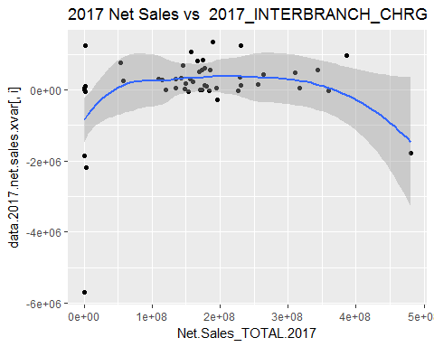

## Warning: Removed 1 rows containing non-finite values (stat_smooth).

## Warning: Removed 1 rows containing missing values (geom_point).

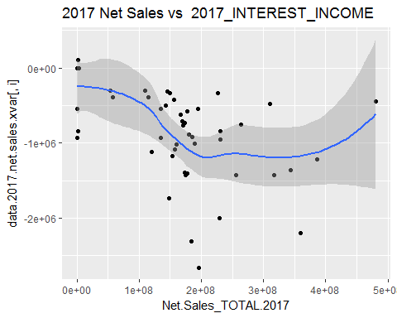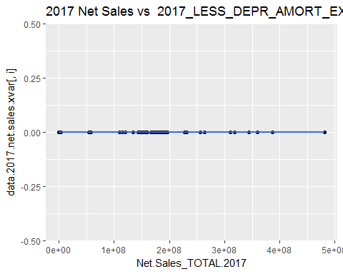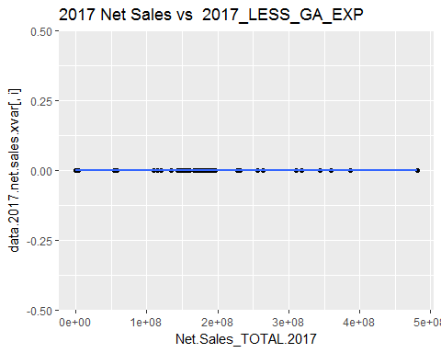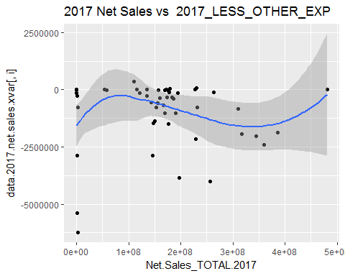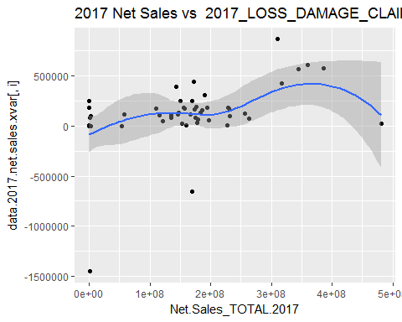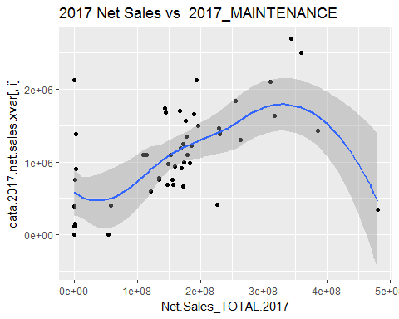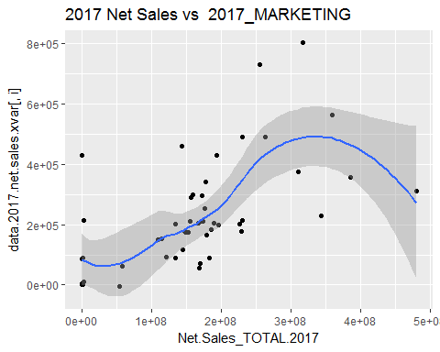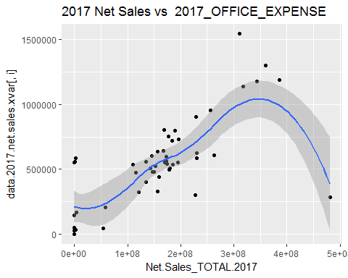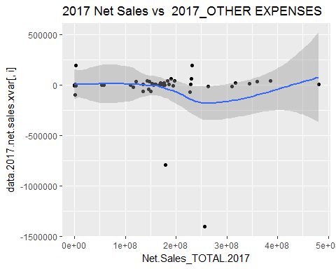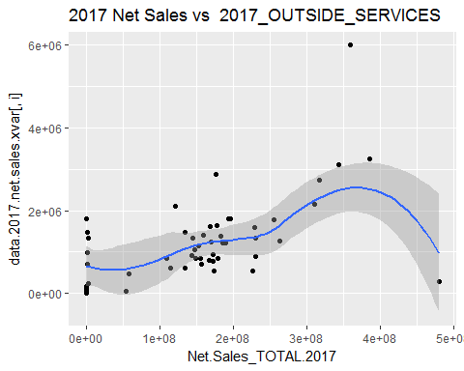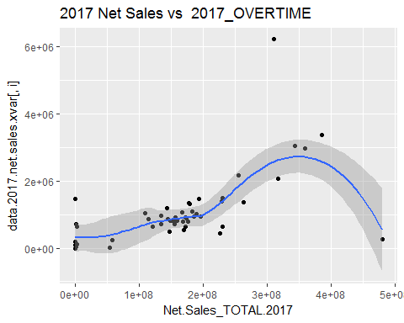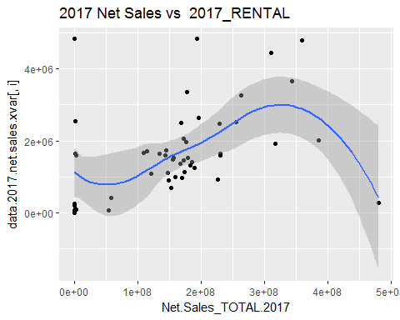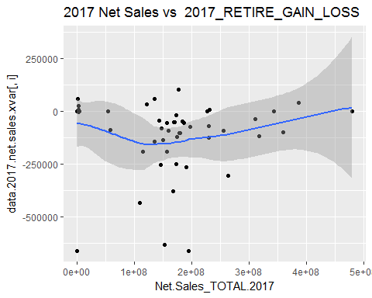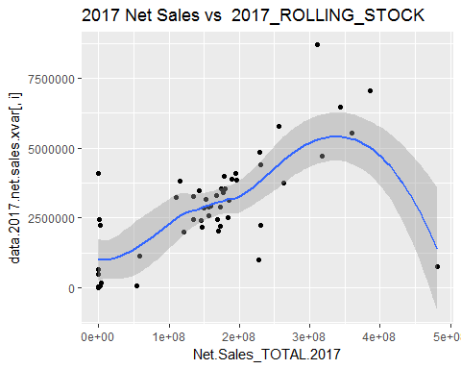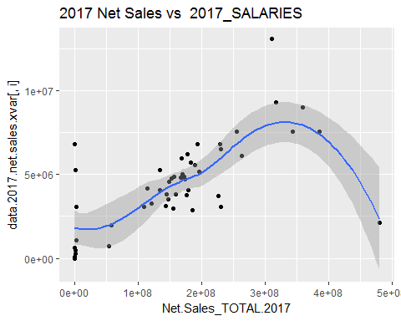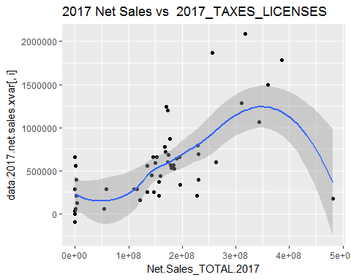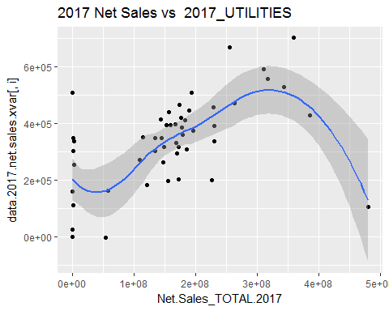

# for (i in cols){  
# #print(i)  
# quant.test <- rq(data.2017.net.sales.xvar[ ,i] ~ Net.Sales_TOTAL.2017, data = data.2017.net.sales.xvar, tau = tau)  
# print(summary(quant.test, se = "boot"))  
# #print(plot(summary(quant.test, se = "boot")))  
# }

#quantile regression for median response  
# for (i in cols){  
# #print(i)  
# quant.test <- rq(data.2017.net.sales.xvar[ ,i] ~ Net.Sales_TOTAL.2017, data = data.2017, tau = tau.50)  
# #create data frame to hold results  
# df <- tidy(quant.test, se.type = "boot")  
# #create col with varaiable name  
# df[,9] <- i  
# colnames(df)[9] <- c("Expense.Acct")  
# #round outputs to 3 decimal points  
# df[,2:8] <- round(df[,2:8], 3)  
# print(df)  
# }

#quantile regression for median response  
for (i in cols){  
 #print(i)  
 quant.test <- rq(data.2017.net.sales.xvar[ ,i] ~ Net.Sales_TOTAL.2017, data = data.2017, tau = tau)  
 print(plot(summary(quant.test, se = "boot"), main = c("Intercept", paste("Net.Sales vs", i, sep = " "))))  
 }

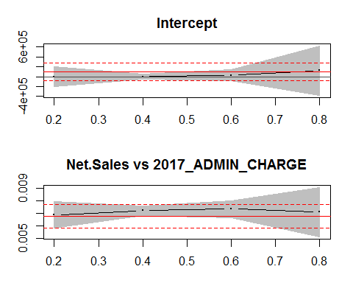

## , , tau= 0.2  
##   
## coefficients lower bd upper bd  
## (Intercept) -15.972245683 -2.057496e+05 2.057176e+05  
## Net.Sales_TOTAL.2017 0.006872148 5.800656e-03 7.943639e-03  
##   
## , , tau= 0.4  
##   
## coefficients lower bd upper bd  
## (Intercept) 0.000000000 -5.187320e+04 5.187320e+04  
## Net.Sales_TOTAL.2017 0.007219989 6.821122e-03 7.618855e-03  
##   
## , , tau= 0.6  
##   
## coefficients lower bd upper bd  
## (Intercept) 2.774344e+04 -8.781840e+04 1.433053e+05  
## Net.Sales_TOTAL.2017 7.358238e-03 6.683099e-03 8.033378e-03  
##   
## , , tau= 0.8  
##   
## coefficients lower bd upper bd  
## (Intercept) 1.205415e+05 -3.835662e+05 6.246492e+05  
## Net.Sales_TOTAL.2017 7.096458e-03 5.103077e-03 9.089839e-03  
##   
## , , ols  
##   
## coefficients lower bd upper bd  
## (Intercept) 9.608800e+04 -8.664416e+04 2.788202e+05  
## Net.Sales_TOTAL.2017 6.782646e-03 5.833038e-03 7.732255e-03

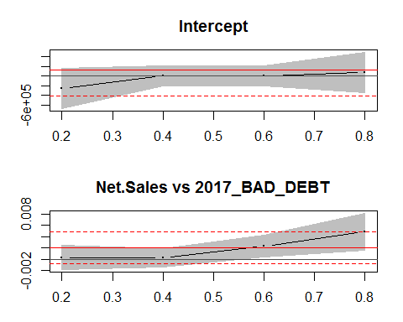

## , , tau= 0.2  
##   
## coefficients lower bd upper bd  
## (Intercept) -2.657346e+05 -6.830938e+05 1.516245e+05  
## Net.Sales_TOTAL.2017 2.976236e-04 -1.854464e-03 2.449711e-03  
##   
## , , tau= 0.4  
##   
## coefficients lower bd upper bd  
## (Intercept) -0.7131512616 -2.079975e+05 2.079960e+05  
## Net.Sales_TOTAL.2017 0.0003068373 -1.297699e-03 1.911374e-03  
##   
## , , tau= 0.6  
##   
## coefficients lower bd upper bd  
## (Intercept) 0.000000000 -2.142676e+05 2.142676e+05  
## Net.Sales_TOTAL.2017 0.002260418 3.495840e-04 4.171252e-03  
##   
## , , tau= 0.8  
##   
## coefficients lower bd upper bd  
## (Intercept) 6.97580e+04 -3.549481e+05 4.944641e+05  
## Net.Sales_TOTAL.2017 4.87434e-03 1.632103e-03 8.116577e-03  
##   
## , , ols  
##   
## coefficients lower bd upper bd  
## (Intercept) 1.181519e+05 -4.239310e+05 6.602348e+05  
## Net.Sales_TOTAL.2017 2.062871e-03 -7.541838e-04 4.879926e-03

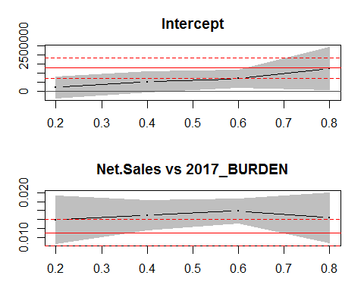

## , , tau= 0.2  
##   
## coefficients lower bd upper bd  
## (Intercept) 2.268659e+05 -3.679761e+05 8.217079e+05  
## Net.Sales_TOTAL.2017 1.396427e-02 8.602365e-03 1.932618e-02  
##   
## , , tau= 0.4  
##   
## coefficients lower bd upper bd  
## (Intercept) 5.295530e+05 -2.121020e+04 1.080316e+06  
## Net.Sales_TOTAL.2017 1.494642e-02 1.160611e-02 1.828674e-02  
##   
## , , tau= 0.6  
##   
## coefficients lower bd upper bd  
## (Intercept) 7.036164e+05 2.436344e+05 1.163598e+06  
## Net.Sales_TOTAL.2017 1.592906e-02 1.324684e-02 1.861128e-02  
##   
## , , tau= 0.8  
##   
## coefficients lower bd upper bd  
## (Intercept) 1.262104e+06 9.215531e+04 2.432053e+06  
## Net.Sales_TOTAL.2017 1.437850e-02 8.753535e-03 2.000347e-02  
##   
## , , ols  
##   
## coefficients lower bd upper bd  
## (Intercept) 1.291640e+06 7.238538e+05 1.859425e+06  
## Net.Sales_TOTAL.2017 1.107873e-02 8.128105e-03 1.402936e-02

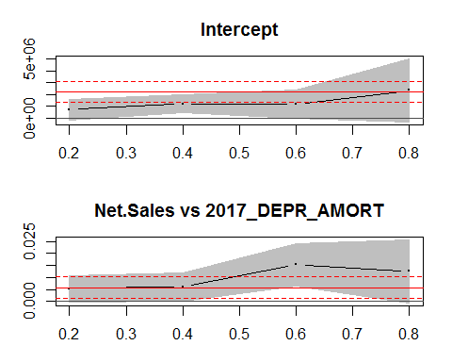

## , , tau= 0.2  
##   
## coefficients lower bd upper bd  
## (Intercept) 7.213585e+05 -1.250554e+05 1.567772e+06  
## Net.Sales_TOTAL.2017 5.398603e-03 -7.155954e-05 1.086877e-02  
##   
## , , tau= 0.4  
##   
## coefficients lower bd upper bd  
## (Intercept) 1.235174e+06 4.447298e+05 2.025618e+06  
## Net.Sales_TOTAL.2017 5.975994e-03 6.633427e-05 1.188565e-02  
##   
## , , tau= 0.6  
##   
## coefficients lower bd upper bd  
## (Intercept) 1.218585e+06 3.717257e+04 2.399997e+06  
## Net.Sales_TOTAL.2017 1.533972e-02 6.556283e-03 2.412317e-02  
##   
## , , tau= 0.8  
##   
## coefficients lower bd upper bd  
## (Intercept) 2.352388e+06 -3.430307e+05 5.047806e+06  
## Net.Sales_TOTAL.2017 1.247670e-02 -7.454074e-04 2.569881e-02  
##   
## , , ols  
##   
## coefficients lower bd upper bd  
## (Intercept) 2.256125e+06 1.372601e+06 3.139649e+06  
## Net.Sales_TOTAL.2017 5.719137e-03 1.127707e-03 1.031057e-02

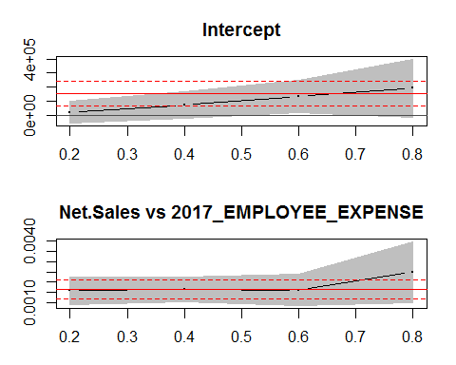

## , , tau= 0.2  
##   
## coefficients lower bd upper bd  
## (Intercept) 1.943432e+04 -5.911382e+04 9.798247e+04  
## Net.Sales_TOTAL.2017 1.590208e-03 9.341105e-04 2.246306e-03  
##   
## , , tau= 0.4  
##   
## coefficients lower bd upper bd  
## (Intercept) 7.149098e+04 -2.333779e+04 1.663197e+05  
## Net.Sales_TOTAL.2017 1.664092e-03 1.066772e-03 2.261412e-03  
##   
## , , tau= 0.6  
##   
## coefficients lower bd upper bd  
## (Intercept) 1.333817e+05 1.756459e+04 2.491988e+05  
## Net.Sales_TOTAL.2017 1.625624e-03 8.633347e-04 2.387913e-03  
##   
## , , tau= 0.8  
##   
## coefficients lower bd upper bd  
## (Intercept) 1.907280e+05 -1.722736e+04 3.986834e+05  
## Net.Sales_TOTAL.2017 2.479987e-03 9.998974e-04 3.960076e-03  
##   
## , , ols  
##   
## coefficients lower bd upper bd  
## (Intercept) 1.505205e+05 6.236539e+04 2.386756e+05  
## Net.Sales_TOTAL.2017 1.635143e-03 1.177026e-03 2.093261e-03

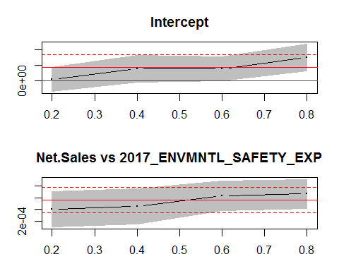

## , , tau= 0.2  
##   
## coefficients lower bd upper bd  
## (Intercept) 3.218000e+03 -3.504317e+04 4.147917e+04  
## Net.Sales_TOTAL.2017 4.028295e-04 1.036927e-04 7.019664e-04  
##   
## , , tau= 0.4  
##   
## coefficients lower bd upper bd  
## (Intercept) 3.743937e+04 -5.234572e+03 8.011331e+04  
## Net.Sales_TOTAL.2017 4.523028e-04 1.499826e-04 7.546229e-04  
##   
## , , tau= 0.6  
##   
## coefficients lower bd upper bd  
## (Intercept) 3.816546e+04 -1.019632e+03 7.735056e+04  
## Net.Sales_TOTAL.2017 6.280446e-04 3.800817e-04 8.760076e-04  
##   
## , , tau= 0.8  
##   
## coefficients lower bd upper bd  
## (Intercept) 7.401552e+04 3.023897e+04 1.177921e+05  
## Net.Sales_TOTAL.2017 6.644915e-04 4.200402e-04 9.089427e-04  
##   
## , , ols  
##   
## coefficients lower bd upper bd  
## (Intercept) 4.173385e+04 1.384050e+02 8.332929e+04  
## Net.Sales_TOTAL.2017 5.586023e-04 3.424422e-04 7.747623e-04

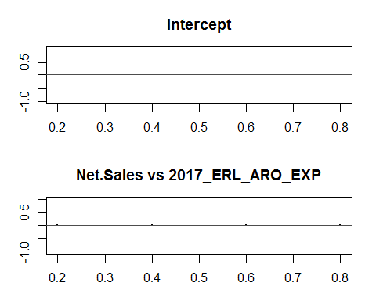

## , , tau= 0.2  
##   
## coefficients lower bd upper bd  
## (Intercept) 0 0 0  
## Net.Sales_TOTAL.2017 0 0 0  
##   
## , , tau= 0.4  
##   
## coefficients lower bd upper bd  
## (Intercept) 0 0 0  
## Net.Sales_TOTAL.2017 0 0 0  
##   
## , , tau= 0.6  
##   
## coefficients lower bd upper bd  
## (Intercept) 0 0 0  
## Net.Sales_TOTAL.2017 0 0 0  
##   
## , , tau= 0.8  
##   
## coefficients lower bd upper bd  
## (Intercept) 0 0 0  
## Net.Sales_TOTAL.2017 0 0 0  
##   
## , , ols  
##   
## coefficients lower bd upper bd  
## (Intercept) 0 0 0  
## Net.Sales_TOTAL.2017 0 0 0

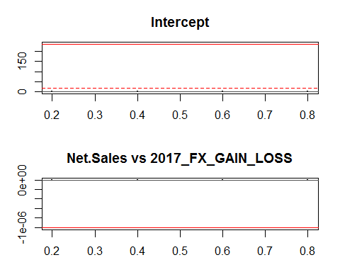

## , , tau= 0.2  
##   
## coefficients lower bd upper bd  
## (Intercept) 0 0 0  
## Net.Sales_TOTAL.2017 0 0 0  
##   
## , , tau= 0.4  
##   
## coefficients lower bd upper bd  
## (Intercept) 0 0 0  
## Net.Sales_TOTAL.2017 0 0 0  
##   
## , , tau= 0.6  
##   
## coefficients lower bd upper bd  
## (Intercept) 0 0 0  
## Net.Sales_TOTAL.2017 0 0 0  
##   
## , , tau= 0.8  
##   
## coefficients lower bd upper bd  
## (Intercept) 0 0 0  
## Net.Sales_TOTAL.2017 0 0 0  
##   
## , , ols  
##   
## coefficients lower bd upper bd  
## (Intercept) 2.363026e+02 1.759222e+01 4.550129e+02  
## Net.Sales_TOTAL.2017 -1.009801e-06 -2.146379e-06 1.267761e-07

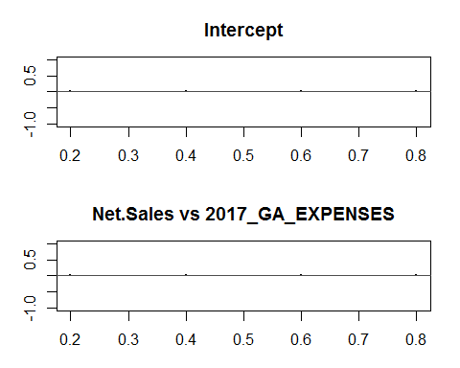

## , , tau= 0.2  
##   
## coefficients lower bd upper bd  
## (Intercept) 0 0 0  
## Net.Sales_TOTAL.2017 0 0 0  
##   
## , , tau= 0.4  
##   
## coefficients lower bd upper bd  
## (Intercept) 0 0 0  
## Net.Sales_TOTAL.2017 0 0 0  
##   
## , , tau= 0.6  
##   
## coefficients lower bd upper bd  
## (Intercept) 0 0 0  
## Net.Sales_TOTAL.2017 0 0 0  
##   
## , , tau= 0.8  
##   
## coefficients lower bd upper bd  
## (Intercept) 0 0 0  
## Net.Sales_TOTAL.2017 0 0 0  
##   
## , , ols  
##   
## coefficients lower bd upper bd  
## (Intercept) 0 0 0  
## Net.Sales_TOTAL.2017 0 0 0

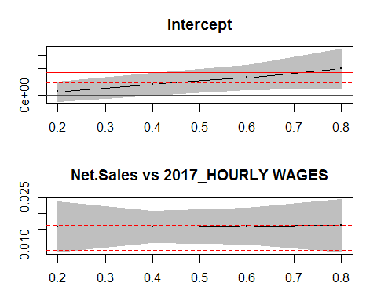

## , , tau= 0.2  
##   
## coefficients lower bd upper bd  
## (Intercept) 2.917137e+05 -4.568929e+05 1.040320e+06  
## Net.Sales_TOTAL.2017 1.575422e-02 7.855987e-03 2.365245e-02  
##   
## , , tau= 0.4  
##   
## coefficients lower bd upper bd  
## (Intercept) 8.399066e+05 2.715761e+04 1.652655e+06  
## Net.Sales_TOTAL.2017 1.582503e-02 1.092679e-02 2.072328e-02  
##   
## , , tau= 0.6  
##   
## coefficients lower bd upper bd  
## (Intercept) 1.339524e+06 4.153755e+05 2.263672e+06  
## Net.Sales_TOTAL.2017 1.591485e-02 1.028795e-02 2.154175e-02  
##   
## , , tau= 0.8  
##   
## coefficients lower bd upper bd  
## (Intercept) 2.007124e+06 5.382548e+05 3.475993e+06  
## Net.Sales_TOTAL.2017 1.617938e-02 8.007704e-03 2.435106e-02  
##   
## , , ols  
##   
## coefficients lower bd upper bd  
## (Intercept) 1.698619e+06 9.562509e+05 2.440987e+06  
## Net.Sales_TOTAL.2017 1.228208e-02 8.424199e-03 1.613996e-02

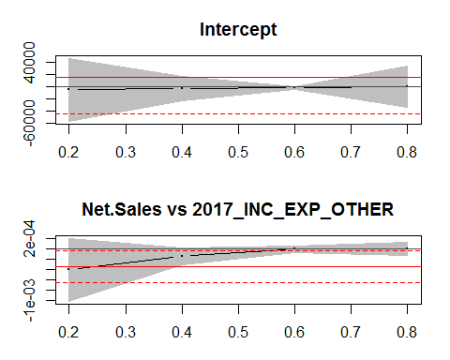

## , , tau= 0.2  
##   
## coefficients lower bd upper bd  
## (Intercept) -5.324063e+03 -5.693819e+04 4.629006e+04  
## Net.Sales_TOTAL.2017 -4.031062e-04 -1.014316e-03 2.081036e-04  
##   
## , , tau= 0.4  
##   
## coefficients lower bd upper bd  
## (Intercept) -2.850790e+03 -2.236094e+04 1.665936e+04  
## Net.Sales_TOTAL.2017 -1.362085e-04 -2.961618e-04 2.374478e-05  
##   
## , , tau= 0.6  
##   
## coefficients lower bd upper bd  
## (Intercept) -2.189712e+03 -4.506881e+03 1.274580e+02  
## Net.Sales_TOTAL.2017 -4.450917e-06 -7.496787e-05 6.606603e-05  
##   
## , , tau= 0.8  
##   
## coefficients lower bd upper bd  
## (Intercept) 0.000000e+00 -3.390989e+04 3.390989e+04  
## Net.Sales_TOTAL.2017 8.926655e-07 -1.210588e-04 1.228442e-04  
##   
## , , ols  
##   
## coefficients lower bd upper bd  
## (Intercept) 1.454670e+04 -4.352589e+04 7.261928e+04  
## Net.Sales_TOTAL.2017 -3.375542e-04 -6.393414e-04 -3.576695e-05

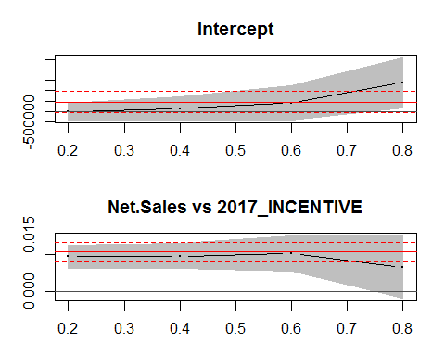

## , , tau= 0.2  
##   
## coefficients lower bd upper bd  
## (Intercept) -5.323000e+03 -4.009616e+05 3.903156e+05  
## Net.Sales_TOTAL.2017 9.291177e-03 6.273637e-03 1.230872e-02  
##   
## , , tau= 0.4  
##   
## coefficients lower bd upper bd  
## (Intercept) 1.455280e+05 -3.997303e+05 6.907863e+05  
## Net.Sales_TOTAL.2017 9.472333e-03 6.124526e-03 1.282014e-02  
##   
## , , tau= 0.6  
##   
## coefficients lower bd upper bd  
## (Intercept) 4.110411e+05 -4.194311e+05 1.241513e+06  
## Net.Sales_TOTAL.2017 1.014631e-02 5.356239e-03 1.493639e-02  
##   
## , , tau= 0.8  
##   
## coefficients lower bd upper bd  
## (Intercept) 1.381668e+06 1.807601e+05 2.582577e+06  
## Net.Sales_TOTAL.2017 6.492230e-03 -1.835900e-03 1.482036e-02  
##   
## , , ols  
##   
## coefficients lower bd upper bd  
## (Intercept) 4.505118e+05 -5.619925e+04 9.572229e+05  
## Net.Sales_TOTAL.2017 1.053513e-02 7.930654e-03 1.313960e-02

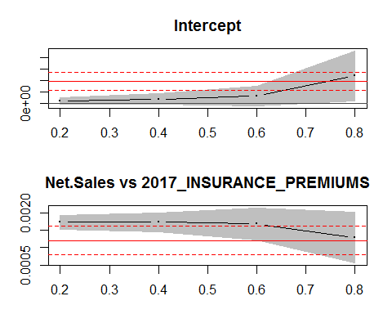

## , , tau= 0.2  
##   
## coefficients lower bd upper bd  
## (Intercept) 2.064026e+04 -8.607185e+03 4.988770e+04  
## Net.Sales_TOTAL.2017 1.728530e-03 1.534503e-03 1.922557e-03  
##   
## , , tau= 0.4  
##   
## coefficients lower bd upper bd  
## (Intercept) 3.513056e+04 -1.160358e+04 8.186470e+04  
## Net.Sales_TOTAL.2017 1.728926e-03 1.461515e-03 1.996336e-03  
##   
## , , tau= 0.6  
##   
## coefficients lower bd upper bd  
## (Intercept) 6.291892e+04 -2.559878e+04 1.514366e+05  
## Net.Sales_TOTAL.2017 1.677701e-03 1.217682e-03 2.137721e-03  
##   
## , , tau= 0.8  
##   
## coefficients lower bd upper bd  
## (Intercept) 2.402501e+05 2.092162e+04 4.595785e+05  
## Net.Sales_TOTAL.2017 1.282505e-03 5.608547e-04 2.004156e-03  
##   
## , , ols  
##   
## coefficients lower bd upper bd  
## (Intercept) 1.909283e+05 1.121063e+05 2.697504e+05  
## Net.Sales_TOTAL.2017 1.208923e-03 7.993062e-04 1.618539e-03

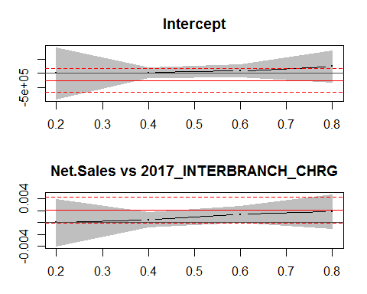

## , , tau= 0.2  
##   
## coefficients lower bd upper bd  
## (Intercept) -1.068479e+02 -9.132364e+05 9.130227e+05  
## Net.Sales_TOTAL.2017 -4.044351e-05 -4.049831e-03 3.968944e-03  
##   
## , , tau= 0.4  
##   
## coefficients lower bd upper bd  
## (Intercept) 2.451000e+04 -1.484945e+05 1.975145e+05  
## Net.Sales_TOTAL.2017 4.616207e-04 -8.036239e-04 1.726865e-03  
##   
## , , tau= 0.6  
##   
## coefficients lower bd upper bd  
## (Intercept) 9.036351e+04 -1.259304e+05 3.066574e+05  
## Net.Sales_TOTAL.2017 1.373543e-03 -2.856028e-05 2.775645e-03  
##   
## , , tau= 0.8  
##   
## coefficients lower bd upper bd  
## (Intercept) 2.448290e+05 -3.204631e+05 8.101211e+05  
## Net.Sales_TOTAL.2017 1.869151e-03 -1.000406e-03 4.738708e-03  
##   
## , , ols  
##   
## coefficients lower bd upper bd  
## (Intercept) -2.506942e+05 -6.758681e+05 1.744797e+05  
## Net.Sales_TOTAL.2017 2.103300e-03 -1.062114e-04 4.312812e-03

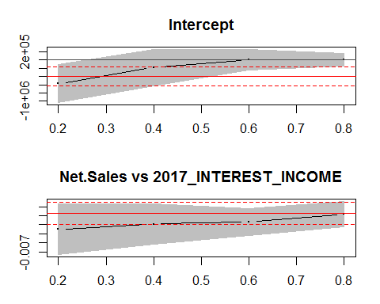

## , , tau= 0.2  
##   
## coefficients lower bd upper bd  
## (Intercept) -5.764590e+05 -1.034710e+06 -1.182077e+05  
## Net.Sales_TOTAL.2017 -4.513234e-03 -7.331261e-03 -1.695208e-03  
##   
## , , tau= 0.4  
##   
## coefficients lower bd upper bd  
## (Intercept) -1.822393e+05 -6.210647e+05 2.56586e+05  
## Net.Sales_TOTAL.2017 -3.925812e-03 -6.186164e-03 -1.66546e-03  
##   
## , , tau= 0.6  
##   
## coefficients lower bd upper bd  
## (Intercept) 0.000000000 -2.51938e+05 2.51938e+05  
## Net.Sales_TOTAL.2017 -0.003700775 -5.20954e-03 -2.19201e-03  
##   
## , , tau= 0.8  
##   
## coefficients lower bd upper bd  
## (Intercept) 2.304819e+03 -1.465103e+05 1.511199e+05  
## Net.Sales_TOTAL.2017 -2.797532e-03 -4.216541e-03 -1.378522e-03  
##   
## , , ols  
##   
## coefficients lower bd upper bd  
## (Intercept) -3.997822e+05 -6.333094e+05 -1.662549e+05  
## Net.Sales_TOTAL.2017 -2.734887e-03 -3.936507e-03 -1.533267e-03

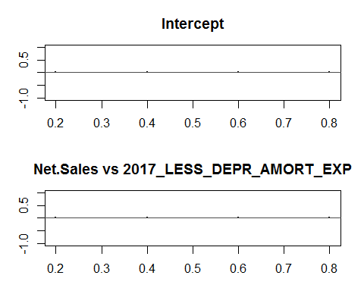

## , , tau= 0.2  
##   
## coefficients lower bd upper bd  
## (Intercept) 0 0 0  
## Net.Sales_TOTAL.2017 0 0 0  
##   
## , , tau= 0.4  
##   
## coefficients lower bd upper bd  
## (Intercept) 0 0 0  
## Net.Sales_TOTAL.2017 0 0 0  
##   
## , , tau= 0.6  
##   
## coefficients lower bd upper bd  
## (Intercept) 0 0 0  
## Net.Sales_TOTAL.2017 0 0 0  
##   
## , , tau= 0.8  
##   
## coefficients lower bd upper bd  
## (Intercept) 0 0 0  
## Net.Sales_TOTAL.2017 0 0 0  
##   
## , , ols  
##   
## coefficients lower bd upper bd  
## (Intercept) 0 0 0  
## Net.Sales_TOTAL.2017 0 0 0

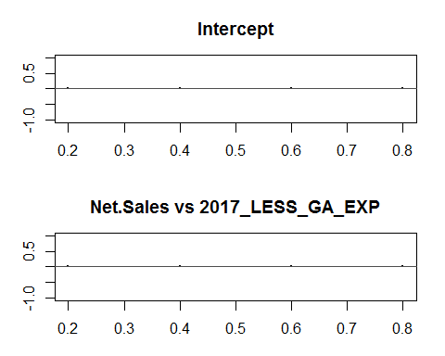

## , , tau= 0.2  
##   
## coefficients lower bd upper bd  
## (Intercept) 0 0 0  
## Net.Sales_TOTAL.2017 0 0 0  
##   
## , , tau= 0.4  
##   
## coefficients lower bd upper bd  
## (Intercept) 0 0 0  
## Net.Sales_TOTAL.2017 0 0 0  
##   
## , , tau= 0.6  
##   
## coefficients lower bd upper bd  
## (Intercept) 0 0 0  
## Net.Sales_TOTAL.2017 0 0 0  
##   
## , , tau= 0.8  
##   
## coefficients lower bd upper bd  
## (Intercept) 0 0 0  
## Net.Sales_TOTAL.2017 0 0 0  
##   
## , , ols  
##   
## coefficients lower bd upper bd  
## (Intercept) 0 0 0  
## Net.Sales_TOTAL.2017 0 0 0

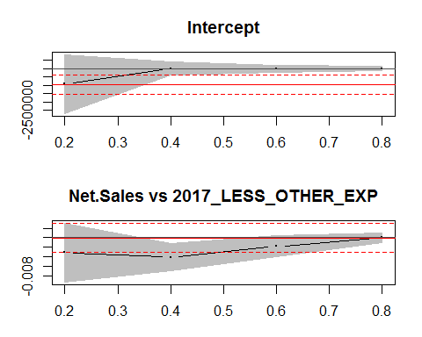

## , , tau= 0.2  
##   
## coefficients lower bd upper bd  
## (Intercept) -9.351412e+05 -2.709513e+06 8.392310e+05  
## Net.Sales_TOTAL.2017 -3.165827e-03 -9.427410e-03 3.095755e-03  
##   
## , , tau= 0.4  
##   
## coefficients lower bd upper bd  
## (Intercept) -95.480813235 -4.026071e+05 4.024161e+05  
## Net.Sales_TOTAL.2017 -0.004095683 -7.050632e-03 -1.140735e-03  
##   
## , , tau= 0.6  
##   
## coefficients lower bd upper bd  
## (Intercept) 0.000000000 -2.181619e+05 2.181619e+05  
## Net.Sales_TOTAL.2017 -0.001867053 -4.092001e-03 3.578955e-04  
##   
## , , tau= 0.8  
##   
## coefficients lower bd upper bd  
## (Intercept) 0.00000e+00 -1.256403e+05 1.256403e+05  
## Net.Sales_TOTAL.2017 2.22654e-08 -9.942290e-04 9.942735e-04  
##   
## , , ols  
##   
## coefficients lower bd upper bd  
## (Intercept) -9.539246e+05 -1.543627e+06 -3.642223e+05  
## Net.Sales_TOTAL.2017 -6.557907e-05 -3.130099e-03 2.998941e-03

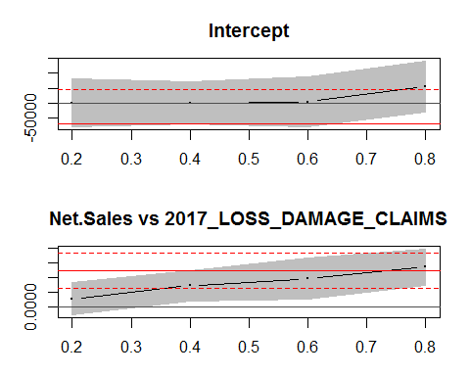

## , , tau= 0.2  
##   
## coefficients lower bd upper bd  
## (Intercept) 0.0000000000 -8.154197e+04 8.154197e+04  
## Net.Sales_TOTAL.2017 0.0002930817 -2.577707e-04 8.439342e-04  
##   
## , , tau= 0.4  
##   
## coefficients lower bd upper bd  
## (Intercept) 0.0000000000 -7.197333e+04 7.197333e+04  
## Net.Sales_TOTAL.2017 0.0007275981 2.111714e-04 1.244025e-03  
##   
## , , tau= 0.6  
##   
## coefficients lower bd upper bd  
## (Intercept) 3.62800e+03 -7.979552e+04 8.705152e+04  
## Net.Sales_TOTAL.2017 9.66057e-04 2.833424e-04 1.648772e-03  
##   
## , , tau= 0.8  
##   
## coefficients lower bd upper bd  
## (Intercept) 5.512962e+04 -3.193890e+04 1.421981e+05  
## Net.Sales_TOTAL.2017 1.355820e-03 7.418067e-04 1.969834e-03  
##   
## , , ols  
##   
## coefficients lower bd upper bd  
## (Intercept) -7.050271e+04 -1.857073e+05 4.470185e+04  
## Net.Sales_TOTAL.2017 1.232277e-03 6.335905e-04 1.830963e-03

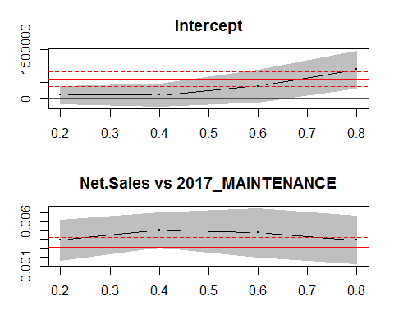

## , , tau= 0.2  
##   
## coefficients lower bd upper bd  
## (Intercept) 1.120870e+05 -1.441112e+05 3.682852e+05  
## Net.Sales_TOTAL.2017 3.892409e-03 1.611684e-03 6.173135e-03  
##   
## , , tau= 0.4  
##   
## coefficients lower bd upper bd  
## (Intercept) 1.120870e+05 -2.329082e+05 4.570822e+05  
## Net.Sales_TOTAL.2017 5.052563e-03 3.077697e-03 7.027429e-03  
##   
## , , tau= 0.6  
##   
## coefficients lower bd upper bd  
## (Intercept) 3.85231e+05 -9.705997e+04 8.675220e+05  
## Net.Sales_TOTAL.2017 4.72811e-03 1.978727e-03 7.477494e-03  
##   
## , , tau= 0.8  
##   
## coefficients lower bd upper bd  
## (Intercept) 8.895477e+05 3.206427e+05 1.458453e+06  
## Net.Sales_TOTAL.2017 3.908050e-03 1.227121e-03 6.588980e-03  
##   
## , , ols  
##   
## coefficients lower bd upper bd  
## (Intercept) 6.105715e+05 3.847155e+05 8.364275e+05  
## Net.Sales_TOTAL.2017 3.066444e-03 1.892733e-03 4.240156e-03

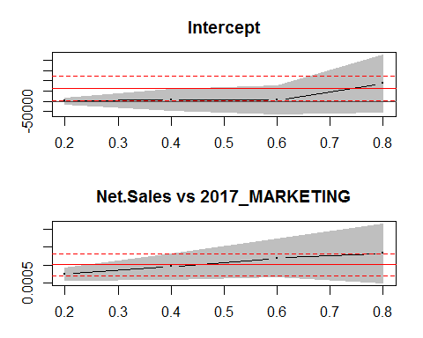

## , , tau= 0.2  
##   
## coefficients lower bd upper bd  
## (Intercept) 1.484407e+03 -1.377397e+04 1.674279e+04  
## Net.Sales_TOTAL.2017 7.505106e-04 5.713625e-04 9.296588e-04  
##   
## , , tau= 0.4  
##   
## coefficients lower bd upper bd  
## (Intercept) 6.929375e+03 -4.377618e+04 5.763493e+04  
## Net.Sales_TOTAL.2017 9.583718e-04 6.126942e-04 1.304050e-03  
##   
## , , tau= 0.6  
##   
## coefficients lower bd upper bd  
## (Intercept) 6.213124e+03 -6.306774e+04 7.549399e+04  
## Net.Sales_TOTAL.2017 1.191804e-03 6.631742e-04 1.720433e-03  
##   
## , , tau= 0.8  
##   
## coefficients lower bd upper bd  
## (Intercept) 8.807843e+04 -5.160476e+04 2.277616e+05  
## Net.Sales_TOTAL.2017 1.320955e-03 4.966653e-04 2.145246e-03  
##   
## , , ols  
##   
## coefficients lower bd upper bd  
## (Intercept) 6.310372e+04 4.836962e+03 1.213705e+05  
## Net.Sales_TOTAL.2017 1.005504e-03 7.027081e-04 1.308301e-03

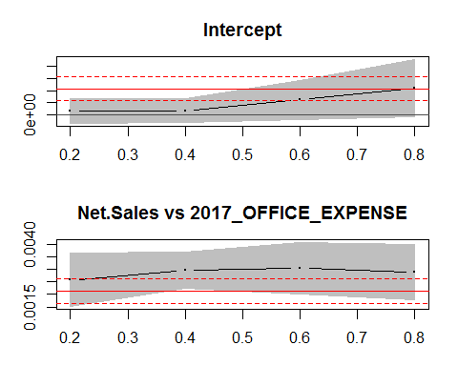

## , , tau= 0.2  
##   
## coefficients lower bd upper bd  
## (Intercept) 3.297600e+04 -7.147129e+04 1.374233e+05  
## Net.Sales_TOTAL.2017 2.569565e-03 1.514218e-03 3.624912e-03  
##   
## , , tau= 0.4  
##   
## coefficients lower bd upper bd  
## (Intercept) 3.601720e+04 -6.250638e+04 1.345408e+05  
## Net.Sales_TOTAL.2017 2.969786e-03 2.259890e-03 3.679683e-03  
##   
## , , tau= 0.6  
##   
## coefficients lower bd upper bd  
## (Intercept) 1.247124e+05 -3.581914e+04 2.852439e+05  
## Net.Sales_TOTAL.2017 3.047935e-03 2.028583e-03 4.067286e-03  
##   
## , , tau= 0.8  
##   
## coefficients lower bd upper bd  
## (Intercept) 2.194167e+05 -1.721253e+04 4.560459e+05  
## Net.Sales_TOTAL.2017 2.884620e-03 1.800250e-03 3.968989e-03  
##   
## , , ols  
##   
## coefficients lower bd upper bd  
## (Intercept) 2.140048e+05 1.167446e+05 3.112650e+05  
## Net.Sales_TOTAL.2017 2.125503e-03 1.620068e-03 2.630937e-03

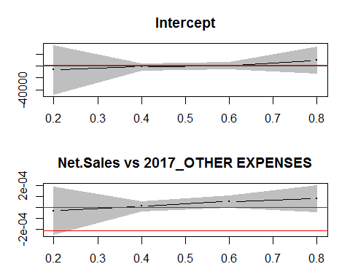

## , , tau= 0.2  
##   
## coefficients lower bd upper bd  
## (Intercept) -6.653000e+03 -4.802460e+04 3.471860e+04  
## Net.Sales_TOTAL.2017 -2.983187e-05 -2.448114e-04 1.851477e-04  
##   
## , , tau= 0.4  
##   
## coefficients lower bd upper bd  
## (Intercept) -1.322814e+03 -6.689228e+03 4.04360e+03  
## Net.Sales_TOTAL.2017 1.300893e-05 -2.920194e-05 5.52198e-05  
##   
## , , tau= 0.6  
##   
## coefficients lower bd upper bd  
## (Intercept) 5.54000e+02 -4.690801e+03 5.798801e+03  
## Net.Sales_TOTAL.2017 5.48896e-05 3.669950e-06 1.061093e-04  
##   
## , , tau= 0.8  
##   
## coefficients lower bd upper bd  
## (Intercept) 1.000534e+04 -1.186655e+04 3.187723e+04  
## Net.Sales_TOTAL.2017 8.104021e-05 -3.849748e-05 2.005779e-04  
##   
## , , ols  
##   
## coefficients lower bd upper bd  
## (Intercept) 1.005617e+03 -9.364280e+04 9.565403e+04  
## Net.Sales_TOTAL.2017 -2.128086e-04 -7.046702e-04 2.790531e-04

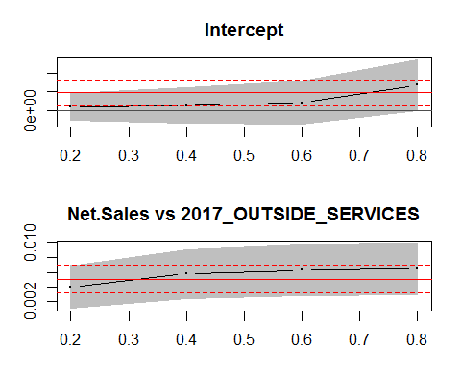

## , , tau= 0.2  
##   
## coefficients lower bd upper bd  
## (Intercept) 1.026278e+05 -2.662865e+05 4.715421e+05  
## Net.Sales_TOTAL.2017 3.956686e-03 9.995400e-04 6.913833e-03  
##   
## , , tau= 0.4  
##   
## coefficients lower bd upper bd  
## (Intercept) 1.295485e+05 -3.451284e+05 6.042254e+05  
## Net.Sales_TOTAL.2017 5.750959e-03 2.375730e-03 9.126189e-03  
##   
## , , tau= 0.6  
##   
## coefficients lower bd upper bd  
## (Intercept) 2.125483e+05 -3.768610e+05 8.019575e+05  
## Net.Sales_TOTAL.2017 6.286011e-03 2.808841e-03 9.763181e-03  
##   
## , , tau= 0.8  
##   
## coefficients lower bd upper bd  
## (Intercept) 6.886129e+05 2.173946e+03 1.375052e+06  
## Net.Sales_TOTAL.2017 6.445043e-03 2.945840e-03 9.944246e-03  
##   
## , , ols  
##   
## coefficients lower bd upper bd  
## (Intercept) 4.801457e+05 1.283487e+05 8.319427e+05  
## Net.Sales_TOTAL.2017 5.004674e-03 3.176483e-03 6.832866e-03

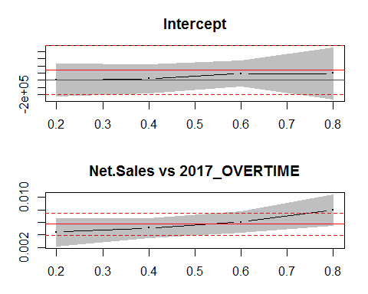

## , , tau= 0.2  
##   
## coefficients lower bd upper bd  
## (Intercept) 1.527000e+03 -2.183629e+05 2.214169e+05  
## Net.Sales_TOTAL.2017 4.421207e-03 2.189013e-03 6.653400e-03  
##   
## , , tau= 0.4  
##   
## coefficients lower bd upper bd  
## (Intercept) 2.102348e+04 -1.775095e+05 2.195564e+05  
## Net.Sales_TOTAL.2017 5.127577e-03 3.614166e-03 6.640989e-03  
##   
## , , tau= 0.6  
##   
## coefficients lower bd upper bd  
## (Intercept) 9.248800e+04 -8.402944e+04 2.690054e+05  
## Net.Sales_TOTAL.2017 6.040025e-03 4.369346e-03 7.710703e-03  
##   
## , , tau= 0.8  
##   
## coefficients lower bd upper bd  
## (Intercept) 9.451045e+04 -2.626864e+05 4.517073e+05  
## Net.Sales_TOTAL.2017 7.987196e-03 5.566028e-03 1.040836e-02  
##   
## , , ols  
##   
## coefficients lower bd upper bd  
## (Intercept) 1.421150e+05 -2.003079e+05 4.845378e+05  
## Net.Sales_TOTAL.2017 5.731477e-03 3.952000e-03 7.510954e-03

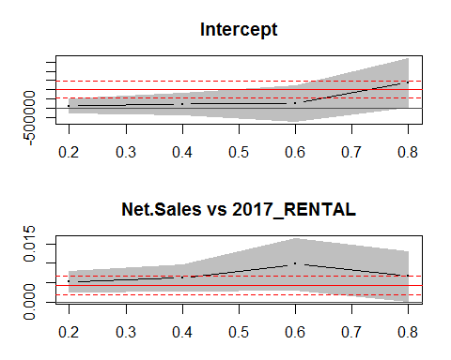

## , , tau= 0.2  
##   
## coefficients lower bd upper bd  
## (Intercept) 1.139832e+05 -2.542604e+05 4.822269e+05  
## Net.Sales_TOTAL.2017 5.249348e-03 2.553811e-03 7.944884e-03  
##   
## , , tau= 0.4  
##   
## coefficients lower bd upper bd  
## (Intercept) 2.189135e+05 -3.575130e+05 7.953399e+05  
## Net.Sales_TOTAL.2017 6.243098e-03 2.825652e-03 9.660544e-03  
##   
## , , tau= 0.6  
##   
## coefficients lower bd upper bd  
## (Intercept) 2.489710e+05 -7.366242e+05 1.234566e+06  
## Net.Sales_TOTAL.2017 9.747432e-03 3.049706e-03 1.644516e-02  
##   
## , , tau= 0.8  
##   
## coefficients lower bd upper bd  
## (Intercept) 1.380592e+06 5.302502e+04 2.708159e+06  
## Net.Sales_TOTAL.2017 6.601163e-03 1.115629e-04 1.309076e-02  
##   
## , , ols  
##   
## coefficients lower bd upper bd  
## (Intercept) 1.010074e+06 5.439772e+05 1.476171e+06  
## Net.Sales_TOTAL.2017 4.400948e-03 1.978770e-03 6.823126e-03

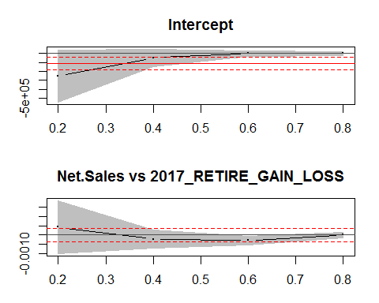

## , , tau= 0.2  
##   
## coefficients lower bd upper bd  
## (Intercept) -2.532031e+05 -5.486223e+05 4.221624e+04  
## Net.Sales_TOTAL.2017 4.215306e-04 -1.023430e-03 1.866491e-03  
##   
## , , tau= 0.4  
##   
## coefficients lower bd upper bd  
## (Intercept) -4.803279e+04 -1.465510e+05 5.048542e+04  
## Net.Sales_TOTAL.2017 -2.244525e-04 -7.262421e-04 2.773372e-04  
##   
## , , tau= 0.6  
##   
## coefficients lower bd upper bd  
## (Intercept) 0.0000000000 -3.212688e+04 3.212688e+04  
## Net.Sales_TOTAL.2017 -0.0002980193 -5.213405e-04 -7.469812e-05  
##   
## , , tau= 0.8  
##   
## coefficients lower bd upper bd  
## (Intercept) 0 -2.114122e+04 2.114122e+04  
## Net.Sales_TOTAL.2017 0 -1.574174e-04 1.574174e-04  
##   
## , , ols  
##   
## coefficients lower bd upper bd  
## (Intercept) -1.132609e+05 -1.854360e+05 -4.108587e+04  
## Net.Sales_TOTAL.2017 3.078514e-06 -3.719954e-04 3.781524e-04

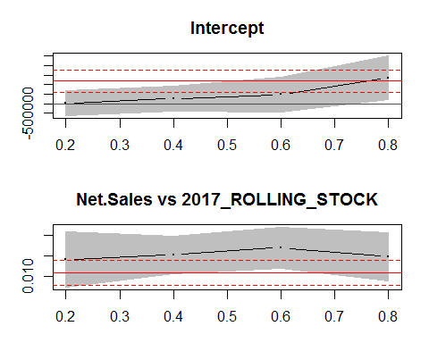

## , , tau= 0.2  
##   
## coefficients lower bd upper bd  
## (Intercept) 3.797800e+04 -6.336508e+05 7.096068e+05  
## Net.Sales_TOTAL.2017 1.416895e-02 7.430277e-03 2.090763e-02  
##   
## , , tau= 0.4  
##   
## coefficients lower bd upper bd  
## (Intercept) 2.666963e+05 -3.747084e+05 9.081010e+05  
## Net.Sales_TOTAL.2017 1.528212e-02 1.080948e-02 1.975476e-02  
##   
## , , tau= 0.6  
##   
## coefficients lower bd upper bd  
## (Intercept) 4.871340e+05 -4.110643e+05 1.385332e+06  
## Net.Sales_TOTAL.2017 1.703027e-02 1.205534e-02 2.200521e-02  
##   
## , , tau= 0.8  
##   
## coefficients lower bd upper bd  
## (Intercept) 1.366671e+06 2.053449e+05 2.527997e+06  
## Net.Sales_TOTAL.2017 1.475453e-02 8.928297e-03 2.058076e-02  
##   
## , , ols  
##   
## coefficients lower bd upper bd  
## (Intercept) 1.18605e+06 6.021316e+05 1.769969e+06  
## Net.Sales_TOTAL.2017 1.09410e-02 7.906531e-03 1.397546e-02

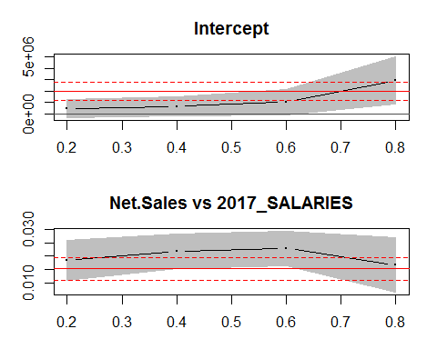

## , , tau= 0.2  
##   
## coefficients lower bd upper bd  
## (Intercept) 4.542729e+05 -3.678158e+05 1.276362e+06  
## Net.Sales_TOTAL.2017 1.842588e-02 1.103907e-02 2.581269e-02  
##   
## , , tau= 0.4  
##   
## coefficients lower bd upper bd  
## (Intercept) 6.418490e+05 -2.113009e+05 1.494999e+06  
## Net.Sales_TOTAL.2017 2.187452e-02 1.558487e-02 2.816416e-02  
##   
## , , tau= 0.6  
##   
## coefficients lower bd upper bd  
## (Intercept) 1.015554e+06 -7.947364e+04 2.110581e+06  
## Net.Sales_TOTAL.2017 2.283553e-02 1.638642e-02 2.928463e-02  
##   
## , , tau= 0.8  
##   
## coefficients lower bd upper bd  
## (Intercept) 2.954073e+06 8.685590e+05 5.039586e+06  
## Net.Sales_TOTAL.2017 1.682932e-02 6.685696e-03 2.697294e-02  
##   
## , , ols  
##   
## coefficients lower bd upper bd  
## (Intercept) 1.972362e+06 1.160960e+06 2.783764e+06  
## Net.Sales_TOTAL.2017 1.536229e-02 1.114566e-02 1.957893e-02

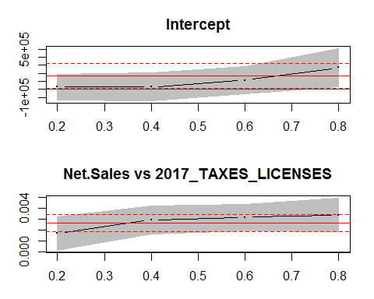

## , , tau= 0.2  
##   
## coefficients lower bd upper bd  
## (Intercept) 3.010500e+04 -1.319283e+05 1.921383e+05  
## Net.Sales_TOTAL.2017 1.671931e-03 1.085734e-04 3.235289e-03  
##   
## , , tau= 0.4  
##   
## coefficients lower bd upper bd  
## (Intercept) 3.010500e+04 -1.438854e+05 2.040954e+05  
## Net.Sales_TOTAL.2017 2.919563e-03 1.599811e-03 4.239314e-03  
##   
## , , tau= 0.6  
##   
## coefficients lower bd upper bd  
## (Intercept) 1.140204e+05 -5.216765e+04 2.802085e+05  
## Net.Sales_TOTAL.2017 3.169963e-03 1.949747e-03 4.390179e-03  
##   
## , , tau= 0.8  
##   
## coefficients lower bd upper bd  
## (Intercept) 2.722048e+05 3.432635e+04 5.100833e+05  
## Net.Sales_TOTAL.2017 3.388127e-03 1.825363e-03 4.950892e-03  
##   
## , , ols  
##   
## coefficients lower bd upper bd  
## (Intercept) 1.708217e+05 1.579511e+04 3.258484e+05  
## Net.Sales_TOTAL.2017 2.646476e-03 1.840845e-03 3.452106e-03

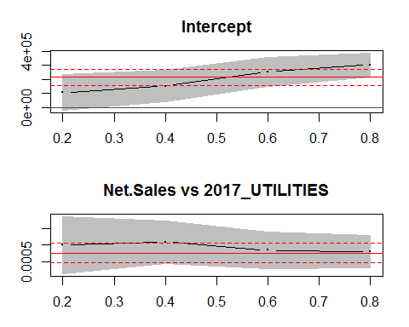

## , , tau= 0.2  
##   
## coefficients lower bd upper bd  
## (Intercept) 1.059773e+05 -2.115996e+04 2.331146e+05  
## Net.Sales_TOTAL.2017 9.996148e-04 1.441332e-04 1.855096e-03  
##   
## , , tau= 0.4  
##   
## coefficients lower bd upper bd  
## (Intercept) 1.527219e+05 4.229525e+04 2.631485e+05  
## Net.Sales_TOTAL.2017 1.095884e-03 4.601640e-04 1.731604e-03  
##   
## , , tau= 0.6  
##   
## coefficients lower bd upper bd  
## (Intercept) 2.531542e+05 1.504434e+05 3.558651e+05  
## Net.Sales_TOTAL.2017 8.492400e-04 3.151244e-04 1.383356e-03  
##   
## , , tau= 0.8  
##   
## coefficients lower bd upper bd  
## (Intercept) 3.017707e+05 2.163780e+05 3.871633e+05  
## Net.Sales_TOTAL.2017 8.074804e-04 3.335218e-04 1.281439e-03  
##   
## , , ols  
##   
## coefficients lower bd upper bd  
## (Intercept) 2.13511e+05 1.576913e+05 2.693307e+05  
## Net.Sales_TOTAL.2017 7.70086e-04 4.800066e-04 1.060165e-03

# #net margin against total payroll, rolling stock, Bad Dept  
# tau <- tau <- seq(from = .20, to = .80, by = .2)  
#   
# df.cutdown <- comb.sales.exp.data[,c("TOTAL.MARGIN.2017","2017_BAD_DEBT", "2017_ROLLING_STOCK", "2017_SALARIES", "2017_FX_GAIN_LOSS")]  
#   
# #multiply expense by -1  
# #df.cutdown[,2:5] <- df.cutdown[,2:5] * -1  
#   
# quant.test <- rq(TOTAL.MARGIN.2017 ~ ., data = df.cutdown, tau = tau)  
#   
# summary(quant.test)  
#   
# plot(summary(quant.test, se = "boot"))

# library(TH.data)  
# library(rpart)  
# library(partykit)

# ggpairs(comb.sales.exp.data[,c("TOTAL.MARGIN.2017","2017_BAD_DEBT", "2017_ROLLING_STOCK", "2017_SALARIES", "2017_FX_GAIN_LOSS")])  
#   
# #data set  
# df.cutdown <- comb.sales.exp.data[,c("TOTAL.MARGIN.2017","2017_BAD_DEBT", "2017_ROLLING_STOCK", "2017_SALARIES", "2017_FX_GAIN_LOSS")]  
#   
# tree.test <- rpart(TOTAL.MARGIN.2017 ~ .,   
# data = df.cutdown,   
# control = rpart.control(minsplit = 10))  
#   
# ## RP-bodyfat-cp  
# print(tree.test$cptable)  
# opt <- which.min(tree.test$cptable[,"xerror"])  
# opt  
#   
# ## RP-bodyfat-prune  
# #Prune back the large tree  
# cp <- tree.test$cptable[opt, "CP"]  
# tree.test_prune <- prune(tree.test, cp = cp)  
#   
# ## RP-bodyfat-pruneplot  
# plot(as.party(tree.test_prune), tp_args = list(id = FALSE))

library(relaimpo)

## Loading required package: MASS

##   
## Attaching package: 'MASS'

## The following object is masked from 'package:dplyr':  
##   
## select

## Loading required package: boot

##   
## Attaching package: 'boot'

## The following object is masked _by_ '.GlobalEnv':  
##   
## tau

## The following object is masked from 'package:survival':  
##   
## aml

## The following object is masked from 'package:lattice':  
##   
## melanoma

## Loading required package: survey

## Loading required package: grid

## Loading required package: Matrix

##   
## Attaching package: 'Matrix'

## The following object is masked from 'package:tidyr':  
##   
## expand

##   
## Attaching package: 'survey'

## The following object is masked from 'package:Hmisc':  
##   
## deff

## The following object is masked from 'package:graphics':  
##   
## dotchart

## Loading required package: mitools

## This is the global version of package relaimpo.

## If you are a non-US user, a version with the interesting additional metric pmvd is available

## from Ulrike Groempings web site at prof.beuth-hochschule.de/groemping.

#set data  
df.cutdown <- comb.sales.exp.data[,c("TOTAL.MARGIN.2017","2017_BAD_DEBT", "2017_ROLLING_STOCK", "2017_SALARIES", "2017_FX_GAIN_LOSS")]  
  
#multiply expense by -1  
#df.cutdown[,2:5] <- df.cutdown[,2:5] * -1  
pairs(df.cutdown)

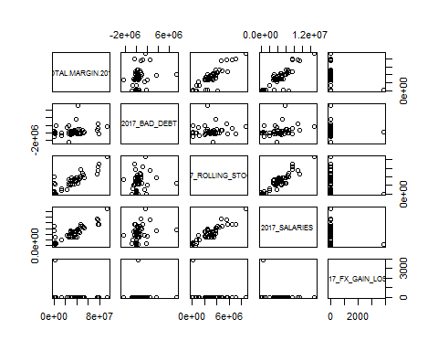

realaimpo.test <- lm(TOTAL.MARGIN.2017 ~ .,   
 data = df.cutdown)  
summary(realaimpo.test)

##   
## Call:  
## lm(formula = TOTAL.MARGIN.2017 ~ ., data = df.cutdown)  
##   
## Residuals:  
## Min 1Q Median 3Q Max   
## -46505906 -1888820 1236148 6142180 18206196   
##   
## Coefficients:  
## Estimate Std. Error t value Pr(>|t|)   
## (Intercept) -1.311e+06 3.099e+06 -0.423 0.67416   
## `2017_BAD_DEBT` 1.789e+00 1.220e+00 1.467 0.14929   
## `2017_ROLLING_STOCK` 8.006e+00 1.996e+00 4.011 0.00022 ***  
## `2017_SALARIES` 2.163e+00 1.468e+00 1.474 0.14740   
## `2017_FX_GAIN_LOSS` 2.240e+02 2.872e+03 0.078 0.93818   
## ---  
## Signif. codes: 0 '***' 0.001 '**' 0.01 '*' 0.05 '.' 0.1 ' ' 1  
##   
## Residual standard error: 10750000 on 46 degrees of freedom  
## Multiple R-squared: 0.8, Adjusted R-squared: 0.7826   
## F-statistic: 46 on 4 and 46 DF, p-value: 1.628e-15

relaimpo.calc <- calc.relimp(realaimpo.test, type = c("lmg"), rela = TRUE)  
relaimpo.calc

## Response variable: TOTAL.MARGIN.2017   
## Total response variance: 5.312089e+14   
## Analysis based on 51 observations   
##   
## 4 Regressors:   
## 2017_BAD_DEBT 2017_ROLLING_STOCK 2017_SALARIES 2017_FX_GAIN_LOSS   
## Proportion of variance explained by model: 80%  
## Metrics are normalized to sum to 100% (rela=TRUE).   
##   
## Relative importance metrics:   
##   
## lmg  
## 2017_BAD_DEBT 0.03312198  
## 2017_ROLLING_STOCK 0.50793822  
## 2017_SALARIES 0.44374963  
## 2017_FX_GAIN_LOSS 0.01519017  
##   
## Average coefficients for different model sizes:   
##   
## 1X 2Xs 3Xs 4Xs  
## 2017_BAD_DEBT 4.244109 2.361796 1.567241 1.789026  
## 2017_ROLLING_STOCK 10.882648 9.593432 8.634995 8.005554  
## 2017_SALARIES 7.581261 5.992646 4.185856 2.162820  
## 2017_FX_GAIN_LOSS -8147.041143 -2730.593125 -6.933246 223.995322