v2.US.Level.Only.Total.OPEX.Forecast

Jason Marshall

August 15, 2018

Version 2: Code clean up / Analysis Focus Clean Up

## Warning: Missing column names filled in: 'X1' [1]

## Parsed with column specification:  
## cols(  
## X1 = col_integer(),  
## GL.Level = col_character(),  
## Summary.Account = col_character(),  
## Parent.Account = col_character(),  
## Account = col_character(),  
## Geography = col_character(),  
## Region = col_character(),  
## Division = col_character(),  
## Period = col_character(),  
## Acct.Per = col_integer(),  
## Year = col_integer(),  
## Currency = col_character(),  
## Amount = col_integer(),  
## day.holder = col_integer(),  
## date.holder = col_date(format = ""),  
## Date = col_date(format = "")  
## )

## Warning in rbind(names(probs), probs_f): number of columns of result is not  
## a multiple of vector length (arg 1)

## Warning: 32 parsing failures.  
## row # A tibble: 5 x 5 col row col expected actual file expected <int> <chr> <chr> <chr> <chr> actual 1 1005 Amount no trailing characters e+05 'Y:/Sharepoint Projects/Jaso~ file 2 15347 Amount no trailing characters e+05 'Y:/Sharepoint Projects/Jaso~ row 3 17619 Amount no trailing characters e+05 'Y:/Sharepoint Projects/Jaso~ col 4 30257 Amount no trailing characters e+05 'Y:/Sharepoint Projects/Jaso~ expected 5 35440 Amount no trailing characters e+05 'Y:/Sharepoint Projects/Jaso~  
## ... ................. ... .......................................................................... ........ .......................................................................... ...... .......................................................................... .... .......................................................................... ... .......................................................................... ... .......................................................................... ........ ..........................................................................  
## See problems(...) for more details.

## [1] "Alabama" "Central Cornbelt"   
## [3] "Central Indiana" "Central Iowa"   
## [5] "Central Valley" "Coastal"   
## [7] "Coastal Plains" "Colonial"   
## [9] "Eastern" "Eastern Cornbelt"   
## [11] "Eastern Illinois" "Eastern Kentucky"   
## [13] "Florida" "Georgia"   
## [15] "Michigan" "Mid-South"   
## [17] "Mid N Carolina - Virginia" "Minnesota - South Dakota"   
## [19] "Mississippi" "Nebraska"   
## [21] "North Dakota - NE MT - NW MN" "North Valley"   
## [23] "Northeast" "Northeast Iowa"   
## [25] "Northern High Plains" "Northern Illinois - Wisconsin"   
## [27] "Northern Ohio" "Northwest"   
## [29] "S Carolina - West N Carolina" "Snake River"   
## [31] "South" "South Delta"   
## [33] "South Plains" "Southeast Iowa"   
## [35] "Southern High Plains" "Southern Illinois"   
## [37] "Southern Ohio" "Southwest"   
## [39] "Southwest IN - Northern KY" "Tennessee - Western Kentucky"   
## [41] "United States" "West"   
## [43] "West Central Illinois" "West Iowa - Northeast Nebraska"  
## [45] "Western Cornbelt" "Western Illinois"

## X1 GL.Level Summary.Account   
## Min. : 1 Non OpEx: 24288 TOTAL PAYROLL :136620   
## 1st Qu.: 68374 OpEx :191268 ADMIN_CHARGE : 3036   
## Median :140581 BAD_DEBT : 3036   
## Mean :139558 DEPR_AMORT : 3036   
## 3rd Qu.:206397 EMPLOYEE_EXPENSE : 3036   
## Max. :295218 ENVMNTL_SAFETY_EXP: 3036   
## (Other) : 63756   
## Parent.Account Account   
## BURDEN :91080 520000 - Hourly Wages : 3036   
## SALARIES :18216 520002 - Hourly Overtime : 3036   
## INCENTIVE :15180 520102 - Hourly Fringe Severance & Stay: 3036   
## HOURLY WAGES: 9108 520104 - Hourly Fringe Other : 3036   
## ADMIN_CHARGE: 3036 520202 - Hourly Retirement 401k Savings: 3036   
## BAD_DEBT : 3036 520301 - Hourly Ins LT Disability : 3036   
## (Other) :75900 (Other) :197340   
## Geography Region Division   
## United States:215556 Central Cornbelt:37488 Alabama : 4686   
## Eastern :28116 Central Cornbelt: 4686   
## Eastern Cornbelt:37488 Central Indiana : 4686   
## South :37488 Central Iowa : 4686   
## United States : 4686 Central Valley : 4686   
## West :32802 Coastal : 4686   
## Western Cornbelt:37488 (Other) :187440   
## Period Acct.Per Year Currency   
## 2013-01: 3266 Min. : 1.000 Min. :2013 USD:215556   
## 2013-02: 3266 1st Qu.: 3.000 1st Qu.:2014   
## 2013-03: 3266 Median : 6.000 Median :2015   
## 2013-04: 3266 Mean : 6.227 Mean :2015   
## 2013-05: 3266 3rd Qu.: 9.000 3rd Qu.:2017   
## 2013-06: 3266 Max. :12.000 Max. :2018   
## (Other):195960   
## Amount day.holder date.holder   
## Min. :-16371964 Min. :1 Min. :2013-01-01   
## 1st Qu.: 0 1st Qu.:1 1st Qu.:2014-05-01   
## Median : 477 Median :1 Median :2015-09-16   
## Mean : 99475 Mean :1 Mean :2015-09-16   
## 3rd Qu.: 35566 3rd Qu.:1 3rd Qu.:2017-02-01   
## Max. : 63920238 Max. :1 Max. :2018-06-01   
## NA's :25   
## Date   
## Min. :2013-01-31   
## 1st Qu.:2014-05-31   
## Median :2015-10-15   
## Mean :2015-10-15   
## 3rd Qu.:2017-02-28   
## Max. :2018-06-30   
##

## # A tibble: 46 x 2  
## Division sum  
## <fct> <dbl>  
## 1 Alabama 101725017  
## 2 Central Cornbelt 1100772563  
## 3 Central Indiana 203215301  
## 4 Central Iowa 137354991  
## 5 Central Valley 258841067  
## 6 Coastal 373235130  
## 7 Coastal Plains 125570572  
## 8 Colonial 204512068  
## 9 Eastern 776233840  
## 10 Eastern Cornbelt 1140747074  
## # ... with 36 more rows

## X1 GL.Level Summary.Account   
## Min. : 1 Non OpEx: 24288 TOTAL PAYROLL :136620   
## 1st Qu.: 68374 OpEx :191268 ADMIN_CHARGE : 3036   
## Median :140581 BAD_DEBT : 3036   
## Mean :139558 DEPR_AMORT : 3036   
## 3rd Qu.:206397 EMPLOYEE_EXPENSE : 3036   
## Max. :295218 ENVMNTL_SAFETY_EXP: 3036   
## (Other) : 63756   
## Parent.Account Account   
## BURDEN :91080 520000 - Hourly Wages : 3036   
## SALARIES :18216 520002 - Hourly Overtime : 3036   
## INCENTIVE :15180 520102 - Hourly Fringe Severance & Stay: 3036   
## HOURLY WAGES: 9108 520104 - Hourly Fringe Other : 3036   
## ADMIN_CHARGE: 3036 520202 - Hourly Retirement 401k Savings: 3036   
## BAD_DEBT : 3036 520301 - Hourly Ins LT Disability : 3036   
## (Other) :75900 (Other) :197340   
## Geography Region Division   
## United States:215556 Central Cornbelt:37488 Alabama : 4686   
## Eastern :28116 Central Cornbelt: 4686   
## Eastern Cornbelt:37488 Central Indiana : 4686   
## South :37488 Central Iowa : 4686   
## United States : 4686 Central Valley : 4686   
## West :32802 Coastal : 4686   
## Western Cornbelt:37488 (Other) :187440   
## Period Acct.Per Year Currency   
## 2013-01: 3266 Min. : 1.000 Min. :2013 USD:215556   
## 2013-02: 3266 1st Qu.: 3.000 1st Qu.:2014   
## 2013-03: 3266 Median : 6.000 Median :2015   
## 2013-04: 3266 Mean : 6.227 Mean :2015   
## 2013-05: 3266 3rd Qu.: 9.000 3rd Qu.:2017   
## 2013-06: 3266 Max. :12.000 Max. :2018   
## (Other):195960   
## Amount day.holder date.holder   
## Min. :-16371964 Min. :1 Min. :2013-01-01   
## 1st Qu.: 0 1st Qu.:1 1st Qu.:2014-05-01   
## Median : 476 Median :1 Median :2015-09-16   
## Mean : 99463 Mean :1 Mean :2015-09-16   
## 3rd Qu.: 35558 3rd Qu.:1 3rd Qu.:2017-02-01   
## Max. : 63920238 Max. :1 Max. :2018-06-01   
##   
## Date   
## Min. :2013-01-31   
## 1st Qu.:2014-05-31   
## Median :2015-10-15   
## Mean :2015-10-15   
## 3rd Qu.:2017-02-28   
## Max. :2018-06-30   
##

## Summary of Data Set

## Date Parent.Account Geography   
## Min. :2013-01-31 ADMIN_CHARGE : 66 United States:2046   
## 1st Qu.:2014-05-31 BAD_DEBT : 66   
## Median :2015-10-15 BURDEN : 66   
## Mean :2015-10-15 DEPR_AMORT : 66   
## 3rd Qu.:2017-02-28 EMPLOYEE_EXPENSE : 66   
## Max. :2018-06-30 ENVMNTL_SAFETY_EXP: 66   
## (Other) :1650   
## Expense.Sum   
## Min. :-32513684   
## 1st Qu.: 2396   
## Median : 4843472   
## Mean : 10478933   
## 3rd Qu.: 15098281   
## Max. :106371388   
##

## [1] TRUE

## ADMIN_CHARGE BAD_DEBT BURDEN   
## Min. :5847911 Min. :-32513684 Min. :24252379   
## 1st Qu.:8646557 1st Qu.: 1415783 1st Qu.:29768896   
## Median :8958515 Median : 4789664 Median :36013045   
## Mean :8893808 Mean : 5483864 Mean :35890666   
## 3rd Qu.:9316565 3rd Qu.: 12301359 3rd Qu.:41756968   
## Max. :9762767 Max. : 21770319 Max. :50592699   
## DEPR_AMORT EMPLOYEE_EXPENSE ENVMNTL_SAFETY_EXP ERL_ARO_EXP   
## Min. : 8005141 Min. :3723928 Min. : 658646 Min. :-376960   
## 1st Qu.:33842902 1st Qu.:4569556 1st Qu.:1275359 1st Qu.: 0   
## Median :37354302 Median :5601458 Median :1641056 Median : 0   
## Mean :38547927 Mean :5879996 Mean :1591305 Mean : 82058   
## 3rd Qu.:41799281 3rd Qu.:6933772 3rd Qu.:1852559 3rd Qu.: 0   
## Max. :90281017 Max. :8872572 Max. :3068871 Max. :1625288   
## FX_GAIN_LOSS GA_EXPENSES HOURLY WAGES   
## Min. :-152028.0 Min. :1658579 Min. :30474265   
## 1st Qu.: -217.5 1st Qu.:5013116 1st Qu.:36663432   
## Median : 696.0 Median :5781849 Median :40494544   
## Mean : 3262.8 Mean :5688503 Mean :41266446   
## 3rd Qu.: 5419.2 3rd Qu.:6538628 3rd Qu.:45783632   
## Max. : 80688.0 Max. :7933734 Max. :57372674   
## INC_EXP_OTHER INCENTIVE INSURANCE_PREMIUMS  
## Min. :-6527431 Min. :-11623690 Min. :4368013   
## 1st Qu.:-1480140 1st Qu.: 4295816 1st Qu.:4845386   
## Median : -616082 Median : 10536341 Median :5066908   
## Mean : -801483 Mean : 27765762 Mean :5116263   
## 3rd Qu.: -5387 3rd Qu.: 55156679 3rd Qu.:5216455   
## Max. : 4517608 Max. :106371388 Max. :7791497   
## INTERBRANCH_CHRG INTEREST_INCOME LESS_DEPR_AMORT_EXP  
## Min. :-5318711 Min. :-16221057 Min. :-1147923   
## 1st Qu.: 1466017 1st Qu.:-12718014 1st Qu.: -510778   
## Median : 2850937 Median : -9730412 Median : -484785   
## Mean : 2578301 Mean : -9386695 Mean : -485104   
## 3rd Qu.: 4327855 3rd Qu.: -7764938 3rd Qu.: -453720   
## Max. : 5990720 Max. : 24213029 Max. : 729839   
## LESS_GA_EXP LESS_OTHER_EXP LOSS_DAMAGE_CLAIMS  
## Min. :-7933734 Min. :-32433740 Min. :-7877514   
## 1st Qu.:-6538628 1st Qu.:-16546192 1st Qu.: 1098854   
## Median :-5781849 Median : -8744740 Median : 1905386   
## Mean :-5688485 Mean :-11787041 Mean : 2130768   
## 3rd Qu.:-5013161 3rd Qu.: -6323770 3rd Qu.: 2534416   
## Max. :-1658309 Max. : -3119394 Max. :12175486   
## MAINTENANCE MARKETING OFFICE_EXPENSE OTHER EXPENSES   
## Min. : 8006763 Min. : 868866 Min. :5545387 Min. :-5057546   
## 1st Qu.:11819866 1st Qu.:2424300 1st Qu.:6658180 1st Qu.:-1343800   
## Median :13959641 Median :2984610 Median :7197884 Median : -149824   
## Mean :14128982 Mean :2987887 Mean :7166464 Mean : 60930   
## 3rd Qu.:16179511 3rd Qu.:3672939 3rd Qu.:7685730 3rd Qu.: 1504949   
## Max. :20920373 Max. :5461318 Max. :8986179 Max. : 5906329   
## OUTSIDE_SERVICES OVERTIME RENTAL   
## Min. : 8504003 Min. : 1322600 Min. :13160644   
## 1st Qu.:12371378 1st Qu.: 6718151 1st Qu.:17532968   
## Median :15265696 Median :10169382 Median :19445220   
## Mean :16130957 Mean :12406059 Mean :19387598   
## 3rd Qu.:19013483 3rd Qu.:17864826 3rd Qu.:21542876   
## Max. :33008289 Max. :33873478 Max. :25815978   
## RETIRE_GAIN_LOSS ROLLING_STOCK SALARIES   
## Min. :-14809464 Min. :20258345 Min. :44578006   
## 1st Qu.: -1157302 1st Qu.:29189958 1st Qu.:51361403   
## Median : -508465 Median :35237349 Median :53880498   
## Mean : -917067 Mean :36395742 Mean :53532590   
## 3rd Qu.: -112472 3rd Qu.:43300505 3rd Qu.:56289683   
## Max. : 1408230 Max. :60158084 Max. :62286810   
## TAXES_LICENSES UTILITIES   
## Min. : 3422734 Min. :2578126   
## 1st Qu.: 5928391 1st Qu.:3418994   
## Median : 6850030 Median :3865054   
## Mean : 6933568 Mean :3863102   
## 3rd Qu.: 7785778 3rd Qu.:4230196   
## Max. :11382200 Max. :5273720

## [1] 2013 1

## [1] 2018 6

## Time Series EDA

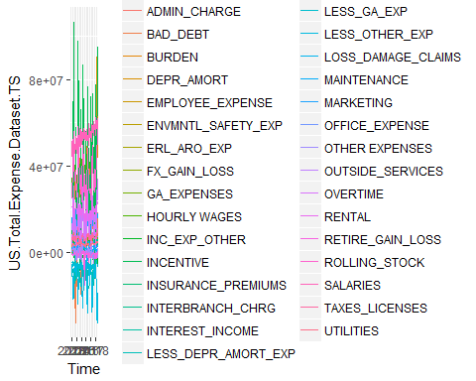

## US.Total EDA loess plots

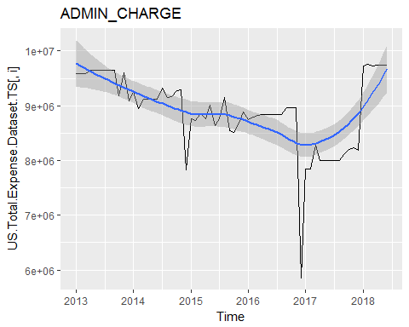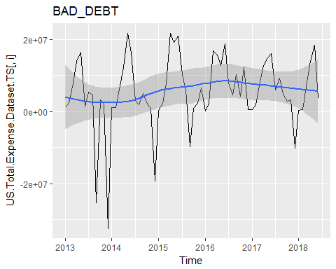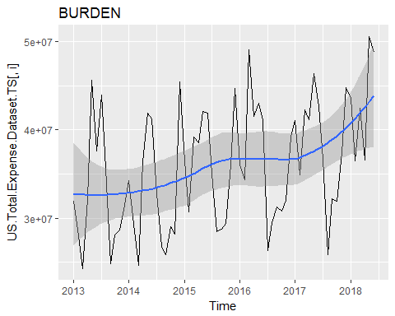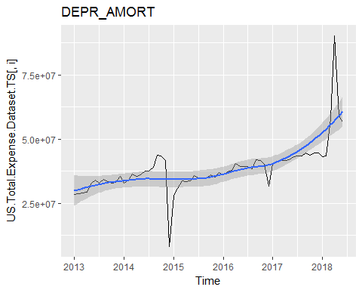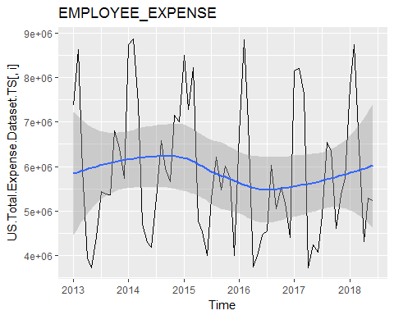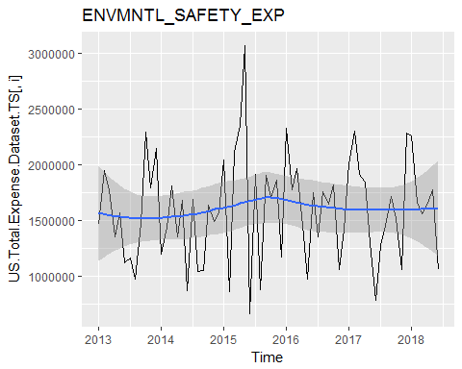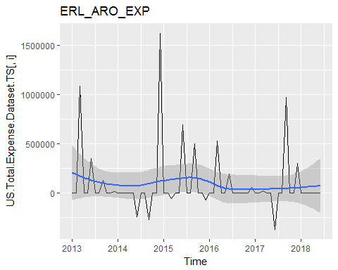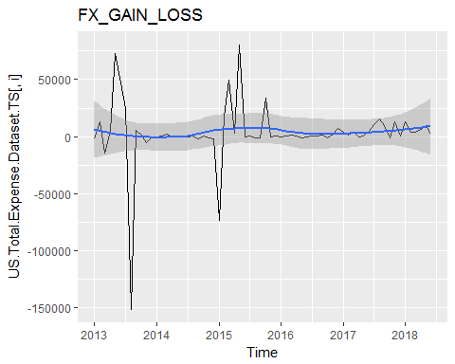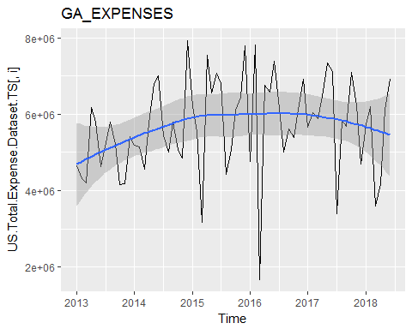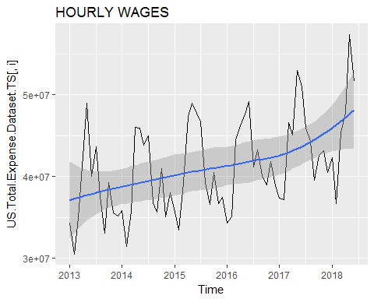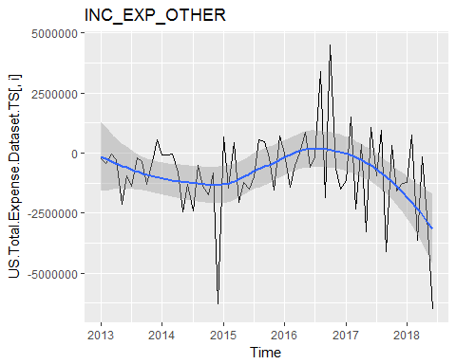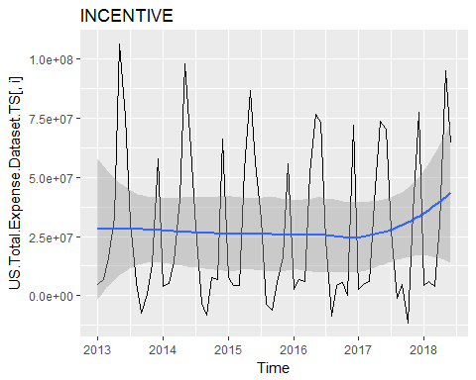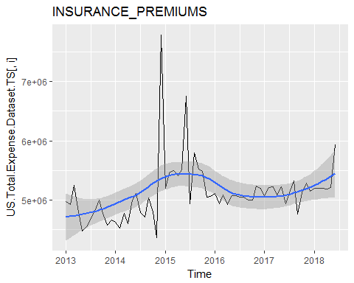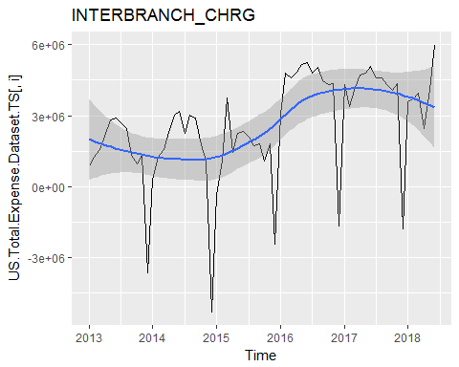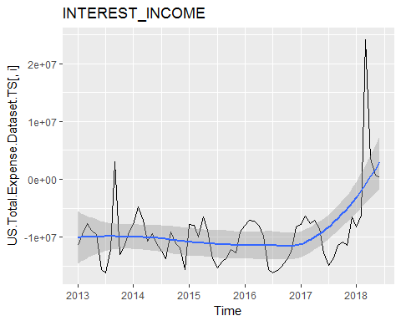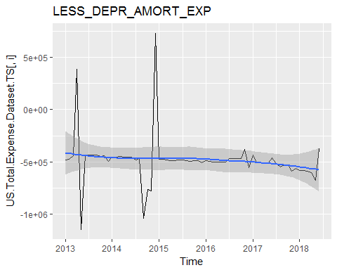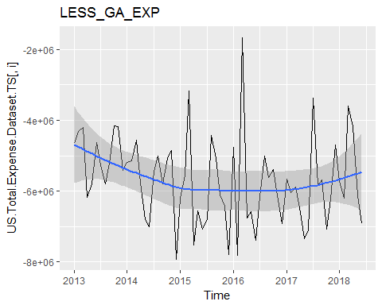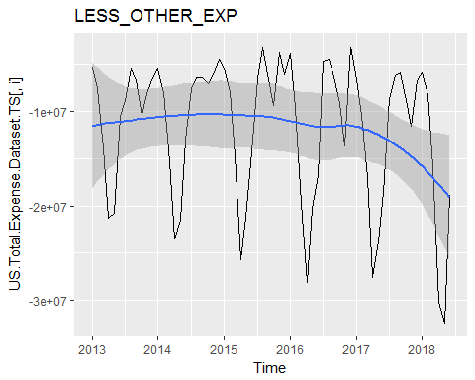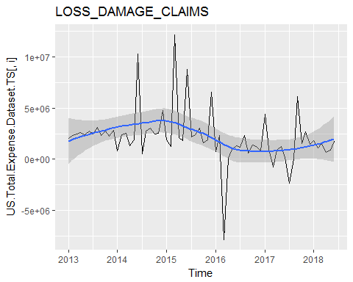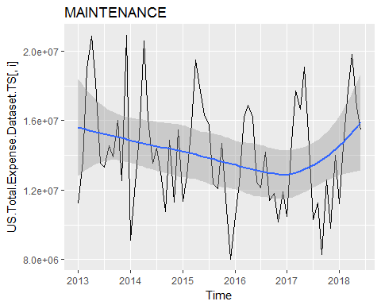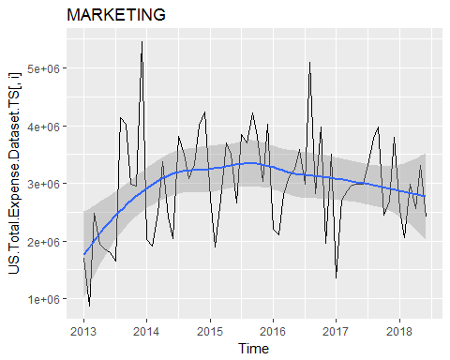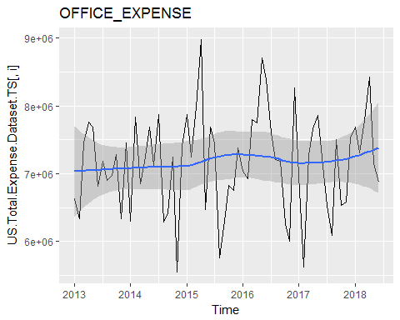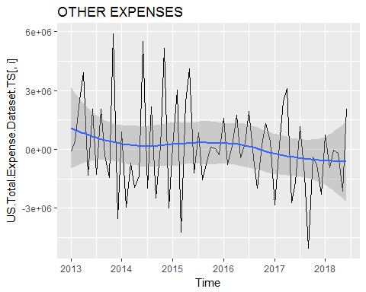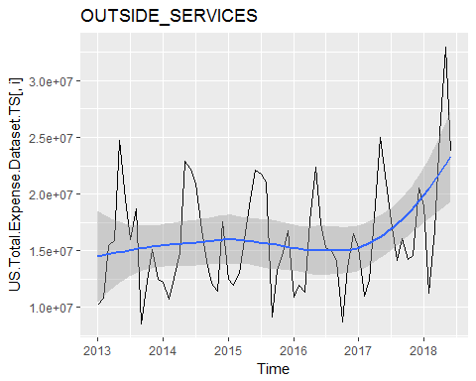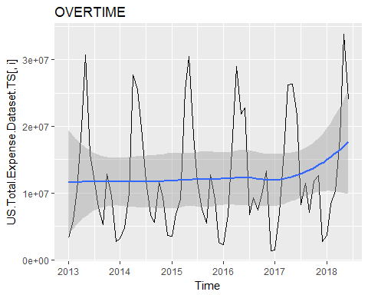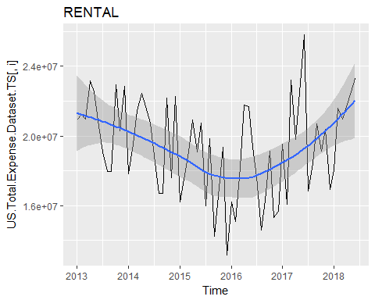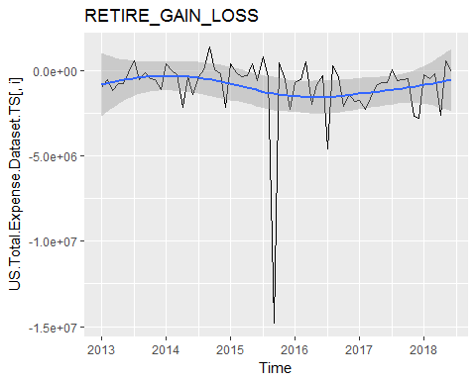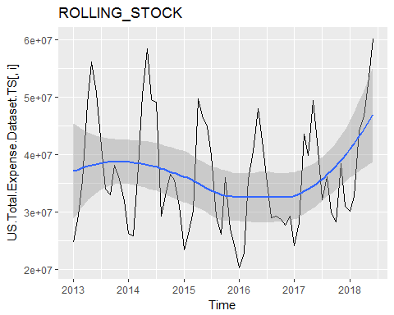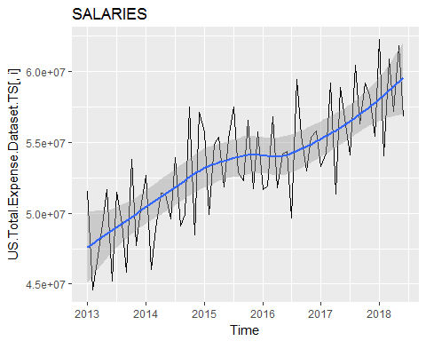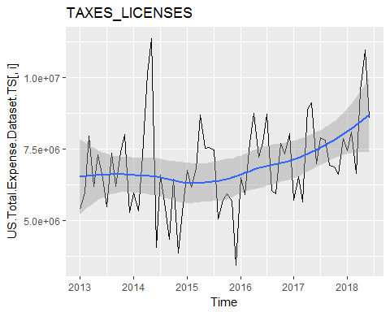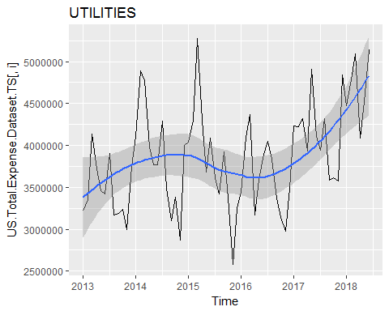

## US.Total EDA loess plots (Drop/Smooth Outliers)

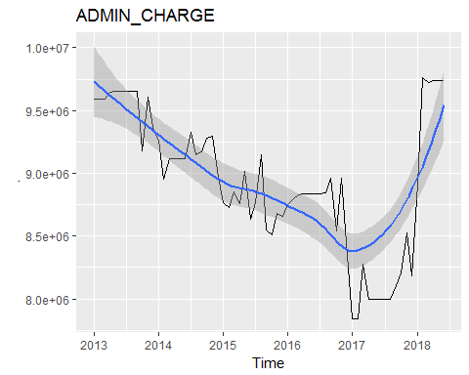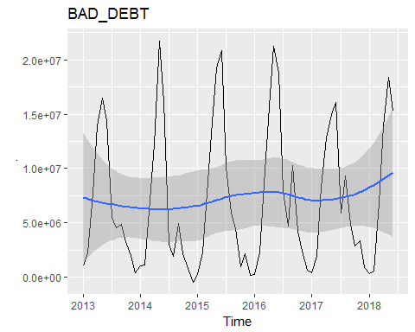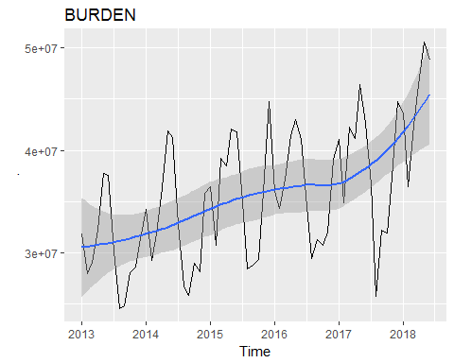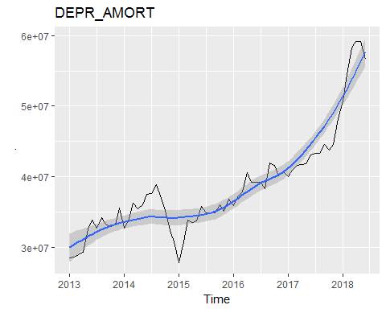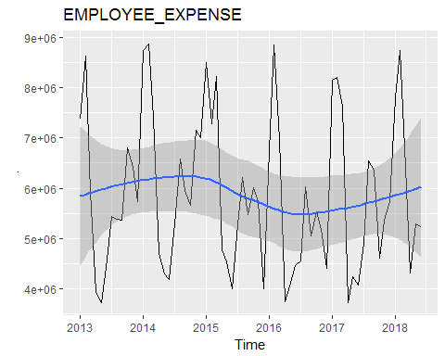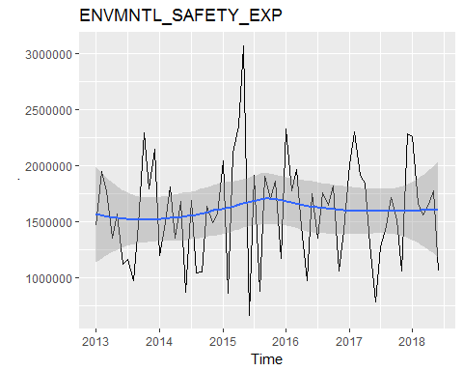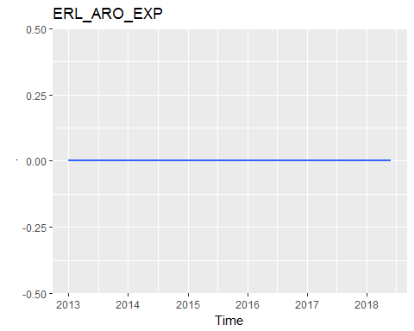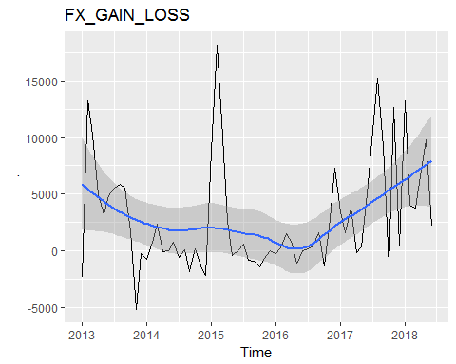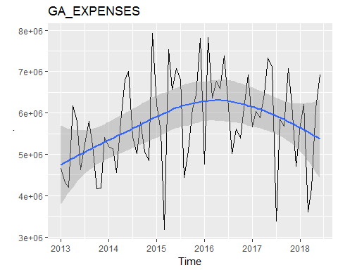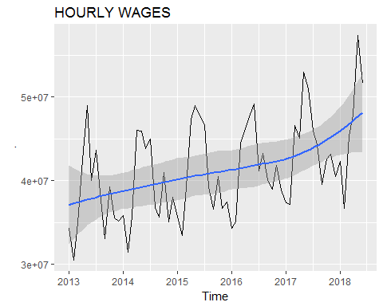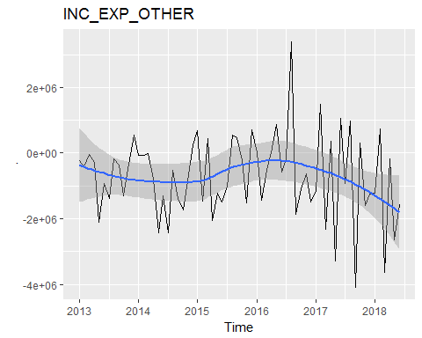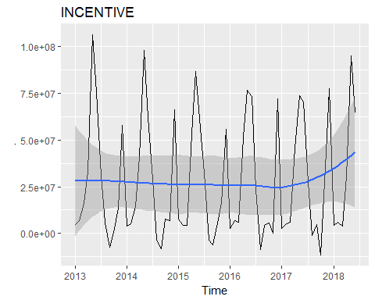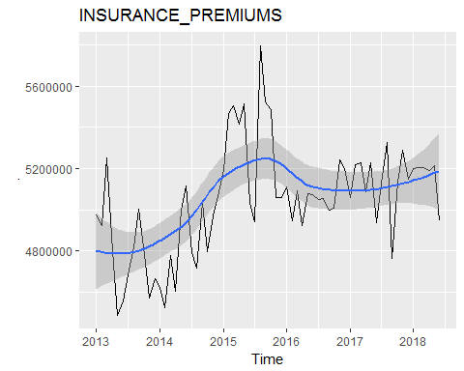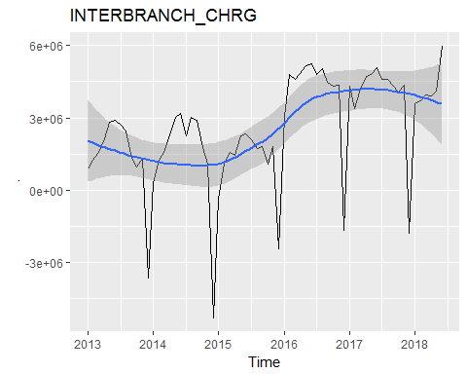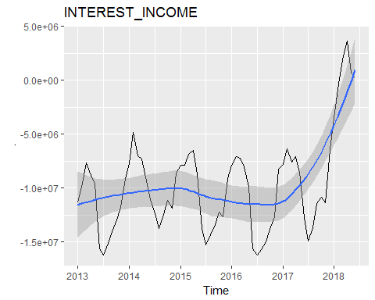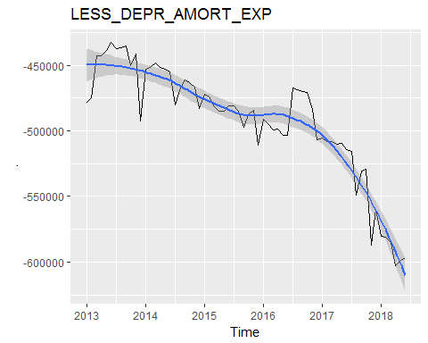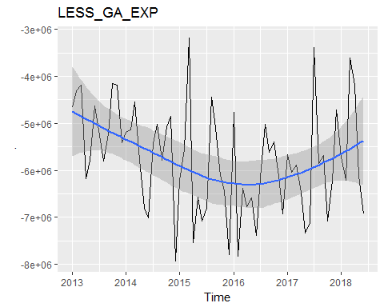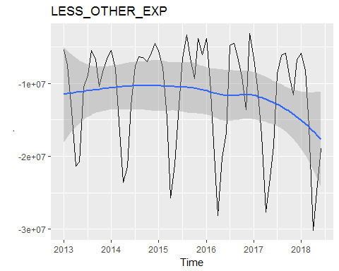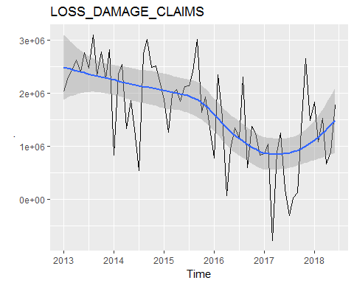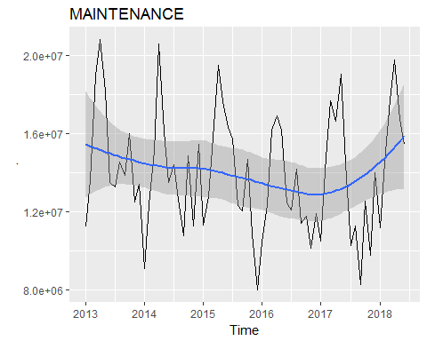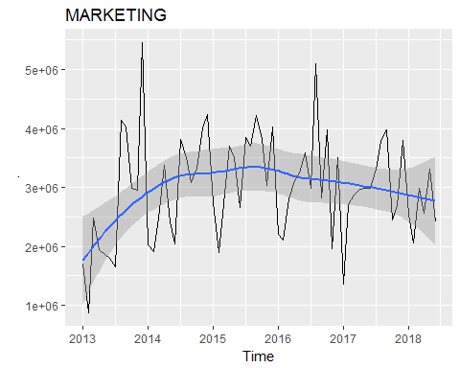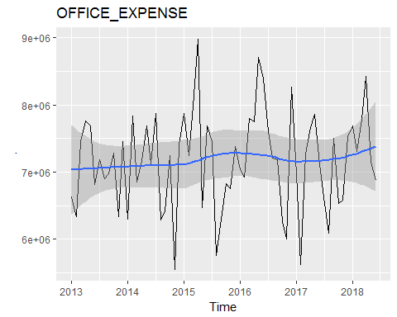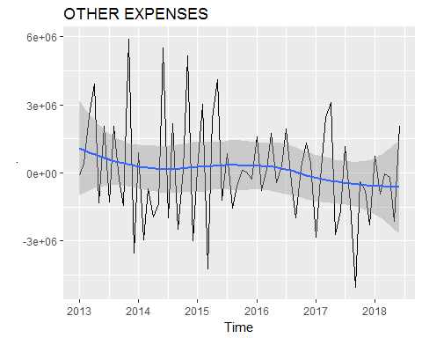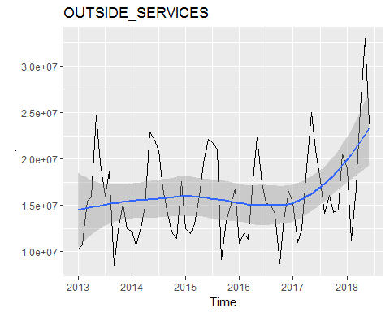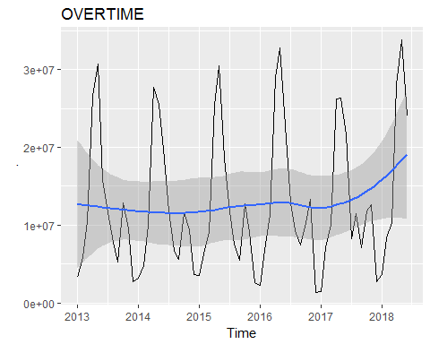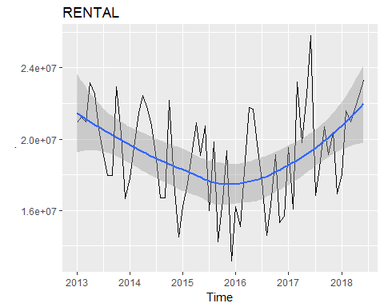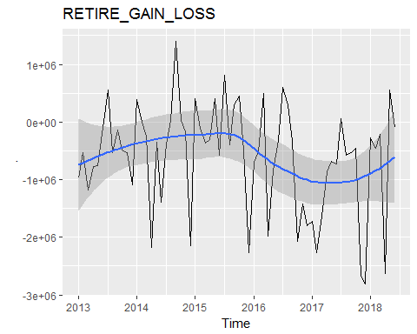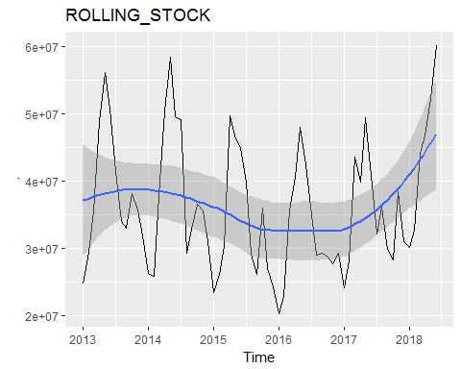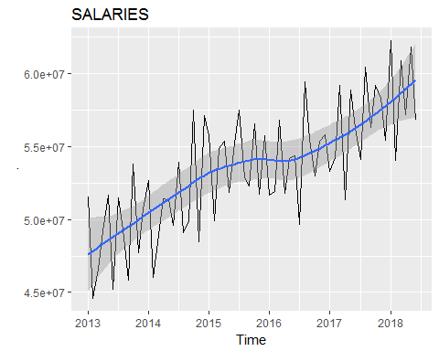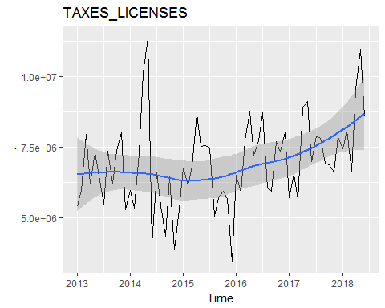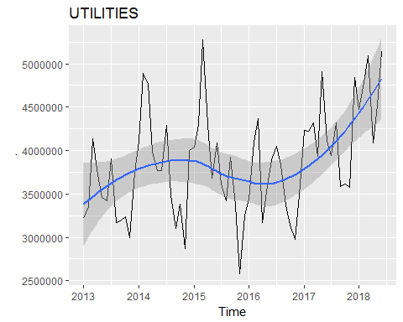

## US.Total EDA Season Plots

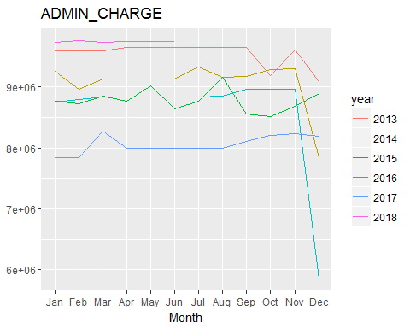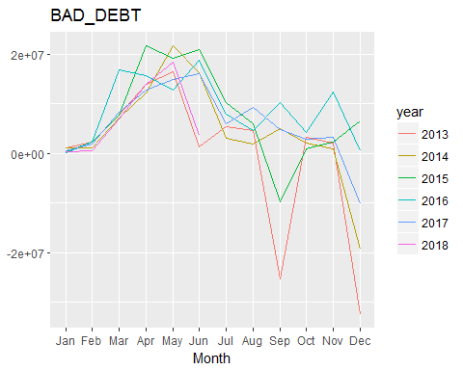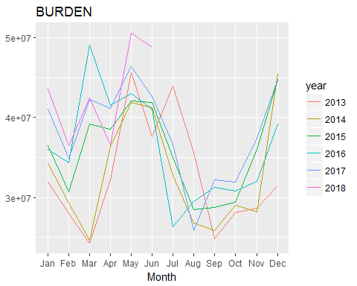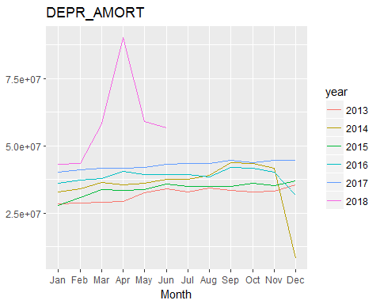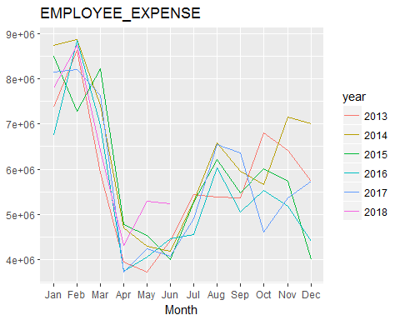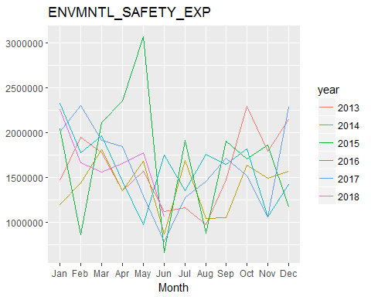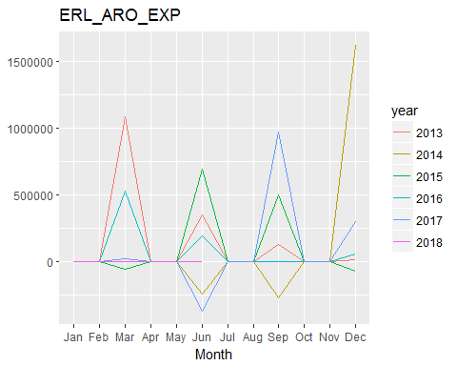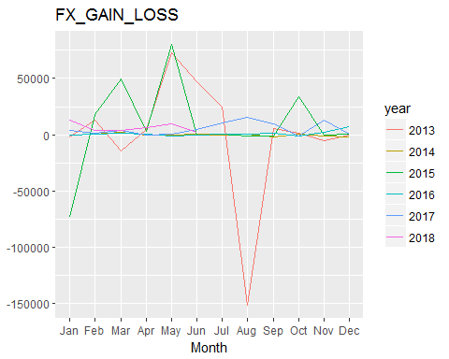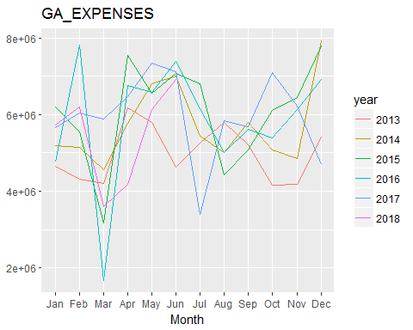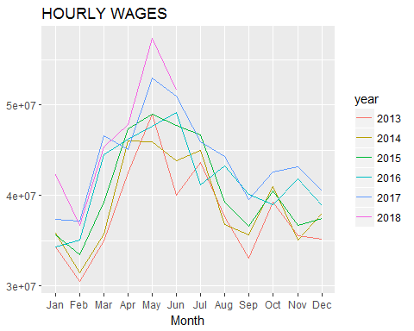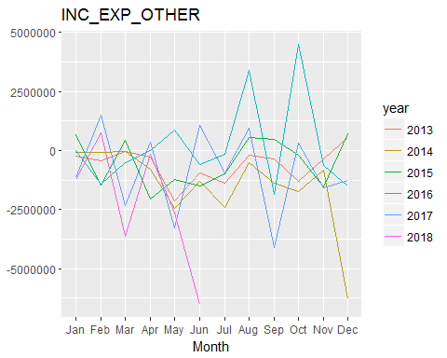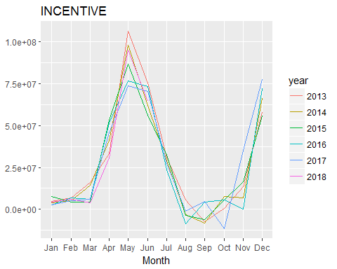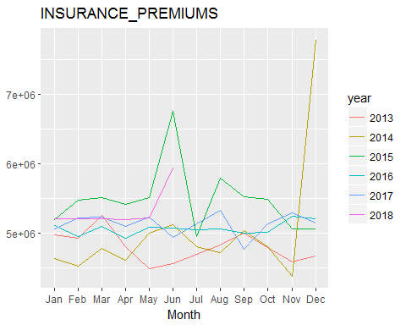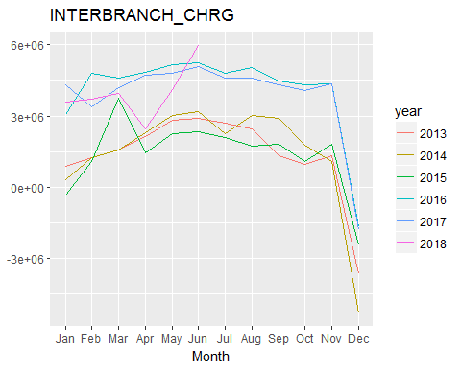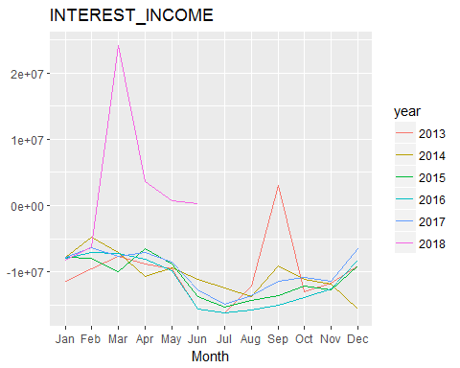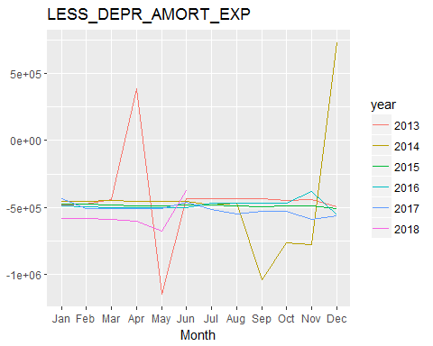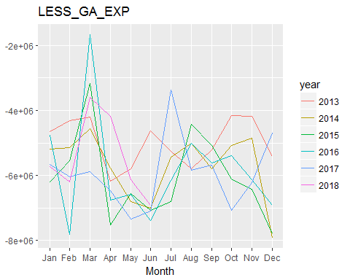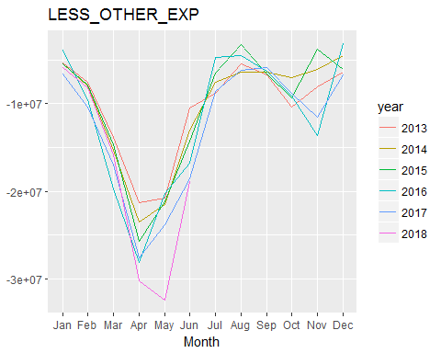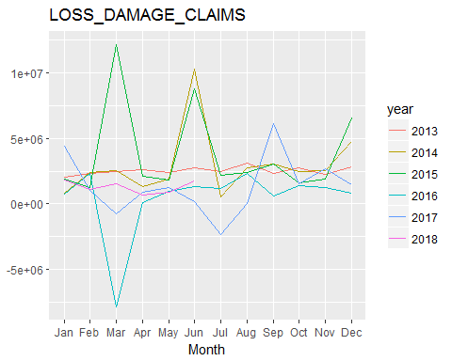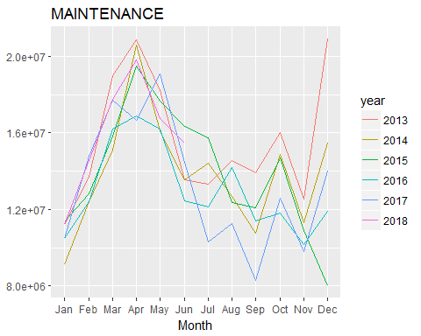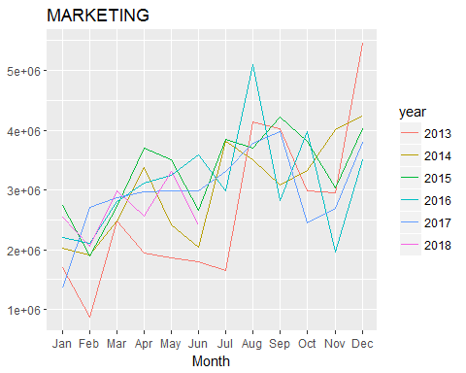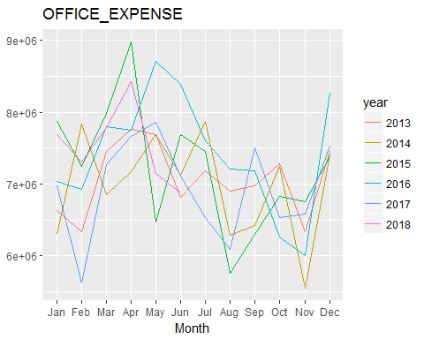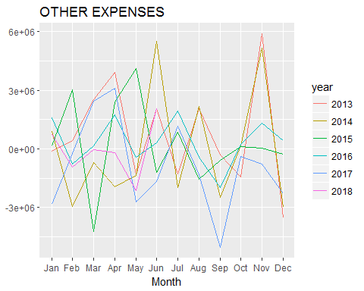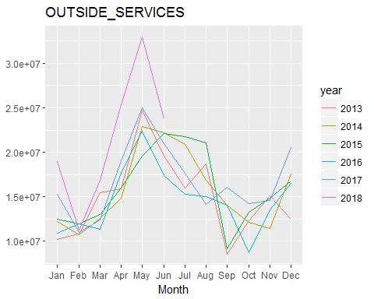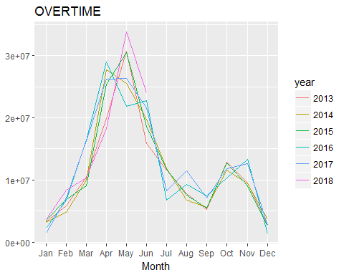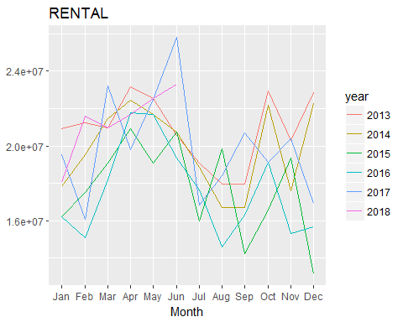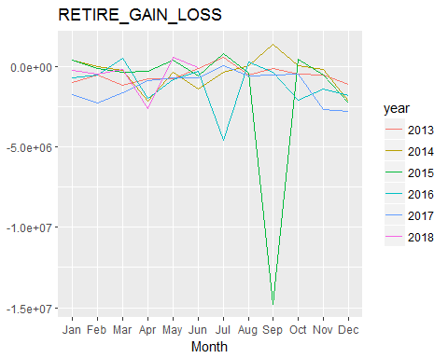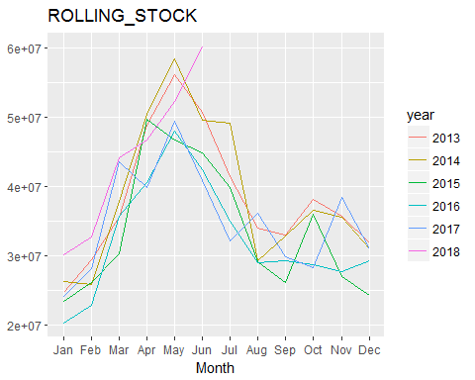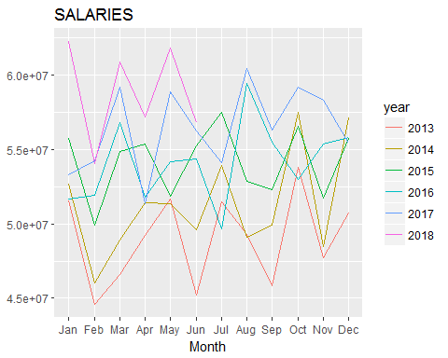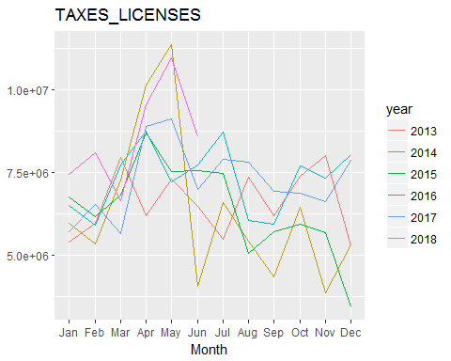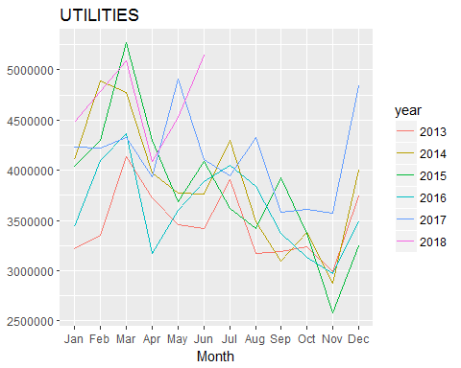

## US.Total EDA Subseries plots

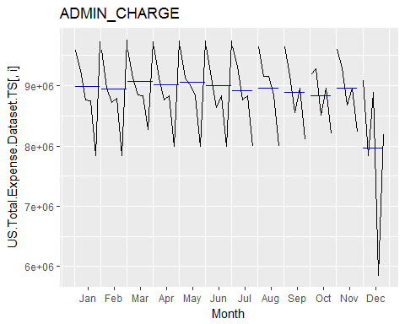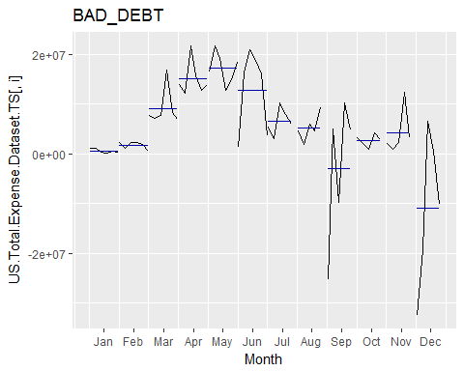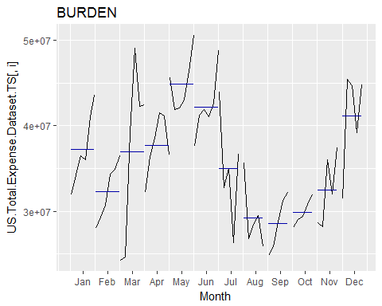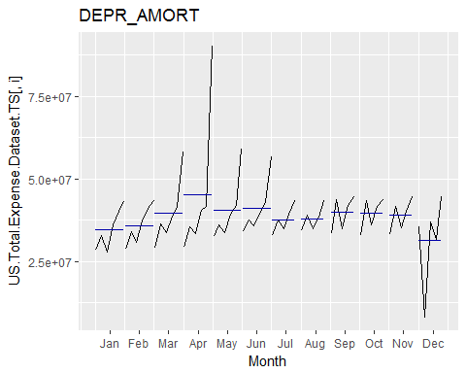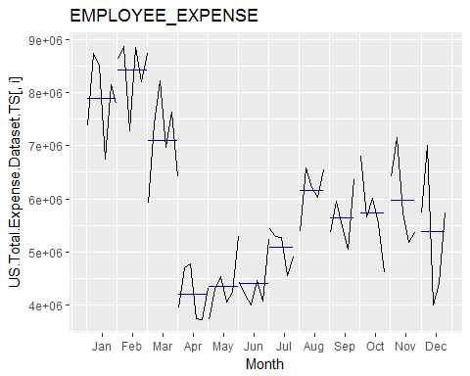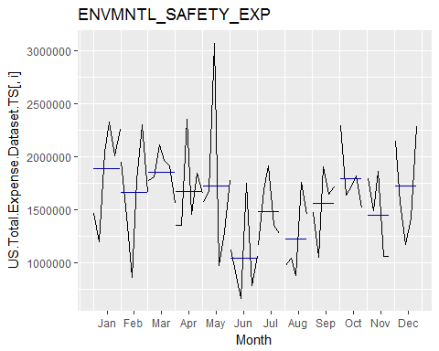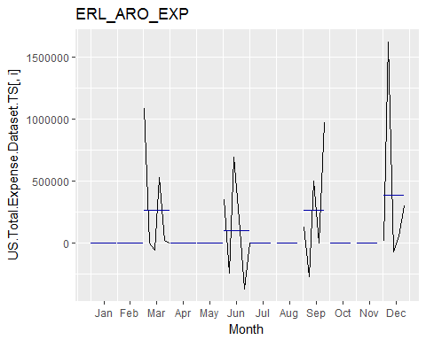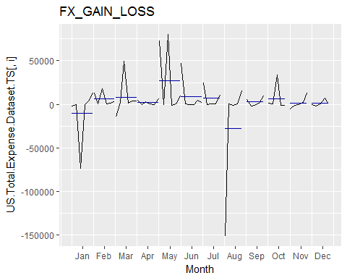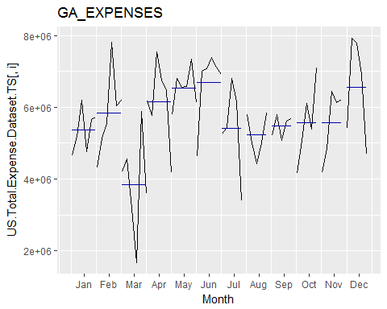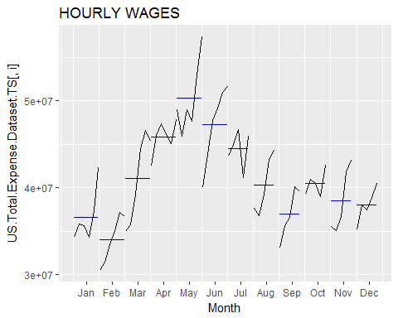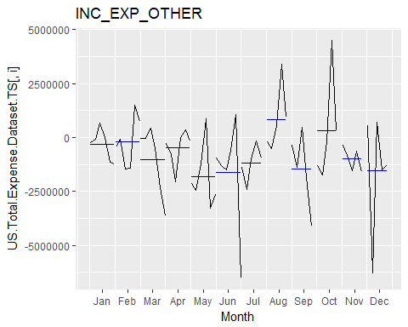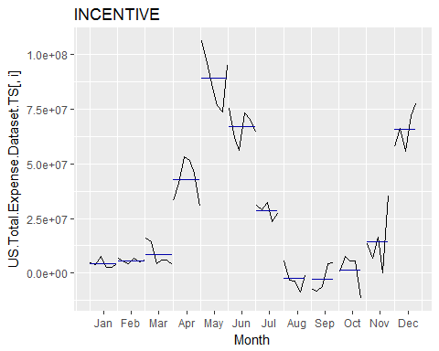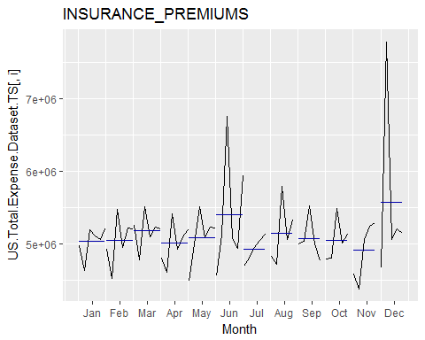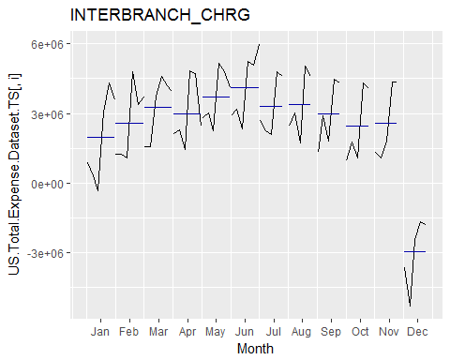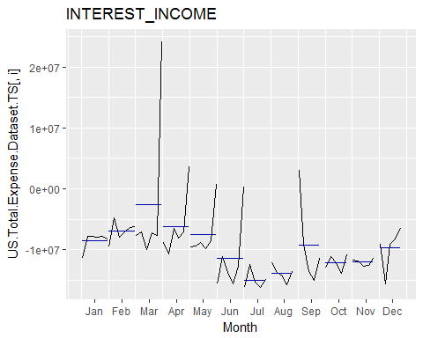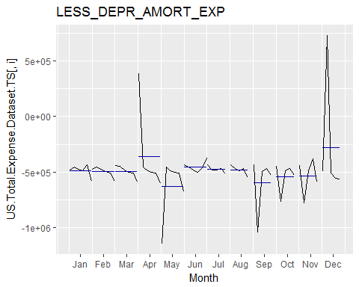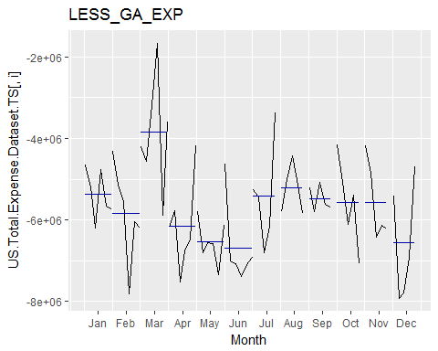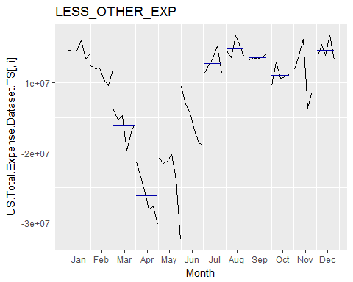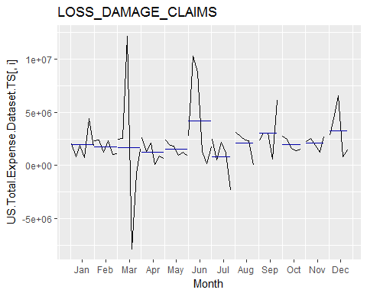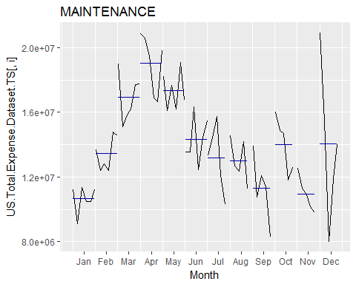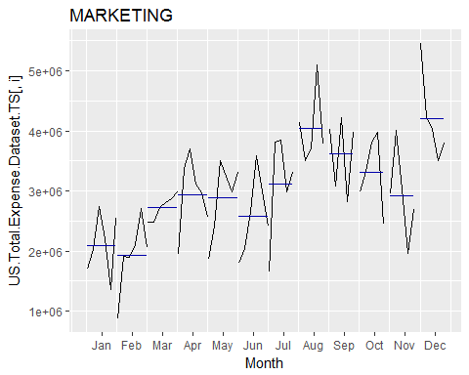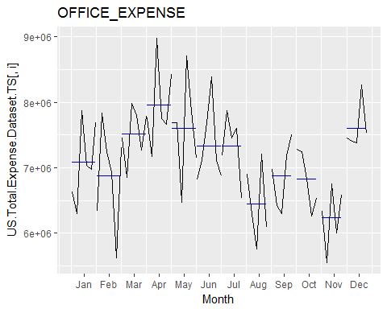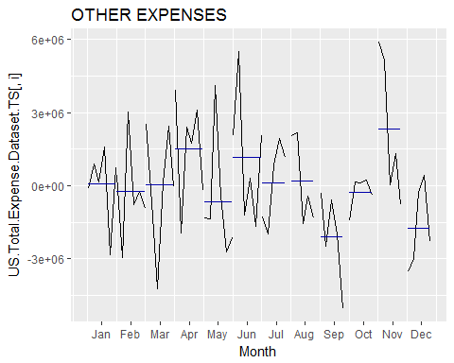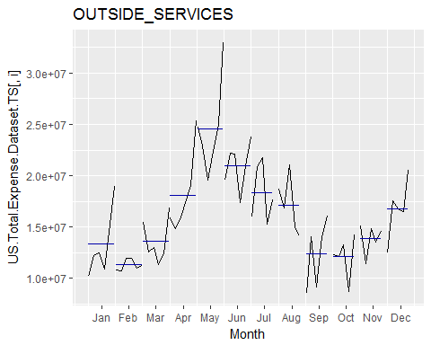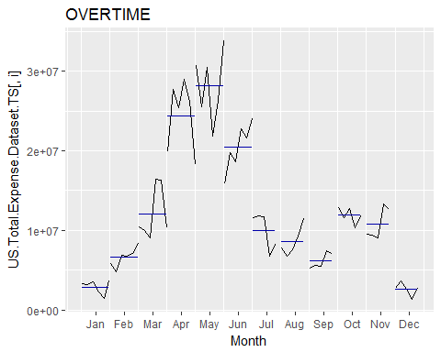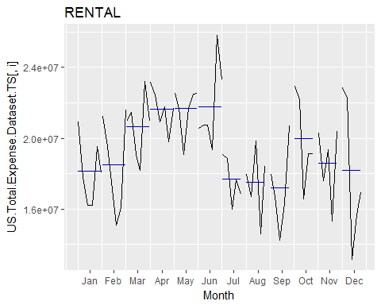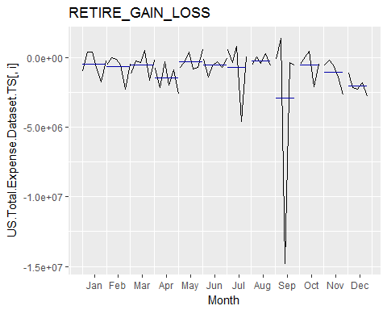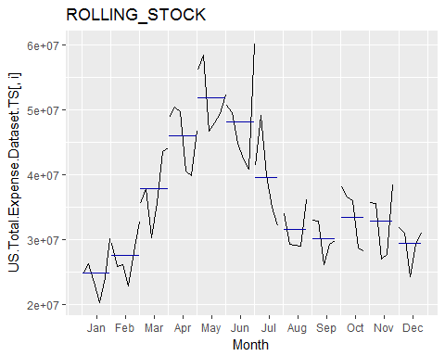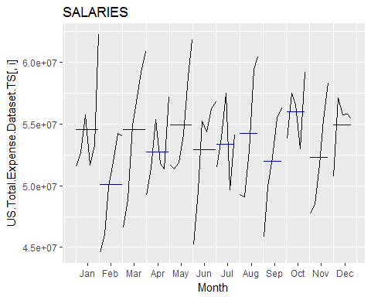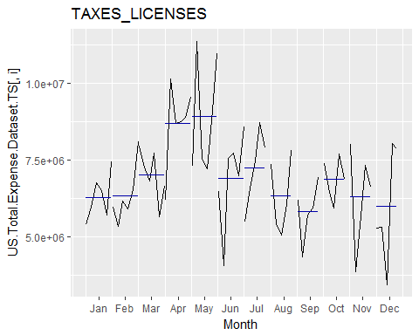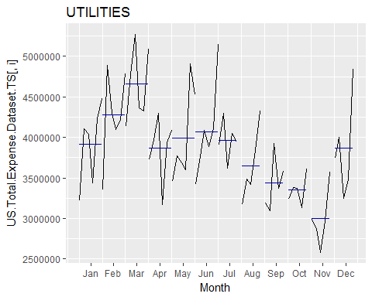

## US.Total EDA Boxplots

# decompose data (season/trend/cycle)

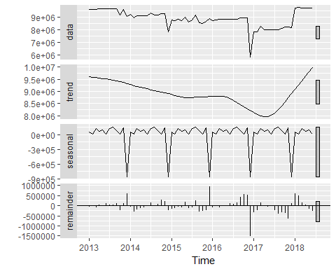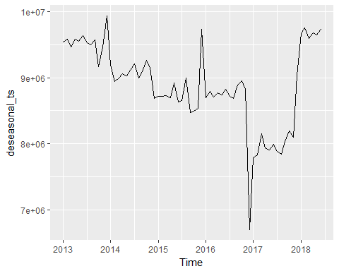

# Stationize the data

## # A tibble: 1 x 5  
## statistic p.value parameter method alternative  
## <dbl> <dbl> <dbl> <fct> <fct>   
## 1 -1.18 0.902 4.00 Augmented Dickey-Fuller Test stationary

## Warning in tseries::adf.test(diff(US.Total.Expense.Dataset.TS[, 1])): p-  
## value smaller than printed p-value

## # A tibble: 1 x 5  
## statistic p.value parameter method alternative  
## <dbl> <dbl> <dbl> <fct> <fct>   
## 1 -5.16 0.0100 3.00 Augmented Dickey-Fuller Test stationary

# lag order

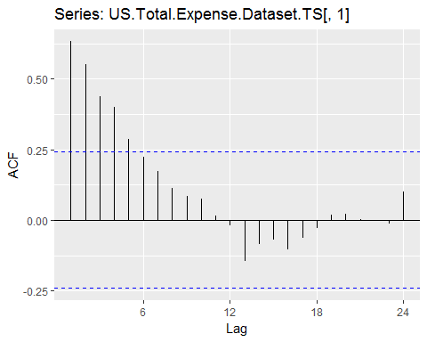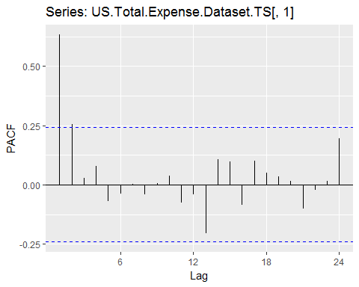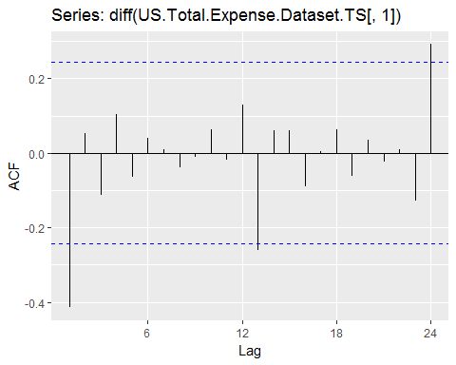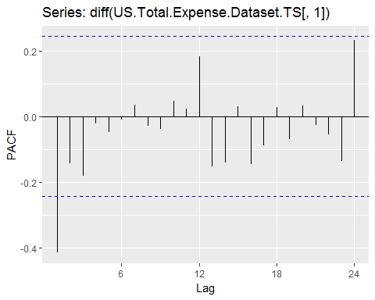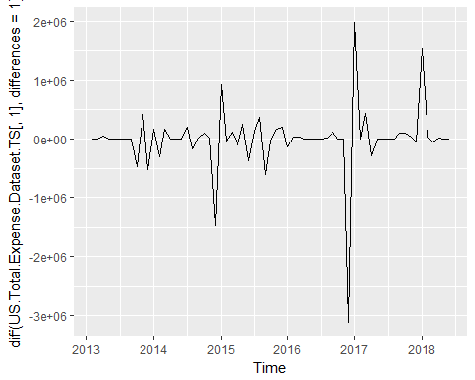

## Warning in tseries::adf.test(diff.data, alternative = "stationary"): p-  
## value smaller than printed p-value

##   
## Augmented Dickey-Fuller Test  
##   
## data: diff.data  
## Dickey-Fuller = -5.156, Lag order = 3, p-value = 0.01  
## alternative hypothesis: stationary

# fit arima model

## # A tibble: 1 x 2  
## term estimate  
## <chr> <dbl>  
## 1 ma1 -0.509

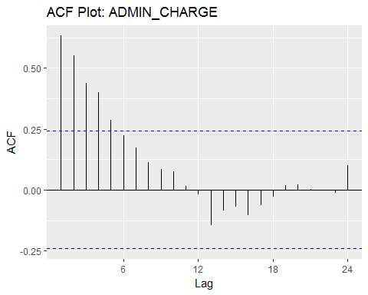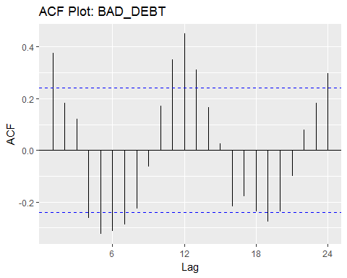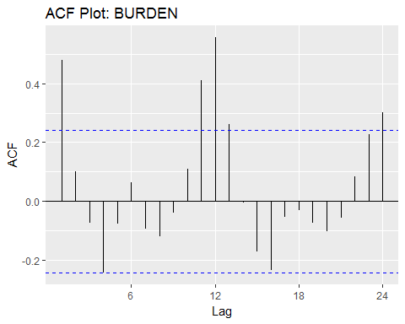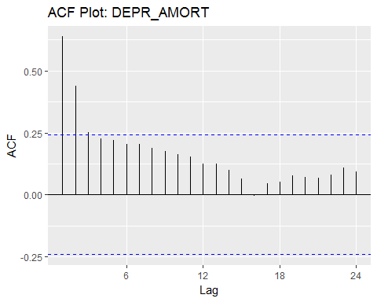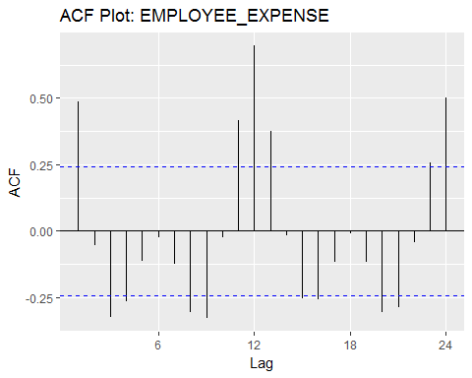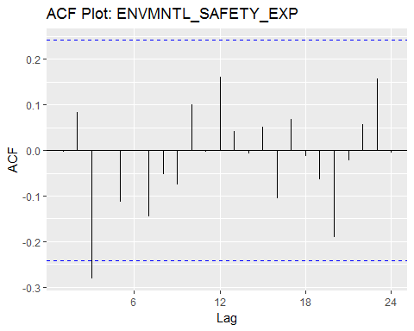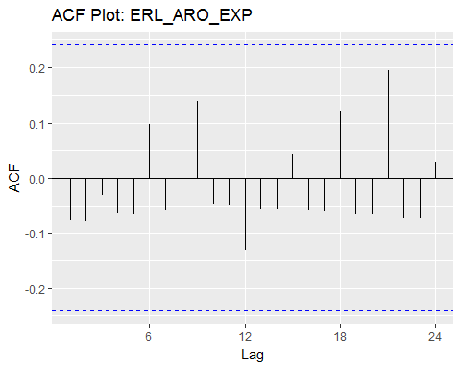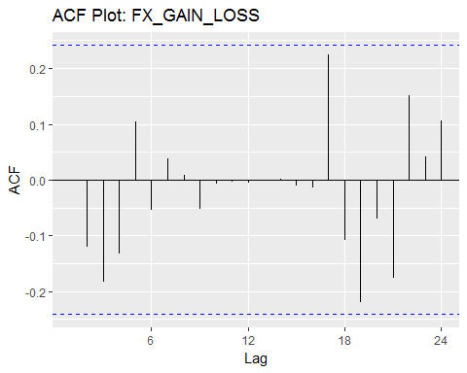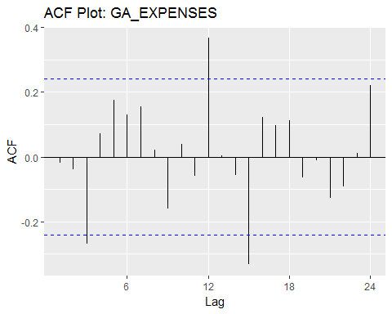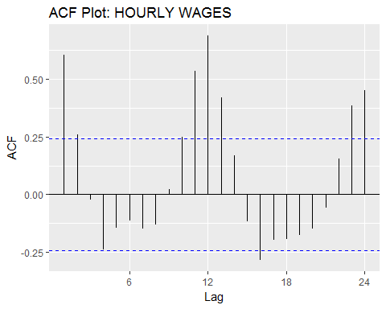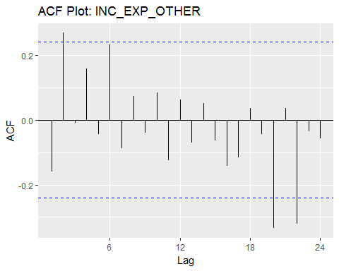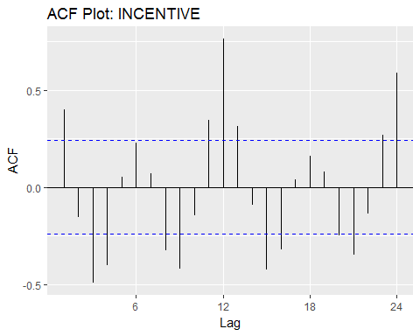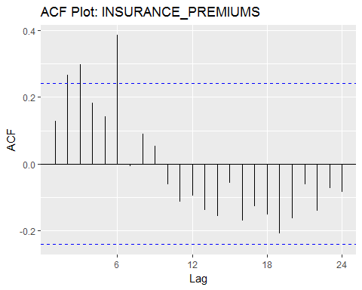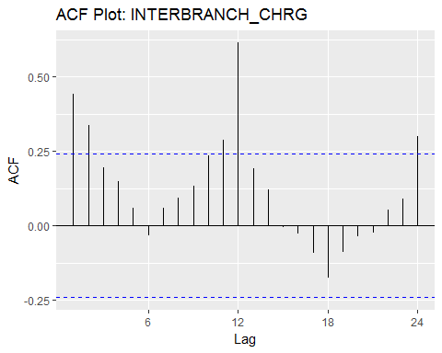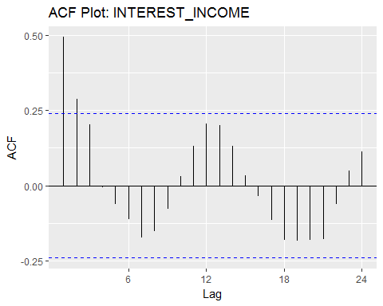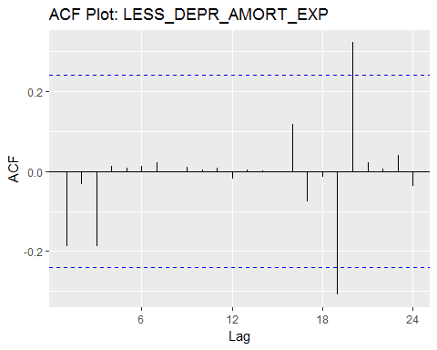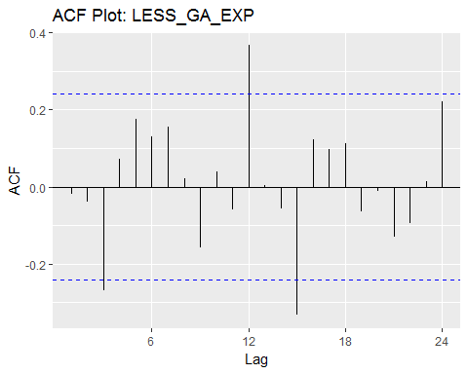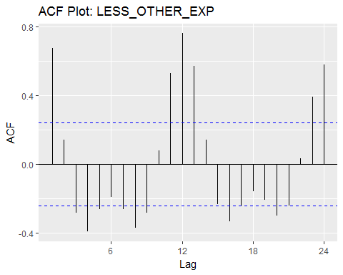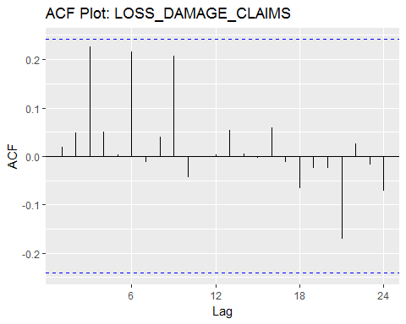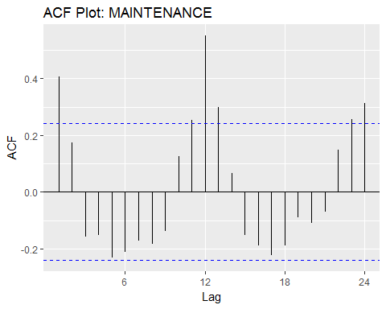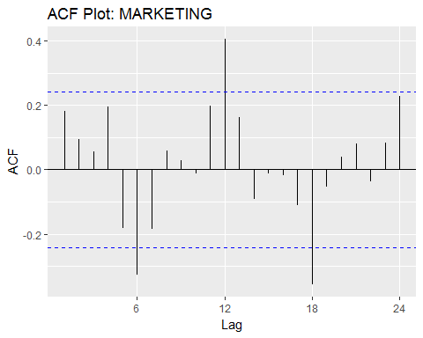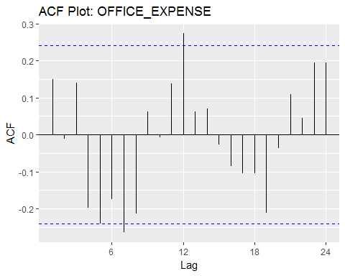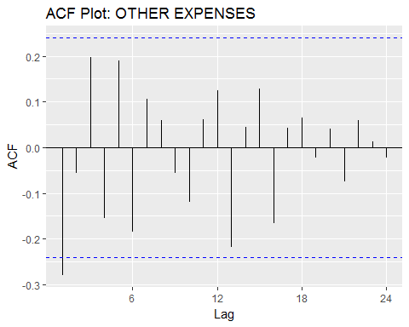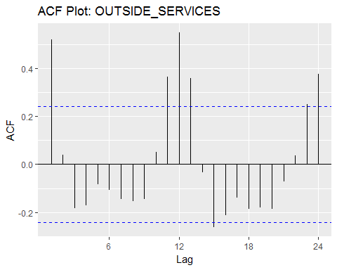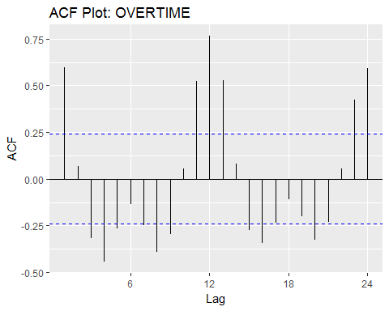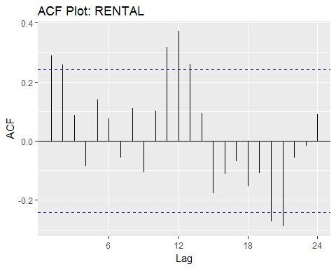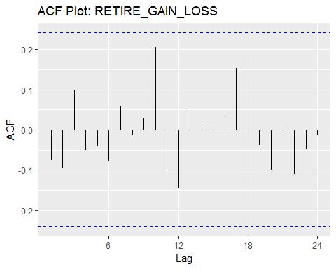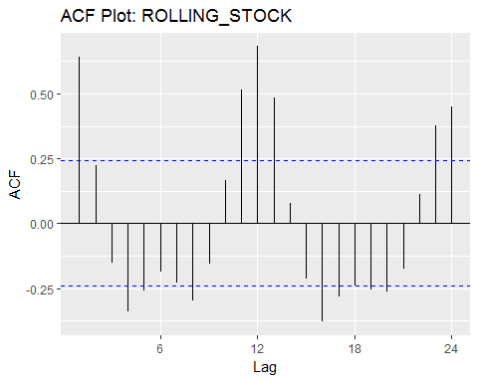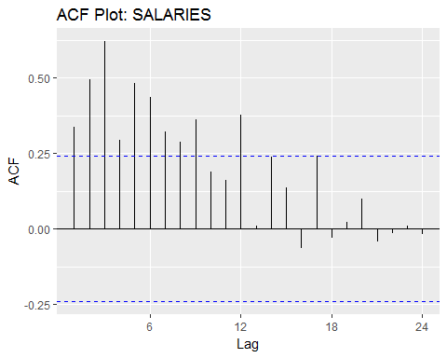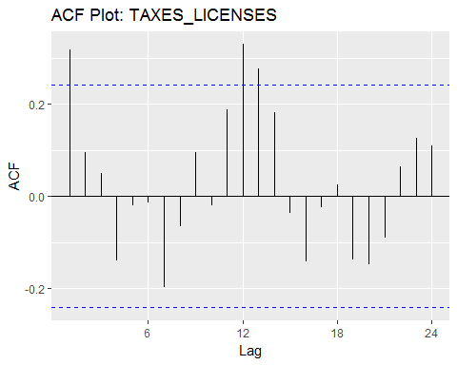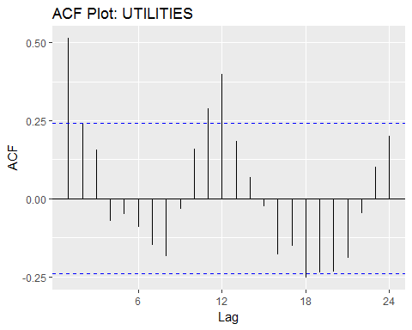

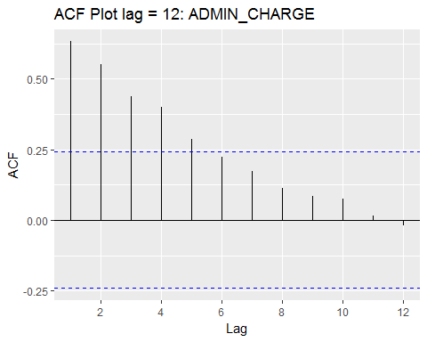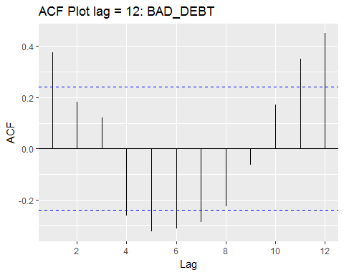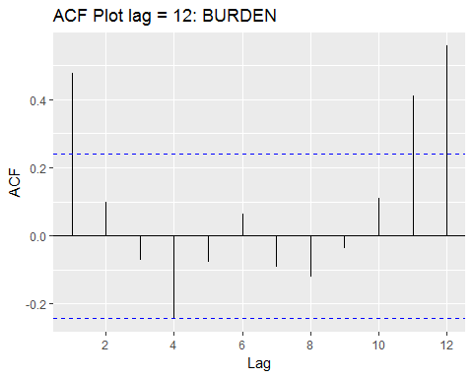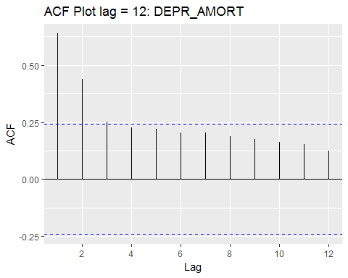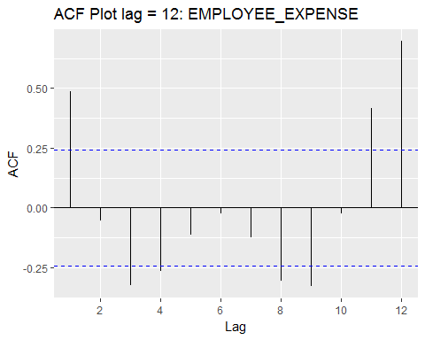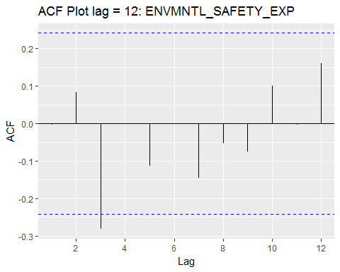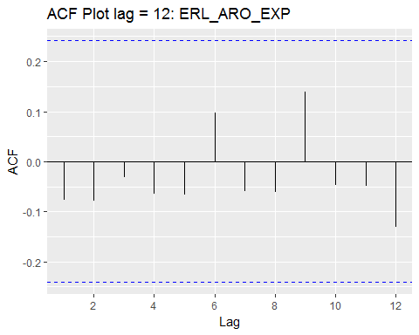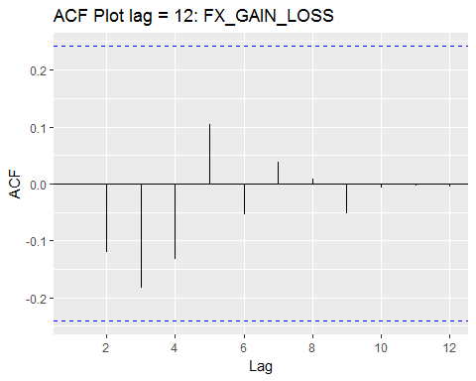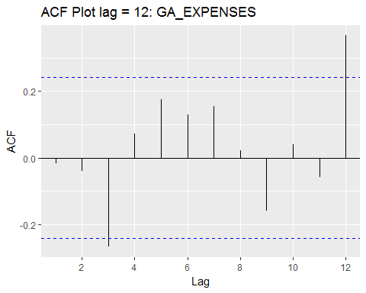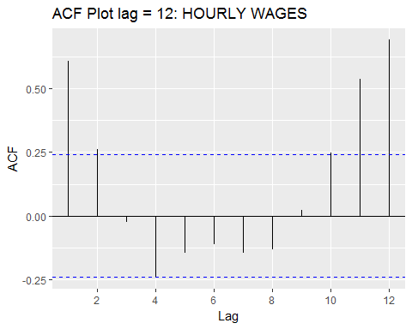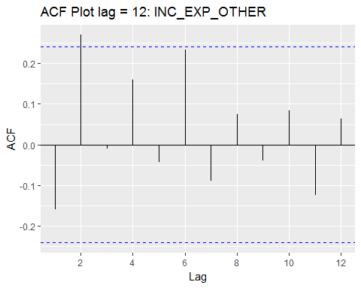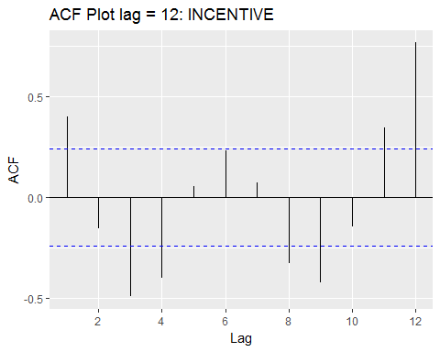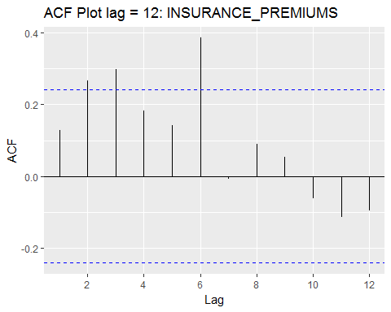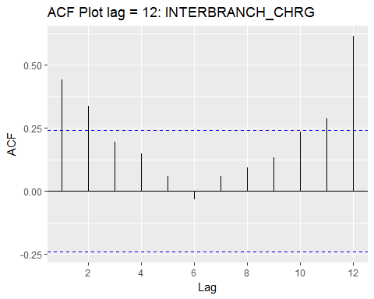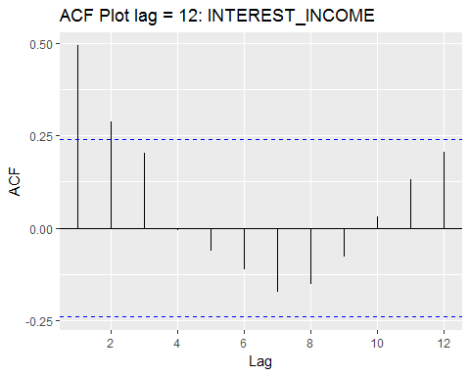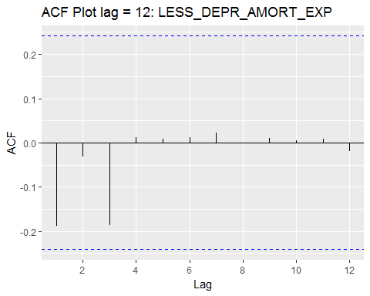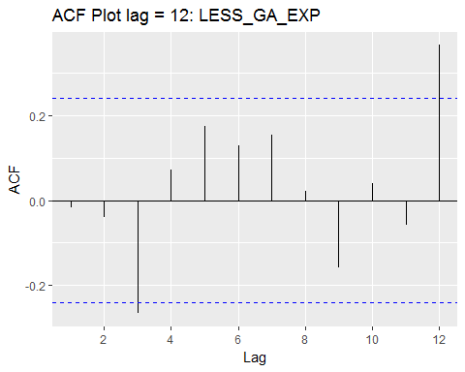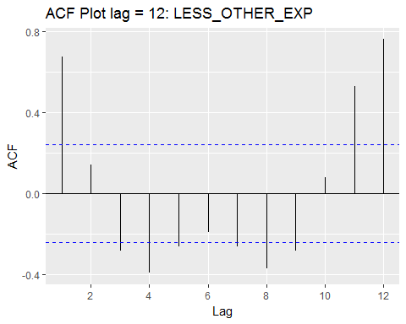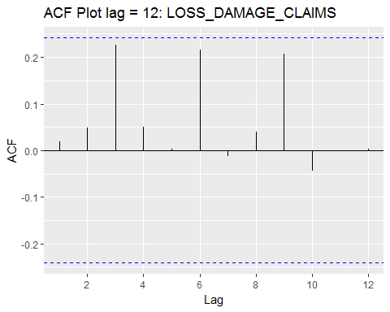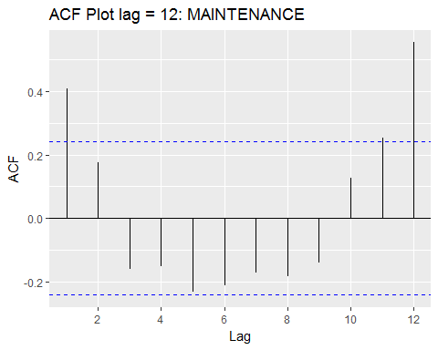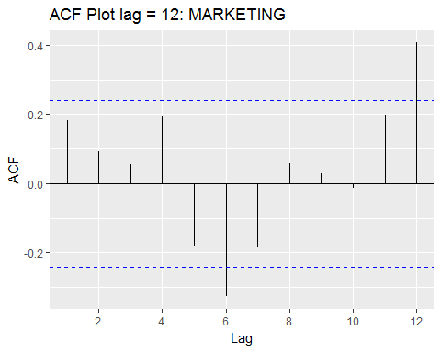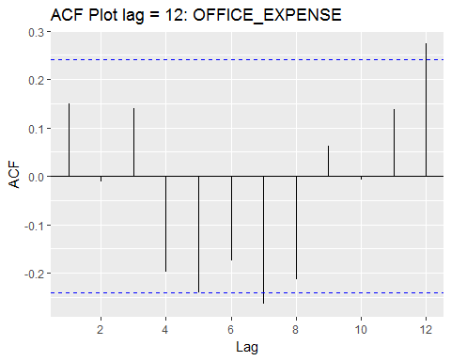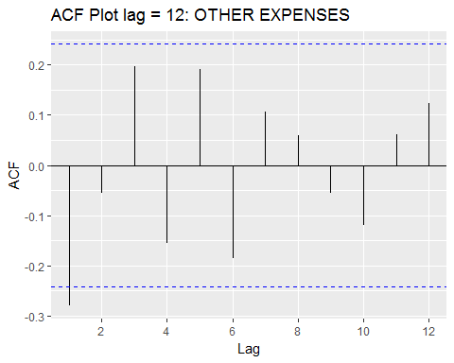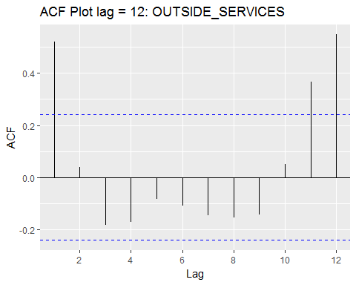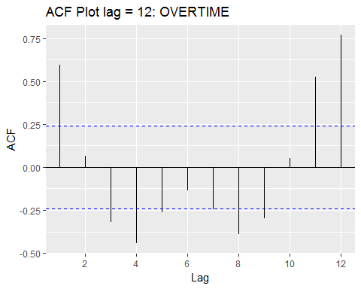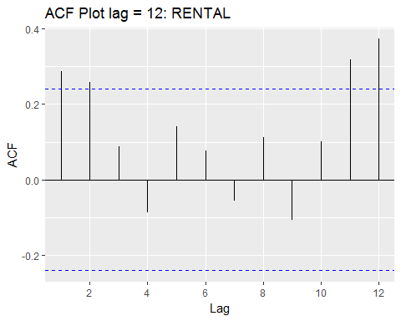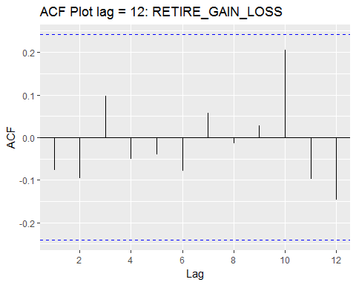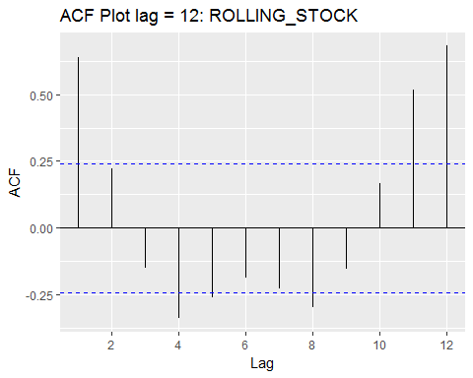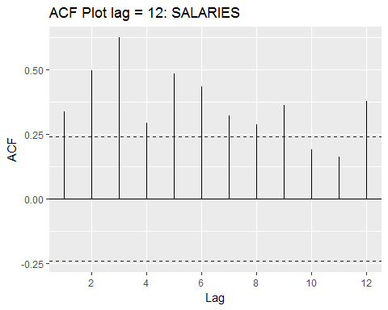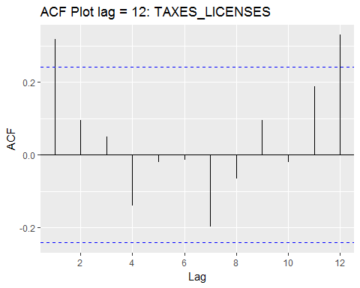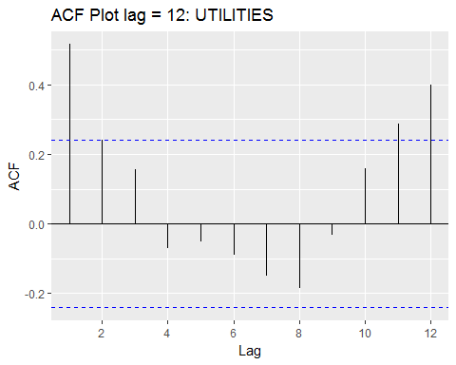

## Forecast Options

## ETS outliers untreated

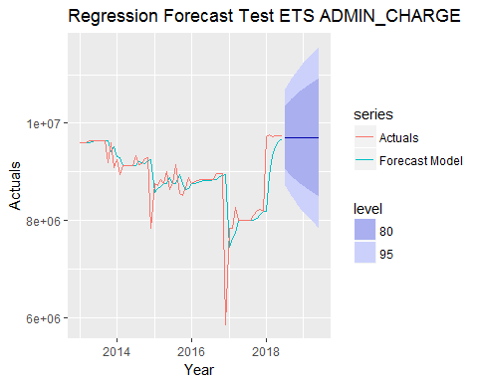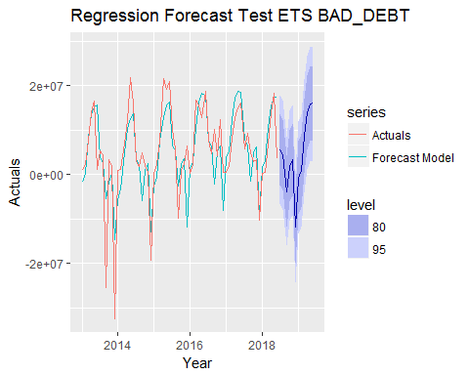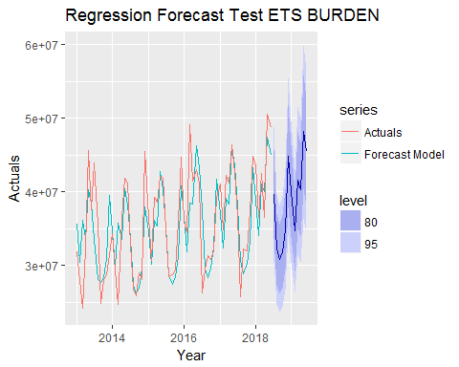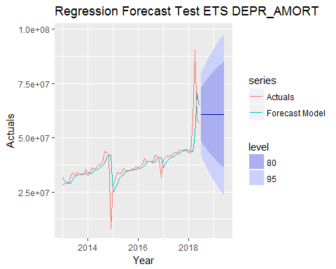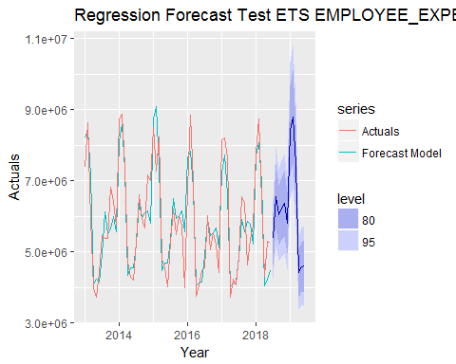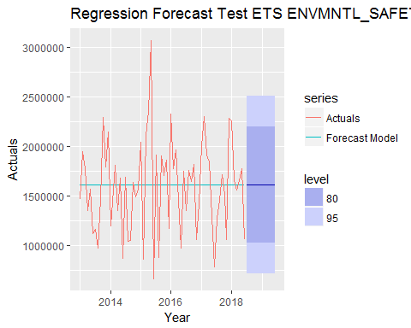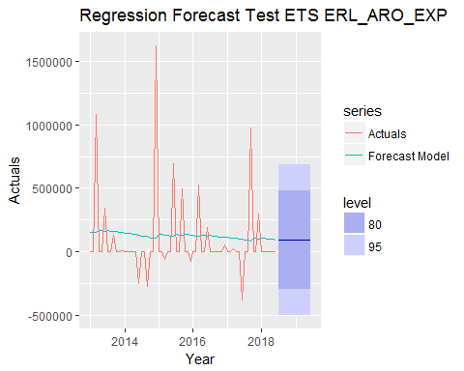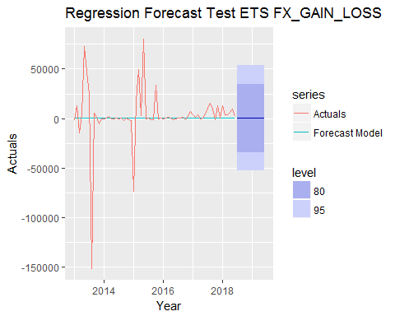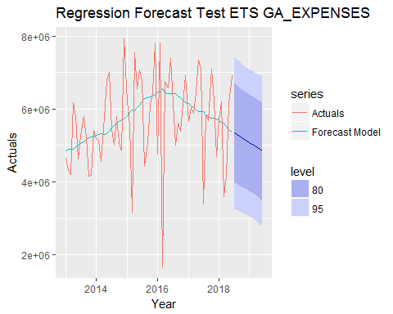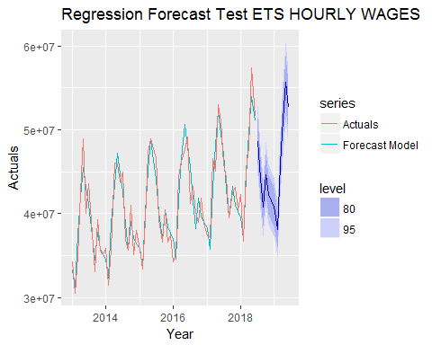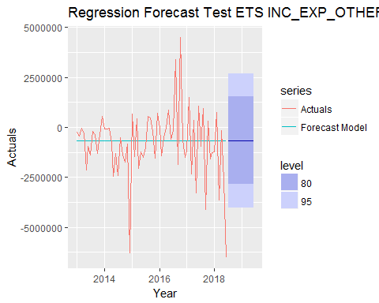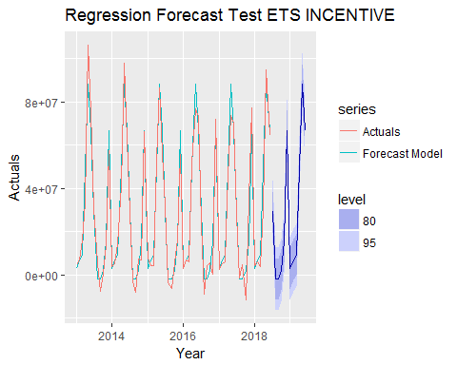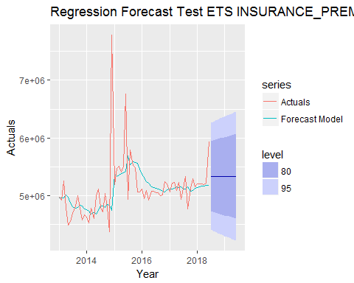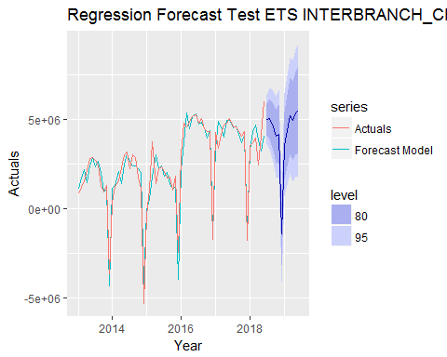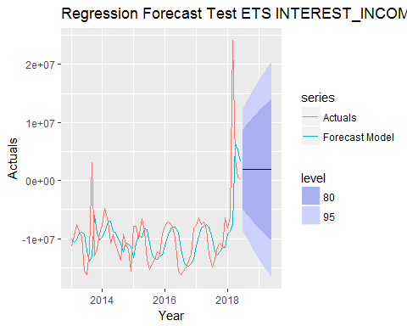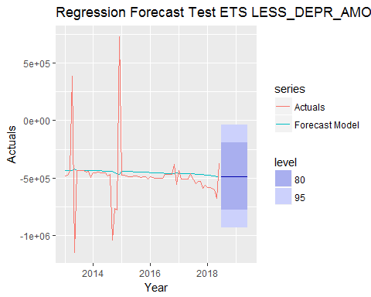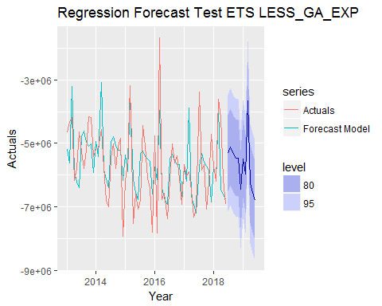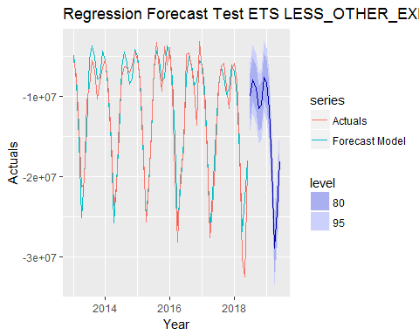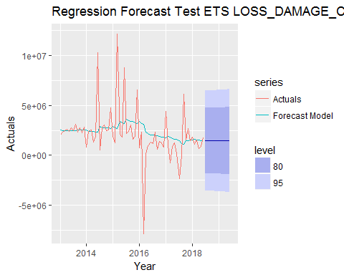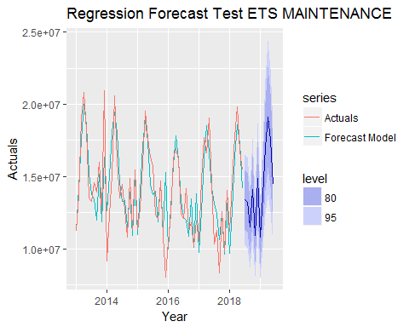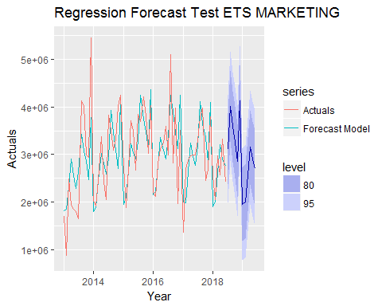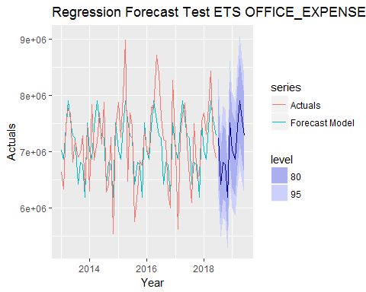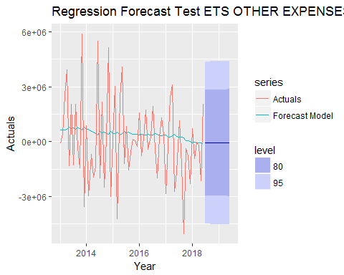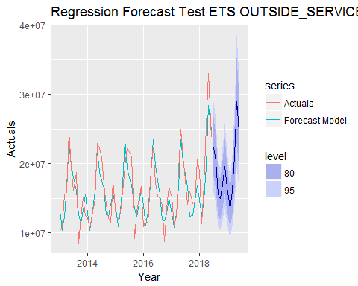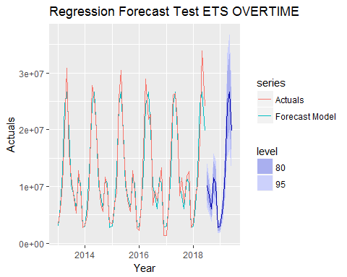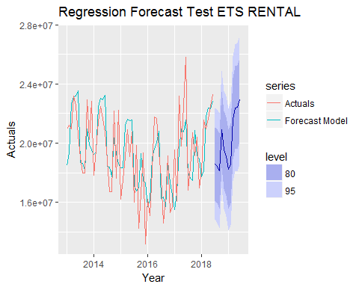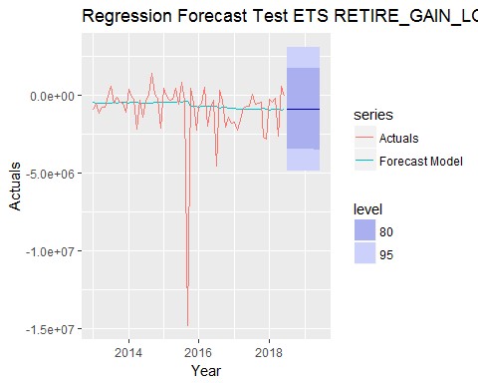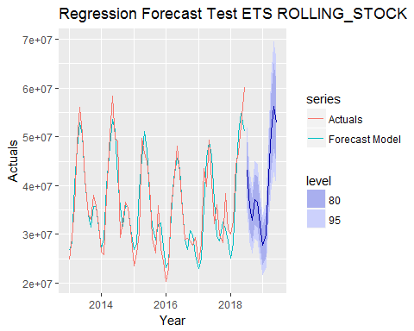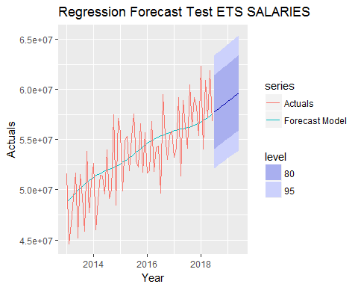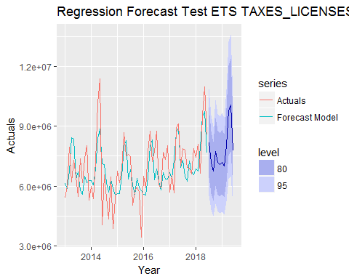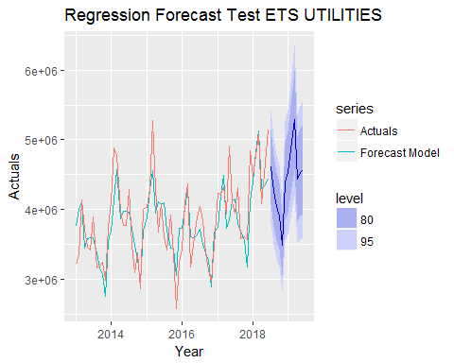

## ETS outliers treated

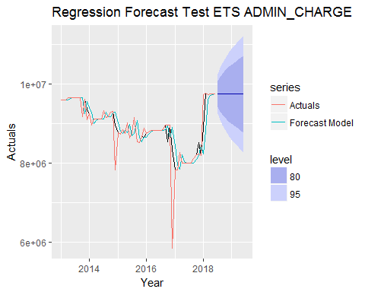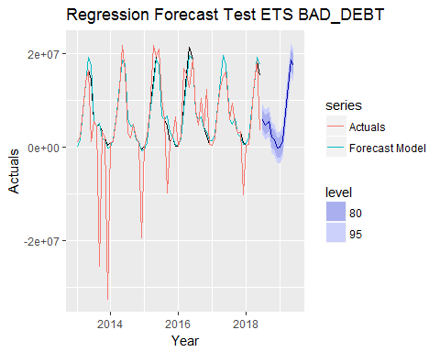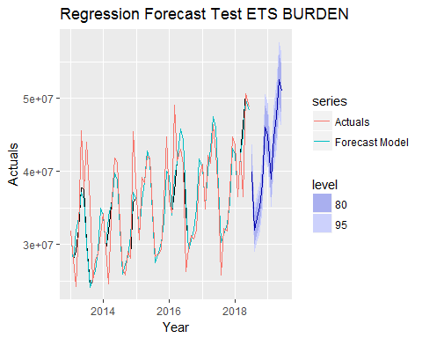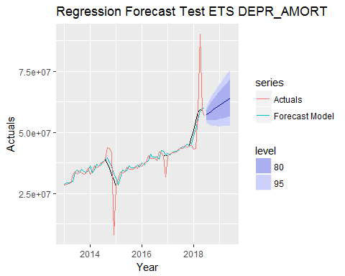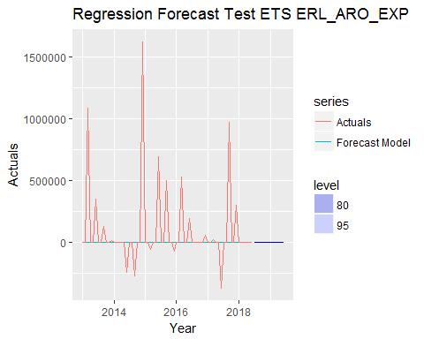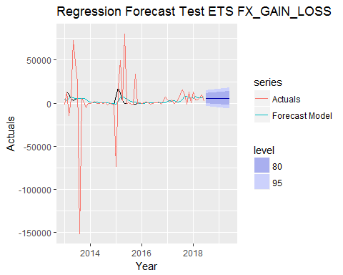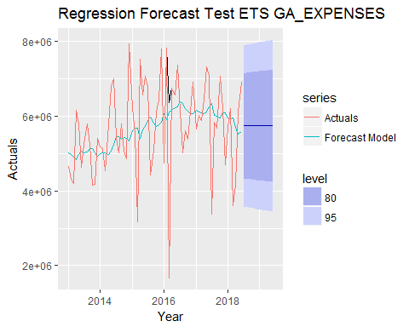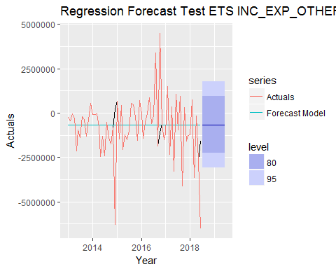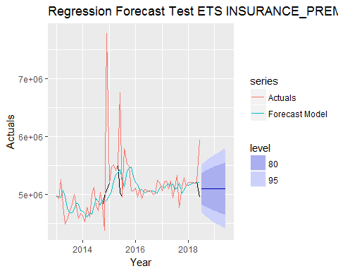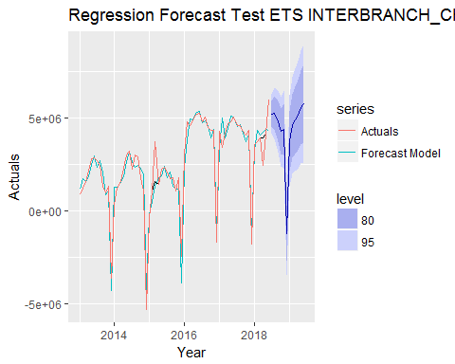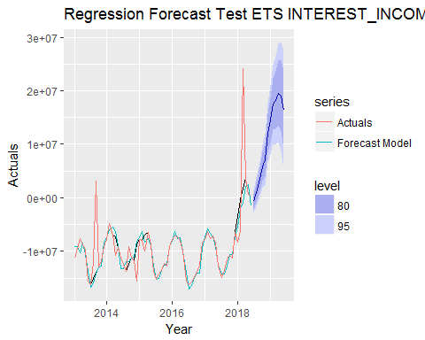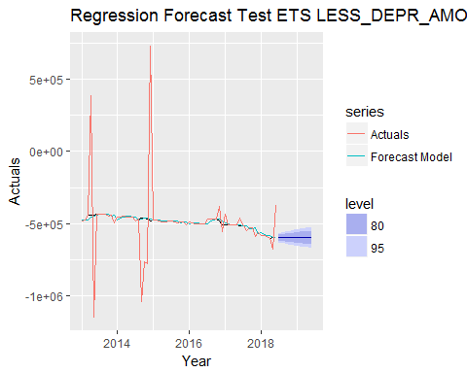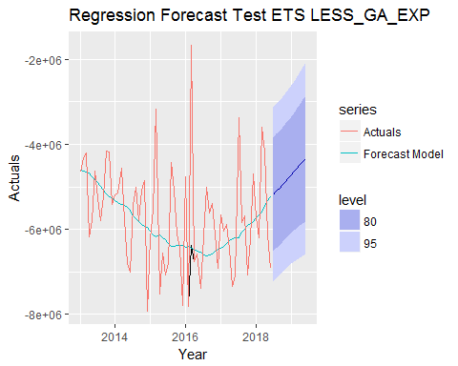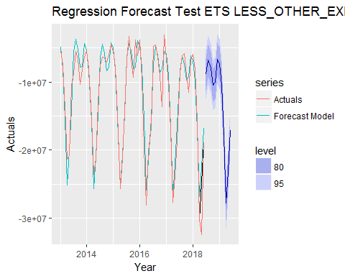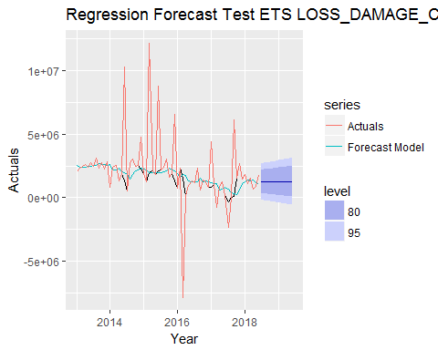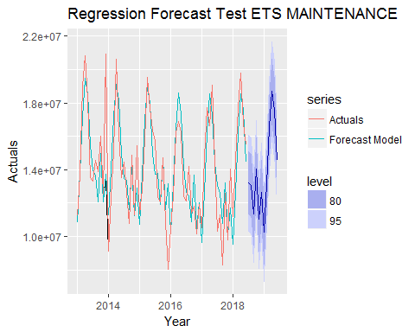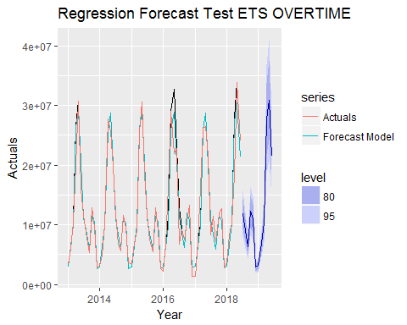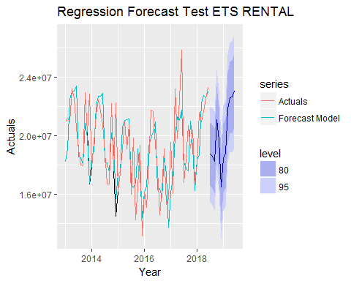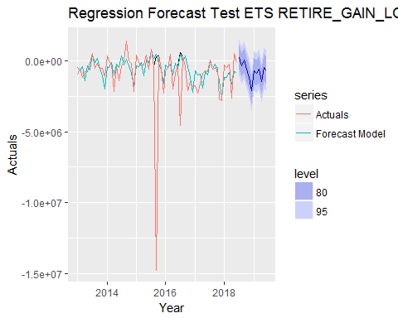

## ARIMA outliers untreated

