v3.OPEX_Forecast.Rolling.Stock.Focus

Jason Marshall

September 5, 2018

## [1] "Date"   
## [2] "Region"   
## [3] "X538000...Fuel.Petrol"   
## [4] "X538004...R.M.Delivery.Plant.Vehicles"  
## [5] "X538006...R.M.Field.Equipment"   
## [6] "X538007...R.M.Passenger.Vehicles"

## Date Region X538000...Fuel.Petrol  
## Min. :2013-01-31 Central Cornbelt:67 Min. : 137594   
## 1st Qu.:2014-05-31 Eastern :67 1st Qu.:1002551   
## Median :2015-10-31 Eastern Cornbelt:67 Median :1578450   
## Mean :2015-10-30 South :67 Mean :1693307   
## 3rd Qu.:2017-03-31 West :67 3rd Qu.:2270387   
## Max. :2018-07-31 Western Cornbelt:67 Max. :4237137   
## X538004...R.M.Delivery.Plant.Vehicles X538006...R.M.Field.Equipment  
## Min. : 439858 Min. : 81108   
## 1st Qu.:1072763 1st Qu.: 485653   
## Median :1335891 Median : 846977   
## Mean :1391412 Mean : 889379   
## 3rd Qu.:1679915 3rd Qu.:1179983   
## Max. :2764006 Max. :2805083   
## X538007...R.M.Passenger.Vehicles Rolling.Stock   
## Min. :-14178 Min. :1492340   
## 1st Qu.: 19784 1st Qu.:2922579   
## Median : 43258 Median :3899425   
## Mean : 45608 Mean :4019707   
## 3rd Qu.: 65351 3rd Qu.:4946985   
## Max. :181906 Max. :8451374

## [1] FALSE

## Parsed with column specification:  
## cols(  
## `Invoice Date` = col_character(),  
## Region = col_character(),  
## `Region Number` = col_integer(),  
## Division = col_character(),  
## `Divsion Number` = col_integer(),  
## `GL Shelf` = col_character(),  
## `Net Sales` = col_number(),  
## `Total Margin` = col_number()  
## )

#set region to uppper case  
expense.dataset.wide$Region <- toupper(expense.dataset.wide$Region)  
  
#replace space in REGION with .  
expense.dataset.wide$Region <- gsub(" ", ".", expense.dataset.wide$Region)  
US.Sales.Data.Wide$Region <- gsub(" ", ".", US.Sales.Data.Wide$Region)  
  
#create Keys expense data  
expense.dataset.wide$key <- paste(expense.dataset.wide$Date, expense.dataset.wide$Region)  
expense.dataset.wide$key <- gsub(" ", ".", expense.dataset.wide$key)  
  
#create keys sales data  
US.Sales.Data.Wide$key <- paste(US.Sales.Data.Wide$Invoice.Date, US.Sales.Data.Wide$Region)  
#fill space between date and region with "."  
US.Sales.Data.Wide$key <- gsub(" ", ".", US.Sales.Data.Wide$key)  
#join data sets  
US.Sales.RollStock.Data <- dplyr::inner_join(x = expense.dataset.wide, y = US.Sales.Data.Wide,  
 by = "key")  
  
#set Region to factor  
US.Sales.RollStock.Data$Region.x <- as.factor(US.Sales.RollStock.Data$Region.x)  
  
summary(US.Sales.RollStock.Data)

## Date Region.x X538000...Fuel.Petrol  
## Min. :2014-01-31 CENTRAL.CORNBELT:54 Min. : 137594   
## 1st Qu.:2015-02-28 EASTERN :54 1st Qu.: 946282   
## Median :2016-04-15 EASTERN.CORNBELT:54 Median :1492450   
## Mean :2016-04-15 SOUTH :54 Mean :1608838   
## 3rd Qu.:2017-05-31 WEST :54 3rd Qu.:2121330   
## Max. :2018-06-30 WESTERN.CORNBELT:54 Max. :4237137   
## X538004...R.M.Delivery.Plant.Vehicles X538006...R.M.Field.Equipment  
## Min. : 439858 Min. : 132090   
## 1st Qu.:1051515 1st Qu.: 487911   
## Median :1347619 Median : 853606   
## Mean :1409563 Mean : 907026   
## 3rd Qu.:1716944 3rd Qu.:1195256   
## Max. :2764006 Max. :2805083   
## X538007...R.M.Passenger.Vehicles Rolling.Stock key   
## Min. :-14178 Min. :1492340 Length:324   
## 1st Qu.: 16662 1st Qu.:2864701 Class :character   
## Median : 40610 Median :3783540 Mode :character   
## Mean : 42091 Mean :3967517   
## 3rd Qu.: 60631 3rd Qu.:4866634   
## Max. :181906 Max. :8451374   
## Invoice.Date Region.y APPL   
## Length:324 Length:324 Min. : 261170   
## Class :character Class :character 1st Qu.: 1492920   
## Mode :character Mode :character Median : 3224912   
## Mean : 3757463   
## 3rd Qu.: 4705117   
## Max. :15784771   
## CHEM FERT OTHE   
## Min. : 1913198 Min. : 2877643 Min. :-543098   
## 1st Qu.: 16705086 1st Qu.: 12331962 1st Qu.: 812475   
## Median : 44663436 Median : 32707308 Median :1566850   
## Mean : 50114334 Mean : 43409072 Mean :1816071   
## 3rd Qu.: 74594908 3rd Qu.: 64866433 3rd Qu.:2727368   
## Max. :163664925 Max. :204482155 Max. :5979289   
## SEED Total.Sales   
## Min. : -5870981 Min. : 10845105   
## 1st Qu.: 1860570 1st Qu.: 40015034   
## Median : 5559909 Median : 92050552   
## Mean : 18907513 Mean :118004453   
## 3rd Qu.: 25621489 3rd Qu.:183457826   
## Max. :176171655 Max. :416789698

colnames(US.Sales.RollStock.Data)

## [1] "Date"   
## [2] "Region.x"   
## [3] "X538000...Fuel.Petrol"   
## [4] "X538004...R.M.Delivery.Plant.Vehicles"  
## [5] "X538006...R.M.Field.Equipment"   
## [6] "X538007...R.M.Passenger.Vehicles"   
## [7] "Rolling.Stock"   
## [8] "key"   
## [9] "Invoice.Date"   
## [10] "Region.y"   
## [11] "APPL"   
## [12] "CHEM"   
## [13] "FERT"   
## [14] "OTHE"   
## [15] "SEED"   
## [16] "Total.Sales"

## Create Nested Datasets

## # A tibble: 6 x 2  
## Region.x data.tbl   
## <fct> <list>   
## 1 CENTRAL.CORNBELT <tibble [54 x 15]>  
## 2 EASTERN <tibble [54 x 15]>  
## 3 EASTERN.CORNBELT <tibble [54 x 15]>  
## 4 SOUTH <tibble [54 x 15]>  
## 5 WEST <tibble [54 x 15]>  
## 6 WESTERN.CORNBELT <tibble [54 x 15]>

## [[1]]  
## # A tibble: 54 x 15  
## Date X538000...Fuel.Pe~ X538004...R.M.Delive~ X538006...R.M.Fiel~  
## <date> <dbl> <dbl> <dbl>  
## 1 2014-01-31 963133 1190587 476554  
## 2 2014-02-28 821119 1243586 947348  
## 3 2014-03-31 1830581 1527040 655394  
## 4 2014-04-30 2966217 1549945 1317038  
## 5 2014-05-31 4084873 1837431 1263922  
## 6 2014-06-30 3073649 1126727 1052564  
## 7 2014-07-31 3048688 1108259 1387388  
## 8 2014-08-31 1359933 900842 378426  
## 9 2014-09-30 1576664 1342239 909274  
## 10 2014-10-31 1856649 1350924 1361978  
## # ... with 44 more rows, and 11 more variables:  
## # X538007...R.M.Passenger.Vehicles <dbl>, Rolling.Stock <dbl>,  
## # key <chr>, Invoice.Date <chr>, Region.y <chr>, APPL <dbl>, CHEM <dbl>,  
## # FERT <dbl>, OTHE <dbl>, SEED <dbl>, Total.Sales <dbl>

## # A tibble: 6 x 2  
## Region.x data.tbl   
## <fct> <list>   
## 1 CENTRAL.CORNBELT <tibble [54 x 2]>  
## 2 EASTERN <tibble [54 x 2]>  
## 3 EASTERN.CORNBELT <tibble [54 x 2]>  
## 4 SOUTH <tibble [54 x 2]>  
## 5 WEST <tibble [54 x 2]>  
## 6 WESTERN.CORNBELT <tibble [54 x 2]>

## [[1]]  
## # A tibble: 54 x 2  
## X538000...Fuel.Petrol Date   
## <dbl> <date>   
## 1 963133 2014-01-31  
## 2 821119 2014-02-28  
## 3 1830581 2014-03-31  
## 4 2966217 2014-04-30  
## 5 4084873 2014-05-31  
## 6 3073649 2014-06-30  
## 7 3048688 2014-07-31  
## 8 1359933 2014-08-31  
## 9 1576664 2014-09-30  
## 10 1856649 2014-10-31  
## # ... with 44 more rows

## # A tibble: 6 x 2  
## Region.x data.tbl   
## <fct> <list>   
## 1 CENTRAL.CORNBELT <tibble [54 x 2]>  
## 2 EASTERN <tibble [54 x 2]>  
## 3 EASTERN.CORNBELT <tibble [54 x 2]>  
## 4 SOUTH <tibble [54 x 2]>  
## 5 WEST <tibble [54 x 2]>  
## 6 WESTERN.CORNBELT <tibble [54 x 2]>

## [[1]]  
## # A tibble: 54 x 2  
## X538004...R.M.Delivery.Plant.Vehicles Date   
## <dbl> <date>   
## 1 1190587 2014-01-31  
## 2 1243586 2014-02-28  
## 3 1527040 2014-03-31  
## 4 1549945 2014-04-30  
## 5 1837431 2014-05-31  
## 6 1126727 2014-06-30  
## 7 1108259 2014-07-31  
## 8 900842 2014-08-31  
## 9 1342239 2014-09-30  
## 10 1350924 2014-10-31  
## # ... with 44 more rows

## # A tibble: 6 x 2  
## Region.x data.tbl   
## <fct> <list>   
## 1 CENTRAL.CORNBELT <tibble [54 x 2]>  
## 2 EASTERN <tibble [54 x 2]>  
## 3 EASTERN.CORNBELT <tibble [54 x 2]>  
## 4 SOUTH <tibble [54 x 2]>  
## 5 WEST <tibble [54 x 2]>  
## 6 WESTERN.CORNBELT <tibble [54 x 2]>

## [[1]]  
## # A tibble: 54 x 2  
## X538006...R.M.Field.Equipment Date   
## <dbl> <date>   
## 1 476554 2014-01-31  
## 2 947348 2014-02-28  
## 3 655394 2014-03-31  
## 4 1317038 2014-04-30  
## 5 1263922 2014-05-31  
## 6 1052564 2014-06-30  
## 7 1387388 2014-07-31  
## 8 378426 2014-08-31  
## 9 909274 2014-09-30  
## 10 1361978 2014-10-31  
## # ... with 44 more rows

## # A tibble: 6 x 2  
## Region.x data.tbl   
## <fct> <list>   
## 1 CENTRAL.CORNBELT <tibble [54 x 2]>  
## 2 EASTERN <tibble [54 x 2]>  
## 3 EASTERN.CORNBELT <tibble [54 x 2]>  
## 4 SOUTH <tibble [54 x 2]>  
## 5 WEST <tibble [54 x 2]>  
## 6 WESTERN.CORNBELT <tibble [54 x 2]>

## [[1]]  
## # A tibble: 54 x 2  
## X538007...R.M.Passenger.Vehicles Date   
## <dbl> <date>   
## 1 64944 2014-01-31  
## 2 41464 2014-02-28  
## 3 52804 2014-03-31  
## 4 106400 2014-04-30  
## 5 61374 2014-05-31  
## 6 103110 2014-06-30  
## 7 55534 2014-07-31  
## 8 43532 2014-08-31  
## 9 141173 2014-09-30  
## 10 60632 2014-10-31  
## # ... with 44 more rows

## # A tibble: 6 x 2  
## Region.x data.tbl   
## <fct> <list>   
## 1 CENTRAL.CORNBELT <tibble [54 x 2]>  
## 2 EASTERN <tibble [54 x 2]>  
## 3 EASTERN.CORNBELT <tibble [54 x 2]>  
## 4 SOUTH <tibble [54 x 2]>  
## 5 WEST <tibble [54 x 2]>  
## 6 WESTERN.CORNBELT <tibble [54 x 2]>

## [[1]]  
## # A tibble: 54 x 2  
## Rolling.Stock Date   
## <dbl> <date>   
## 1 2695218 2014-01-31  
## 2 3053517 2014-02-28  
## 3 4065819 2014-03-31  
## 4 5939600 2014-04-30  
## 5 7247600 2014-05-31  
## 6 5356050 2014-06-30  
## 7 5599869 2014-07-31  
## 8 2682733 2014-08-31  
## 9 3969350 2014-09-30  
## 10 4630183 2014-10-31  
## # ... with 44 more rows

## Create TS Objects

## Warning in tk_xts_.data.frame(ret, select = select, silent = silent): Non-  
## numeric columns being dropped: Date  
  
## Warning in tk_xts_.data.frame(ret, select = select, silent = silent): Non-  
## numeric columns being dropped: Date  
  
## Warning in tk_xts_.data.frame(ret, select = select, silent = silent): Non-  
## numeric columns being dropped: Date  
  
## Warning in tk_xts_.data.frame(ret, select = select, silent = silent): Non-  
## numeric columns being dropped: Date  
  
## Warning in tk_xts_.data.frame(ret, select = select, silent = silent): Non-  
## numeric columns being dropped: Date  
  
## Warning in tk_xts_.data.frame(ret, select = select, silent = silent): Non-  
## numeric columns being dropped: Date

## # A tibble: 6 x 3  
## Region.x data.tbl data.ts   
## <fct> <list> <list>   
## 1 CENTRAL.CORNBELT <tibble [54 x 15]> <S3: mts>  
## 2 EASTERN <tibble [54 x 15]> <S3: mts>  
## 3 EASTERN.CORNBELT <tibble [54 x 15]> <S3: mts>  
## 4 SOUTH <tibble [54 x 15]> <S3: mts>  
## 5 WEST <tibble [54 x 15]> <S3: mts>  
## 6 WESTERN.CORNBELT <tibble [54 x 15]> <S3: mts>

## [[1]]  
## X538000...Fuel.Petrol X538004...R.M.Delivery.Plant.Vehicles  
## Jan 2014 963133 1190587  
## Feb 2014 821119 1243586  
## Mar 2014 1830581 1527040  
## Apr 2014 2966217 1549945  
## May 2014 4084873 1837431  
## Jun 2014 3073649 1126727  
## Jul 2014 3048688 1108259  
## Aug 2014 1359933 900842  
## Sep 2014 1576664 1342239  
## Oct 2014 1856649 1350924  
## Nov 2014 2693075 1167164  
## Dec 2014 1957203 1295850  
## Jan 2015 833248 887534  
## Feb 2015 877618 1213361  
## Mar 2015 808040 1444542  
## Apr 2015 2398777 1844400  
## May 2015 2994689 1631492  
## Jun 2015 2232625 1380945  
## Jul 2015 2158878 1471078  
## Aug 2015 1174408 1240015  
## Sep 2015 804677 1355173  
## Oct 2015 1593981 1658464  
## Nov 2015 1574643 1252342  
## Dec 2015 950062 1200289  
## Jan 2016 611064 964264  
## Feb 2016 253493 1492107  
## Mar 2016 1132309 1783793  
## Apr 2016 1625091 2026265  
## May 2016 2236212 1684020  
## Jun 2016 2086915 1515990  
## Jul 2016 1631023 1150006  
## Aug 2016 788380 1314865  
## Sep 2016 1001382 1366047  
## Oct 2016 1089383 1286730  
## Nov 2016 1411802 1173919  
## Dec 2016 1437602 1173095  
## Jan 2017 654189 1262664  
## Feb 2017 564073 1737907  
## Mar 2017 1364630 2098016  
## Apr 2017 1686814 1357297  
## May 2017 2095930 1895039  
## Jun 2017 2020880 891053  
## Jul 2017 1784133 860027  
## Aug 2017 1372306 677653  
## Sep 2017 940486 791841  
## Oct 2017 1341256 980378  
## Nov 2017 2453568 919318  
## Dec 2017 2063383 1038927  
## Jan 2018 966503 843734  
## Feb 2018 814348 1076669  
## Mar 2018 1594110 1506324  
## Apr 2018 2105127 1421889  
## May 2018 3056718 1173170  
## Jun 2018 3705276 1409043  
## X538006...R.M.Field.Equipment X538007...R.M.Passenger.Vehicles  
## Jan 2014 476554 64944  
## Feb 2014 947348 41464  
## Mar 2014 655394 52804  
## Apr 2014 1317038 106400  
## May 2014 1263922 61374  
## Jun 2014 1052564 103110  
## Jul 2014 1387388 55534  
## Aug 2014 378426 43532  
## Sep 2014 909274 141173  
## Oct 2014 1361978 60632  
## Nov 2014 1584922 -14178  
## Dec 2014 1235860 91144  
## Jan 2015 293544 66188  
## Feb 2015 629678 48994  
## Mar 2015 1133860 58741  
## Apr 2015 1182319 75076  
## May 2015 1505441 85656  
## Jun 2015 900502 50566  
## Jul 2015 676542 50658  
## Aug 2015 756738 33506  
## Sep 2015 1005879 50774  
## Oct 2015 1215934 68379  
## Nov 2015 1050690 39302  
## Dec 2015 693086 36796  
## Jan 2016 571502 44572  
## Feb 2016 797230 23764  
## Mar 2016 1056810 44976  
## Apr 2016 1041542 36280  
## May 2016 1148454 42258  
## Jun 2016 742344 47158  
## Jul 2016 702412 26362  
## Aug 2016 714146 47908  
## Sep 2016 1116848 34865  
## Oct 2016 1009546 30436  
## Nov 2016 1011136 30006  
## Dec 2016 696062 39442  
## Jan 2017 600502 26182  
## Feb 2017 562470 46954  
## Mar 2017 1165036 38412  
## Apr 2017 850036 44591  
## May 2017 1492014 81987  
## Jun 2017 1417053 79092  
## Jul 2017 1020833 56590  
## Aug 2017 1614139 63832  
## Sep 2017 1432820 47123  
## Oct 2017 1232313 62705  
## Nov 2017 1747650 40797  
## Dec 2017 1216432 61129  
## Jan 2018 1070075 30239  
## Feb 2018 1462693 51764  
## Mar 2018 1802362 47566  
## Apr 2018 2028089 65925  
## May 2018 1788911 77732  
## Jun 2018 1779660 65193  
## Rolling.Stock APPL CHEM FERT OTHE  
## Jan 2014 2695218 570082.0 6215619 11359216 148083.3  
## Feb 2014 3053517 424992.6 11551143 9594887 210892.0  
## Mar 2014 4065819 2261136.6 48188510 48613114 360321.2  
## Apr 2014 5939600 7360490.5 81154890 127696195 403363.8  
## May 2014 7247600 8782747.6 77235393 93429979 262280.9  
## Jun 2014 5356050 8016045.8 76087465 55787892 208584.9  
## Jul 2014 5599869 8913834.2 64498593 24530113 259723.3  
## Aug 2014 2682733 3324339.2 21999373 13127914 277683.7  
## Sep 2014 3969350 1747843.2 14126679 18370671 447483.9  
## Oct 2014 4630183 3391086.2 9654606 49809520 994151.9  
## Nov 2014 5430983 5767618.9 8062546 70017971 1944332.7  
## Dec 2014 4580057 2622296.8 12720999 36871766 1010674.3  
## Jan 2015 2080514 773541.1 10510571 18211424 -39247.6  
## Feb 2015 2769651 1034939.9 10488058 21945392 384562.4  
## Mar 2015 3445183 2007918.8 54184799 41690868 302338.8  
## Apr 2015 5500572 8072909.8 80371690 140541306 392043.6  
## May 2015 6217278 9800379.7 75050713 101589502 410610.4  
## Jun 2015 4564638 7613869.0 81419081 64633451 408818.8  
## Jul 2015 4357156 9667960.9 65295971 25078234 297987.7  
## Aug 2015 3204667 3947274.9 26216038 11266757 452669.5  
## Sep 2015 3216503 1948280.3 10657334 23017398 815022.5  
## Oct 2015 4536758 4995157.0 8084538 64591325 2295322.3  
## Nov 2015 3916977 5261233.8 18056720 63032738 1893100.9  
## Dec 2015 2880233 2104348.0 7935889 11598413 481035.4  
## Jan 2016 2191402 612713.0 9626272 8998498 -543097.5  
## Feb 2016 2566594 1083227.3 17483681 19154417 232330.2  
## Mar 2016 4017888 4170140.9 60918518 70886495 179982.4  
## Apr 2016 4729178 8633170.4 81454925 100457525 451579.1  
## May 2016 5110944 8969088.3 74055126 60643529 383962.2  
## Jun 2016 4392407 10549840.4 94266575 57279541 402075.6  
## Jul 2016 3509803 7452578.7 47944922 15110694 112864.1  
## Aug 2016 2865299 3967782.0 26529816 7897895 437402.5  
## Sep 2016 3519142 2156759.8 11039571 13418269 603887.8  
## Oct 2016 3416095 4384913.8 12191429 42891624 1756176.7  
## Nov 2016 3626863 6956174.1 17490393 69425972 2340762.1  
## Dec 2016 3346201 2401109.2 8724220 18953911 1069713.9  
## Jan 2017 2543537 463610.2 6782145 6474472 152706.5  
## Feb 2017 2911404 1904974.5 16591760 30553581 221916.6  
## Mar 2017 4666094 3689576.4 47759092 54317666 394650.1  
## Apr 2017 3938738 7222994.0 82624460 75852417 221840.2  
## May 2017 5564970 8064864.7 76283784 59948665 424108.5  
## Jun 2017 4408078 10967364.3 106887528 56603507 267512.3  
## Jul 2017 3721583 7959930.5 59228626 18625028 114246.1  
## Aug 2017 3727930 4437361.3 27928260 9472887 394207.0  
## Sep 2017 3212270 1659185.5 5981826 12188773 606040.2  
## Oct 2017 3616652 4022179.7 10994063 39420169 1359373.5  
## Nov 2017 5161333 7043057.1 19719267 66000400 1900266.7  
## Dec 2017 4379871 4158519.5 13557010 41026350 2036685.1  
## Jan 2018 2910551 588434.4 7330416 5038756 255040.5  
## Feb 2018 3405474 621883.6 12608095 10733281 140485.1  
## Mar 2018 4950362 2543777.3 42828137 42902199 114127.7  
## Apr 2018 5621030 6613207.6 76713271 90458923 170518.9  
## May 2018 6096531 12698594.7 113812256 107700424 348202.3  
## Jun 2018 6959172 9388679.4 97110452 51258663 212566.0  
## SEED Total.Sales  
## Jan 2014 3871337.39 22164338  
## Feb 2014 5420481.05 27202396  
## Mar 2014 29064912.05 128487993  
## Apr 2014 52940287.78 269555226  
## May 2014 37921500.61 217631901  
## Jun 2014 15161514.30 155261501  
## Jul 2014 1721609.94 99923873  
## Aug 2014 293600.24 39022910  
## Sep 2014 980990.32 35673667  
## Oct 2014 1080126.84 64929492  
## Nov 2014 193316.97 85985786  
## Dec 2014 330694.78 53556431  
## Jan 2015 3715265.74 33171554  
## Feb 2015 8908449.83 42761402  
## Mar 2015 32971691.03 131157616  
## Apr 2015 56017806.21 285395756  
## May 2015 36058226.33 222909431  
## Jun 2015 13537818.99 167613040  
## Jul 2015 3457240.80 103797394  
## Aug 2015 132287.41 42015028  
## Sep 2015 1019779.32 37457814  
## Oct 2015 1560051.79 81526394  
## Nov 2015 -60583.27 88183210  
## Dec 2015 343119.66 22462805  
## Jan 2016 4017662.66 22712048  
## Feb 2016 8449024.27 46402679  
## Mar 2016 33837679.81 169992815  
## Apr 2016 54310821.53 245308022  
## May 2016 33814372.10 177866077  
## Jun 2016 17223492.78 179721526  
## Jul 2016 81122.64 70702181  
## Aug 2016 123718.24 38956614  
## Sep 2016 994674.65 28213162  
## Oct 2016 826600.71 62050744  
## Nov 2016 133367.41 96346669  
## Dec 2016 1558441.49 32707396  
## Jan 2017 6069296.43 19942230  
## Feb 2017 11870998.76 61143231  
## Mar 2017 33087396.44 139248381  
## Apr 2017 55237206.76 221158918  
## May 2017 37304330.02 182025752  
## Jun 2017 20872750.10 195598662  
## Jul 2017 1963409.63 87891240  
## Aug 2017 453614.45 42686329  
## Sep 2017 954695.33 21390520  
## Oct 2017 998966.08 56794752  
## Nov 2017 -232271.77 94430719  
## Dec 2017 -420579.11 60357986  
## Jan 2018 4407323.87 17619971  
## Feb 2018 8964678.12 33068423  
## Mar 2018 28460674.57 116848915  
## Apr 2018 65316570.91 239272491  
## May 2018 48610407.41 283169885  
## Jun 2018 13924441.12 171894801  
## attr(,"index")  
## [1] 1391126400 1393545600 1396224000 1398816000 1401494400 1404086400  
## [7] 1406764800 1409443200 1412035200 1414713600 1417305600 1419984000  
## [13] 1422662400 1425081600 1427760000 1430352000 1433030400 1435622400  
## [19] 1438300800 1440979200 1443571200 1446249600 1448841600 1451520000  
## [25] 1454198400 1456704000 1459382400 1461974400 1464652800 1467244800  
## [31] 1469923200 1472601600 1475193600 1477872000 1480464000 1483142400  
## [37] 1485820800 1488240000 1490918400 1493510400 1496188800 1498780800  
## [43] 1501459200 1504137600 1506729600 1509408000 1512000000 1514678400  
## [49] 1517356800 1519776000 1522454400 1525046400 1527724800 1530316800  
## attr(,"index")attr(,"tzone")  
## [1] UTC  
## attr(,"index")attr(,"tclass")  
## [1] Date  
## attr(,".indexCLASS")  
## [1] Date  
## attr(,"tclass")  
## [1] Date  
## attr(,".indexTZ")  
## [1] UTC  
## attr(,"tzone")  
## [1] UTC  
##   
## [[2]]  
## X538000...Fuel.Petrol X538004...R.M.Delivery.Plant.Vehicles  
## Jan 2014 880595 919744  
## Feb 2014 690743 988380  
## Mar 2014 1580237 1568197  
## Apr 2014 2478108 1253454  
## May 2014 3013524 1483987  
## Jun 2014 2629027 1359447  
## Jul 2014 2520983 1112927  
## Aug 2014 1236042 879613  
## Sep 2014 1022284 1008648  
## Oct 2014 1218365 935959  
## Nov 2014 1075684 839338  
## Dec 2014 738568 996916  
## Jan 2015 692385 1012048  
## Feb 2015 619591 969094  
## Mar 2015 767676 989032  
## Apr 2015 1932496 1793145  
## May 2015 2044856 1673690  
## Jun 2015 1849007 1585777  
## Jul 2015 1619902 1314869  
## Aug 2015 896657 1126005  
## Sep 2015 654723 885014  
## Oct 2015 764181 1105559  
## Nov 2015 582190 889711  
## Dec 2015 480849 845322  
## Jan 2016 463255 857346  
## Feb 2016 137594 1319004  
## Mar 2016 923665 1382212  
## Apr 2016 1143144 1801574  
## May 2016 1657800 1988845  
## Jun 2016 1512668 1634660  
## Jul 2016 1503122 1240362  
## Aug 2016 370043 1761185  
## Sep 2016 760267 1181489  
## Oct 2016 629768 1166188  
## Nov 2016 609923 943836  
## Dec 2016 584042 1230461  
## Jan 2017 436750 1097587  
## Feb 2017 451069 1512352  
## Mar 2017 1178225 2388564  
## Apr 2017 1534481 1571746  
## May 2017 1546842 1908272  
## Jun 2017 1583216 695974  
## Jul 2017 1189340 793833  
## Aug 2017 1110191 977919  
## Sep 2017 786414 551449  
## Oct 2017 713665 602652  
## Nov 2017 1159351 1020649  
## Dec 2017 793291 633435  
## Jan 2018 703220 833480  
## Feb 2018 893968 1086730  
## Mar 2018 1337203 1548055  
## Apr 2018 1839257 1268600  
## May 2018 2212671 1183414  
## Jun 2018 2634188 1855882  
## X538006...R.M.Field.Equipment X538007...R.M.Passenger.Vehicles  
## Jan 2014 478064 36898  
## Feb 2014 464600 29612  
## Mar 2014 518018 20820  
## Apr 2014 837754 24422  
## May 2014 623122 25443  
## Jun 2014 573134 18934  
## Jul 2014 586538 26177  
## Aug 2014 408402 15987  
## Sep 2014 442940 10374  
## Oct 2014 284092 23304  
## Nov 2014 409746 20870  
## Dec 2014 322112 13481  
## Jan 2015 338708 21582  
## Feb 2015 466176 54838  
## Mar 2015 462316 32002  
## Apr 2015 558968 14660  
## May 2015 500772 10725  
## Jun 2015 711180 6714  
## Jul 2015 381956 13732  
## Aug 2015 132561 21898  
## Sep 2015 233812 18540  
## Oct 2015 386338 11122  
## Nov 2015 303724 11910  
## Dec 2015 157290 8879  
## Jan 2016 211540 11076  
## Feb 2016 344640 6618  
## Mar 2016 386014 4246  
## Apr 2016 489040 6320  
## May 2016 474656 6848  
## Jun 2016 480906 11054  
## Jul 2016 392904 16416  
## Aug 2016 318246 6768  
## Sep 2016 147988 3990  
## Oct 2016 161488 3934  
## Nov 2016 174004 12682  
## Dec 2016 186326 1974  
## Jan 2017 134944 15242  
## Feb 2017 249402 6322  
## Mar 2017 287966 7950  
## Apr 2017 352364 2376  
## May 2017 325862 16082  
## Jun 2017 1158830 15752  
## Jul 2017 873470 6265  
## Aug 2017 1070050 13056  
## Sep 2017 768264 6672  
## Oct 2017 625845 10559  
## Nov 2017 780758 12064  
## Dec 2017 593114 10625  
## Jan 2018 1047854 5815  
## Feb 2018 946708 6655  
## Mar 2018 934651 19887  
## Apr 2018 1052938 9675  
## May 2018 1048327 86390  
## Jun 2018 1193242 7770  
## Rolling.Stock APPL CHEM FERT OTHE SEED  
## Jan 2014 2315301 506822.0 4102443 8012195 1838010 3363644.7  
## Feb 2014 2173335 747495.6 7251816 11919368 2853051 4874761.6  
## Mar 2014 3687272 2234466.2 28280118 41905022 4104756 20686445.2  
## Apr 2014 4593738 4245573.2 53967887 84967186 4237043 40591375.2  
## May 2014 5146076 5317335.7 66464922 104110778 2711422 48208201.0  
## Jun 2014 4580542 4697782.1 68549760 68065893 2723252 29245844.5  
## Jul 2014 4246625 3274299.7 57636445 29317414 2542361 6413252.7  
## Aug 2014 2540044 1199878.6 32609005 9973594 1426660 2276802.5  
## Sep 2014 2484246 775664.1 12297880 4626725 1435181 2508457.8  
## Oct 2014 2461720 1454167.6 8519312 10378056 3058247 7860003.6  
## Nov 2014 2345638 1289028.5 1913198 7269173 2376395 5153258.9  
## Dec 2014 2071077 938296.9 2670496 6642307 1851424 3235856.8  
## Jan 2015 2064723 355040.4 3599627 7409608 1644156 2562260.9  
## Feb 2015 2109699 832689.2 6017336 11241532 2813720 5207379.9  
## Mar 2015 2251026 1646819.2 29952252 36084583 3257547 24324448.8  
## Apr 2015 4299269 4060911.5 61586657 83259470 3642527 36771210.9  
## May 2015 4230043 5517465.3 70211909 102554033 2701737 42284611.1  
## Jun 2015 4152678 4673771.2 68964493 58432259 3169764 23694289.3  
## Jul 2015 3330459 2638026.5 54542670 24903039 2023261 5796105.8  
## Aug 2015 2177121 1120608.7 31836943 10203207 1405755 2066370.2  
## Sep 2015 1792089 753943.3 13884089 6256432 1785576 3720855.2  
## Oct 2015 2267200 1002967.0 7222527 9394867 2321902 6581716.9  
## Nov 2015 1787535 1036592.4 4683037 5545720 1709525 3433758.2  
## Dec 2015 1492340 751345.5 3911302 3812969 1165183 2984599.6  
## Jan 2016 1543217 261169.9 4714151 3286380 1155260 1428143.8  
## Feb 2016 1807856 550408.6 7804242 6754818 1993421 5582311.2  
## Mar 2016 2696137 2967689.8 40680640 48145902 4582249 32865188.4  
## Apr 2016 3440078 4099020.6 55304370 78663607 2790399 35967591.2  
## May 2016 4128149 4165343.4 59217541 69285577 2132887 36090535.7  
## Jun 2016 3639288 4838067.9 67715649 50944130 2526741 21940100.1  
## Jul 2016 3152804 2492914.2 45660974 19095674 1696871 4818952.5  
## Aug 2016 2456242 1226975.4 37706889 9271807 1207353 1741236.0  
## Sep 2016 2093734 1112111.6 14542195 5960190 1218550 3157033.7  
## Oct 2016 1961378 1065734.1 7012321 6607615 1679641 4581029.8  
## Nov 2016 1740445 1070360.0 3918197 5289679 2357816 4004915.2  
## Dec 2016 2002803 557786.4 4011076 3021787 1412540 2860988.8  
## Jan 2017 1684523 485172.7 5404494 4168473 1308615 1708574.7  
## Feb 2017 2219145 1338472.6 12758783 14751562 4018928 4836400.2  
## Mar 2017 3862705 2692551.5 33731731 35282731 4726522 24685989.3  
## Apr 2017 3460967 3512579.7 55864625 64746015 2808250 40645822.7  
## May 2017 3797058 4456026.1 65340960 70533989 1867939 45847758.9  
## Jun 2017 3453772 4564035.8 68149309 48718026 2304325 22094343.1  
## Jul 2017 2862908 3170545.4 54081289 24714111 1973028 2922123.7  
## Aug 2017 3171216 1521927.9 42076778 10571847 1385030 1245409.9  
## Sep 2017 2112799 830486.1 13606296 4826164 1576986 2609422.4  
## Oct 2017 1952721 1653744.3 8710655 8676015 3133497 5537506.3  
## Nov 2017 2972822 2477487.4 5869638 6955006 3568829 4202193.5  
## Dec 2017 2030465 2493804.8 4274869 4190208 1100436 2354257.2  
## Jan 2018 2590369 2053256.6 4053018 4829811 2896281 408927.6  
## Feb 2018 2934061 997831.9 14646896 10661704 3627230 5046652.4  
## Mar 2018 3839796 2750570.5 30534509 38999104 5456828 25415048.5  
## Apr 2018 4170470 3702928.8 57396843 73212293 3363490 43921655.7  
## May 2018 4530802 5561173.7 76413390 97682234 3173272 52224376.1  
## Jun 2018 5691082 5459874.3 73349347 63625454 3103341 24283602.7  
## Total.Sales  
## Jan 2014 17823114  
## Feb 2014 27646492  
## Mar 2014 97210807  
## Apr 2014 188009064  
## May 2014 226812658  
## Jun 2014 173282532  
## Jul 2014 99183773  
## Aug 2014 47485940  
## Sep 2014 21643908  
## Oct 2014 31269786  
## Nov 2014 18001053  
## Dec 2014 15338382  
## Jan 2015 15570692  
## Feb 2015 26112658  
## Mar 2015 95265650  
## Apr 2015 189320777  
## May 2015 223269755  
## Jun 2015 158934577  
## Jul 2015 89903102  
## Aug 2015 46632884  
## Sep 2015 26400895  
## Oct 2015 26523981  
## Nov 2015 16408633  
## Dec 2015 12625398  
## Jan 2016 10845105  
## Feb 2016 22685201  
## Mar 2016 129241669  
## Apr 2016 176824988  
## May 2016 170891884  
## Jun 2016 147964688  
## Jul 2016 73765386  
## Aug 2016 51154260  
## Sep 2016 25990080  
## Oct 2016 20946341  
## Nov 2016 16640967  
## Dec 2016 11864177  
## Jan 2017 13075330  
## Feb 2017 37704146  
## Mar 2017 101119525  
## Apr 2017 167577292  
## May 2017 188046672  
## Jun 2017 145830040  
## Jul 2017 86861096  
## Aug 2017 56800993  
## Sep 2017 23449355  
## Oct 2017 27711417  
## Nov 2017 23073153  
## Dec 2017 14413576  
## Jan 2018 14241294  
## Feb 2018 34980313  
## Mar 2018 103156059  
## Apr 2018 181597210  
## May 2018 235054446  
## Jun 2018 169821619  
## attr(,"index")  
## [1] 1391126400 1393545600 1396224000 1398816000 1401494400 1404086400  
## [7] 1406764800 1409443200 1412035200 1414713600 1417305600 1419984000  
## [13] 1422662400 1425081600 1427760000 1430352000 1433030400 1435622400  
## [19] 1438300800 1440979200 1443571200 1446249600 1448841600 1451520000  
## [25] 1454198400 1456704000 1459382400 1461974400 1464652800 1467244800  
## [31] 1469923200 1472601600 1475193600 1477872000 1480464000 1483142400  
## [37] 1485820800 1488240000 1490918400 1493510400 1496188800 1498780800  
## [43] 1501459200 1504137600 1506729600 1509408000 1512000000 1514678400  
## [49] 1517356800 1519776000 1522454400 1525046400 1527724800 1530316800  
## attr(,"index")attr(,"tzone")  
## [1] UTC  
## attr(,"index")attr(,"tclass")  
## [1] Date  
## attr(,".indexCLASS")  
## [1] Date  
## attr(,"tclass")  
## [1] Date  
## attr(,".indexTZ")  
## [1] UTC  
## attr(,"tzone")  
## [1] UTC  
##   
## [[3]]  
## X538000...Fuel.Petrol X538004...R.M.Delivery.Plant.Vehicles  
## Jan 2014 1026049 1084439  
## Feb 2014 799953 1612339  
## Mar 2014 1493450 1388577  
## Apr 2014 2591957 1971716  
## May 2014 4237137 2359827  
## Jun 2014 3564804 1758547  
## Jul 2014 2882625 1712054  
## Aug 2014 1340122 941336  
## Sep 2014 1372257 1003564  
## Oct 2014 1571016 1201573  
## Nov 2014 1774151 1003696  
## Dec 2014 958742 926079  
## Jan 2015 836481 1205077  
## Feb 2015 671427 1398982  
## Mar 2015 602281 1662732  
## Apr 2015 1763491 2148210  
## May 2015 2750491 1640506  
## Jun 2015 2522910 1935695  
## Jul 2015 1590668 1275123  
## Aug 2015 1078046 920801  
## Sep 2015 736739 884555  
## Oct 2015 1633895 1529151  
## Nov 2015 1222017 1055711  
## Dec 2015 659977 1177152  
## Jan 2016 508515 894475  
## Feb 2016 187683 1699762  
## Mar 2016 704928 1949719  
## Apr 2016 1273243 1980028  
## May 2016 2065794 2291255  
## Jun 2016 2114221 1847186  
## Jul 2016 1656850 1167584  
## Aug 2016 745626 1304496  
## Sep 2016 800915 1159551  
## Oct 2016 1006057 1027919  
## Nov 2016 1141562 761831  
## Dec 2016 848255 976781  
## Jan 2017 527045 1351700  
## Feb 2017 386923 1766368  
## Mar 2017 961976 2610453  
## Apr 2017 1557053 1747238  
## May 2017 1989589 1994031  
## Jun 2017 2351192 635401  
## Jul 2017 1393106 662303  
## Aug 2017 1340315 651896  
## Sep 2017 920282 538701  
## Oct 2017 1084127 569210  
## Nov 2017 1463107 647017  
## Dec 2017 1280622 439858  
## Jan 2018 800370 938772  
## Feb 2018 739663 1382496  
## Mar 2018 1195441 1666449  
## Apr 2018 1545569 1389208  
## May 2018 3178842 1210572  
## Jun 2018 3559532 1239768  
## X538006...R.M.Field.Equipment X538007...R.M.Passenger.Vehicles  
## Jan 2014 823844 64390  
## Feb 2014 619406 82442  
## Mar 2014 1283849 98863  
## Apr 2014 1275164 69847  
## May 2014 1742148 112262  
## Jun 2014 1329043 104718  
## Jul 2014 1381566 94678  
## Aug 2014 726546 68404  
## Sep 2014 757664 44368  
## Oct 2014 1065979 78030  
## Nov 2014 787828 46812  
## Dec 2014 875606 62624  
## Jan 2015 493332 40612  
## Feb 2015 650577 43286  
## Mar 2015 960236 83732  
## Apr 2015 1103198 62062  
## May 2015 1233354 55549  
## Jun 2015 1497624 60270  
## Jul 2015 1030557 72172  
## Aug 2015 773280 61242  
## Sep 2015 662766 50420  
## Oct 2015 796474 33692  
## Nov 2015 605834 35190  
## Dec 2015 718162 44610  
## Jan 2016 318316 22740  
## Feb 2016 537594 26686  
## Mar 2016 885943 30666  
## Apr 2016 978480 31308  
## May 2016 1251729 28024  
## Jun 2016 951736 23710  
## Jul 2016 797622 28470  
## Aug 2016 694992 21434  
## Sep 2016 496112 30444  
## Oct 2016 672756 72980  
## Nov 2016 484524 9406  
## Dec 2016 507452 29515  
## Jan 2017 450440 13394  
## Feb 2017 828940 40284  
## Mar 2017 817546 30010  
## Apr 2017 682882 30028  
## May 2017 1693878 49673  
## Jun 2017 1689163 55843  
## Jul 2017 1136898 42415  
## Aug 2017 1199299 35770  
## Sep 2017 1367573 26886  
## Oct 2017 905482 19890  
## Nov 2017 859183 31088  
## Dec 2017 676695 47824  
## Jan 2018 1287418 30535  
## Feb 2018 1410384 32883  
## Mar 2018 1851797 78688  
## Apr 2018 1837344 77999  
## May 2018 1728355 76984  
## Jun 2018 2132192 41554  
## Rolling.Stock APPL CHEM FERT OTHE SEED  
## Jan 2014 2998722 822042.9 3162121 11152380 396243.6 1689639.54  
## Feb 2014 3114140 432922.0 4558104 8760441 504472.7 5507615.86  
## Mar 2014 4264739 2169587.4 28319094 43575659 919245.9 33058479.57  
## Apr 2014 5908684 6661671.5 72484515 124364695 1179808.4 66174372.89  
## May 2014 8451374 12508860.1 76153762 186629283 887221.2 64182778.07  
## Jun 2014 6757112 9355678.0 64994686 98223371 518173.7 31421671.51  
## Jul 2014 6070923 8917400.7 53096353 23326535 392224.2 4590251.98  
## Aug 2014 3076408 3702243.8 18546350 8774375 539740.0 558733.01  
## Sep 2014 3177853 2000189.7 6691207 11978414 491626.2 2349483.00  
## Oct 2014 3916598 4486190.7 5610944 44825808 1441019.9 6548512.97  
## Nov 2014 3612487 4145896.7 4349178 35374018 1991298.0 1327207.56  
## Dec 2014 2823051 2043691.5 4905241 16699736 1159086.7 70703.82  
## Jan 2015 2575502 827462.7 3473215 12156625 496432.7 2441895.98  
## Feb 2015 2764272 1004011.3 5135418 16713476 804166.2 8529925.22  
## Mar 2015 3308981 1077196.2 32166517 27579350 563957.9 42501670.39  
## Apr 2015 5076961 5284434.7 71461342 112044062 963076.6 60440420.41  
## May 2015 5679900 14278706.5 78907299 204482155 835768.6 67675776.54  
## Jun 2015 6016499 7441888.2 58331433 79504470 590816.7 28576240.18  
## Jul 2015 3968520 9663213.1 49180592 18462136 237982.6 2471956.08  
## Aug 2015 2833369 3814817.4 16742861 8990060 419559.6 1570180.18  
## Sep 2015 2334480 2498283.2 5853261 21905554 1129548.7 3374401.61  
## Oct 2015 3993212 5866839.1 7987548 57678113 2499401.1 5952656.84  
## Nov 2015 2918752 3852625.3 6272287 26266217 2280141.5 440204.22  
## Dec 2015 2599901 1443932.2 4614930 7144832 1008061.7 294894.86  
## Jan 2016 1744046 530031.2 2195253 5185662 494459.0 4381454.67  
## Feb 2016 2451725 411822.0 7136140 7952726 552224.3 12346869.48  
## Mar 2016 3571256 2266830.5 46270248 42108787 801302.7 46171767.13  
## Apr 2016 4263059 8393834.1 72468789 121327822 690608.4 66624939.01  
## May 2016 5636802 9365213.1 59538068 104776138 641510.9 50208997.12  
## Jun 2016 4936853 9777784.8 68544051 82762997 588580.9 26387871.44  
## Jul 2016 3650526 7058638.2 41538963 12695778 176490.8 1489105.46  
## Aug 2016 2766548 3882252.4 18771236 5958610 522862.6 571676.34  
## Sep 2016 2487022 1758315.7 6101360 10357196 792578.4 2330460.56  
## Oct 2016 2779712 5201300.3 7922272 40021489 1846843.1 4535990.99  
## Nov 2016 2397323 5843742.4 11689420 32459451 3137165.4 1961782.46  
## Dec 2016 2362003 1536407.4 3517211 7969415 1305655.9 1131041.70  
## Jan 2017 2342579 464832.4 5194132 4974143 347579.8 3049243.21  
## Feb 2017 3022515 1360384.0 10495382 15471940 557815.9 10727956.13  
## Mar 2017 4419985 2005110.0 41150380 29628653 910501.2 32976171.81  
## Apr 2017 4017201 8059684.4 83168502 103331205 740150.6 59461681.49  
## May 2017 5727171 9444250.7 62552513 98533037 804834.4 59011572.54  
## Jun 2017 4731599 9755168.7 72972509 75553694 534395.8 28581464.96  
## Jul 2017 3234722 8519923.7 50856505 14864691 345792.5 617943.55  
## Aug 2017 3227280 6334119.0 23247184 7040137 498962.6 -772992.62  
## Sep 2017 2853442 1977596.2 6318275 13671785 556985.1 2599688.92  
## Oct 2017 2578709 4709710.1 7765961 38663384 1398845.4 4771226.86  
## Nov 2017 3000395 3608202.4 8976797 22859304 1596817.7 2000616.83  
## Dec 2017 2444999 3597735.1 5449237 22176763 1950747.4 1643090.81  
## Jan 2018 3057095 358982.8 3692511 4105769 493705.3 3888306.30  
## Feb 2018 3565426 442351.3 7006055 6353616 459251.5 9172258.32  
## Mar 2018 4792375 2217718.2 31793652 31779792 689116.4 26240809.79  
## Apr 2018 4850120 4703585.5 71382948 79524920 837428.9 64290826.91  
## May 2018 6194753 15784770.8 95161704 175298013 821107.6 75870977.36  
## Jun 2018 6973046 9227393.9 69344462 72042572 416012.5 22209090.52  
## Total.Sales  
## Jan 2014 17222427  
## Feb 2014 19763555  
## Mar 2014 108042066  
## Apr 2014 270865063  
## May 2014 340361904  
## Jun 2014 204513580  
## Jul 2014 90322765  
## Aug 2014 32121442  
## Sep 2014 23510919  
## Oct 2014 62912476  
## Nov 2014 47187598  
## Dec 2014 24878459  
## Jan 2015 19395631  
## Feb 2015 32186996  
## Mar 2015 103888692  
## Apr 2015 250193335  
## May 2015 366179706  
## Jun 2015 174444849  
## Jul 2015 80015881  
## Aug 2015 31537478  
## Sep 2015 34761048  
## Oct 2015 79984557  
## Nov 2015 39111475  
## Dec 2015 14506650  
## Jan 2016 12786860  
## Feb 2016 28399782  
## Mar 2016 137618935  
## Apr 2016 269505993  
## May 2016 224529928  
## Jun 2016 188061285  
## Jul 2016 62958976  
## Aug 2016 29706637  
## Sep 2016 21339910  
## Oct 2016 59527895  
## Nov 2016 55091561  
## Dec 2016 15459731  
## Jan 2017 14029931  
## Feb 2017 38613477  
## Mar 2017 106670816  
## Apr 2017 254761224  
## May 2017 230346208  
## Jun 2017 187397232  
## Jul 2017 75204856  
## Aug 2017 36347410  
## Sep 2017 25124331  
## Oct 2017 57309127  
## Nov 2017 39041738  
## Dec 2017 34817574  
## Jan 2018 12539274  
## Feb 2018 23433533  
## Mar 2018 92721088  
## Apr 2018 220739709  
## May 2018 362936573  
## Jun 2018 173239530  
## attr(,"index")  
## [1] 1391126400 1393545600 1396224000 1398816000 1401494400 1404086400  
## [7] 1406764800 1409443200 1412035200 1414713600 1417305600 1419984000  
## [13] 1422662400 1425081600 1427760000 1430352000 1433030400 1435622400  
## [19] 1438300800 1440979200 1443571200 1446249600 1448841600 1451520000  
## [25] 1454198400 1456704000 1459382400 1461974400 1464652800 1467244800  
## [31] 1469923200 1472601600 1475193600 1477872000 1480464000 1483142400  
## [37] 1485820800 1488240000 1490918400 1493510400 1496188800 1498780800  
## [43] 1501459200 1504137600 1506729600 1509408000 1512000000 1514678400  
## [49] 1517356800 1519776000 1522454400 1525046400 1527724800 1530316800  
## attr(,"index")attr(,"tzone")  
## [1] UTC  
## attr(,"index")attr(,"tclass")  
## [1] Date  
## attr(,".indexCLASS")  
## [1] Date  
## attr(,"tclass")  
## [1] Date  
## attr(,".indexTZ")  
## [1] UTC  
## attr(,"tzone")  
## [1] UTC  
##   
## [[4]]  
## X538000...Fuel.Petrol X538004...R.M.Delivery.Plant.Vehicles  
## Jan 2014 1444331 1344314  
## Feb 2014 1148450 1524118  
## Mar 2014 2171206 1679199  
## Apr 2014 2720771 1878202  
## May 2014 2967179 1974958  
## Jun 2014 3137211 1714507  
## Jul 2014 3148262 1892615  
## Aug 2014 1753684 1546230  
## Sep 2014 1988025 1409588  
## Oct 2014 1910683 1620366  
## Nov 2014 1294860 1203493  
## Dec 2014 1135347 1177034  
## Jan 2015 913655 1564516  
## Feb 2015 1125358 1502129  
## Mar 2015 898714 1785579  
## Apr 2015 2064732 2082750  
## May 2015 2028644 1596139  
## Jun 2015 2434238 1795369  
## Jul 2015 2215480 1780760  
## Aug 2015 1487161 1343791  
## Sep 2015 1135955 1155886  
## Oct 2015 1332069 1735968  
## Nov 2015 791175 931370  
## Dec 2015 788646 1382198  
## Jan 2016 662426 1617064  
## Feb 2016 453752 1975487  
## Mar 2016 1218623 1898599  
## Apr 2016 1390143 2003855  
## May 2016 2217273 2368407  
## Jun 2016 2002029 2160683  
## Jul 2016 1921950 1490198  
## Aug 2016 794715 1876759  
## Sep 2016 1281371 1587279  
## Oct 2016 1086555 1529188  
## Nov 2016 956810 1324157  
## Dec 2016 988860 1335502  
## Jan 2017 849577 1774559  
## Feb 2017 791076 2228539  
## Mar 2017 1797482 2302521  
## Apr 2017 1985028 1714422  
## May 2017 1683261 2165452  
## Jun 2017 1844043 1098871  
## Jul 2017 1662849 970010  
## Aug 2017 1824624 1264476  
## Sep 2017 1293812 834537  
## Oct 2017 1033934 857034  
## Nov 2017 1662928 873464  
## Dec 2017 1021447 952920  
## Jan 2018 945473 1242106  
## Feb 2018 1179754 1412433  
## Mar 2018 1816615 1738325  
## Apr 2018 2038524 1501447  
## May 2018 2334627 1185964  
## Jun 2018 3026491 2037311  
## X538006...R.M.Field.Equipment X538007...R.M.Passenger.Vehicles  
## Jan 2014 538880 9066  
## Feb 2014 334014 32814  
## Mar 2014 647360 16320  
## Apr 2014 347862 38200  
## May 2014 475278 19750  
## Jun 2014 383010 11406  
## Jul 2014 307972 16710  
## Aug 2014 166550 2970  
## Sep 2014 139460 10596  
## Oct 2014 228370 10604  
## Nov 2014 252222 7052  
## Dec 2014 240606 18012  
## Jan 2015 159576 8194  
## Feb 2015 256464 31542  
## Mar 2015 272752 17746  
## Apr 2015 739860 806  
## May 2015 623658 1792  
## Jun 2015 432580 5572  
## Jul 2015 391892 5814  
## Aug 2015 286792 2874  
## Sep 2015 132090 6876  
## Oct 2015 258426 544  
## Nov 2015 141524 4032  
## Dec 2015 171432 4502  
## Jan 2016 184420 522  
## Feb 2016 316130 4012  
## Mar 2016 720158 4804  
## Apr 2016 516292 2096  
## May 2016 597238 4922  
## Jun 2016 476604 2206  
## Jul 2016 226470 6568  
## Aug 2016 299648 1480  
## Sep 2016 257034 4316  
## Oct 2016 428894 -400  
## Nov 2016 322760 7172  
## Dec 2016 192190 3134  
## Jan 2017 440480 5790  
## Feb 2017 464494 -4886  
## Mar 2017 817680 2976  
## Apr 2017 458556 10082  
## May 2017 805898 970  
## Jun 2017 896838 20668  
## Jul 2017 695532 16519  
## Aug 2017 744978 17177  
## Sep 2017 741220 10526  
## Oct 2017 613018 11457  
## Nov 2017 749370 48411  
## Dec 2017 478358 33276  
## Jan 2018 1174970 11007  
## Feb 2018 914238 11472  
## Mar 2018 1168656 27714  
## Apr 2018 1152278 13768  
## May 2018 935076 98607  
## Jun 2018 1027585 29438  
## Rolling.Stock APPL CHEM FERT OTHE SEED  
## Jan 2014 3336591 1052365.7 18122495 25778958 626324.6 2476334.9  
## Feb 2014 3039396 1118049.4 25211540 32234601 1021459.5 16895191.9  
## Mar 2014 4514085 2784599.8 64817582 65227684 1127734.4 54039088.1  
## Apr 2014 4985035 3175524.4 78598997 74304329 1210392.7 109866752.4  
## May 2014 5437165 4115976.3 109175777 92923548 2754956.9 132974743.9  
## Jun 2014 5246134 3731960.8 114907905 79975225 3662254.9 44596824.5  
## Jul 2014 5365559 2652301.0 106936259 54127845 3956047.8 4498905.0  
## Aug 2014 3469434 1387572.4 55560442 17747108 1521145.9 723019.5  
## Sep 2014 3547669 1238095.7 32343114 13362421 1419533.1 1520916.4  
## Oct 2014 3770023 2722942.7 36743763 26407260 1796823.8 7047623.5  
## Nov 2014 2757627 2072986.3 13589010 13786182 1350705.0 4189363.2  
## Dec 2014 2570999 1326103.4 17409886 16624061 1331258.2 1105099.4  
## Jan 2015 2645941 947117.3 22882914 14867695 929755.9 2937955.5  
## Feb 2015 2915493 1510442.4 27524582 40053688 1045550.5 9692488.3  
## Mar 2015 2974791 1735386.0 59369242 45374965 826873.3 45674862.7  
## Apr 2015 4888148 3361138.4 80212765 73098079 1102584.5 105855598.5  
## May 2015 4250233 4550641.9 89257023 86321969 2024395.8 118023542.2  
## Jun 2015 4667759 4149705.1 128219624 89817674 5979289.0 62339451.3  
## Jul 2015 4393946 2697040.4 93907129 41366073 3415940.6 128781.0  
## Aug 2015 3120618 1554678.4 52479431 15053859 1558671.3 480098.6  
## Sep 2015 2430807 1570028.4 33531487 17245375 1271761.1 2022102.1  
## Oct 2015 3327007 2323220.4 22853821 20064442 1447518.4 4339494.5  
## Nov 2015 1868101 1469919.4 16316960 11310645 644319.2 2159368.7  
## Dec 2015 2346778 867637.6 19416668 12740578 640748.4 801120.7  
## Jan 2016 2464432 631008.7 18920986 12413330 708980.6 2212635.4  
## Feb 2016 2749381 1876810.6 31654989 35515171 1522567.2 24126369.1  
## Mar 2016 3842184 2812183.9 66855997 63859191 1645236.8 81135008.7  
## Apr 2016 3912386 4141578.5 88910794 63952646 1219684.1 121875102.1  
## May 2016 5187840 4361158.0 106376285 77785555 4626293.5 109849289.4  
## Jun 2016 4641522 4194158.0 112809638 65845028 5729549.3 28158174.4  
## Jul 2016 3645186 1889704.9 73029162 27690618 3476476.5 -564946.8  
## Aug 2016 2972602 1109247.0 54197840 12379691 1688058.9 1160542.3  
## Sep 2016 3130000 1595411.6 40421252 13238684 2050071.3 2381832.3  
## Oct 2016 3044237 2634658.8 27049090 18917689 3310224.1 3293905.8  
## Nov 2016 2610899 2465949.9 17976117 15240425 2714668.3 2406803.6  
## Dec 2016 2519686 714529.6 16580393 9025006 1335275.9 1423121.6  
## Jan 2017 3070406 600106.4 24841745 16577269 872668.6 6444747.3  
## Feb 2017 3479223 1494332.2 38759496 30236828 1396783.2 19492576.7  
## Mar 2017 4920659 2824422.4 65348837 55879846 1848538.3 65421060.6  
## Apr 2017 4168088 4323634.6 94696404 74965939 1468219.0 151046386.7  
## May 2017 4655581 3935757.0 101143724 58618933 2648030.8 140932647.4  
## Jun 2017 3860420 3659372.9 114174606 53341735 3956378.9 31234555.4  
## Jul 2017 3344910 2445203.1 93396954 30620088 4102935.8 -2731557.9  
## Aug 2017 3851255 1852678.5 62133066 14482453 1530214.8 -2816456.2  
## Sep 2017 2880095 1631406.5 34577298 11592528 1410821.9 934480.6  
## Oct 2017 2515443 2778577.3 31002469 22138930 2157714.5 3496997.0  
## Nov 2017 3334173 1798080.3 18663021 15994930 1458515.0 2231280.0  
## Dec 2017 2486001 973198.2 15482527 10334779 873972.2 1473986.1  
## Jan 2018 3373556 611955.1 16063042 15717767 686594.6 3949876.6  
## Feb 2018 3517897 926968.3 29335253 19834758 766951.7 15222761.1  
## Mar 2018 4751310 2384537.5 63072079 56485811 1977583.7 71909115.9  
## Apr 2018 4706017 3492287.1 78975327 64429678 1631254.8 130042887.2  
## May 2018 4554274 6164040.7 141694475 88738075 4021452.1 176171655.1  
## Jun 2018 6120825 4688680.6 123959983 69685538 5118513.7 22896395.6  
## Total.Sales  
## Jan 2014 48056478  
## Feb 2014 76480842  
## Mar 2014 187996689  
## Apr 2014 267155996  
## May 2014 341945002  
## Jun 2014 246874171  
## Jul 2014 172171357  
## Aug 2014 76939288  
## Sep 2014 49884080  
## Oct 2014 74718414  
## Nov 2014 34988246  
## Dec 2014 37796408  
## Jan 2015 42565437  
## Feb 2015 79826751  
## Mar 2015 152981330  
## Apr 2015 263630166  
## May 2015 300177572  
## Jun 2015 290505743  
## Jul 2015 141514964  
## Aug 2015 71126738  
## Sep 2015 55640754  
## Oct 2015 51028496  
## Nov 2015 31901213  
## Dec 2015 34466753  
## Jan 2016 34886941  
## Feb 2016 94695907  
## Mar 2016 216307618  
## Apr 2016 280099804  
## May 2016 302998581  
## Jun 2016 216736547  
## Jul 2016 105521015  
## Aug 2016 70535379  
## Sep 2016 59687251  
## Oct 2016 55205567  
## Nov 2016 40803964  
## Dec 2016 29078326  
## Jan 2017 49336536  
## Feb 2017 91380016  
## Mar 2017 191322704  
## Apr 2017 326500583  
## May 2017 307279092  
## Jun 2017 206366649  
## Jul 2017 127833622  
## Aug 2017 77181956  
## Sep 2017 50146535  
## Oct 2017 61574688  
## Nov 2017 40145826  
## Dec 2017 29138462  
## Jan 2018 37029236  
## Feb 2018 66086692  
## Mar 2018 195829127  
## Apr 2018 278571435  
## May 2018 416789698  
## Jun 2018 226349110  
## attr(,"index")  
## [1] 1391126400 1393545600 1396224000 1398816000 1401494400 1404086400  
## [7] 1406764800 1409443200 1412035200 1414713600 1417305600 1419984000  
## [13] 1422662400 1425081600 1427760000 1430352000 1433030400 1435622400  
## [19] 1438300800 1440979200 1443571200 1446249600 1448841600 1451520000  
## [25] 1454198400 1456704000 1459382400 1461974400 1464652800 1467244800  
## [31] 1469923200 1472601600 1475193600 1477872000 1480464000 1483142400  
## [37] 1485820800 1488240000 1490918400 1493510400 1496188800 1498780800  
## [43] 1501459200 1504137600 1506729600 1509408000 1512000000 1514678400  
## [49] 1517356800 1519776000 1522454400 1525046400 1527724800 1530316800  
## attr(,"index")attr(,"tzone")  
## [1] UTC  
## attr(,"index")attr(,"tclass")  
## [1] Date  
## attr(,".indexCLASS")  
## [1] Date  
## attr(,"tclass")  
## [1] Date  
## attr(,".indexTZ")  
## [1] UTC  
## attr(,"tzone")  
## [1] UTC  
##   
## [[5]]  
## X538000...Fuel.Petrol X538004...R.M.Delivery.Plant.Vehicles  
## Jan 2014 1793188 1163955  
## Feb 2014 1491449 1290521  
## Mar 2014 2820067 1253317  
## Apr 2014 3397805 1603558  
## May 2014 3545973 1808627  
## Jun 2014 3255363 1615986  
## Jul 2014 3420383 1870247  
## Aug 2014 2722648 1401790  
## Sep 2014 2864680 1585095  
## Oct 2014 2968439 1724254  
## Nov 2014 2325188 1285330  
## Dec 2014 1694746 1239688  
## Jan 2015 1390904 1641188  
## Feb 2015 1456840 1600854  
## Mar 2015 1798666 2126388  
## Apr 2015 2787409 2597059  
## May 2015 2401826 2135186  
## Jun 2015 2461130 2270616  
## Jul 2015 2799695 2082554  
## Aug 2015 2404930 1901744  
## Sep 2015 1929067 1954018  
## Oct 2015 2219248 2341026  
## Nov 2015 1630451 1338026  
## Dec 2015 1411795 1645473  
## Jan 2016 913234 1762945  
## Feb 2016 886150 1680153  
## Mar 2016 1441324 2430181  
## Apr 2016 1840038 2539256  
## May 2016 2417333 2764006  
## Jun 2016 2443003 2306605  
## Jul 2016 2258082 2133413  
## Aug 2016 1640731 2529058  
## Sep 2016 1942212 2183732  
## Oct 2016 1721119 1871350  
## Nov 2016 1727948 1558610  
## Dec 2016 1668166 1578052  
## Jan 2017 1116533 1792154  
## Feb 2017 964979 1809631  
## Mar 2017 1934896 2725535  
## Apr 2017 2519667 2031000  
## May 2017 2453021 2369165  
## Jun 2017 2454154 1244642  
## Jul 2017 2235770 1096647  
## Aug 2017 2336842 1613097  
## Sep 2017 2273488 1153140  
## Oct 2017 2386155 1270474  
## Nov 2017 2804107 1336279  
## Dec 2017 1977057 989049  
## Jan 2018 1774389 1544451  
## Feb 2018 1899616 1549988  
## Mar 2018 2142658 1837024  
## Apr 2018 2724220 1424227  
## May 2018 3354834 1686649  
## Jun 2018 4038698 1962606  
## X538006...R.M.Field.Equipment X538007...R.M.Passenger.Vehicles  
## Jan 2014 1122978 48240  
## Feb 2014 1047733 41160  
## Mar 2014 1214156 86036  
## Apr 2014 1790832 61030  
## May 2014 1549074 81942  
## Jun 2014 1290992 82728  
## Jul 2014 1555707 105997  
## Aug 2014 1059166 74533  
## Sep 2014 1013934 62868  
## Oct 2014 1240016 82129  
## Nov 2014 1075366 90616  
## Dec 2014 1037344 73642  
## Jan 2015 857176 73580  
## Feb 2015 1062112 81404  
## Mar 2015 1420251 71025  
## Apr 2015 1886034 87314  
## May 2015 1173378 92766  
## Jun 2015 1416036 94956  
## Jul 2015 1714170 73546  
## Aug 2015 1083117 109567  
## Sep 2015 1032174 43894  
## Oct 2015 1355306 71806  
## Nov 2015 1245378 62300  
## Dec 2015 1061591 52430  
## Jan 2016 1021582 58806  
## Feb 2016 1136082 60184  
## Mar 2016 1523475 60094  
## Apr 2016 1507351 89200  
## May 2016 1631206 55643  
## Jun 2016 1294874 89338  
## Jul 2016 1517390 73428  
## Aug 2016 1193908 55161  
## Sep 2016 905336 53486  
## Oct 2016 993547 89304  
## Nov 2016 930392 57064  
## Dec 2016 935940 64044  
## Jan 2017 732551 77002  
## Feb 2017 1096200 63580  
## Mar 2017 1650032 41564  
## Apr 2017 1523616 61782  
## May 2017 2245000 60630  
## Jun 2017 2658162 72841  
## Jul 2017 1573693 97723  
## Aug 2017 2653512 120738  
## Sep 2017 2024036 181906  
## Oct 2017 1493326 58857  
## Nov 2017 1751106 114564  
## Dec 2017 1589360 19662  
## Jan 2018 2204962 57056  
## Feb 2018 1666935 55976  
## Mar 2018 2716902 43663  
## Apr 2018 2356947 41952  
## May 2018 2805083 124055  
## Jun 2018 1555806 102873  
## Rolling.Stock APPL CHEM FERT OTHE SEED  
## Jan 2014 4128361 1191392.8 25645441 29422343 1988053 1522855.3  
## Feb 2014 3870863 1381702.2 35244478 39349967 1479295 2099496.4  
## Mar 2014 5373576 2994197.7 74442973 93017910 2567883 6621092.6  
## Apr 2014 6853225 4101625.3 88436500 114170450 3063138 10271144.1  
## May 2014 6985616 4294110.7 94583504 101189234 3163687 6402307.6  
## Jun 2014 6245069 3648976.5 95192038 79695982 2782514 1820969.9  
## Jul 2014 6952334 3544658.2 83080906 59675634 2916433 1100779.7  
## Aug 2014 5258137 3767158.7 54657219 37585768 4437666 2304901.8  
## Sep 2014 5526577 3623284.7 46514540 46739410 3326224 7320244.1  
## Oct 2014 6014838 4251690.2 53269909 66019980 4234395 8981535.7  
## Nov 2014 4776500 2348737.7 26412060 31872462 2777511 4580529.4  
## Dec 2014 4045420 1482452.3 32618924 20265426 2739714 2421745.4  
## Jan 2015 3962848 1896387.5 39844400 28227795 2468881 943273.1  
## Feb 2015 4201210 2092773.1 51898760 62185186 2312207 1583286.1  
## Mar 2015 5416330 3758589.8 76040008 106352210 3059421 6964278.6  
## Apr 2015 7357816 4129408.2 95310295 114724599 2870281 9420123.8  
## May 2015 5803156 3495286.4 90954400 98162643 2918272 5605382.4  
## Jun 2015 6242738 3720280.1 103608126 78273331 3062129 1335628.1  
## Jul 2015 6669965 4442646.6 85573360 56470849 3477282 1456187.4  
## Aug 2015 5499358 3827175.9 54500415 35859261 4443152 3132667.0  
## Sep 2015 4959153 4203505.7 49154407 53773119 3670911 6966187.8  
## Oct 2015 5987386 3971276.6 44578454 60555033 4460885 7314292.1  
## Nov 2015 4276155 2407793.4 33462427 31261475 3452564 6597198.5  
## Dec 2015 4171289 1437773.4 30694085 18245062 3074506 1810763.9  
## Jan 2016 3756567 1166252.1 30076055 19250820 2258730 921133.2  
## Feb 2016 3762569 2248497.8 51863597 52977025 2123682 2047837.0  
## Mar 2016 5455074 3278978.3 84769924 89160162 3264504 9098538.0  
## Apr 2016 5975845 4501128.0 92275268 117320301 3242810 9700353.2  
## May 2016 6868188 3845488.8 94919519 94751470 3081689 6204379.4  
## Jun 2016 6133820 4261542.0 104969087 79906388 3679592 2279101.1  
## Jul 2016 5982313 3788796.2 80058750 51994314 2449287 670760.6  
## Aug 2016 5418858 4332339.2 61525167 40040703 3810806 3391114.7  
## Sep 2016 5084766 4375411.3 46378142 44640294 3812792 9579675.1  
## Oct 2016 4675320 3662643.5 41198681 49345994 4061475 7026024.6  
## Nov 2016 4274014 2649867.2 40400900 30379514 3307305 4576419.5  
## Dec 2016 4246202 1857268.8 33355680 16960922 2615482 1967081.3  
## Jan 2017 3718240 968897.3 28014563 17884657 1764330 397919.0  
## Feb 2017 3934390 1488682.0 47163730 31245364 1885095 3470777.5  
## Mar 2017 6352027 3490916.1 75611272 85369112 3034634 10204694.8  
## Apr 2017 6136065 4138366.6 84130486 103468561 3179716 12528319.8  
## May 2017 7127816 4833843.8 103969707 107699254 3493520 7795028.3  
## Jun 2017 6429799 3782453.8 97852986 84767084 3655984 1594000.8  
## Jul 2017 5003833 4327398.7 99295505 58138486 3672715 1017437.5  
## Aug 2017 6724189 4501259.6 72273444 40119778 4160926 4386565.6  
## Sep 2017 5632570 3955750.9 56918103 41911676 3716289 7945623.0  
## Oct 2017 5208812 4156131.0 50688973 59978108 4483408 7826262.8  
## Nov 2017 6006056 3415987.4 41004375 32912290 3406393 6868353.4  
## Dec 2017 4575128 1932539.9 31510251 20183946 2870111 2190897.8  
## Jan 2018 5580858 2196869.8 42535752 23909387 2389707 1734426.2  
## Feb 2018 5172515 2368216.1 50456230 50018401 2306803 2731759.3  
## Mar 2018 6740247 2637587.5 68508535 77791918 2707148 11047167.5  
## Apr 2018 6547346 4694286.3 90383217 118730477 2858470 14749914.6  
## May 2018 7970621 5359500.1 116008574 119017156 3423017 8998293.9  
## Jun 2018 7659983 4222055.8 109712225 90661819 3280490 2886852.5  
## Total.Sales  
## Jan 2014 59770085  
## Feb 2014 79554939  
## Mar 2014 179644056  
## Apr 2014 220042857  
## May 2014 209632843  
## Jun 2014 183140481  
## Jul 2014 150318412  
## Aug 2014 102752715  
## Sep 2014 107523703  
## Oct 2014 136757509  
## Nov 2014 67991300  
## Dec 2014 59528261  
## Jan 2015 73380737  
## Feb 2015 120072212  
## Mar 2015 196174507  
## Apr 2015 226454707  
## May 2015 201135983  
## Jun 2015 189999495  
## Jul 2015 151420325  
## Aug 2015 101762670  
## Sep 2015 117768131  
## Oct 2015 120879941  
## Nov 2015 77181459  
## Dec 2015 55262190  
## Jan 2016 53672990  
## Feb 2016 111260639  
## Mar 2016 189572105  
## Apr 2016 227039859  
## May 2016 202802546  
## Jun 2016 195095711  
## Jul 2016 138961907  
## Aug 2016 113100130  
## Sep 2016 108786314  
## Oct 2016 105294817  
## Nov 2016 81314005  
## Dec 2016 56756434  
## Jan 2017 49030366  
## Feb 2017 85253649  
## Mar 2017 177710628  
## Apr 2017 207445448  
## May 2017 227791353  
## Jun 2017 191652508  
## Jul 2017 166451542  
## Aug 2017 125441973  
## Sep 2017 114447442  
## Oct 2017 127132883  
## Nov 2017 87607398  
## Dec 2017 58687746  
## Jan 2018 72766142  
## Feb 2018 107881410  
## Mar 2018 162692356  
## Apr 2018 231416365  
## May 2018 252806541  
## Jun 2018 210763442  
## attr(,"index")  
## [1] 1391126400 1393545600 1396224000 1398816000 1401494400 1404086400  
## [7] 1406764800 1409443200 1412035200 1414713600 1417305600 1419984000  
## [13] 1422662400 1425081600 1427760000 1430352000 1433030400 1435622400  
## [19] 1438300800 1440979200 1443571200 1446249600 1448841600 1451520000  
## [25] 1454198400 1456704000 1459382400 1461974400 1464652800 1467244800  
## [31] 1469923200 1472601600 1475193600 1477872000 1480464000 1483142400  
## [37] 1485820800 1488240000 1490918400 1493510400 1496188800 1498780800  
## [43] 1501459200 1504137600 1506729600 1509408000 1512000000 1514678400  
## [49] 1517356800 1519776000 1522454400 1525046400 1527724800 1530316800  
## attr(,"index")attr(,"tzone")  
## [1] UTC  
## attr(,"index")attr(,"tclass")  
## [1] Date  
## attr(,".indexCLASS")  
## [1] Date  
## attr(,"tclass")  
## [1] Date  
## attr(,".indexTZ")  
## [1] UTC  
## attr(,"tzone")  
## [1] UTC  
##   
## [[6]]  
## X538000...Fuel.Petrol X538004...R.M.Delivery.Plant.Vehicles  
## Jan 2014 804906 816311  
## Feb 2014 664816 904387  
## Mar 2014 1438743 1491271  
## Apr 2014 2490429 1661164  
## May 2014 3371214 1371357  
## Jun 2014 2753360 1243288  
## Jul 2014 2447509 1167296  
## Aug 2014 1103644 784024  
## Sep 2014 1112172 999775  
## Oct 2014 1362693 1260827  
## Nov 2014 2376626 1386794  
## Dec 2014 2315561 1258734  
## Jan 2015 955510 846150  
## Feb 2015 955367 1086128  
## Mar 2015 767044 1410183  
## Apr 2015 2341508 2125231  
## May 2015 2405597 1357639  
## Jun 2015 2238266 1072147  
## Jul 2015 1859201 1008999  
## Aug 2015 946551 815877  
## Sep 2015 815170 1000109  
## Oct 2015 1212868 1342648  
## Nov 2015 1293227 966302  
## Dec 2015 1128971 936384  
## Jan 2016 517163 836633  
## Feb 2016 325281 1088571  
## Mar 2016 1247900 1755441  
## Apr 2016 1556557 1823937  
## May 2016 1902645 1857014  
## Jun 2016 1829385 1463819  
## Jul 2016 1431566 973934  
## Aug 2016 698315 1219159  
## Sep 2016 792692 1333418  
## Oct 2016 875250 1292664  
## Nov 2016 1295083 1330477  
## Dec 2016 1584808 2234988  
## Jan 2017 899696 1258292  
## Feb 2017 796219 1471076  
## Mar 2017 1443061 2173111  
## Apr 2017 1751873 1702948  
## May 2017 2304602 2294031  
## Jun 2017 2022219 578205  
## Jul 2017 1640348 628053  
## Aug 2017 1186534 731172  
## Sep 2017 948907 804274  
## Oct 2017 732737 695075  
## Nov 2017 2411708 924754  
## Dec 2017 2050404 953111  
## Jan 2018 670760 885157  
## Feb 2018 897066 1009311  
## Mar 2018 1195366 1228251  
## Apr 2018 1929562 1513024  
## May 2018 2734282 976848  
## Jun 2018 3428213 1190964  
## X538006...R.M.Field.Equipment X538007...R.M.Passenger.Vehicles  
## Jan 2014 227986 20309  
## Feb 2014 275232 35306  
## Mar 2014 421776 30362  
## Apr 2014 913938 63420  
## May 2014 664818 57482  
## Jun 2014 570922 44661  
## Jul 2014 622298 37108  
## Aug 2014 429927 23085  
## Sep 2014 790318 47560  
## Oct 2014 757840 66631  
## Nov 2014 921640 51615  
## Dec 2014 753093 85960  
## Jan 2015 308830 40607  
## Feb 2015 477492 45260  
## Mar 2015 466980 49696  
## Apr 2015 1231832 40842  
## May 2015 1033238 55389  
## Jun 2015 746298 53058  
## Jul 2015 743108 49373  
## Aug 2015 634606 41356  
## Sep 2015 706468 35736  
## Oct 2015 1056720 37306  
## Nov 2015 768364 44359  
## Dec 2015 482298 46951  
## Jan 2016 288180 24618  
## Feb 2016 395016 34259  
## Mar 2016 958340 51558  
## Apr 2016 1037884 72106  
## May 2016 1057696 28917  
## Jun 2016 920908 36211  
## Jul 2016 730295 44731  
## Aug 2016 726154 26673  
## Sep 2016 810738 35012  
## Oct 2016 861655 57682  
## Nov 2016 972670 55571  
## Dec 2016 968378 54174  
## Jan 2017 492846 54289  
## Feb 2017 636398 65404  
## Mar 2017 871404 56832  
## Apr 2017 1130428 30632  
## May 2017 1181654 46605  
## Jun 2017 1524186 31132  
## Jul 2017 828369 36334  
## Aug 2017 1116018 48573  
## Sep 2017 1226257 28940  
## Oct 2017 1333622 58709  
## Nov 2017 1475130 47870  
## Dec 2017 1018657 66221  
## Jan 2018 1222523 42142  
## Feb 2018 1086343 27917  
## Mar 2018 1618732 40489  
## Apr 2018 1532118 44571  
## May 2018 1501393 99340  
## Jun 2018 1780807 49336  
## Rolling.Stock APPL CHEM FERT OTHE  
## Jan 2014 1869512 918303.0 43478298 11224011 1836861.8  
## Feb 2014 1879741 523794.9 59834952 7586378 1504902.5  
## Mar 2014 3382152 1762993.9 99397707 29683233 2026245.7  
## Apr 2014 5128951 6440371.0 122278088 105009111 1863154.1  
## May 2014 5464871 9579514.0 127948301 117775434 1215432.0  
## Jun 2014 4612231 7397164.5 133150977 38447202 969049.3  
## Jul 2014 4274211 6242401.9 52165179 11658630 1139410.9  
## Aug 2014 2340680 5121832.0 28198458 5586020 1070523.4  
## Sep 2014 2949825 1160519.3 32102131 7794729 1042958.2  
## Oct 2014 3447991 2388969.7 64977351 34948077 1894296.6  
## Nov 2014 4736675 5431872.0 28784138 60302126 1885124.5  
## Dec 2014 4413348 3310386.2 64080071 34842872 2396832.7  
## Jan 2015 2151097 828982.6 34672414 10901565 1675325.8  
## Feb 2015 2564247 810358.3 36916054 9633425 1000170.7  
## Mar 2015 2693903 1952708.5 122152452 32871102 2181526.0  
## Apr 2015 5739413 9733556.1 148277344 161146240 2098675.8  
## May 2015 4851863 9005942.0 123462774 93916049 1749232.0  
## Jun 2015 4109769 8676866.2 119296691 41633185 1004827.6  
## Jul 2015 3660681 7712114.6 70440432 10374144 1460602.1  
## Aug 2015 2438390 6694111.4 26356627 5159231 1398785.8  
## Sep 2015 2557483 1002173.1 29088409 8288479 1621911.4  
## Oct 2015 3649542 2914365.4 44748419 42226103 3217327.4  
## Nov 2015 3072252 4982216.8 34274671 54988269 2393445.6  
## Dec 2015 2594604 1926112.3 78212098 12942958 1575029.1  
## Jan 2016 1666594 744048.7 17177230 7234401 1278031.5  
## Feb 2016 1843127 770573.8 38041750 10272408 1170157.5  
## Mar 2016 4013239 3591443.9 132358259 50438238 1794755.0  
## Apr 2016 4490484 8427466.6 128189032 121462744 1979260.7  
## May 2016 4846272 9516157.9 130995142 82498809 1194808.4  
## Jun 2016 4250323 10284604.6 134539321 33250826 1254132.5  
## Jul 2016 3180526 5227597.5 37199943 6322285 1318482.1  
## Aug 2016 2670301 4447264.8 12657502 2877643 1095731.7  
## Sep 2016 2971860 782749.8 17993276 6645509 1336426.2  
## Oct 2016 3087251 3090798.9 54497960 31569383 2921728.1  
## Nov 2016 3653801 6680500.2 57162592 61336969 3007311.6  
## Dec 2016 4842348 3077627.5 72643514 21912020 2222611.9  
## Jan 2017 2705123 578423.8 33524483 7259902 1520666.2  
## Feb 2017 2969097 1504183.5 45476297 17406761 1271923.5  
## Mar 2017 4544408 3310152.0 131669832 42448879 2095496.1  
## Apr 2017 4615881 7999546.3 138463696 101137497 1994739.3  
## May 2017 5826892 9962754.3 134615109 90330293 1380222.2  
## Jun 2017 4155742 11070501.4 134076820 36734113 1139853.5  
## Jul 2017 3133104 5933420.1 62582321 8261443 1381070.1  
## Aug 2017 3082297 5518375.6 11255135 3928944 1299043.5  
## Sep 2017 3008378 751206.7 22721455 5505768 1549852.6  
## Oct 2017 2820143 2271474.8 63027059 23938776 2796929.1  
## Nov 2017 4859462 7273466.5 97831243 67282178 3556170.5  
## Dec 2017 4088393 4078070.0 68235864 32543515 2879037.4  
## Jan 2018 2820582 716111.3 35620321 4548316 2028290.4  
## Feb 2018 3020637 627488.6 41253123 6133081 1507870.5  
## Mar 2018 4082838 1567751.4 103743128 20871711 1696313.6  
## Apr 2018 5019275 5404922.9 119338918 73503346 2123988.5  
## May 2018 5311863 14198554.8 163664925 135872074 2637352.4  
## Jun 2018 6449320 10019585.5 130476557 37170128 1300582.4  
## SEED Total.Sales  
## Jan 2014 6935853.75 64393327  
## Feb 2014 9252179.38 78702207  
## Mar 2014 31056075.99 163926256  
## Apr 2014 77720405.32 313311130  
## May 2014 66618221.48 323136902  
## Jun 2014 7592988.29 187557381  
## Jul 2014 -3525817.50 67679804  
## Aug 2014 -3199260.49 36777573  
## Sep 2014 29966.28 42130304  
## Oct 2014 704775.21 104913470  
## Nov 2014 4190923.19 100594184  
## Dec 2014 9702036.04 114332198  
## Jan 2015 8667980.63 56746268  
## Feb 2015 10790605.58 59150614  
## Mar 2015 43564881.24 202722669  
## Apr 2015 81006678.07 402262494  
## May 2015 56318958.06 284452955  
## Jun 2015 13798293.61 184409863  
## Jul 2015 -2624954.68 87362338  
## Aug 2015 13901.70 39622657  
## Sep 2015 -1658013.72 38342958  
## Oct 2015 291477.32 93397692  
## Nov 2015 3054126.76 99692729  
## Dec 2015 10857719.20 105513917  
## Jan 2016 8263687.26 34697399  
## Feb 2016 15166780.19 65421670  
## Mar 2016 37234539.30 225417235  
## Apr 2016 93519620.38 353578124  
## May 2016 62776521.89 286981439  
## Jun 2016 6380745.20 185709629  
## Jul 2016 -992479.66 49075828  
## Aug 2016 -224490.42 20853651  
## Sep 2016 -3084909.96 23673051  
## Oct 2016 5296494.58 97376365  
## Nov 2016 14799726.78 142987099  
## Dec 2016 16010842.08 115866616  
## Jan 2017 15760268.76 58643743  
## Feb 2017 31173442.37 96832607  
## Mar 2017 37154411.49 216678770  
## Apr 2017 100067511.51 349662990  
## May 2017 80605719.50 316894099  
## Jun 2017 1873769.79 184895057  
## Jul 2017 -5870980.73 72287274  
## Aug 2017 -2879481.69 19122016  
## Sep 2017 -1598530.44 28929752  
## Oct 2017 3678044.73 95712283  
## Nov 2017 11777925.82 187720984  
## Dec 2017 14127806.45 121864293  
## Jan 2018 22354252.14 65267291  
## Feb 2018 15599833.46 65121396  
## Mar 2018 32873140.40 160752044  
## Apr 2018 91169807.01 291540983  
## May 2018 99507998.15 415880905  
## Jun 2018 3776929.60 182743782  
## attr(,"index")  
## [1] 1391126400 1393545600 1396224000 1398816000 1401494400 1404086400  
## [7] 1406764800 1409443200 1412035200 1414713600 1417305600 1419984000  
## [13] 1422662400 1425081600 1427760000 1430352000 1433030400 1435622400  
## [19] 1438300800 1440979200 1443571200 1446249600 1448841600 1451520000  
## [25] 1454198400 1456704000 1459382400 1461974400 1464652800 1467244800  
## [31] 1469923200 1472601600 1475193600 1477872000 1480464000 1483142400  
## [37] 1485820800 1488240000 1490918400 1493510400 1496188800 1498780800  
## [43] 1501459200 1504137600 1506729600 1509408000 1512000000 1514678400  
## [49] 1517356800 1519776000 1522454400 1525046400 1527724800 1530316800  
## attr(,"index")attr(,"tzone")  
## [1] UTC  
## attr(,"index")attr(,"tclass")  
## [1] Date  
## attr(,".indexCLASS")  
## [1] Date  
## attr(,"tclass")  
## [1] Date  
## attr(,".indexTZ")  
## [1] UTC  
## attr(,"tzone")  
## [1] UTC

## Warning in tk_xts_.data.frame(ret, select = select, silent = silent): Non-  
## numeric columns being dropped: Date  
  
## Warning in tk_xts_.data.frame(ret, select = select, silent = silent): Non-  
## numeric columns being dropped: Date  
  
## Warning in tk_xts_.data.frame(ret, select = select, silent = silent): Non-  
## numeric columns being dropped: Date  
  
## Warning in tk_xts_.data.frame(ret, select = select, silent = silent): Non-  
## numeric columns being dropped: Date  
  
## Warning in tk_xts_.data.frame(ret, select = select, silent = silent): Non-  
## numeric columns being dropped: Date  
  
## Warning in tk_xts_.data.frame(ret, select = select, silent = silent): Non-  
## numeric columns being dropped: Date

## # A tibble: 6 x 3  
## Region.x data.tbl fuel.data.ts  
## <fct> <list> <list>   
## 1 CENTRAL.CORNBELT <tibble [54 x 2]> <S3: ts>   
## 2 EASTERN <tibble [54 x 2]> <S3: ts>   
## 3 EASTERN.CORNBELT <tibble [54 x 2]> <S3: ts>   
## 4 SOUTH <tibble [54 x 2]> <S3: ts>   
## 5 WEST <tibble [54 x 2]> <S3: ts>   
## 6 WESTERN.CORNBELT <tibble [54 x 2]> <S3: ts>

## [[1]]  
## X538000...Fuel.Petrol X538004...R.M.Delivery.Plant.Vehicles  
## Jan 2014 963133 1190587  
## Feb 2014 821119 1243586  
## Mar 2014 1830581 1527040  
## Apr 2014 2966217 1549945  
## May 2014 4084873 1837431  
## Jun 2014 3073649 1126727  
## Jul 2014 3048688 1108259  
## Aug 2014 1359933 900842  
## Sep 2014 1576664 1342239  
## Oct 2014 1856649 1350924  
## Nov 2014 2693075 1167164  
## Dec 2014 1957203 1295850  
## Jan 2015 833248 887534  
## Feb 2015 877618 1213361  
## Mar 2015 808040 1444542  
## Apr 2015 2398777 1844400  
## May 2015 2994689 1631492  
## Jun 2015 2232625 1380945  
## Jul 2015 2158878 1471078  
## Aug 2015 1174408 1240015  
## Sep 2015 804677 1355173  
## Oct 2015 1593981 1658464  
## Nov 2015 1574643 1252342  
## Dec 2015 950062 1200289  
## Jan 2016 611064 964264  
## Feb 2016 253493 1492107  
## Mar 2016 1132309 1783793  
## Apr 2016 1625091 2026265  
## May 2016 2236212 1684020  
## Jun 2016 2086915 1515990  
## Jul 2016 1631023 1150006  
## Aug 2016 788380 1314865  
## Sep 2016 1001382 1366047  
## Oct 2016 1089383 1286730  
## Nov 2016 1411802 1173919  
## Dec 2016 1437602 1173095  
## Jan 2017 654189 1262664  
## Feb 2017 564073 1737907  
## Mar 2017 1364630 2098016  
## Apr 2017 1686814 1357297  
## May 2017 2095930 1895039  
## Jun 2017 2020880 891053  
## Jul 2017 1784133 860027  
## Aug 2017 1372306 677653  
## Sep 2017 940486 791841  
## Oct 2017 1341256 980378  
## Nov 2017 2453568 919318  
## Dec 2017 2063383 1038927  
## Jan 2018 966503 843734  
## Feb 2018 814348 1076669  
## Mar 2018 1594110 1506324  
## Apr 2018 2105127 1421889  
## May 2018 3056718 1173170  
## Jun 2018 3705276 1409043  
## X538006...R.M.Field.Equipment X538007...R.M.Passenger.Vehicles  
## Jan 2014 476554 64944  
## Feb 2014 947348 41464  
## Mar 2014 655394 52804  
## Apr 2014 1317038 106400  
## May 2014 1263922 61374  
## Jun 2014 1052564 103110  
## Jul 2014 1387388 55534  
## Aug 2014 378426 43532  
## Sep 2014 909274 141173  
## Oct 2014 1361978 60632  
## Nov 2014 1584922 -14178  
## Dec 2014 1235860 91144  
## Jan 2015 293544 66188  
## Feb 2015 629678 48994  
## Mar 2015 1133860 58741  
## Apr 2015 1182319 75076  
## May 2015 1505441 85656  
## Jun 2015 900502 50566  
## Jul 2015 676542 50658  
## Aug 2015 756738 33506  
## Sep 2015 1005879 50774  
## Oct 2015 1215934 68379  
## Nov 2015 1050690 39302  
## Dec 2015 693086 36796  
## Jan 2016 571502 44572  
## Feb 2016 797230 23764  
## Mar 2016 1056810 44976  
## Apr 2016 1041542 36280  
## May 2016 1148454 42258  
## Jun 2016 742344 47158  
## Jul 2016 702412 26362  
## Aug 2016 714146 47908  
## Sep 2016 1116848 34865  
## Oct 2016 1009546 30436  
## Nov 2016 1011136 30006  
## Dec 2016 696062 39442  
## Jan 2017 600502 26182  
## Feb 2017 562470 46954  
## Mar 2017 1165036 38412  
## Apr 2017 850036 44591  
## May 2017 1492014 81987  
## Jun 2017 1417053 79092  
## Jul 2017 1020833 56590  
## Aug 2017 1614139 63832  
## Sep 2017 1432820 47123  
## Oct 2017 1232313 62705  
## Nov 2017 1747650 40797  
## Dec 2017 1216432 61129  
## Jan 2018 1070075 30239  
## Feb 2018 1462693 51764  
## Mar 2018 1802362 47566  
## Apr 2018 2028089 65925  
## May 2018 1788911 77732  
## Jun 2018 1779660 65193  
## Rolling.Stock APPL CHEM FERT OTHE  
## Jan 2014 2695218 570082.0 6215619 11359216 148083.3  
## Feb 2014 3053517 424992.6 11551143 9594887 210892.0  
## Mar 2014 4065819 2261136.6 48188510 48613114 360321.2  
## Apr 2014 5939600 7360490.5 81154890 127696195 403363.8  
## May 2014 7247600 8782747.6 77235393 93429979 262280.9  
## Jun 2014 5356050 8016045.8 76087465 55787892 208584.9  
## Jul 2014 5599869 8913834.2 64498593 24530113 259723.3  
## Aug 2014 2682733 3324339.2 21999373 13127914 277683.7  
## Sep 2014 3969350 1747843.2 14126679 18370671 447483.9  
## Oct 2014 4630183 3391086.2 9654606 49809520 994151.9  
## Nov 2014 5430983 5767618.9 8062546 70017971 1944332.7  
## Dec 2014 4580057 2622296.8 12720999 36871766 1010674.3  
## Jan 2015 2080514 773541.1 10510571 18211424 -39247.6  
## Feb 2015 2769651 1034939.9 10488058 21945392 384562.4  
## Mar 2015 3445183 2007918.8 54184799 41690868 302338.8  
## Apr 2015 5500572 8072909.8 80371690 140541306 392043.6  
## May 2015 6217278 9800379.7 75050713 101589502 410610.4  
## Jun 2015 4564638 7613869.0 81419081 64633451 408818.8  
## Jul 2015 4357156 9667960.9 65295971 25078234 297987.7  
## Aug 2015 3204667 3947274.9 26216038 11266757 452669.5  
## Sep 2015 3216503 1948280.3 10657334 23017398 815022.5  
## Oct 2015 4536758 4995157.0 8084538 64591325 2295322.3  
## Nov 2015 3916977 5261233.8 18056720 63032738 1893100.9  
## Dec 2015 2880233 2104348.0 7935889 11598413 481035.4  
## Jan 2016 2191402 612713.0 9626272 8998498 -543097.5  
## Feb 2016 2566594 1083227.3 17483681 19154417 232330.2  
## Mar 2016 4017888 4170140.9 60918518 70886495 179982.4  
## Apr 2016 4729178 8633170.4 81454925 100457525 451579.1  
## May 2016 5110944 8969088.3 74055126 60643529 383962.2  
## Jun 2016 4392407 10549840.4 94266575 57279541 402075.6  
## Jul 2016 3509803 7452578.7 47944922 15110694 112864.1  
## Aug 2016 2865299 3967782.0 26529816 7897895 437402.5  
## Sep 2016 3519142 2156759.8 11039571 13418269 603887.8  
## Oct 2016 3416095 4384913.8 12191429 42891624 1756176.7  
## Nov 2016 3626863 6956174.1 17490393 69425972 2340762.1  
## Dec 2016 3346201 2401109.2 8724220 18953911 1069713.9  
## Jan 2017 2543537 463610.2 6782145 6474472 152706.5  
## Feb 2017 2911404 1904974.5 16591760 30553581 221916.6  
## Mar 2017 4666094 3689576.4 47759092 54317666 394650.1  
## Apr 2017 3938738 7222994.0 82624460 75852417 221840.2  
## May 2017 5564970 8064864.7 76283784 59948665 424108.5  
## Jun 2017 4408078 10967364.3 106887528 56603507 267512.3  
## Jul 2017 3721583 7959930.5 59228626 18625028 114246.1  
## Aug 2017 3727930 4437361.3 27928260 9472887 394207.0  
## Sep 2017 3212270 1659185.5 5981826 12188773 606040.2  
## Oct 2017 3616652 4022179.7 10994063 39420169 1359373.5  
## Nov 2017 5161333 7043057.1 19719267 66000400 1900266.7  
## Dec 2017 4379871 4158519.5 13557010 41026350 2036685.1  
## Jan 2018 2910551 588434.4 7330416 5038756 255040.5  
## Feb 2018 3405474 621883.6 12608095 10733281 140485.1  
## Mar 2018 4950362 2543777.3 42828137 42902199 114127.7  
## Apr 2018 5621030 6613207.6 76713271 90458923 170518.9  
## May 2018 6096531 12698594.7 113812256 107700424 348202.3  
## Jun 2018 6959172 9388679.4 97110452 51258663 212566.0  
## SEED Total.Sales  
## Jan 2014 3871337.39 22164338  
## Feb 2014 5420481.05 27202396  
## Mar 2014 29064912.05 128487993  
## Apr 2014 52940287.78 269555226  
## May 2014 37921500.61 217631901  
## Jun 2014 15161514.30 155261501  
## Jul 2014 1721609.94 99923873  
## Aug 2014 293600.24 39022910  
## Sep 2014 980990.32 35673667  
## Oct 2014 1080126.84 64929492  
## Nov 2014 193316.97 85985786  
## Dec 2014 330694.78 53556431  
## Jan 2015 3715265.74 33171554  
## Feb 2015 8908449.83 42761402  
## Mar 2015 32971691.03 131157616  
## Apr 2015 56017806.21 285395756  
## May 2015 36058226.33 222909431  
## Jun 2015 13537818.99 167613040  
## Jul 2015 3457240.80 103797394  
## Aug 2015 132287.41 42015028  
## Sep 2015 1019779.32 37457814  
## Oct 2015 1560051.79 81526394  
## Nov 2015 -60583.27 88183210  
## Dec 2015 343119.66 22462805  
## Jan 2016 4017662.66 22712048  
## Feb 2016 8449024.27 46402679  
## Mar 2016 33837679.81 169992815  
## Apr 2016 54310821.53 245308022  
## May 2016 33814372.10 177866077  
## Jun 2016 17223492.78 179721526  
## Jul 2016 81122.64 70702181  
## Aug 2016 123718.24 38956614  
## Sep 2016 994674.65 28213162  
## Oct 2016 826600.71 62050744  
## Nov 2016 133367.41 96346669  
## Dec 2016 1558441.49 32707396  
## Jan 2017 6069296.43 19942230  
## Feb 2017 11870998.76 61143231  
## Mar 2017 33087396.44 139248381  
## Apr 2017 55237206.76 221158918  
## May 2017 37304330.02 182025752  
## Jun 2017 20872750.10 195598662  
## Jul 2017 1963409.63 87891240  
## Aug 2017 453614.45 42686329  
## Sep 2017 954695.33 21390520  
## Oct 2017 998966.08 56794752  
## Nov 2017 -232271.77 94430719  
## Dec 2017 -420579.11 60357986  
## Jan 2018 4407323.87 17619971  
## Feb 2018 8964678.12 33068423  
## Mar 2018 28460674.57 116848915  
## Apr 2018 65316570.91 239272491  
## May 2018 48610407.41 283169885  
## Jun 2018 13924441.12 171894801  
## attr(,"index")  
## [1] 1391126400 1393545600 1396224000 1398816000 1401494400 1404086400  
## [7] 1406764800 1409443200 1412035200 1414713600 1417305600 1419984000  
## [13] 1422662400 1425081600 1427760000 1430352000 1433030400 1435622400  
## [19] 1438300800 1440979200 1443571200 1446249600 1448841600 1451520000  
## [25] 1454198400 1456704000 1459382400 1461974400 1464652800 1467244800  
## [31] 1469923200 1472601600 1475193600 1477872000 1480464000 1483142400  
## [37] 1485820800 1488240000 1490918400 1493510400 1496188800 1498780800  
## [43] 1501459200 1504137600 1506729600 1509408000 1512000000 1514678400  
## [49] 1517356800 1519776000 1522454400 1525046400 1527724800 1530316800  
## attr(,"index")attr(,"tzone")  
## [1] UTC  
## attr(,"index")attr(,"tclass")  
## [1] Date  
## attr(,".indexCLASS")  
## [1] Date  
## attr(,"tclass")  
## [1] Date  
## attr(,".indexTZ")  
## [1] UTC  
## attr(,"tzone")  
## [1] UTC  
##   
## [[2]]  
## X538000...Fuel.Petrol X538004...R.M.Delivery.Plant.Vehicles  
## Jan 2014 880595 919744  
## Feb 2014 690743 988380  
## Mar 2014 1580237 1568197  
## Apr 2014 2478108 1253454  
## May 2014 3013524 1483987  
## Jun 2014 2629027 1359447  
## Jul 2014 2520983 1112927  
## Aug 2014 1236042 879613  
## Sep 2014 1022284 1008648  
## Oct 2014 1218365 935959  
## Nov 2014 1075684 839338  
## Dec 2014 738568 996916  
## Jan 2015 692385 1012048  
## Feb 2015 619591 969094  
## Mar 2015 767676 989032  
## Apr 2015 1932496 1793145  
## May 2015 2044856 1673690  
## Jun 2015 1849007 1585777  
## Jul 2015 1619902 1314869  
## Aug 2015 896657 1126005  
## Sep 2015 654723 885014  
## Oct 2015 764181 1105559  
## Nov 2015 582190 889711  
## Dec 2015 480849 845322  
## Jan 2016 463255 857346  
## Feb 2016 137594 1319004  
## Mar 2016 923665 1382212  
## Apr 2016 1143144 1801574  
## May 2016 1657800 1988845  
## Jun 2016 1512668 1634660  
## Jul 2016 1503122 1240362  
## Aug 2016 370043 1761185  
## Sep 2016 760267 1181489  
## Oct 2016 629768 1166188  
## Nov 2016 609923 943836  
## Dec 2016 584042 1230461  
## Jan 2017 436750 1097587  
## Feb 2017 451069 1512352  
## Mar 2017 1178225 2388564  
## Apr 2017 1534481 1571746  
## May 2017 1546842 1908272  
## Jun 2017 1583216 695974  
## Jul 2017 1189340 793833  
## Aug 2017 1110191 977919  
## Sep 2017 786414 551449  
## Oct 2017 713665 602652  
## Nov 2017 1159351 1020649  
## Dec 2017 793291 633435  
## Jan 2018 703220 833480  
## Feb 2018 893968 1086730  
## Mar 2018 1337203 1548055  
## Apr 2018 1839257 1268600  
## May 2018 2212671 1183414  
## Jun 2018 2634188 1855882  
## X538006...R.M.Field.Equipment X538007...R.M.Passenger.Vehicles  
## Jan 2014 478064 36898  
## Feb 2014 464600 29612  
## Mar 2014 518018 20820  
## Apr 2014 837754 24422  
## May 2014 623122 25443  
## Jun 2014 573134 18934  
## Jul 2014 586538 26177  
## Aug 2014 408402 15987  
## Sep 2014 442940 10374  
## Oct 2014 284092 23304  
## Nov 2014 409746 20870  
## Dec 2014 322112 13481  
## Jan 2015 338708 21582  
## Feb 2015 466176 54838  
## Mar 2015 462316 32002  
## Apr 2015 558968 14660  
## May 2015 500772 10725  
## Jun 2015 711180 6714  
## Jul 2015 381956 13732  
## Aug 2015 132561 21898  
## Sep 2015 233812 18540  
## Oct 2015 386338 11122  
## Nov 2015 303724 11910  
## Dec 2015 157290 8879  
## Jan 2016 211540 11076  
## Feb 2016 344640 6618  
## Mar 2016 386014 4246  
## Apr 2016 489040 6320  
## May 2016 474656 6848  
## Jun 2016 480906 11054  
## Jul 2016 392904 16416  
## Aug 2016 318246 6768  
## Sep 2016 147988 3990  
## Oct 2016 161488 3934  
## Nov 2016 174004 12682  
## Dec 2016 186326 1974  
## Jan 2017 134944 15242  
## Feb 2017 249402 6322  
## Mar 2017 287966 7950  
## Apr 2017 352364 2376  
## May 2017 325862 16082  
## Jun 2017 1158830 15752  
## Jul 2017 873470 6265  
## Aug 2017 1070050 13056  
## Sep 2017 768264 6672  
## Oct 2017 625845 10559  
## Nov 2017 780758 12064  
## Dec 2017 593114 10625  
## Jan 2018 1047854 5815  
## Feb 2018 946708 6655  
## Mar 2018 934651 19887  
## Apr 2018 1052938 9675  
## May 2018 1048327 86390  
## Jun 2018 1193242 7770  
## Rolling.Stock APPL CHEM FERT OTHE SEED  
## Jan 2014 2315301 506822.0 4102443 8012195 1838010 3363644.7  
## Feb 2014 2173335 747495.6 7251816 11919368 2853051 4874761.6  
## Mar 2014 3687272 2234466.2 28280118 41905022 4104756 20686445.2  
## Apr 2014 4593738 4245573.2 53967887 84967186 4237043 40591375.2  
## May 2014 5146076 5317335.7 66464922 104110778 2711422 48208201.0  
## Jun 2014 4580542 4697782.1 68549760 68065893 2723252 29245844.5  
## Jul 2014 4246625 3274299.7 57636445 29317414 2542361 6413252.7  
## Aug 2014 2540044 1199878.6 32609005 9973594 1426660 2276802.5  
## Sep 2014 2484246 775664.1 12297880 4626725 1435181 2508457.8  
## Oct 2014 2461720 1454167.6 8519312 10378056 3058247 7860003.6  
## Nov 2014 2345638 1289028.5 1913198 7269173 2376395 5153258.9  
## Dec 2014 2071077 938296.9 2670496 6642307 1851424 3235856.8  
## Jan 2015 2064723 355040.4 3599627 7409608 1644156 2562260.9  
## Feb 2015 2109699 832689.2 6017336 11241532 2813720 5207379.9  
## Mar 2015 2251026 1646819.2 29952252 36084583 3257547 24324448.8  
## Apr 2015 4299269 4060911.5 61586657 83259470 3642527 36771210.9  
## May 2015 4230043 5517465.3 70211909 102554033 2701737 42284611.1  
## Jun 2015 4152678 4673771.2 68964493 58432259 3169764 23694289.3  
## Jul 2015 3330459 2638026.5 54542670 24903039 2023261 5796105.8  
## Aug 2015 2177121 1120608.7 31836943 10203207 1405755 2066370.2  
## Sep 2015 1792089 753943.3 13884089 6256432 1785576 3720855.2  
## Oct 2015 2267200 1002967.0 7222527 9394867 2321902 6581716.9  
## Nov 2015 1787535 1036592.4 4683037 5545720 1709525 3433758.2  
## Dec 2015 1492340 751345.5 3911302 3812969 1165183 2984599.6  
## Jan 2016 1543217 261169.9 4714151 3286380 1155260 1428143.8  
## Feb 2016 1807856 550408.6 7804242 6754818 1993421 5582311.2  
## Mar 2016 2696137 2967689.8 40680640 48145902 4582249 32865188.4  
## Apr 2016 3440078 4099020.6 55304370 78663607 2790399 35967591.2  
## May 2016 4128149 4165343.4 59217541 69285577 2132887 36090535.7  
## Jun 2016 3639288 4838067.9 67715649 50944130 2526741 21940100.1  
## Jul 2016 3152804 2492914.2 45660974 19095674 1696871 4818952.5  
## Aug 2016 2456242 1226975.4 37706889 9271807 1207353 1741236.0  
## Sep 2016 2093734 1112111.6 14542195 5960190 1218550 3157033.7  
## Oct 2016 1961378 1065734.1 7012321 6607615 1679641 4581029.8  
## Nov 2016 1740445 1070360.0 3918197 5289679 2357816 4004915.2  
## Dec 2016 2002803 557786.4 4011076 3021787 1412540 2860988.8  
## Jan 2017 1684523 485172.7 5404494 4168473 1308615 1708574.7  
## Feb 2017 2219145 1338472.6 12758783 14751562 4018928 4836400.2  
## Mar 2017 3862705 2692551.5 33731731 35282731 4726522 24685989.3  
## Apr 2017 3460967 3512579.7 55864625 64746015 2808250 40645822.7  
## May 2017 3797058 4456026.1 65340960 70533989 1867939 45847758.9  
## Jun 2017 3453772 4564035.8 68149309 48718026 2304325 22094343.1  
## Jul 2017 2862908 3170545.4 54081289 24714111 1973028 2922123.7  
## Aug 2017 3171216 1521927.9 42076778 10571847 1385030 1245409.9  
## Sep 2017 2112799 830486.1 13606296 4826164 1576986 2609422.4  
## Oct 2017 1952721 1653744.3 8710655 8676015 3133497 5537506.3  
## Nov 2017 2972822 2477487.4 5869638 6955006 3568829 4202193.5  
## Dec 2017 2030465 2493804.8 4274869 4190208 1100436 2354257.2  
## Jan 2018 2590369 2053256.6 4053018 4829811 2896281 408927.6  
## Feb 2018 2934061 997831.9 14646896 10661704 3627230 5046652.4  
## Mar 2018 3839796 2750570.5 30534509 38999104 5456828 25415048.5  
## Apr 2018 4170470 3702928.8 57396843 73212293 3363490 43921655.7  
## May 2018 4530802 5561173.7 76413390 97682234 3173272 52224376.1  
## Jun 2018 5691082 5459874.3 73349347 63625454 3103341 24283602.7  
## Total.Sales  
## Jan 2014 17823114  
## Feb 2014 27646492  
## Mar 2014 97210807  
## Apr 2014 188009064  
## May 2014 226812658  
## Jun 2014 173282532  
## Jul 2014 99183773  
## Aug 2014 47485940  
## Sep 2014 21643908  
## Oct 2014 31269786  
## Nov 2014 18001053  
## Dec 2014 15338382  
## Jan 2015 15570692  
## Feb 2015 26112658  
## Mar 2015 95265650  
## Apr 2015 189320777  
## May 2015 223269755  
## Jun 2015 158934577  
## Jul 2015 89903102  
## Aug 2015 46632884  
## Sep 2015 26400895  
## Oct 2015 26523981  
## Nov 2015 16408633  
## Dec 2015 12625398  
## Jan 2016 10845105  
## Feb 2016 22685201  
## Mar 2016 129241669  
## Apr 2016 176824988  
## May 2016 170891884  
## Jun 2016 147964688  
## Jul 2016 73765386  
## Aug 2016 51154260  
## Sep 2016 25990080  
## Oct 2016 20946341  
## Nov 2016 16640967  
## Dec 2016 11864177  
## Jan 2017 13075330  
## Feb 2017 37704146  
## Mar 2017 101119525  
## Apr 2017 167577292  
## May 2017 188046672  
## Jun 2017 145830040  
## Jul 2017 86861096  
## Aug 2017 56800993  
## Sep 2017 23449355  
## Oct 2017 27711417  
## Nov 2017 23073153  
## Dec 2017 14413576  
## Jan 2018 14241294  
## Feb 2018 34980313  
## Mar 2018 103156059  
## Apr 2018 181597210  
## May 2018 235054446  
## Jun 2018 169821619  
## attr(,"index")  
## [1] 1391126400 1393545600 1396224000 1398816000 1401494400 1404086400  
## [7] 1406764800 1409443200 1412035200 1414713600 1417305600 1419984000  
## [13] 1422662400 1425081600 1427760000 1430352000 1433030400 1435622400  
## [19] 1438300800 1440979200 1443571200 1446249600 1448841600 1451520000  
## [25] 1454198400 1456704000 1459382400 1461974400 1464652800 1467244800  
## [31] 1469923200 1472601600 1475193600 1477872000 1480464000 1483142400  
## [37] 1485820800 1488240000 1490918400 1493510400 1496188800 1498780800  
## [43] 1501459200 1504137600 1506729600 1509408000 1512000000 1514678400  
## [49] 1517356800 1519776000 1522454400 1525046400 1527724800 1530316800  
## attr(,"index")attr(,"tzone")  
## [1] UTC  
## attr(,"index")attr(,"tclass")  
## [1] Date  
## attr(,".indexCLASS")  
## [1] Date  
## attr(,"tclass")  
## [1] Date  
## attr(,".indexTZ")  
## [1] UTC  
## attr(,"tzone")  
## [1] UTC  
##   
## [[3]]  
## X538000...Fuel.Petrol X538004...R.M.Delivery.Plant.Vehicles  
## Jan 2014 1026049 1084439  
## Feb 2014 799953 1612339  
## Mar 2014 1493450 1388577  
## Apr 2014 2591957 1971716  
## May 2014 4237137 2359827  
## Jun 2014 3564804 1758547  
## Jul 2014 2882625 1712054  
## Aug 2014 1340122 941336  
## Sep 2014 1372257 1003564  
## Oct 2014 1571016 1201573  
## Nov 2014 1774151 1003696  
## Dec 2014 958742 926079  
## Jan 2015 836481 1205077  
## Feb 2015 671427 1398982  
## Mar 2015 602281 1662732  
## Apr 2015 1763491 2148210  
## May 2015 2750491 1640506  
## Jun 2015 2522910 1935695  
## Jul 2015 1590668 1275123  
## Aug 2015 1078046 920801  
## Sep 2015 736739 884555  
## Oct 2015 1633895 1529151  
## Nov 2015 1222017 1055711  
## Dec 2015 659977 1177152  
## Jan 2016 508515 894475  
## Feb 2016 187683 1699762  
## Mar 2016 704928 1949719  
## Apr 2016 1273243 1980028  
## May 2016 2065794 2291255  
## Jun 2016 2114221 1847186  
## Jul 2016 1656850 1167584  
## Aug 2016 745626 1304496  
## Sep 2016 800915 1159551  
## Oct 2016 1006057 1027919  
## Nov 2016 1141562 761831  
## Dec 2016 848255 976781  
## Jan 2017 527045 1351700  
## Feb 2017 386923 1766368  
## Mar 2017 961976 2610453  
## Apr 2017 1557053 1747238  
## May 2017 1989589 1994031  
## Jun 2017 2351192 635401  
## Jul 2017 1393106 662303  
## Aug 2017 1340315 651896  
## Sep 2017 920282 538701  
## Oct 2017 1084127 569210  
## Nov 2017 1463107 647017  
## Dec 2017 1280622 439858  
## Jan 2018 800370 938772  
## Feb 2018 739663 1382496  
## Mar 2018 1195441 1666449  
## Apr 2018 1545569 1389208  
## May 2018 3178842 1210572  
## Jun 2018 3559532 1239768  
## X538006...R.M.Field.Equipment X538007...R.M.Passenger.Vehicles  
## Jan 2014 823844 64390  
## Feb 2014 619406 82442  
## Mar 2014 1283849 98863  
## Apr 2014 1275164 69847  
## May 2014 1742148 112262  
## Jun 2014 1329043 104718  
## Jul 2014 1381566 94678  
## Aug 2014 726546 68404  
## Sep 2014 757664 44368  
## Oct 2014 1065979 78030  
## Nov 2014 787828 46812  
## Dec 2014 875606 62624  
## Jan 2015 493332 40612  
## Feb 2015 650577 43286  
## Mar 2015 960236 83732  
## Apr 2015 1103198 62062  
## May 2015 1233354 55549  
## Jun 2015 1497624 60270  
## Jul 2015 1030557 72172  
## Aug 2015 773280 61242  
## Sep 2015 662766 50420  
## Oct 2015 796474 33692  
## Nov 2015 605834 35190  
## Dec 2015 718162 44610  
## Jan 2016 318316 22740  
## Feb 2016 537594 26686  
## Mar 2016 885943 30666  
## Apr 2016 978480 31308  
## May 2016 1251729 28024  
## Jun 2016 951736 23710  
## Jul 2016 797622 28470  
## Aug 2016 694992 21434  
## Sep 2016 496112 30444  
## Oct 2016 672756 72980  
## Nov 2016 484524 9406  
## Dec 2016 507452 29515  
## Jan 2017 450440 13394  
## Feb 2017 828940 40284  
## Mar 2017 817546 30010  
## Apr 2017 682882 30028  
## May 2017 1693878 49673  
## Jun 2017 1689163 55843  
## Jul 2017 1136898 42415  
## Aug 2017 1199299 35770  
## Sep 2017 1367573 26886  
## Oct 2017 905482 19890  
## Nov 2017 859183 31088  
## Dec 2017 676695 47824  
## Jan 2018 1287418 30535  
## Feb 2018 1410384 32883  
## Mar 2018 1851797 78688  
## Apr 2018 1837344 77999  
## May 2018 1728355 76984  
## Jun 2018 2132192 41554  
## Rolling.Stock APPL CHEM FERT OTHE SEED  
## Jan 2014 2998722 822042.9 3162121 11152380 396243.6 1689639.54  
## Feb 2014 3114140 432922.0 4558104 8760441 504472.7 5507615.86  
## Mar 2014 4264739 2169587.4 28319094 43575659 919245.9 33058479.57  
## Apr 2014 5908684 6661671.5 72484515 124364695 1179808.4 66174372.89  
## May 2014 8451374 12508860.1 76153762 186629283 887221.2 64182778.07  
## Jun 2014 6757112 9355678.0 64994686 98223371 518173.7 31421671.51  
## Jul 2014 6070923 8917400.7 53096353 23326535 392224.2 4590251.98  
## Aug 2014 3076408 3702243.8 18546350 8774375 539740.0 558733.01  
## Sep 2014 3177853 2000189.7 6691207 11978414 491626.2 2349483.00  
## Oct 2014 3916598 4486190.7 5610944 44825808 1441019.9 6548512.97  
## Nov 2014 3612487 4145896.7 4349178 35374018 1991298.0 1327207.56  
## Dec 2014 2823051 2043691.5 4905241 16699736 1159086.7 70703.82  
## Jan 2015 2575502 827462.7 3473215 12156625 496432.7 2441895.98  
## Feb 2015 2764272 1004011.3 5135418 16713476 804166.2 8529925.22  
## Mar 2015 3308981 1077196.2 32166517 27579350 563957.9 42501670.39  
## Apr 2015 5076961 5284434.7 71461342 112044062 963076.6 60440420.41  
## May 2015 5679900 14278706.5 78907299 204482155 835768.6 67675776.54  
## Jun 2015 6016499 7441888.2 58331433 79504470 590816.7 28576240.18  
## Jul 2015 3968520 9663213.1 49180592 18462136 237982.6 2471956.08  
## Aug 2015 2833369 3814817.4 16742861 8990060 419559.6 1570180.18  
## Sep 2015 2334480 2498283.2 5853261 21905554 1129548.7 3374401.61  
## Oct 2015 3993212 5866839.1 7987548 57678113 2499401.1 5952656.84  
## Nov 2015 2918752 3852625.3 6272287 26266217 2280141.5 440204.22  
## Dec 2015 2599901 1443932.2 4614930 7144832 1008061.7 294894.86  
## Jan 2016 1744046 530031.2 2195253 5185662 494459.0 4381454.67  
## Feb 2016 2451725 411822.0 7136140 7952726 552224.3 12346869.48  
## Mar 2016 3571256 2266830.5 46270248 42108787 801302.7 46171767.13  
## Apr 2016 4263059 8393834.1 72468789 121327822 690608.4 66624939.01  
## May 2016 5636802 9365213.1 59538068 104776138 641510.9 50208997.12  
## Jun 2016 4936853 9777784.8 68544051 82762997 588580.9 26387871.44  
## Jul 2016 3650526 7058638.2 41538963 12695778 176490.8 1489105.46  
## Aug 2016 2766548 3882252.4 18771236 5958610 522862.6 571676.34  
## Sep 2016 2487022 1758315.7 6101360 10357196 792578.4 2330460.56  
## Oct 2016 2779712 5201300.3 7922272 40021489 1846843.1 4535990.99  
## Nov 2016 2397323 5843742.4 11689420 32459451 3137165.4 1961782.46  
## Dec 2016 2362003 1536407.4 3517211 7969415 1305655.9 1131041.70  
## Jan 2017 2342579 464832.4 5194132 4974143 347579.8 3049243.21  
## Feb 2017 3022515 1360384.0 10495382 15471940 557815.9 10727956.13  
## Mar 2017 4419985 2005110.0 41150380 29628653 910501.2 32976171.81  
## Apr 2017 4017201 8059684.4 83168502 103331205 740150.6 59461681.49  
## May 2017 5727171 9444250.7 62552513 98533037 804834.4 59011572.54  
## Jun 2017 4731599 9755168.7 72972509 75553694 534395.8 28581464.96  
## Jul 2017 3234722 8519923.7 50856505 14864691 345792.5 617943.55  
## Aug 2017 3227280 6334119.0 23247184 7040137 498962.6 -772992.62  
## Sep 2017 2853442 1977596.2 6318275 13671785 556985.1 2599688.92  
## Oct 2017 2578709 4709710.1 7765961 38663384 1398845.4 4771226.86  
## Nov 2017 3000395 3608202.4 8976797 22859304 1596817.7 2000616.83  
## Dec 2017 2444999 3597735.1 5449237 22176763 1950747.4 1643090.81  
## Jan 2018 3057095 358982.8 3692511 4105769 493705.3 3888306.30  
## Feb 2018 3565426 442351.3 7006055 6353616 459251.5 9172258.32  
## Mar 2018 4792375 2217718.2 31793652 31779792 689116.4 26240809.79  
## Apr 2018 4850120 4703585.5 71382948 79524920 837428.9 64290826.91  
## May 2018 6194753 15784770.8 95161704 175298013 821107.6 75870977.36  
## Jun 2018 6973046 9227393.9 69344462 72042572 416012.5 22209090.52  
## Total.Sales  
## Jan 2014 17222427  
## Feb 2014 19763555  
## Mar 2014 108042066  
## Apr 2014 270865063  
## May 2014 340361904  
## Jun 2014 204513580  
## Jul 2014 90322765  
## Aug 2014 32121442  
## Sep 2014 23510919  
## Oct 2014 62912476  
## Nov 2014 47187598  
## Dec 2014 24878459  
## Jan 2015 19395631  
## Feb 2015 32186996  
## Mar 2015 103888692  
## Apr 2015 250193335  
## May 2015 366179706  
## Jun 2015 174444849  
## Jul 2015 80015881  
## Aug 2015 31537478  
## Sep 2015 34761048  
## Oct 2015 79984557  
## Nov 2015 39111475  
## Dec 2015 14506650  
## Jan 2016 12786860  
## Feb 2016 28399782  
## Mar 2016 137618935  
## Apr 2016 269505993  
## May 2016 224529928  
## Jun 2016 188061285  
## Jul 2016 62958976  
## Aug 2016 29706637  
## Sep 2016 21339910  
## Oct 2016 59527895  
## Nov 2016 55091561  
## Dec 2016 15459731  
## Jan 2017 14029931  
## Feb 2017 38613477  
## Mar 2017 106670816  
## Apr 2017 254761224  
## May 2017 230346208  
## Jun 2017 187397232  
## Jul 2017 75204856  
## Aug 2017 36347410  
## Sep 2017 25124331  
## Oct 2017 57309127  
## Nov 2017 39041738  
## Dec 2017 34817574  
## Jan 2018 12539274  
## Feb 2018 23433533  
## Mar 2018 92721088  
## Apr 2018 220739709  
## May 2018 362936573  
## Jun 2018 173239530  
## attr(,"index")  
## [1] 1391126400 1393545600 1396224000 1398816000 1401494400 1404086400  
## [7] 1406764800 1409443200 1412035200 1414713600 1417305600 1419984000  
## [13] 1422662400 1425081600 1427760000 1430352000 1433030400 1435622400  
## [19] 1438300800 1440979200 1443571200 1446249600 1448841600 1451520000  
## [25] 1454198400 1456704000 1459382400 1461974400 1464652800 1467244800  
## [31] 1469923200 1472601600 1475193600 1477872000 1480464000 1483142400  
## [37] 1485820800 1488240000 1490918400 1493510400 1496188800 1498780800  
## [43] 1501459200 1504137600 1506729600 1509408000 1512000000 1514678400  
## [49] 1517356800 1519776000 1522454400 1525046400 1527724800 1530316800  
## attr(,"index")attr(,"tzone")  
## [1] UTC  
## attr(,"index")attr(,"tclass")  
## [1] Date  
## attr(,".indexCLASS")  
## [1] Date  
## attr(,"tclass")  
## [1] Date  
## attr(,".indexTZ")  
## [1] UTC  
## attr(,"tzone")  
## [1] UTC  
##   
## [[4]]  
## X538000...Fuel.Petrol X538004...R.M.Delivery.Plant.Vehicles  
## Jan 2014 1444331 1344314  
## Feb 2014 1148450 1524118  
## Mar 2014 2171206 1679199  
## Apr 2014 2720771 1878202  
## May 2014 2967179 1974958  
## Jun 2014 3137211 1714507  
## Jul 2014 3148262 1892615  
## Aug 2014 1753684 1546230  
## Sep 2014 1988025 1409588  
## Oct 2014 1910683 1620366  
## Nov 2014 1294860 1203493  
## Dec 2014 1135347 1177034  
## Jan 2015 913655 1564516  
## Feb 2015 1125358 1502129  
## Mar 2015 898714 1785579  
## Apr 2015 2064732 2082750  
## May 2015 2028644 1596139  
## Jun 2015 2434238 1795369  
## Jul 2015 2215480 1780760  
## Aug 2015 1487161 1343791  
## Sep 2015 1135955 1155886  
## Oct 2015 1332069 1735968  
## Nov 2015 791175 931370  
## Dec 2015 788646 1382198  
## Jan 2016 662426 1617064  
## Feb 2016 453752 1975487  
## Mar 2016 1218623 1898599  
## Apr 2016 1390143 2003855  
## May 2016 2217273 2368407  
## Jun 2016 2002029 2160683  
## Jul 2016 1921950 1490198  
## Aug 2016 794715 1876759  
## Sep 2016 1281371 1587279  
## Oct 2016 1086555 1529188  
## Nov 2016 956810 1324157  
## Dec 2016 988860 1335502  
## Jan 2017 849577 1774559  
## Feb 2017 791076 2228539  
## Mar 2017 1797482 2302521  
## Apr 2017 1985028 1714422  
## May 2017 1683261 2165452  
## Jun 2017 1844043 1098871  
## Jul 2017 1662849 970010  
## Aug 2017 1824624 1264476  
## Sep 2017 1293812 834537  
## Oct 2017 1033934 857034  
## Nov 2017 1662928 873464  
## Dec 2017 1021447 952920  
## Jan 2018 945473 1242106  
## Feb 2018 1179754 1412433  
## Mar 2018 1816615 1738325  
## Apr 2018 2038524 1501447  
## May 2018 2334627 1185964  
## Jun 2018 3026491 2037311  
## X538006...R.M.Field.Equipment X538007...R.M.Passenger.Vehicles  
## Jan 2014 538880 9066  
## Feb 2014 334014 32814  
## Mar 2014 647360 16320  
## Apr 2014 347862 38200  
## May 2014 475278 19750  
## Jun 2014 383010 11406  
## Jul 2014 307972 16710  
## Aug 2014 166550 2970  
## Sep 2014 139460 10596  
## Oct 2014 228370 10604  
## Nov 2014 252222 7052  
## Dec 2014 240606 18012  
## Jan 2015 159576 8194  
## Feb 2015 256464 31542  
## Mar 2015 272752 17746  
## Apr 2015 739860 806  
## May 2015 623658 1792  
## Jun 2015 432580 5572  
## Jul 2015 391892 5814  
## Aug 2015 286792 2874  
## Sep 2015 132090 6876  
## Oct 2015 258426 544  
## Nov 2015 141524 4032  
## Dec 2015 171432 4502  
## Jan 2016 184420 522  
## Feb 2016 316130 4012  
## Mar 2016 720158 4804  
## Apr 2016 516292 2096  
## May 2016 597238 4922  
## Jun 2016 476604 2206  
## Jul 2016 226470 6568  
## Aug 2016 299648 1480  
## Sep 2016 257034 4316  
## Oct 2016 428894 -400  
## Nov 2016 322760 7172  
## Dec 2016 192190 3134  
## Jan 2017 440480 5790  
## Feb 2017 464494 -4886  
## Mar 2017 817680 2976  
## Apr 2017 458556 10082  
## May 2017 805898 970  
## Jun 2017 896838 20668  
## Jul 2017 695532 16519  
## Aug 2017 744978 17177  
## Sep 2017 741220 10526  
## Oct 2017 613018 11457  
## Nov 2017 749370 48411  
## Dec 2017 478358 33276  
## Jan 2018 1174970 11007  
## Feb 2018 914238 11472  
## Mar 2018 1168656 27714  
## Apr 2018 1152278 13768  
## May 2018 935076 98607  
## Jun 2018 1027585 29438  
## Rolling.Stock APPL CHEM FERT OTHE SEED  
## Jan 2014 3336591 1052365.7 18122495 25778958 626324.6 2476334.9  
## Feb 2014 3039396 1118049.4 25211540 32234601 1021459.5 16895191.9  
## Mar 2014 4514085 2784599.8 64817582 65227684 1127734.4 54039088.1  
## Apr 2014 4985035 3175524.4 78598997 74304329 1210392.7 109866752.4  
## May 2014 5437165 4115976.3 109175777 92923548 2754956.9 132974743.9  
## Jun 2014 5246134 3731960.8 114907905 79975225 3662254.9 44596824.5  
## Jul 2014 5365559 2652301.0 106936259 54127845 3956047.8 4498905.0  
## Aug 2014 3469434 1387572.4 55560442 17747108 1521145.9 723019.5  
## Sep 2014 3547669 1238095.7 32343114 13362421 1419533.1 1520916.4  
## Oct 2014 3770023 2722942.7 36743763 26407260 1796823.8 7047623.5  
## Nov 2014 2757627 2072986.3 13589010 13786182 1350705.0 4189363.2  
## Dec 2014 2570999 1326103.4 17409886 16624061 1331258.2 1105099.4  
## Jan 2015 2645941 947117.3 22882914 14867695 929755.9 2937955.5  
## Feb 2015 2915493 1510442.4 27524582 40053688 1045550.5 9692488.3  
## Mar 2015 2974791 1735386.0 59369242 45374965 826873.3 45674862.7  
## Apr 2015 4888148 3361138.4 80212765 73098079 1102584.5 105855598.5  
## May 2015 4250233 4550641.9 89257023 86321969 2024395.8 118023542.2  
## Jun 2015 4667759 4149705.1 128219624 89817674 5979289.0 62339451.3  
## Jul 2015 4393946 2697040.4 93907129 41366073 3415940.6 128781.0  
## Aug 2015 3120618 1554678.4 52479431 15053859 1558671.3 480098.6  
## Sep 2015 2430807 1570028.4 33531487 17245375 1271761.1 2022102.1  
## Oct 2015 3327007 2323220.4 22853821 20064442 1447518.4 4339494.5  
## Nov 2015 1868101 1469919.4 16316960 11310645 644319.2 2159368.7  
## Dec 2015 2346778 867637.6 19416668 12740578 640748.4 801120.7  
## Jan 2016 2464432 631008.7 18920986 12413330 708980.6 2212635.4  
## Feb 2016 2749381 1876810.6 31654989 35515171 1522567.2 24126369.1  
## Mar 2016 3842184 2812183.9 66855997 63859191 1645236.8 81135008.7  
## Apr 2016 3912386 4141578.5 88910794 63952646 1219684.1 121875102.1  
## May 2016 5187840 4361158.0 106376285 77785555 4626293.5 109849289.4  
## Jun 2016 4641522 4194158.0 112809638 65845028 5729549.3 28158174.4  
## Jul 2016 3645186 1889704.9 73029162 27690618 3476476.5 -564946.8  
## Aug 2016 2972602 1109247.0 54197840 12379691 1688058.9 1160542.3  
## Sep 2016 3130000 1595411.6 40421252 13238684 2050071.3 2381832.3  
## Oct 2016 3044237 2634658.8 27049090 18917689 3310224.1 3293905.8  
## Nov 2016 2610899 2465949.9 17976117 15240425 2714668.3 2406803.6  
## Dec 2016 2519686 714529.6 16580393 9025006 1335275.9 1423121.6  
## Jan 2017 3070406 600106.4 24841745 16577269 872668.6 6444747.3  
## Feb 2017 3479223 1494332.2 38759496 30236828 1396783.2 19492576.7  
## Mar 2017 4920659 2824422.4 65348837 55879846 1848538.3 65421060.6  
## Apr 2017 4168088 4323634.6 94696404 74965939 1468219.0 151046386.7  
## May 2017 4655581 3935757.0 101143724 58618933 2648030.8 140932647.4  
## Jun 2017 3860420 3659372.9 114174606 53341735 3956378.9 31234555.4  
## Jul 2017 3344910 2445203.1 93396954 30620088 4102935.8 -2731557.9  
## Aug 2017 3851255 1852678.5 62133066 14482453 1530214.8 -2816456.2  
## Sep 2017 2880095 1631406.5 34577298 11592528 1410821.9 934480.6  
## Oct 2017 2515443 2778577.3 31002469 22138930 2157714.5 3496997.0  
## Nov 2017 3334173 1798080.3 18663021 15994930 1458515.0 2231280.0  
## Dec 2017 2486001 973198.2 15482527 10334779 873972.2 1473986.1  
## Jan 2018 3373556 611955.1 16063042 15717767 686594.6 3949876.6  
## Feb 2018 3517897 926968.3 29335253 19834758 766951.7 15222761.1  
## Mar 2018 4751310 2384537.5 63072079 56485811 1977583.7 71909115.9  
## Apr 2018 4706017 3492287.1 78975327 64429678 1631254.8 130042887.2  
## May 2018 4554274 6164040.7 141694475 88738075 4021452.1 176171655.1  
## Jun 2018 6120825 4688680.6 123959983 69685538 5118513.7 22896395.6  
## Total.Sales  
## Jan 2014 48056478  
## Feb 2014 76480842  
## Mar 2014 187996689  
## Apr 2014 267155996  
## May 2014 341945002  
## Jun 2014 246874171  
## Jul 2014 172171357  
## Aug 2014 76939288  
## Sep 2014 49884080  
## Oct 2014 74718414  
## Nov 2014 34988246  
## Dec 2014 37796408  
## Jan 2015 42565437  
## Feb 2015 79826751  
## Mar 2015 152981330  
## Apr 2015 263630166  
## May 2015 300177572  
## Jun 2015 290505743  
## Jul 2015 141514964  
## Aug 2015 71126738  
## Sep 2015 55640754  
## Oct 2015 51028496  
## Nov 2015 31901213  
## Dec 2015 34466753  
## Jan 2016 34886941  
## Feb 2016 94695907  
## Mar 2016 216307618  
## Apr 2016 280099804  
## May 2016 302998581  
## Jun 2016 216736547  
## Jul 2016 105521015  
## Aug 2016 70535379  
## Sep 2016 59687251  
## Oct 2016 55205567  
## Nov 2016 40803964  
## Dec 2016 29078326  
## Jan 2017 49336536  
## Feb 2017 91380016  
## Mar 2017 191322704  
## Apr 2017 326500583  
## May 2017 307279092  
## Jun 2017 206366649  
## Jul 2017 127833622  
## Aug 2017 77181956  
## Sep 2017 50146535  
## Oct 2017 61574688  
## Nov 2017 40145826  
## Dec 2017 29138462  
## Jan 2018 37029236  
## Feb 2018 66086692  
## Mar 2018 195829127  
## Apr 2018 278571435  
## May 2018 416789698  
## Jun 2018 226349110  
## attr(,"index")  
## [1] 1391126400 1393545600 1396224000 1398816000 1401494400 1404086400  
## [7] 1406764800 1409443200 1412035200 1414713600 1417305600 1419984000  
## [13] 1422662400 1425081600 1427760000 1430352000 1433030400 1435622400  
## [19] 1438300800 1440979200 1443571200 1446249600 1448841600 1451520000  
## [25] 1454198400 1456704000 1459382400 1461974400 1464652800 1467244800  
## [31] 1469923200 1472601600 1475193600 1477872000 1480464000 1483142400  
## [37] 1485820800 1488240000 1490918400 1493510400 1496188800 1498780800  
## [43] 1501459200 1504137600 1506729600 1509408000 1512000000 1514678400  
## [49] 1517356800 1519776000 1522454400 1525046400 1527724800 1530316800  
## attr(,"index")attr(,"tzone")  
## [1] UTC  
## attr(,"index")attr(,"tclass")  
## [1] Date  
## attr(,".indexCLASS")  
## [1] Date  
## attr(,"tclass")  
## [1] Date  
## attr(,".indexTZ")  
## [1] UTC  
## attr(,"tzone")  
## [1] UTC  
##   
## [[5]]  
## X538000...Fuel.Petrol X538004...R.M.Delivery.Plant.Vehicles  
## Jan 2014 1793188 1163955  
## Feb 2014 1491449 1290521  
## Mar 2014 2820067 1253317  
## Apr 2014 3397805 1603558  
## May 2014 3545973 1808627  
## Jun 2014 3255363 1615986  
## Jul 2014 3420383 1870247  
## Aug 2014 2722648 1401790  
## Sep 2014 2864680 1585095  
## Oct 2014 2968439 1724254  
## Nov 2014 2325188 1285330  
## Dec 2014 1694746 1239688  
## Jan 2015 1390904 1641188  
## Feb 2015 1456840 1600854  
## Mar 2015 1798666 2126388  
## Apr 2015 2787409 2597059  
## May 2015 2401826 2135186  
## Jun 2015 2461130 2270616  
## Jul 2015 2799695 2082554  
## Aug 2015 2404930 1901744  
## Sep 2015 1929067 1954018  
## Oct 2015 2219248 2341026  
## Nov 2015 1630451 1338026  
## Dec 2015 1411795 1645473  
## Jan 2016 913234 1762945  
## Feb 2016 886150 1680153  
## Mar 2016 1441324 2430181  
## Apr 2016 1840038 2539256  
## May 2016 2417333 2764006  
## Jun 2016 2443003 2306605  
## Jul 2016 2258082 2133413  
## Aug 2016 1640731 2529058  
## Sep 2016 1942212 2183732  
## Oct 2016 1721119 1871350  
## Nov 2016 1727948 1558610  
## Dec 2016 1668166 1578052  
## Jan 2017 1116533 1792154  
## Feb 2017 964979 1809631  
## Mar 2017 1934896 2725535  
## Apr 2017 2519667 2031000  
## May 2017 2453021 2369165  
## Jun 2017 2454154 1244642  
## Jul 2017 2235770 1096647  
## Aug 2017 2336842 1613097  
## Sep 2017 2273488 1153140  
## Oct 2017 2386155 1270474  
## Nov 2017 2804107 1336279  
## Dec 2017 1977057 989049  
## Jan 2018 1774389 1544451  
## Feb 2018 1899616 1549988  
## Mar 2018 2142658 1837024  
## Apr 2018 2724220 1424227  
## May 2018 3354834 1686649  
## Jun 2018 4038698 1962606  
## X538006...R.M.Field.Equipment X538007...R.M.Passenger.Vehicles  
## Jan 2014 1122978 48240  
## Feb 2014 1047733 41160  
## Mar 2014 1214156 86036  
## Apr 2014 1790832 61030  
## May 2014 1549074 81942  
## Jun 2014 1290992 82728  
## Jul 2014 1555707 105997  
## Aug 2014 1059166 74533  
## Sep 2014 1013934 62868  
## Oct 2014 1240016 82129  
## Nov 2014 1075366 90616  
## Dec 2014 1037344 73642  
## Jan 2015 857176 73580  
## Feb 2015 1062112 81404  
## Mar 2015 1420251 71025  
## Apr 2015 1886034 87314  
## May 2015 1173378 92766  
## Jun 2015 1416036 94956  
## Jul 2015 1714170 73546  
## Aug 2015 1083117 109567  
## Sep 2015 1032174 43894  
## Oct 2015 1355306 71806  
## Nov 2015 1245378 62300  
## Dec 2015 1061591 52430  
## Jan 2016 1021582 58806  
## Feb 2016 1136082 60184  
## Mar 2016 1523475 60094  
## Apr 2016 1507351 89200  
## May 2016 1631206 55643  
## Jun 2016 1294874 89338  
## Jul 2016 1517390 73428  
## Aug 2016 1193908 55161  
## Sep 2016 905336 53486  
## Oct 2016 993547 89304  
## Nov 2016 930392 57064  
## Dec 2016 935940 64044  
## Jan 2017 732551 77002  
## Feb 2017 1096200 63580  
## Mar 2017 1650032 41564  
## Apr 2017 1523616 61782  
## May 2017 2245000 60630  
## Jun 2017 2658162 72841  
## Jul 2017 1573693 97723  
## Aug 2017 2653512 120738  
## Sep 2017 2024036 181906  
## Oct 2017 1493326 58857  
## Nov 2017 1751106 114564  
## Dec 2017 1589360 19662  
## Jan 2018 2204962 57056  
## Feb 2018 1666935 55976  
## Mar 2018 2716902 43663  
## Apr 2018 2356947 41952  
## May 2018 2805083 124055  
## Jun 2018 1555806 102873  
## Rolling.Stock APPL CHEM FERT OTHE SEED  
## Jan 2014 4128361 1191392.8 25645441 29422343 1988053 1522855.3  
## Feb 2014 3870863 1381702.2 35244478 39349967 1479295 2099496.4  
## Mar 2014 5373576 2994197.7 74442973 93017910 2567883 6621092.6  
## Apr 2014 6853225 4101625.3 88436500 114170450 3063138 10271144.1  
## May 2014 6985616 4294110.7 94583504 101189234 3163687 6402307.6  
## Jun 2014 6245069 3648976.5 95192038 79695982 2782514 1820969.9  
## Jul 2014 6952334 3544658.2 83080906 59675634 2916433 1100779.7  
## Aug 2014 5258137 3767158.7 54657219 37585768 4437666 2304901.8  
## Sep 2014 5526577 3623284.7 46514540 46739410 3326224 7320244.1  
## Oct 2014 6014838 4251690.2 53269909 66019980 4234395 8981535.7  
## Nov 2014 4776500 2348737.7 26412060 31872462 2777511 4580529.4  
## Dec 2014 4045420 1482452.3 32618924 20265426 2739714 2421745.4  
## Jan 2015 3962848 1896387.5 39844400 28227795 2468881 943273.1  
## Feb 2015 4201210 2092773.1 51898760 62185186 2312207 1583286.1  
## Mar 2015 5416330 3758589.8 76040008 106352210 3059421 6964278.6  
## Apr 2015 7357816 4129408.2 95310295 114724599 2870281 9420123.8  
## May 2015 5803156 3495286.4 90954400 98162643 2918272 5605382.4  
## Jun 2015 6242738 3720280.1 103608126 78273331 3062129 1335628.1  
## Jul 2015 6669965 4442646.6 85573360 56470849 3477282 1456187.4  
## Aug 2015 5499358 3827175.9 54500415 35859261 4443152 3132667.0  
## Sep 2015 4959153 4203505.7 49154407 53773119 3670911 6966187.8  
## Oct 2015 5987386 3971276.6 44578454 60555033 4460885 7314292.1  
## Nov 2015 4276155 2407793.4 33462427 31261475 3452564 6597198.5  
## Dec 2015 4171289 1437773.4 30694085 18245062 3074506 1810763.9  
## Jan 2016 3756567 1166252.1 30076055 19250820 2258730 921133.2  
## Feb 2016 3762569 2248497.8 51863597 52977025 2123682 2047837.0  
## Mar 2016 5455074 3278978.3 84769924 89160162 3264504 9098538.0  
## Apr 2016 5975845 4501128.0 92275268 117320301 3242810 9700353.2  
## May 2016 6868188 3845488.8 94919519 94751470 3081689 6204379.4  
## Jun 2016 6133820 4261542.0 104969087 79906388 3679592 2279101.1  
## Jul 2016 5982313 3788796.2 80058750 51994314 2449287 670760.6  
## Aug 2016 5418858 4332339.2 61525167 40040703 3810806 3391114.7  
## Sep 2016 5084766 4375411.3 46378142 44640294 3812792 9579675.1  
## Oct 2016 4675320 3662643.5 41198681 49345994 4061475 7026024.6  
## Nov 2016 4274014 2649867.2 40400900 30379514 3307305 4576419.5  
## Dec 2016 4246202 1857268.8 33355680 16960922 2615482 1967081.3  
## Jan 2017 3718240 968897.3 28014563 17884657 1764330 397919.0  
## Feb 2017 3934390 1488682.0 47163730 31245364 1885095 3470777.5  
## Mar 2017 6352027 3490916.1 75611272 85369112 3034634 10204694.8  
## Apr 2017 6136065 4138366.6 84130486 103468561 3179716 12528319.8  
## May 2017 7127816 4833843.8 103969707 107699254 3493520 7795028.3  
## Jun 2017 6429799 3782453.8 97852986 84767084 3655984 1594000.8  
## Jul 2017 5003833 4327398.7 99295505 58138486 3672715 1017437.5  
## Aug 2017 6724189 4501259.6 72273444 40119778 4160926 4386565.6  
## Sep 2017 5632570 3955750.9 56918103 41911676 3716289 7945623.0  
## Oct 2017 5208812 4156131.0 50688973 59978108 4483408 7826262.8  
## Nov 2017 6006056 3415987.4 41004375 32912290 3406393 6868353.4  
## Dec 2017 4575128 1932539.9 31510251 20183946 2870111 2190897.8  
## Jan 2018 5580858 2196869.8 42535752 23909387 2389707 1734426.2  
## Feb 2018 5172515 2368216.1 50456230 50018401 2306803 2731759.3  
## Mar 2018 6740247 2637587.5 68508535 77791918 2707148 11047167.5  
## Apr 2018 6547346 4694286.3 90383217 118730477 2858470 14749914.6  
## May 2018 7970621 5359500.1 116008574 119017156 3423017 8998293.9  
## Jun 2018 7659983 4222055.8 109712225 90661819 3280490 2886852.5  
## Total.Sales  
## Jan 2014 59770085  
## Feb 2014 79554939  
## Mar 2014 179644056  
## Apr 2014 220042857  
## May 2014 209632843  
## Jun 2014 183140481  
## Jul 2014 150318412  
## Aug 2014 102752715  
## Sep 2014 107523703  
## Oct 2014 136757509  
## Nov 2014 67991300  
## Dec 2014 59528261  
## Jan 2015 73380737  
## Feb 2015 120072212  
## Mar 2015 196174507  
## Apr 2015 226454707  
## May 2015 201135983  
## Jun 2015 189999495  
## Jul 2015 151420325  
## Aug 2015 101762670  
## Sep 2015 117768131  
## Oct 2015 120879941  
## Nov 2015 77181459  
## Dec 2015 55262190  
## Jan 2016 53672990  
## Feb 2016 111260639  
## Mar 2016 189572105  
## Apr 2016 227039859  
## May 2016 202802546  
## Jun 2016 195095711  
## Jul 2016 138961907  
## Aug 2016 113100130  
## Sep 2016 108786314  
## Oct 2016 105294817  
## Nov 2016 81314005  
## Dec 2016 56756434  
## Jan 2017 49030366  
## Feb 2017 85253649  
## Mar 2017 177710628  
## Apr 2017 207445448  
## May 2017 227791353  
## Jun 2017 191652508  
## Jul 2017 166451542  
## Aug 2017 125441973  
## Sep 2017 114447442  
## Oct 2017 127132883  
## Nov 2017 87607398  
## Dec 2017 58687746  
## Jan 2018 72766142  
## Feb 2018 107881410  
## Mar 2018 162692356  
## Apr 2018 231416365  
## May 2018 252806541  
## Jun 2018 210763442  
## attr(,"index")  
## [1] 1391126400 1393545600 1396224000 1398816000 1401494400 1404086400  
## [7] 1406764800 1409443200 1412035200 1414713600 1417305600 1419984000  
## [13] 1422662400 1425081600 1427760000 1430352000 1433030400 1435622400  
## [19] 1438300800 1440979200 1443571200 1446249600 1448841600 1451520000  
## [25] 1454198400 1456704000 1459382400 1461974400 1464652800 1467244800  
## [31] 1469923200 1472601600 1475193600 1477872000 1480464000 1483142400  
## [37] 1485820800 1488240000 1490918400 1493510400 1496188800 1498780800  
## [43] 1501459200 1504137600 1506729600 1509408000 1512000000 1514678400  
## [49] 1517356800 1519776000 1522454400 1525046400 1527724800 1530316800  
## attr(,"index")attr(,"tzone")  
## [1] UTC  
## attr(,"index")attr(,"tclass")  
## [1] Date  
## attr(,".indexCLASS")  
## [1] Date  
## attr(,"tclass")  
## [1] Date  
## attr(,".indexTZ")  
## [1] UTC  
## attr(,"tzone")  
## [1] UTC  
##   
## [[6]]  
## X538000...Fuel.Petrol X538004...R.M.Delivery.Plant.Vehicles  
## Jan 2014 804906 816311  
## Feb 2014 664816 904387  
## Mar 2014 1438743 1491271  
## Apr 2014 2490429 1661164  
## May 2014 3371214 1371357  
## Jun 2014 2753360 1243288  
## Jul 2014 2447509 1167296  
## Aug 2014 1103644 784024  
## Sep 2014 1112172 999775  
## Oct 2014 1362693 1260827  
## Nov 2014 2376626 1386794  
## Dec 2014 2315561 1258734  
## Jan 2015 955510 846150  
## Feb 2015 955367 1086128  
## Mar 2015 767044 1410183  
## Apr 2015 2341508 2125231  
## May 2015 2405597 1357639  
## Jun 2015 2238266 1072147  
## Jul 2015 1859201 1008999  
## Aug 2015 946551 815877  
## Sep 2015 815170 1000109  
## Oct 2015 1212868 1342648  
## Nov 2015 1293227 966302  
## Dec 2015 1128971 936384  
## Jan 2016 517163 836633  
## Feb 2016 325281 1088571  
## Mar 2016 1247900 1755441  
## Apr 2016 1556557 1823937  
## May 2016 1902645 1857014  
## Jun 2016 1829385 1463819  
## Jul 2016 1431566 973934  
## Aug 2016 698315 1219159  
## Sep 2016 792692 1333418  
## Oct 2016 875250 1292664  
## Nov 2016 1295083 1330477  
## Dec 2016 1584808 2234988  
## Jan 2017 899696 1258292  
## Feb 2017 796219 1471076  
## Mar 2017 1443061 2173111  
## Apr 2017 1751873 1702948  
## May 2017 2304602 2294031  
## Jun 2017 2022219 578205  
## Jul 2017 1640348 628053  
## Aug 2017 1186534 731172  
## Sep 2017 948907 804274  
## Oct 2017 732737 695075  
## Nov 2017 2411708 924754  
## Dec 2017 2050404 953111  
## Jan 2018 670760 885157  
## Feb 2018 897066 1009311  
## Mar 2018 1195366 1228251  
## Apr 2018 1929562 1513024  
## May 2018 2734282 976848  
## Jun 2018 3428213 1190964  
## X538006...R.M.Field.Equipment X538007...R.M.Passenger.Vehicles  
## Jan 2014 227986 20309  
## Feb 2014 275232 35306  
## Mar 2014 421776 30362  
## Apr 2014 913938 63420  
## May 2014 664818 57482  
## Jun 2014 570922 44661  
## Jul 2014 622298 37108  
## Aug 2014 429927 23085  
## Sep 2014 790318 47560  
## Oct 2014 757840 66631  
## Nov 2014 921640 51615  
## Dec 2014 753093 85960  
## Jan 2015 308830 40607  
## Feb 2015 477492 45260  
## Mar 2015 466980 49696  
## Apr 2015 1231832 40842  
## May 2015 1033238 55389  
## Jun 2015 746298 53058  
## Jul 2015 743108 49373  
## Aug 2015 634606 41356  
## Sep 2015 706468 35736  
## Oct 2015 1056720 37306  
## Nov 2015 768364 44359  
## Dec 2015 482298 46951  
## Jan 2016 288180 24618  
## Feb 2016 395016 34259  
## Mar 2016 958340 51558  
## Apr 2016 1037884 72106  
## May 2016 1057696 28917  
## Jun 2016 920908 36211  
## Jul 2016 730295 44731  
## Aug 2016 726154 26673  
## Sep 2016 810738 35012  
## Oct 2016 861655 57682  
## Nov 2016 972670 55571  
## Dec 2016 968378 54174  
## Jan 2017 492846 54289  
## Feb 2017 636398 65404  
## Mar 2017 871404 56832  
## Apr 2017 1130428 30632  
## May 2017 1181654 46605  
## Jun 2017 1524186 31132  
## Jul 2017 828369 36334  
## Aug 2017 1116018 48573  
## Sep 2017 1226257 28940  
## Oct 2017 1333622 58709  
## Nov 2017 1475130 47870  
## Dec 2017 1018657 66221  
## Jan 2018 1222523 42142  
## Feb 2018 1086343 27917  
## Mar 2018 1618732 40489  
## Apr 2018 1532118 44571  
## May 2018 1501393 99340  
## Jun 2018 1780807 49336  
## Rolling.Stock APPL CHEM FERT OTHE  
## Jan 2014 1869512 918303.0 43478298 11224011 1836861.8  
## Feb 2014 1879741 523794.9 59834952 7586378 1504902.5  
## Mar 2014 3382152 1762993.9 99397707 29683233 2026245.7  
## Apr 2014 5128951 6440371.0 122278088 105009111 1863154.1  
## May 2014 5464871 9579514.0 127948301 117775434 1215432.0  
## Jun 2014 4612231 7397164.5 133150977 38447202 969049.3  
## Jul 2014 4274211 6242401.9 52165179 11658630 1139410.9  
## Aug 2014 2340680 5121832.0 28198458 5586020 1070523.4  
## Sep 2014 2949825 1160519.3 32102131 7794729 1042958.2  
## Oct 2014 3447991 2388969.7 64977351 34948077 1894296.6  
## Nov 2014 4736675 5431872.0 28784138 60302126 1885124.5  
## Dec 2014 4413348 3310386.2 64080071 34842872 2396832.7  
## Jan 2015 2151097 828982.6 34672414 10901565 1675325.8  
## Feb 2015 2564247 810358.3 36916054 9633425 1000170.7  
## Mar 2015 2693903 1952708.5 122152452 32871102 2181526.0  
## Apr 2015 5739413 9733556.1 148277344 161146240 2098675.8  
## May 2015 4851863 9005942.0 123462774 93916049 1749232.0  
## Jun 2015 4109769 8676866.2 119296691 41633185 1004827.6  
## Jul 2015 3660681 7712114.6 70440432 10374144 1460602.1  
## Aug 2015 2438390 6694111.4 26356627 5159231 1398785.8  
## Sep 2015 2557483 1002173.1 29088409 8288479 1621911.4  
## Oct 2015 3649542 2914365.4 44748419 42226103 3217327.4  
## Nov 2015 3072252 4982216.8 34274671 54988269 2393445.6  
## Dec 2015 2594604 1926112.3 78212098 12942958 1575029.1  
## Jan 2016 1666594 744048.7 17177230 7234401 1278031.5  
## Feb 2016 1843127 770573.8 38041750 10272408 1170157.5  
## Mar 2016 4013239 3591443.9 132358259 50438238 1794755.0  
## Apr 2016 4490484 8427466.6 128189032 121462744 1979260.7  
## May 2016 4846272 9516157.9 130995142 82498809 1194808.4  
## Jun 2016 4250323 10284604.6 134539321 33250826 1254132.5  
## Jul 2016 3180526 5227597.5 37199943 6322285 1318482.1  
## Aug 2016 2670301 4447264.8 12657502 2877643 1095731.7  
## Sep 2016 2971860 782749.8 17993276 6645509 1336426.2  
## Oct 2016 3087251 3090798.9 54497960 31569383 2921728.1  
## Nov 2016 3653801 6680500.2 57162592 61336969 3007311.6  
## Dec 2016 4842348 3077627.5 72643514 21912020 2222611.9  
## Jan 2017 2705123 578423.8 33524483 7259902 1520666.2  
## Feb 2017 2969097 1504183.5 45476297 17406761 1271923.5  
## Mar 2017 4544408 3310152.0 131669832 42448879 2095496.1  
## Apr 2017 4615881 7999546.3 138463696 101137497 1994739.3  
## May 2017 5826892 9962754.3 134615109 90330293 1380222.2  
## Jun 2017 4155742 11070501.4 134076820 36734113 1139853.5  
## Jul 2017 3133104 5933420.1 62582321 8261443 1381070.1  
## Aug 2017 3082297 5518375.6 11255135 3928944 1299043.5  
## Sep 2017 3008378 751206.7 22721455 5505768 1549852.6  
## Oct 2017 2820143 2271474.8 63027059 23938776 2796929.1  
## Nov 2017 4859462 7273466.5 97831243 67282178 3556170.5  
## Dec 2017 4088393 4078070.0 68235864 32543515 2879037.4  
## Jan 2018 2820582 716111.3 35620321 4548316 2028290.4  
## Feb 2018 3020637 627488.6 41253123 6133081 1507870.5  
## Mar 2018 4082838 1567751.4 103743128 20871711 1696313.6  
## Apr 2018 5019275 5404922.9 119338918 73503346 2123988.5  
## May 2018 5311863 14198554.8 163664925 135872074 2637352.4  
## Jun 2018 6449320 10019585.5 130476557 37170128 1300582.4  
## SEED Total.Sales  
## Jan 2014 6935853.75 64393327  
## Feb 2014 9252179.38 78702207  
## Mar 2014 31056075.99 163926256  
## Apr 2014 77720405.32 313311130  
## May 2014 66618221.48 323136902  
## Jun 2014 7592988.29 187557381  
## Jul 2014 -3525817.50 67679804  
## Aug 2014 -3199260.49 36777573  
## Sep 2014 29966.28 42130304  
## Oct 2014 704775.21 104913470  
## Nov 2014 4190923.19 100594184  
## Dec 2014 9702036.04 114332198  
## Jan 2015 8667980.63 56746268  
## Feb 2015 10790605.58 59150614  
## Mar 2015 43564881.24 202722669  
## Apr 2015 81006678.07 402262494  
## May 2015 56318958.06 284452955  
## Jun 2015 13798293.61 184409863  
## Jul 2015 -2624954.68 87362338  
## Aug 2015 13901.70 39622657  
## Sep 2015 -1658013.72 38342958  
## Oct 2015 291477.32 93397692  
## Nov 2015 3054126.76 99692729  
## Dec 2015 10857719.20 105513917  
## Jan 2016 8263687.26 34697399  
## Feb 2016 15166780.19 65421670  
## Mar 2016 37234539.30 225417235  
## Apr 2016 93519620.38 353578124  
## May 2016 62776521.89 286981439  
## Jun 2016 6380745.20 185709629  
## Jul 2016 -992479.66 49075828  
## Aug 2016 -224490.42 20853651  
## Sep 2016 -3084909.96 23673051  
## Oct 2016 5296494.58 97376365  
## Nov 2016 14799726.78 142987099  
## Dec 2016 16010842.08 115866616  
## Jan 2017 15760268.76 58643743  
## Feb 2017 31173442.37 96832607  
## Mar 2017 37154411.49 216678770  
## Apr 2017 100067511.51 349662990  
## May 2017 80605719.50 316894099  
## Jun 2017 1873769.79 184895057  
## Jul 2017 -5870980.73 72287274  
## Aug 2017 -2879481.69 19122016  
## Sep 2017 -1598530.44 28929752  
## Oct 2017 3678044.73 95712283  
## Nov 2017 11777925.82 187720984  
## Dec 2017 14127806.45 121864293  
## Jan 2018 22354252.14 65267291  
## Feb 2018 15599833.46 65121396  
## Mar 2018 32873140.40 160752044  
## Apr 2018 91169807.01 291540983  
## May 2018 99507998.15 415880905  
## Jun 2018 3776929.60 182743782  
## attr(,"index")  
## [1] 1391126400 1393545600 1396224000 1398816000 1401494400 1404086400  
## [7] 1406764800 1409443200 1412035200 1414713600 1417305600 1419984000  
## [13] 1422662400 1425081600 1427760000 1430352000 1433030400 1435622400  
## [19] 1438300800 1440979200 1443571200 1446249600 1448841600 1451520000  
## [25] 1454198400 1456704000 1459382400 1461974400 1464652800 1467244800  
## [31] 1469923200 1472601600 1475193600 1477872000 1480464000 1483142400  
## [37] 1485820800 1488240000 1490918400 1493510400 1496188800 1498780800  
## [43] 1501459200 1504137600 1506729600 1509408000 1512000000 1514678400  
## [49] 1517356800 1519776000 1522454400 1525046400 1527724800 1530316800  
## attr(,"index")attr(,"tzone")  
## [1] UTC  
## attr(,"index")attr(,"tclass")  
## [1] Date  
## attr(,".indexCLASS")  
## [1] Date  
## attr(,"tclass")  
## [1] Date  
## attr(,".indexTZ")  
## [1] UTC  
## attr(,"tzone")  
## [1] UTC

## Warning in tk_xts_.data.frame(ret, select = select, silent = silent): Non-  
## numeric columns being dropped: Date  
  
## Warning in tk_xts_.data.frame(ret, select = select, silent = silent): Non-  
## numeric columns being dropped: Date  
  
## Warning in tk_xts_.data.frame(ret, select = select, silent = silent): Non-  
## numeric columns being dropped: Date  
  
## Warning in tk_xts_.data.frame(ret, select = select, silent = silent): Non-  
## numeric columns being dropped: Date  
  
## Warning in tk_xts_.data.frame(ret, select = select, silent = silent): Non-  
## numeric columns being dropped: Date  
  
## Warning in tk_xts_.data.frame(ret, select = select, silent = silent): Non-  
## numeric columns being dropped: Date

## # A tibble: 6 x 3  
## Region.x data.tbl plant.vehix.data.ts  
## <fct> <list> <list>   
## 1 CENTRAL.CORNBELT <tibble [54 x 15]> <S3: ts>   
## 2 EASTERN <tibble [54 x 15]> <S3: ts>   
## 3 EASTERN.CORNBELT <tibble [54 x 15]> <S3: ts>   
## 4 SOUTH <tibble [54 x 15]> <S3: ts>   
## 5 WEST <tibble [54 x 15]> <S3: ts>   
## 6 WESTERN.CORNBELT <tibble [54 x 15]> <S3: ts>

## [[1]]  
## Jan Feb Mar Apr May Jun Jul Aug  
## 2014 1190587 1243586 1527040 1549945 1837431 1126727 1108259 900842  
## 2015 887534 1213361 1444542 1844400 1631492 1380945 1471078 1240015  
## 2016 964264 1492107 1783793 2026265 1684020 1515990 1150006 1314865  
## 2017 1262664 1737907 2098016 1357297 1895039 891053 860027 677653  
## 2018 843734 1076669 1506324 1421889 1173170 1409043   
## Sep Oct Nov Dec  
## 2014 1342239 1350924 1167164 1295850  
## 2015 1355173 1658464 1252342 1200289  
## 2016 1366047 1286730 1173919 1173095  
## 2017 791841 980378 919318 1038927  
## 2018   
##   
## [[2]]  
## Jan Feb Mar Apr May Jun Jul Aug  
## 2014 919744 988380 1568197 1253454 1483987 1359447 1112927 879613  
## 2015 1012048 969094 989032 1793145 1673690 1585777 1314869 1126005  
## 2016 857346 1319004 1382212 1801574 1988845 1634660 1240362 1761185  
## 2017 1097587 1512352 2388564 1571746 1908272 695974 793833 977919  
## 2018 833480 1086730 1548055 1268600 1183414 1855882   
## Sep Oct Nov Dec  
## 2014 1008648 935959 839338 996916  
## 2015 885014 1105559 889711 845322  
## 2016 1181489 1166188 943836 1230461  
## 2017 551449 602652 1020649 633435  
## 2018   
##   
## [[3]]  
## Jan Feb Mar Apr May Jun Jul Aug  
## 2014 1084439 1612339 1388577 1971716 2359827 1758547 1712054 941336  
## 2015 1205077 1398982 1662732 2148210 1640506 1935695 1275123 920801  
## 2016 894475 1699762 1949719 1980028 2291255 1847186 1167584 1304496  
## 2017 1351700 1766368 2610453 1747238 1994031 635401 662303 651896  
## 2018 938772 1382496 1666449 1389208 1210572 1239768   
## Sep Oct Nov Dec  
## 2014 1003564 1201573 1003696 926079  
## 2015 884555 1529151 1055711 1177152  
## 2016 1159551 1027919 761831 976781  
## 2017 538701 569210 647017 439858  
## 2018   
##   
## [[4]]  
## Jan Feb Mar Apr May Jun Jul Aug  
## 2014 1344314 1524118 1679199 1878202 1974958 1714507 1892615 1546230  
## 2015 1564516 1502129 1785579 2082750 1596139 1795369 1780760 1343791  
## 2016 1617064 1975487 1898599 2003855 2368407 2160683 1490198 1876759  
## 2017 1774559 2228539 2302521 1714422 2165452 1098871 970010 1264476  
## 2018 1242106 1412433 1738325 1501447 1185964 2037311   
## Sep Oct Nov Dec  
## 2014 1409588 1620366 1203493 1177034  
## 2015 1155886 1735968 931370 1382198  
## 2016 1587279 1529188 1324157 1335502  
## 2017 834537 857034 873464 952920  
## 2018   
##   
## [[5]]  
## Jan Feb Mar Apr May Jun Jul Aug  
## 2014 1163955 1290521 1253317 1603558 1808627 1615986 1870247 1401790  
## 2015 1641188 1600854 2126388 2597059 2135186 2270616 2082554 1901744  
## 2016 1762945 1680153 2430181 2539256 2764006 2306605 2133413 2529058  
## 2017 1792154 1809631 2725535 2031000 2369165 1244642 1096647 1613097  
## 2018 1544451 1549988 1837024 1424227 1686649 1962606   
## Sep Oct Nov Dec  
## 2014 1585095 1724254 1285330 1239688  
## 2015 1954018 2341026 1338026 1645473  
## 2016 2183732 1871350 1558610 1578052  
## 2017 1153140 1270474 1336279 989049  
## 2018   
##   
## [[6]]  
## Jan Feb Mar Apr May Jun Jul Aug  
## 2014 816311 904387 1491271 1661164 1371357 1243288 1167296 784024  
## 2015 846150 1086128 1410183 2125231 1357639 1072147 1008999 815877  
## 2016 836633 1088571 1755441 1823937 1857014 1463819 973934 1219159  
## 2017 1258292 1471076 2173111 1702948 2294031 578205 628053 731172  
## 2018 885157 1009311 1228251 1513024 976848 1190964   
## Sep Oct Nov Dec  
## 2014 999775 1260827 1386794 1258734  
## 2015 1000109 1342648 966302 936384  
## 2016 1333418 1292664 1330477 2234988  
## 2017 804274 695075 924754 953111  
## 2018

## Warning in tk_xts_.data.frame(ret, select = select, silent = silent): Non-  
## numeric columns being dropped: Date  
  
## Warning in tk_xts_.data.frame(ret, select = select, silent = silent): Non-  
## numeric columns being dropped: Date  
  
## Warning in tk_xts_.data.frame(ret, select = select, silent = silent): Non-  
## numeric columns being dropped: Date  
  
## Warning in tk_xts_.data.frame(ret, select = select, silent = silent): Non-  
## numeric columns being dropped: Date  
  
## Warning in tk_xts_.data.frame(ret, select = select, silent = silent): Non-  
## numeric columns being dropped: Date  
  
## Warning in tk_xts_.data.frame(ret, select = select, silent = silent): Non-  
## numeric columns being dropped: Date

## # A tibble: 6 x 3  
## Region.x data.tbl field.equip.data.ts  
## <fct> <list> <list>   
## 1 CENTRAL.CORNBELT <tibble [54 x 15]> <S3: ts>   
## 2 EASTERN <tibble [54 x 15]> <S3: ts>   
## 3 EASTERN.CORNBELT <tibble [54 x 15]> <S3: ts>   
## 4 SOUTH <tibble [54 x 15]> <S3: ts>   
## 5 WEST <tibble [54 x 15]> <S3: ts>   
## 6 WESTERN.CORNBELT <tibble [54 x 15]> <S3: ts>

## [[1]]  
## Jan Feb Mar Apr May Jun Jul Aug  
## 2014 476554 947348 655394 1317038 1263922 1052564 1387388 378426  
## 2015 293544 629678 1133860 1182319 1505441 900502 676542 756738  
## 2016 571502 797230 1056810 1041542 1148454 742344 702412 714146  
## 2017 600502 562470 1165036 850036 1492014 1417053 1020833 1614139  
## 2018 1070075 1462693 1802362 2028089 1788911 1779660   
## Sep Oct Nov Dec  
## 2014 909274 1361978 1584922 1235860  
## 2015 1005879 1215934 1050690 693086  
## 2016 1116848 1009546 1011136 696062  
## 2017 1432820 1232313 1747650 1216432  
## 2018   
##   
## [[2]]  
## Jan Feb Mar Apr May Jun Jul Aug  
## 2014 478064 464600 518018 837754 623122 573134 586538 408402  
## 2015 338708 466176 462316 558968 500772 711180 381956 132561  
## 2016 211540 344640 386014 489040 474656 480906 392904 318246  
## 2017 134944 249402 287966 352364 325862 1158830 873470 1070050  
## 2018 1047854 946708 934651 1052938 1048327 1193242   
## Sep Oct Nov Dec  
## 2014 442940 284092 409746 322112  
## 2015 233812 386338 303724 157290  
## 2016 147988 161488 174004 186326  
## 2017 768264 625845 780758 593114  
## 2018   
##   
## [[3]]  
## Jan Feb Mar Apr May Jun Jul Aug  
## 2014 823844 619406 1283849 1275164 1742148 1329043 1381566 726546  
## 2015 493332 650577 960236 1103198 1233354 1497624 1030557 773280  
## 2016 318316 537594 885943 978480 1251729 951736 797622 694992  
## 2017 450440 828940 817546 682882 1693878 1689163 1136898 1199299  
## 2018 1287418 1410384 1851797 1837344 1728355 2132192   
## Sep Oct Nov Dec  
## 2014 757664 1065979 787828 875606  
## 2015 662766 796474 605834 718162  
## 2016 496112 672756 484524 507452  
## 2017 1367573 905482 859183 676695  
## 2018   
##   
## [[4]]  
## Jan Feb Mar Apr May Jun Jul Aug  
## 2014 538880 334014 647360 347862 475278 383010 307972 166550  
## 2015 159576 256464 272752 739860 623658 432580 391892 286792  
## 2016 184420 316130 720158 516292 597238 476604 226470 299648  
## 2017 440480 464494 817680 458556 805898 896838 695532 744978  
## 2018 1174970 914238 1168656 1152278 935076 1027585   
## Sep Oct Nov Dec  
## 2014 139460 228370 252222 240606  
## 2015 132090 258426 141524 171432  
## 2016 257034 428894 322760 192190  
## 2017 741220 613018 749370 478358  
## 2018   
##   
## [[5]]  
## Jan Feb Mar Apr May Jun Jul Aug  
## 2014 1122978 1047733 1214156 1790832 1549074 1290992 1555707 1059166  
## 2015 857176 1062112 1420251 1886034 1173378 1416036 1714170 1083117  
## 2016 1021582 1136082 1523475 1507351 1631206 1294874 1517390 1193908  
## 2017 732551 1096200 1650032 1523616 2245000 2658162 1573693 2653512  
## 2018 2204962 1666935 2716902 2356947 2805083 1555806   
## Sep Oct Nov Dec  
## 2014 1013934 1240016 1075366 1037344  
## 2015 1032174 1355306 1245378 1061591  
## 2016 905336 993547 930392 935940  
## 2017 2024036 1493326 1751106 1589360  
## 2018   
##   
## [[6]]  
## Jan Feb Mar Apr May Jun Jul Aug  
## 2014 227986 275232 421776 913938 664818 570922 622298 429927  
## 2015 308830 477492 466980 1231832 1033238 746298 743108 634606  
## 2016 288180 395016 958340 1037884 1057696 920908 730295 726154  
## 2017 492846 636398 871404 1130428 1181654 1524186 828369 1116018  
## 2018 1222523 1086343 1618732 1532118 1501393 1780807   
## Sep Oct Nov Dec  
## 2014 790318 757840 921640 753093  
## 2015 706468 1056720 768364 482298  
## 2016 810738 861655 972670 968378  
## 2017 1226257 1333622 1475130 1018657  
## 2018

## Warning in tk_xts_.data.frame(ret, select = select, silent = silent): Non-  
## numeric columns being dropped: Date  
  
## Warning in tk_xts_.data.frame(ret, select = select, silent = silent): Non-  
## numeric columns being dropped: Date  
  
## Warning in tk_xts_.data.frame(ret, select = select, silent = silent): Non-  
## numeric columns being dropped: Date  
  
## Warning in tk_xts_.data.frame(ret, select = select, silent = silent): Non-  
## numeric columns being dropped: Date  
  
## Warning in tk_xts_.data.frame(ret, select = select, silent = silent): Non-  
## numeric columns being dropped: Date  
  
## Warning in tk_xts_.data.frame(ret, select = select, silent = silent): Non-  
## numeric columns being dropped: Date

## # A tibble: 6 x 3  
## Region.x data.tbl passeger.vehix.data.ts  
## <fct> <list> <list>   
## 1 CENTRAL.CORNBELT <tibble [54 x 15]> <S3: ts>   
## 2 EASTERN <tibble [54 x 15]> <S3: ts>   
## 3 EASTERN.CORNBELT <tibble [54 x 15]> <S3: ts>   
## 4 SOUTH <tibble [54 x 15]> <S3: ts>   
## 5 WEST <tibble [54 x 15]> <S3: ts>   
## 6 WESTERN.CORNBELT <tibble [54 x 15]> <S3: ts>

## [[1]]  
## Jan Feb Mar Apr May Jun Jul Aug Sep Oct  
## 2014 64944 41464 52804 106400 61374 103110 55534 43532 141173 60632  
## 2015 66188 48994 58741 75076 85656 50566 50658 33506 50774 68379  
## 2016 44572 23764 44976 36280 42258 47158 26362 47908 34865 30436  
## 2017 26182 46954 38412 44591 81987 79092 56590 63832 47123 62705  
## 2018 30239 51764 47566 65925 77732 65193   
## Nov Dec  
## 2014 -14178 91144  
## 2015 39302 36796  
## 2016 30006 39442  
## 2017 40797 61129  
## 2018   
##   
## [[2]]  
## Jan Feb Mar Apr May Jun Jul Aug Sep Oct Nov  
## 2014 36898 29612 20820 24422 25443 18934 26177 15987 10374 23304 20870  
## 2015 21582 54838 32002 14660 10725 6714 13732 21898 18540 11122 11910  
## 2016 11076 6618 4246 6320 6848 11054 16416 6768 3990 3934 12682  
## 2017 15242 6322 7950 2376 16082 15752 6265 13056 6672 10559 12064  
## 2018 5815 6655 19887 9675 86390 7770   
## Dec  
## 2014 13481  
## 2015 8879  
## 2016 1974  
## 2017 10625  
## 2018   
##   
## [[3]]  
## Jan Feb Mar Apr May Jun Jul Aug Sep Oct  
## 2014 64390 82442 98863 69847 112262 104718 94678 68404 44368 78030  
## 2015 40612 43286 83732 62062 55549 60270 72172 61242 50420 33692  
## 2016 22740 26686 30666 31308 28024 23710 28470 21434 30444 72980  
## 2017 13394 40284 30010 30028 49673 55843 42415 35770 26886 19890  
## 2018 30535 32883 78688 77999 76984 41554   
## Nov Dec  
## 2014 46812 62624  
## 2015 35190 44610  
## 2016 9406 29515  
## 2017 31088 47824  
## 2018   
##   
## [[4]]  
## Jan Feb Mar Apr May Jun Jul Aug Sep Oct Nov  
## 2014 9066 32814 16320 38200 19750 11406 16710 2970 10596 10604 7052  
## 2015 8194 31542 17746 806 1792 5572 5814 2874 6876 544 4032  
## 2016 522 4012 4804 2096 4922 2206 6568 1480 4316 -400 7172  
## 2017 5790 -4886 2976 10082 970 20668 16519 17177 10526 11457 48411  
## 2018 11007 11472 27714 13768 98607 29438   
## Dec  
## 2014 18012  
## 2015 4502  
## 2016 3134  
## 2017 33276  
## 2018   
##   
## [[5]]  
## Jan Feb Mar Apr May Jun Jul Aug Sep Oct  
## 2014 48240 41160 86036 61030 81942 82728 105997 74533 62868 82129  
## 2015 73580 81404 71025 87314 92766 94956 73546 109567 43894 71806  
## 2016 58806 60184 60094 89200 55643 89338 73428 55161 53486 89304  
## 2017 77002 63580 41564 61782 60630 72841 97723 120738 181906 58857  
## 2018 57056 55976 43663 41952 124055 102873   
## Nov Dec  
## 2014 90616 73642  
## 2015 62300 52430  
## 2016 57064 64044  
## 2017 114564 19662  
## 2018   
##   
## [[6]]  
## Jan Feb Mar Apr May Jun Jul Aug Sep Oct Nov  
## 2014 20309 35306 30362 63420 57482 44661 37108 23085 47560 66631 51615  
## 2015 40607 45260 49696 40842 55389 53058 49373 41356 35736 37306 44359  
## 2016 24618 34259 51558 72106 28917 36211 44731 26673 35012 57682 55571  
## 2017 54289 65404 56832 30632 46605 31132 36334 48573 28940 58709 47870  
## 2018 42142 27917 40489 44571 99340 49336   
## Dec  
## 2014 85960  
## 2015 46951  
## 2016 54174  
## 2017 66221  
## 2018

## Warning in tk_xts_.data.frame(ret, select = select, silent = silent): Non-  
## numeric columns being dropped: Date  
  
## Warning in tk_xts_.data.frame(ret, select = select, silent = silent): Non-  
## numeric columns being dropped: Date  
  
## Warning in tk_xts_.data.frame(ret, select = select, silent = silent): Non-  
## numeric columns being dropped: Date  
  
## Warning in tk_xts_.data.frame(ret, select = select, silent = silent): Non-  
## numeric columns being dropped: Date  
  
## Warning in tk_xts_.data.frame(ret, select = select, silent = silent): Non-  
## numeric columns being dropped: Date  
  
## Warning in tk_xts_.data.frame(ret, select = select, silent = silent): Non-  
## numeric columns being dropped: Date

## # A tibble: 6 x 3  
## Region.x data.tbl rolling.stock.data.ts  
## <fct> <list> <list>   
## 1 CENTRAL.CORNBELT <tibble [54 x 15]> <S3: ts>   
## 2 EASTERN <tibble [54 x 15]> <S3: ts>   
## 3 EASTERN.CORNBELT <tibble [54 x 15]> <S3: ts>   
## 4 SOUTH <tibble [54 x 15]> <S3: ts>   
## 5 WEST <tibble [54 x 15]> <S3: ts>   
## 6 WESTERN.CORNBELT <tibble [54 x 15]> <S3: ts>

## [[1]]  
## Jan Feb Mar Apr May Jun Jul Aug  
## 2014 2695218 3053517 4065819 5939600 7247600 5356050 5599869 2682733  
## 2015 2080514 2769651 3445183 5500572 6217278 4564638 4357156 3204667  
## 2016 2191402 2566594 4017888 4729178 5110944 4392407 3509803 2865299  
## 2017 2543537 2911404 4666094 3938738 5564970 4408078 3721583 3727930  
## 2018 2910551 3405474 4950362 5621030 6096531 6959172   
## Sep Oct Nov Dec  
## 2014 3969350 4630183 5430983 4580057  
## 2015 3216503 4536758 3916977 2880233  
## 2016 3519142 3416095 3626863 3346201  
## 2017 3212270 3616652 5161333 4379871  
## 2018   
##   
## [[2]]  
## Jan Feb Mar Apr May Jun Jul Aug  
## 2014 2315301 2173335 3687272 4593738 5146076 4580542 4246625 2540044  
## 2015 2064723 2109699 2251026 4299269 4230043 4152678 3330459 2177121  
## 2016 1543217 1807856 2696137 3440078 4128149 3639288 3152804 2456242  
## 2017 1684523 2219145 3862705 3460967 3797058 3453772 2862908 3171216  
## 2018 2590369 2934061 3839796 4170470 4530802 5691082   
## Sep Oct Nov Dec  
## 2014 2484246 2461720 2345638 2071077  
## 2015 1792089 2267200 1787535 1492340  
## 2016 2093734 1961378 1740445 2002803  
## 2017 2112799 1952721 2972822 2030465  
## 2018   
##   
## [[3]]  
## Jan Feb Mar Apr May Jun Jul Aug  
## 2014 2998722 3114140 4264739 5908684 8451374 6757112 6070923 3076408  
## 2015 2575502 2764272 3308981 5076961 5679900 6016499 3968520 2833369  
## 2016 1744046 2451725 3571256 4263059 5636802 4936853 3650526 2766548  
## 2017 2342579 3022515 4419985 4017201 5727171 4731599 3234722 3227280  
## 2018 3057095 3565426 4792375 4850120 6194753 6973046   
## Sep Oct Nov Dec  
## 2014 3177853 3916598 3612487 2823051  
## 2015 2334480 3993212 2918752 2599901  
## 2016 2487022 2779712 2397323 2362003  
## 2017 2853442 2578709 3000395 2444999  
## 2018   
##   
## [[4]]  
## Jan Feb Mar Apr May Jun Jul Aug  
## 2014 3336591 3039396 4514085 4985035 5437165 5246134 5365559 3469434  
## 2015 2645941 2915493 2974791 4888148 4250233 4667759 4393946 3120618  
## 2016 2464432 2749381 3842184 3912386 5187840 4641522 3645186 2972602  
## 2017 3070406 3479223 4920659 4168088 4655581 3860420 3344910 3851255  
## 2018 3373556 3517897 4751310 4706017 4554274 6120825   
## Sep Oct Nov Dec  
## 2014 3547669 3770023 2757627 2570999  
## 2015 2430807 3327007 1868101 2346778  
## 2016 3130000 3044237 2610899 2519686  
## 2017 2880095 2515443 3334173 2486001  
## 2018   
##   
## [[5]]  
## Jan Feb Mar Apr May Jun Jul Aug  
## 2014 4128361 3870863 5373576 6853225 6985616 6245069 6952334 5258137  
## 2015 3962848 4201210 5416330 7357816 5803156 6242738 6669965 5499358  
## 2016 3756567 3762569 5455074 5975845 6868188 6133820 5982313 5418858  
## 2017 3718240 3934390 6352027 6136065 7127816 6429799 5003833 6724189  
## 2018 5580858 5172515 6740247 6547346 7970621 7659983   
## Sep Oct Nov Dec  
## 2014 5526577 6014838 4776500 4045420  
## 2015 4959153 5987386 4276155 4171289  
## 2016 5084766 4675320 4274014 4246202  
## 2017 5632570 5208812 6006056 4575128  
## 2018   
##   
## [[6]]  
## Jan Feb Mar Apr May Jun Jul Aug  
## 2014 1869512 1879741 3382152 5128951 5464871 4612231 4274211 2340680  
## 2015 2151097 2564247 2693903 5739413 4851863 4109769 3660681 2438390  
## 2016 1666594 1843127 4013239 4490484 4846272 4250323 3180526 2670301  
## 2017 2705123 2969097 4544408 4615881 5826892 4155742 3133104 3082297  
## 2018 2820582 3020637 4082838 5019275 5311863 6449320   
## Sep Oct Nov Dec  
## 2014 2949825 3447991 4736675 4413348  
## 2015 2557483 3649542 3072252 2594604  
## 2016 2971860 3087251 3653801 4842348  
## 2017 3008378 2820143 4859462 4088393  
## 2018

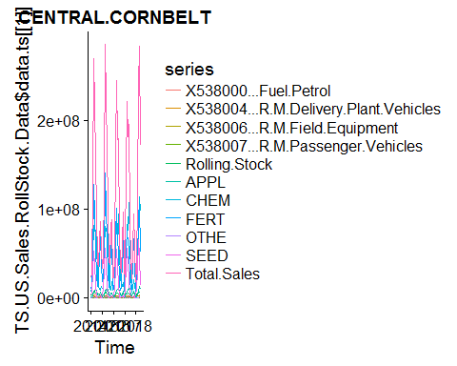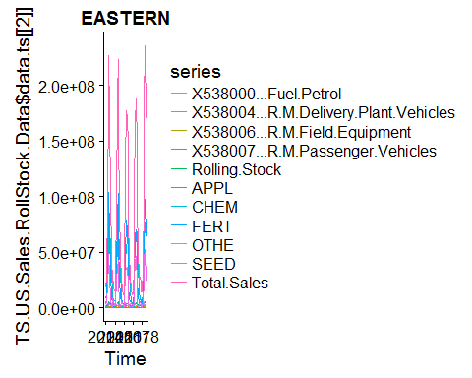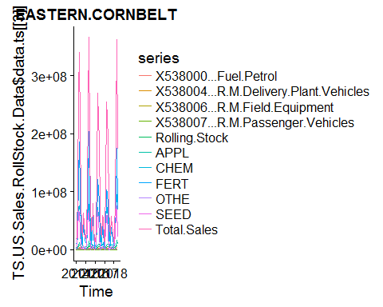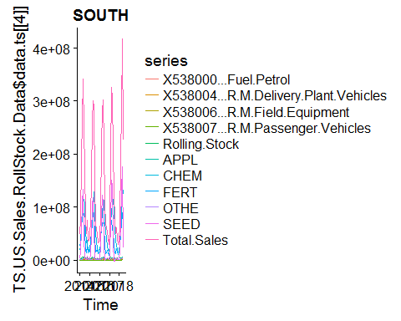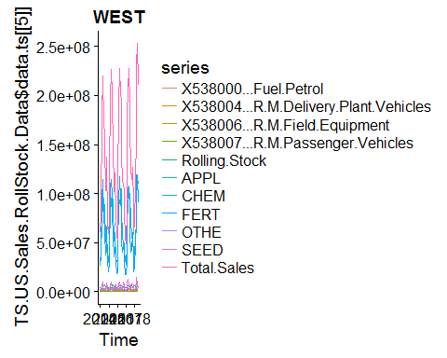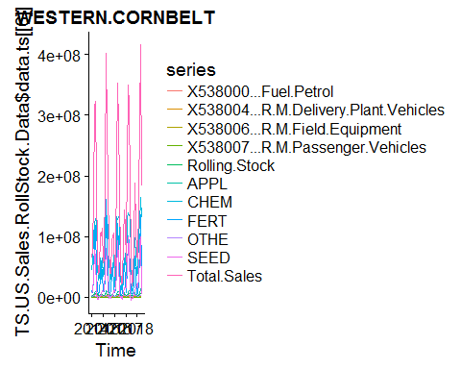

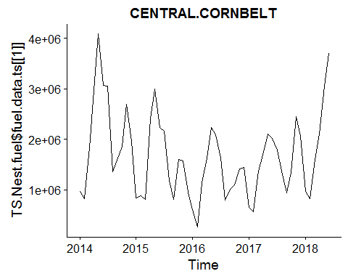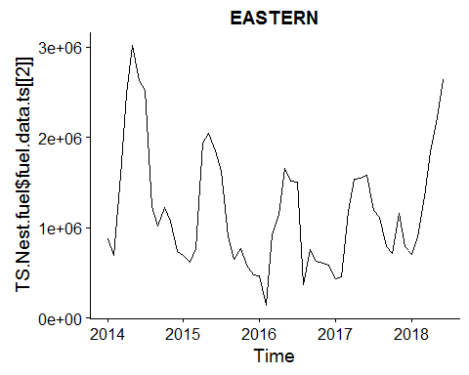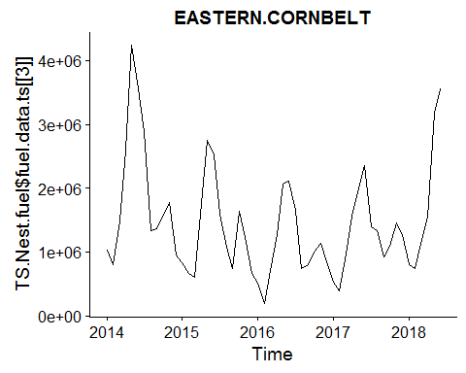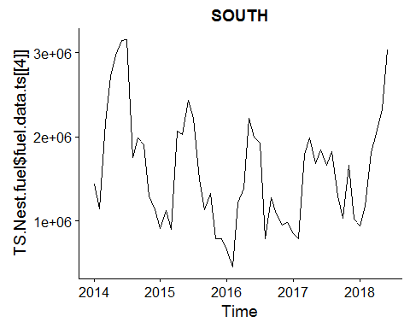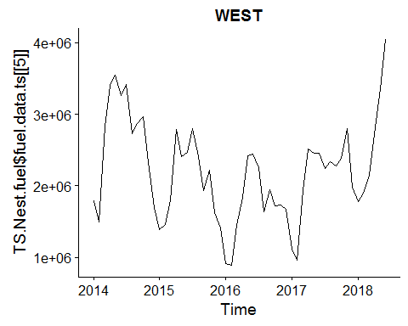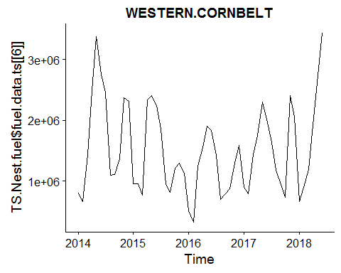

## # A tibble: 6 x 4  
## Region.x data.tbl fuel.data.ts fit.ets   
## <fct> <list> <list> <list>   
## 1 CENTRAL.CORNBELT <tibble [54 x 2]> <S3: ts> <S3: ets>  
## 2 EASTERN <tibble [54 x 2]> <S3: ts> <S3: ets>  
## 3 EASTERN.CORNBELT <tibble [54 x 2]> <S3: ts> <S3: ets>  
## 4 SOUTH <tibble [54 x 2]> <S3: ts> <S3: ets>  
## 5 WEST <tibble [54 x 2]> <S3: ts> <S3: ets>  
## 6 WESTERN.CORNBELT <tibble [54 x 2]> <S3: ts> <S3: ets>

## # A tibble: 16 x 7  
## term CENTRAL.CORNBELT EASTERN EASTERN.CORNBELT SOUTH WEST  
## <chr> <dbl> <dbl> <dbl> <dbl> <dbl>  
## 1 alpha 0.233 3.06e-1 0.373 2.80e-1 5.60e-1  
## 2 b - 30835 NA NA NA NA   
## 3 beta 0.0453 NA NA NA NA   
## 4 gamma 0.000110 6.45e-4 0.000101 1.92e-4 1.00e-4  
## 5 l 2463117 1.33e+6 1670687 1.75e+6 2.37e+6  
## 6 s0 0.992 5.77e-1 0.728 6.56e-1 - 4.35e+5  
## 7 s1 1.22 7.73e-1 0.986 8.15e-1 5.29e+3  
## 8 s10 0.380 4.98e-1 0.383 5.80e-1 - 8.73e+5  
## 9 s2 0.906 7.05e-1 0.978 8.40e-1 1.98e+5  
## 10 s3 0.688 7.21e-1 0.668 9.05e-1 1.13e+5  
## 11 s4 0.727 8.59e-1 0.826 9.46e-1 1.34e+5  
## 12 s5 1.32 1.46e+0 1.25 1.41e+0 5.40e+5  
## 13 s6 1.53 1.68e+0 1.86 1.52e+0 4.98e+5  
## 14 s7 1.70 1.72e+0 1.86 1.44e+0 4.79e+5  
## 15 s8 1.26 1.45e+0 1.22 1.28e+0 4.36e+5  
## 16 s9 0.830 1.04e+0 0.738 1.01e+0 - 2.37e+5  
## # ... with 1 more variable: WESTERN.CORNBELT <dbl>

## # A tibble: 6 x 13  
## Region.x model.desc sigma logLik AIC BIC ME RMSE MAE MPE  
## <fct> <chr> <dbl> <dbl> <dbl> <dbl> <dbl> <dbl> <dbl> <dbl>  
## 1 CENTRAL~ ETS(M,A,M) 0.194 -785 1604 1638 38996 292041 232704 -0.391   
## 2 EASTERN ETS(M,N,M) 0.216 -773 1576 1606 14093 208339 164243 -6.19   
## 3 EASTERN~ ETS(M,N,M) 0.193 -777 1584 1614 20506 256181 205233 -4.14   
## 4 SOUTH ETS(M,N,M) 0.199 -787 1605 1635 3349 282251 210140 -3.89   
## 5 WEST ETS(M,N,A) 0.131 -783 1597 1627 25758 284097 224149 -0.0743  
## 6 WESTERN~ ETS(M,N,M) 0.198 -783 1596 1626 16428 303071 215456 -3.78   
## # ... with 3 more variables: MAPE <dbl>, MASE <dbl>, ACF1 <dbl>

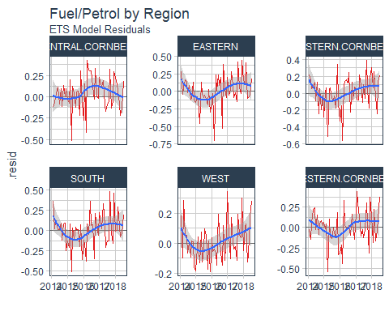

## # A tibble: 6 x 5  
## Region.x data.tbl fuel.data.ts fit.ets fuel.fcast.ets  
## <fct> <list> <list> <list> <list>   
## 1 CENTRAL.CORNBELT <tibble [54 x 2]> <S3: ts> <S3: ets> <S3: forecast>  
## 2 EASTERN <tibble [54 x 2]> <S3: ts> <S3: ets> <S3: forecast>  
## 3 EASTERN.CORNBELT <tibble [54 x 2]> <S3: ts> <S3: ets> <S3: forecast>  
## 4 SOUTH <tibble [54 x 2]> <S3: ts> <S3: ets> <S3: forecast>  
## 5 WEST <tibble [54 x 2]> <S3: ts> <S3: ets> <S3: forecast>  
## 6 WESTERN.CORNBELT <tibble [54 x 2]> <S3: ts> <S3: ets> <S3: forecast>

## # A tibble: 6 x 4  
## Region.x data.tbl fuel.data.ts fit.ets   
## <fct> <list> <list> <list>   
## 1 CENTRAL.CORNBELT <tibble [54 x 2]> <S3: ts> <S3: ets>  
## 2 EASTERN <tibble [54 x 2]> <S3: ts> <S3: ets>  
## 3 EASTERN.CORNBELT <tibble [54 x 2]> <S3: ts> <S3: ets>  
## 4 SOUTH <tibble [54 x 2]> <S3: ts> <S3: ets>  
## 5 WEST <tibble [54 x 2]> <S3: ts> <S3: ets>  
## 6 WESTERN.CORNBELT <tibble [54 x 2]> <S3: ts> <S3: ets>

## # A tibble: 396 x 8  
## Region.x index key X538000...Fuel.P~ lo.80 lo.95 hi.80 hi.95  
## <fct> <date> <chr> <dbl> <dbl> <dbl> <dbl> <dbl>  
## 1 CENTRAL.CO~ 2014-01-31 actual 963133 NA NA NA NA  
## 2 CENTRAL.CO~ 2014-02-28 actual 821119 NA NA NA NA  
## 3 CENTRAL.CO~ 2014-03-31 actual 1830581 NA NA NA NA  
## 4 CENTRAL.CO~ 2014-04-30 actual 2966217 NA NA NA NA  
## 5 CENTRAL.CO~ 2014-05-31 actual 4084873 NA NA NA NA  
## 6 CENTRAL.CO~ 2014-06-30 actual 3073649 NA NA NA NA  
## 7 CENTRAL.CO~ 2014-07-31 actual 3048688 NA NA NA NA  
## 8 CENTRAL.CO~ 2014-08-31 actual 1359933 NA NA NA NA  
## 9 CENTRAL.CO~ 2014-09-30 actual 1576664 NA NA NA NA  
## 10 CENTRAL.CO~ 2014-10-31 actual 1856649 NA NA NA NA  
## # ... with 386 more rows

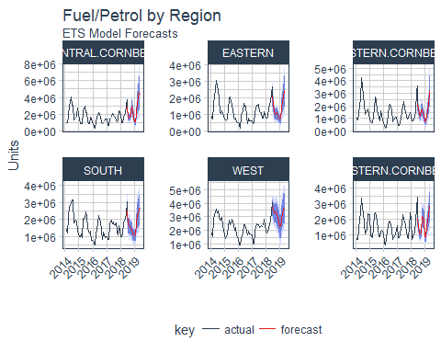

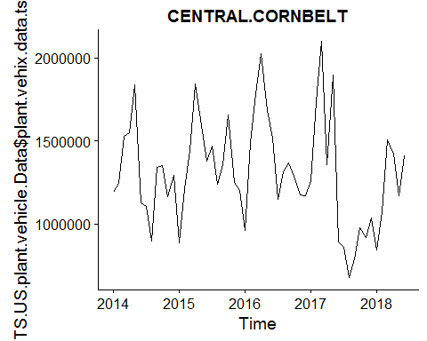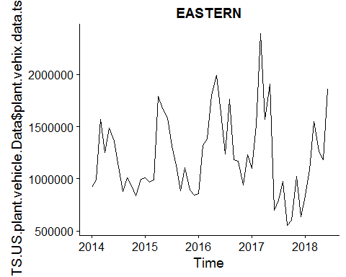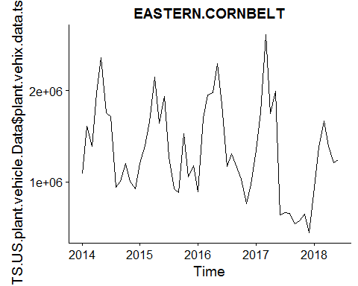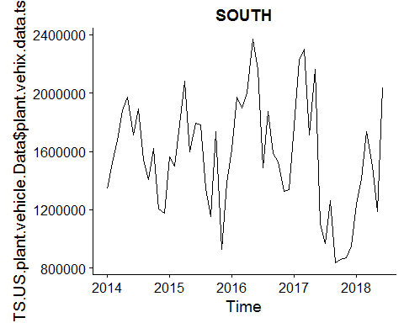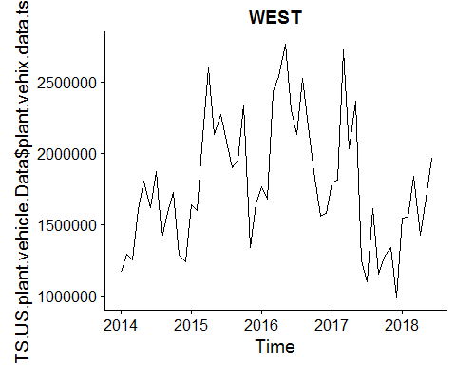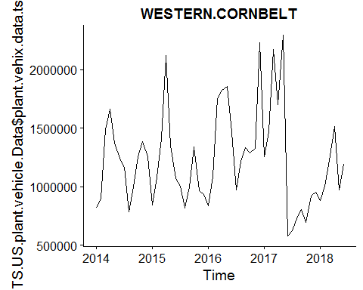

## # A tibble: 14 x 7  
## term CENTRAL.CORNBELT EASTERN EASTERN.CORNBELT SOUTH WEST  
## <chr> <dbl> <dbl> <dbl> <dbl> <dbl>  
## 1 alpha 0.193 1.90e-1 0.286 6.69e-1 6.30e-1  
## 2 gamma 0.000102 1.16e-4 0.000100 NA NA   
## 3 l 1354784 1.16e+6 1444397 1.66e+6 1.53e+6  
## 4 s0 0.895 7.45e-1 0.655 NA NA   
## 5 s1 0.845 7.61e-1 0.665 NA NA   
## 6 s10 1.04 1.02e+0 1.22 NA NA   
## 7 s2 1.00 7.79e-1 0.858 NA NA   
## 8 s3 0.930 7.85e-1 0.666 NA NA   
## 9 s4 0.772 9.94e-1 0.706 NA NA   
## 10 s5 0.870 9.72e-1 0.905 NA NA   
## 11 s6 0.971 1.24e+0 1.19 NA NA   
## 12 s7 1.31 1.34e+0 1.43 NA NA   
## 13 s8 1.29 1.26e+0 1.39 NA NA   
## 14 s9 1.32 1.32e+0 1.46 NA NA   
## # ... with 1 more variable: WESTERN.CORNBELT <dbl>

## # A tibble: 6 x 13  
## Region.x model.desc sigma logLik AIC BIC ME RMSE MAE MPE  
## <fct> <chr> <dbl> <dbl> <dbl> <dbl> <dbl> <dbl> <dbl> <dbl>  
## 1 CENTRAL.~ ETS(M,N,M) 0.150 -766 1562 1592 -25920 198680 157041 -3.99  
## 2 EASTERN ETS(M,N,M) 0.201 -776 1582 1612 - 4747 271729 192203 -5.34  
## 3 EASTERN.~ ETS(M,N,M) 0.200 -781 1592 1621 -29431 289331 216801 -7.50  
## 4 SOUTH ETS(M,N,N) 0.223 -796 1597 1603 3747 348167 288555 -3.44  
## 5 WEST ETS(M,N,N) 0.210 -799 1604 1610 9030 374794 296871 -2.67  
## 6 WESTERN.~ ETS(M,N,M) 0.189 -774 1577 1607 -10682 262320 192099 -5.36  
## # ... with 3 more variables: MAPE <dbl>, MASE <dbl>, ACF1 <dbl>

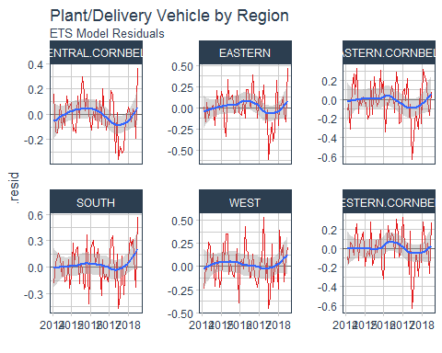

## # A tibble: 6 x 5  
## Region.x data.tbl plant.vehix.data~ fit.ets fcast.delivery.~  
## <fct> <list> <list> <list> <list>   
## 1 CENTRAL.CORNBELT <tibble [5~ <S3: ts> <S3: et~ <S3: forecast>   
## 2 EASTERN <tibble [5~ <S3: ts> <S3: et~ <S3: forecast>   
## 3 EASTERN.CORNBELT <tibble [5~ <S3: ts> <S3: et~ <S3: forecast>   
## 4 SOUTH <tibble [5~ <S3: ts> <S3: et~ <S3: forecast>   
## 5 WEST <tibble [5~ <S3: ts> <S3: et~ <S3: forecast>   
## 6 WESTERN.CORNBELT <tibble [5~ <S3: ts> <S3: et~ <S3: forecast>

## # A tibble: 6 x 5  
## Region.x data.tbl plant.vehix.data~ fit.ets fcast.delivery.~  
## <fct> <list> <list> <list> <list>   
## 1 CENTRAL.CORNBELT <tibble [5~ <S3: ts> <S3: et~ <S3: forecast>   
## 2 EASTERN <tibble [5~ <S3: ts> <S3: et~ <S3: forecast>   
## 3 EASTERN.CORNBELT <tibble [5~ <S3: ts> <S3: et~ <S3: forecast>   
## 4 SOUTH <tibble [5~ <S3: ts> <S3: et~ <S3: forecast>   
## 5 WEST <tibble [5~ <S3: ts> <S3: et~ <S3: forecast>   
## 6 WESTERN.CORNBELT <tibble [5~ <S3: ts> <S3: et~ <S3: forecast>

## # A tibble: 396 x 8  
## Region.x index key X538004...R.M.Deli~ lo.80 lo.95 hi.80 hi.95  
## <fct> <date> <chr> <dbl> <dbl> <dbl> <dbl> <dbl>  
## 1 CENTRAL.C~ 2014-01-31 actu~ 1190587 NA NA NA NA  
## 2 CENTRAL.C~ 2014-02-28 actu~ 1243586 NA NA NA NA  
## 3 CENTRAL.C~ 2014-03-31 actu~ 1527040 NA NA NA NA  
## 4 CENTRAL.C~ 2014-04-30 actu~ 1549945 NA NA NA NA  
## 5 CENTRAL.C~ 2014-05-31 actu~ 1837431 NA NA NA NA  
## 6 CENTRAL.C~ 2014-06-30 actu~ 1126727 NA NA NA NA  
## 7 CENTRAL.C~ 2014-07-31 actu~ 1108259 NA NA NA NA  
## 8 CENTRAL.C~ 2014-08-31 actu~ 900842 NA NA NA NA  
## 9 CENTRAL.C~ 2014-09-30 actu~ 1342239 NA NA NA NA  
## 10 CENTRAL.C~ 2014-10-31 actu~ 1350924 NA NA NA NA  
## # ... with 386 more rows

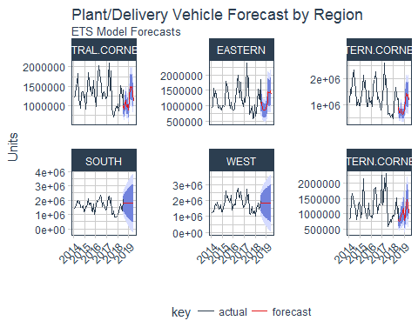

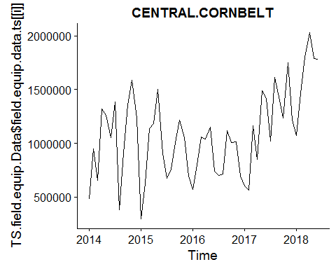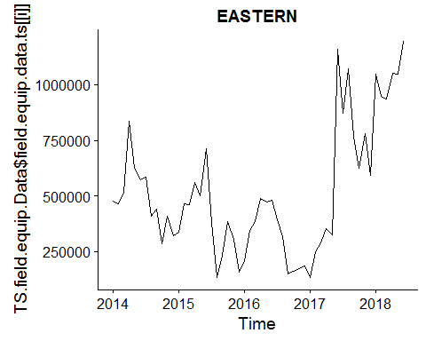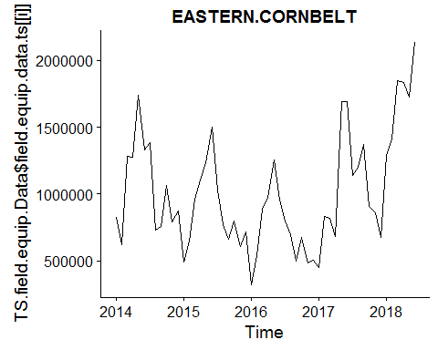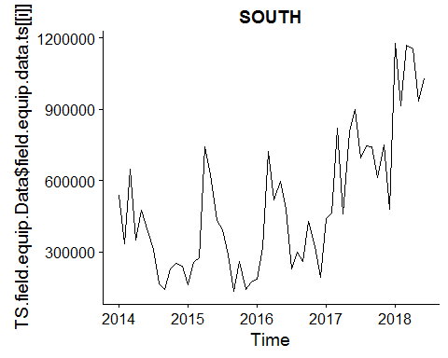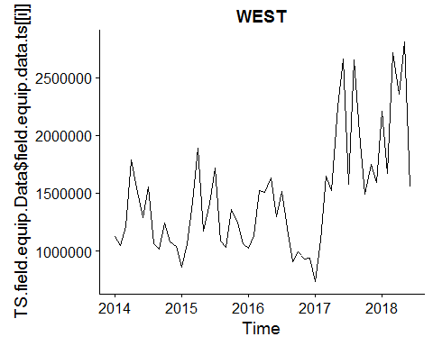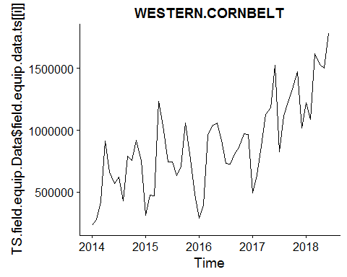

## # A tibble: 14 x 7  
## term CENTRAL.CORNBELT EASTERN EASTERN.CORNBELT SOUTH WEST  
## <chr> <dbl> <dbl> <dbl> <dbl> <dbl>  
## 1 alpha 0.212 0.700 0.436 5.60e-1 6.89e-1  
## 2 gamma NA NA 0.000101 NA NA   
## 3 l 974989 521666 981944 3.93e+5 1.29e+6  
## 4 s0 NA NA 0.691 NA NA   
## 5 s1 NA NA 0.658 NA NA   
## 6 s10 NA NA 0.876 NA NA   
## 7 s2 NA NA 0.881 NA NA   
## 8 s3 NA NA 0.838 NA NA   
## 9 s4 NA NA 0.869 NA NA   
## 10 s5 NA NA 1.11 NA NA   
## 11 s6 NA NA 1.46 NA NA   
## 12 s7 NA NA 1.63 NA NA   
## 13 s8 NA NA 1.12 NA NA   
## 14 s9 NA NA 1.16 NA NA   
## # ... with 1 more variable: WESTERN.CORNBELT <dbl>

## # A tibble: 6 x 13  
## Region.x model.desc sigma logLik AIC BIC ME RMSE MAE MPE  
## <fct> <chr> <dbl> <dbl> <dbl> <dbl> <dbl> <dbl> <dbl> <dbl>  
## 1 CENTRAL~ ETS(M,N,N) 3.36e-1 -796 1597 1603 57517 343445 285529 -9.51  
## 2 EASTERN ETS(A,N,N) 1.78e+5 -760 1527 1533 16548 177833 115761 -7.70  
## 3 EASTERN~ ETS(M,N,M) 2.29e-1 -770 1570 1600 17835 238973 178138 -2.98  
## 4 SOUTH ETS(A,N,N) 1.86e+5 -763 1532 1538 20791 185814 137639 -9.57  
## 5 WEST ETS(M,N,N) 2.61e-1 -799 1604 1610 16513 410148 316488 -3.05  
## 6 WESTERN~ ETS(M,N,A) 2.17e-1 -756 1543 1573 45735 167826 128969 2.11  
## # ... with 3 more variables: MAPE <dbl>, MASE <dbl>, ACF1 <dbl>

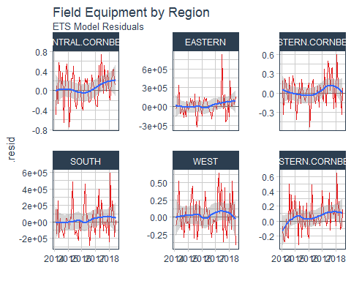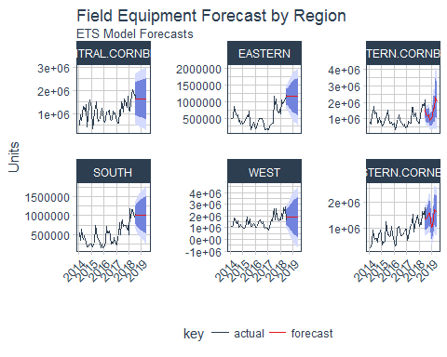

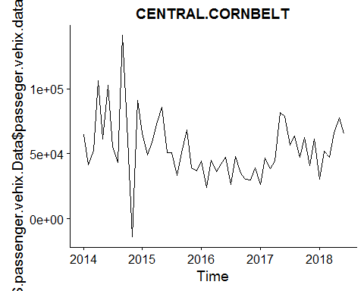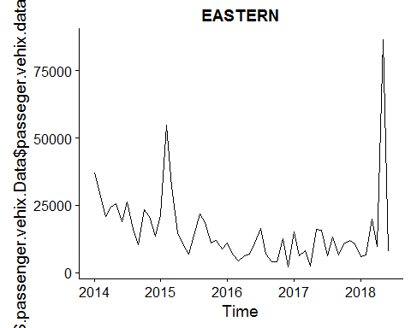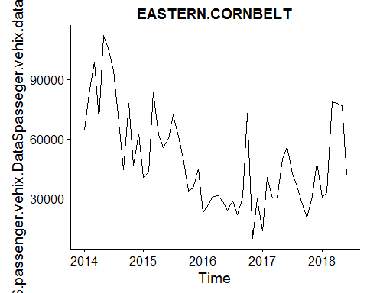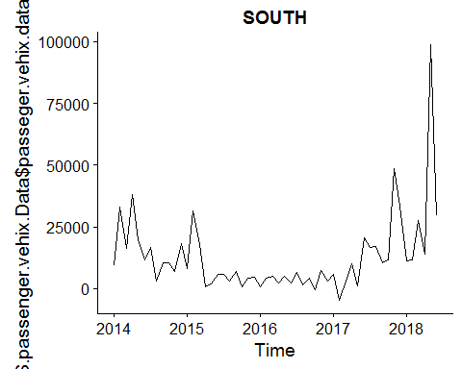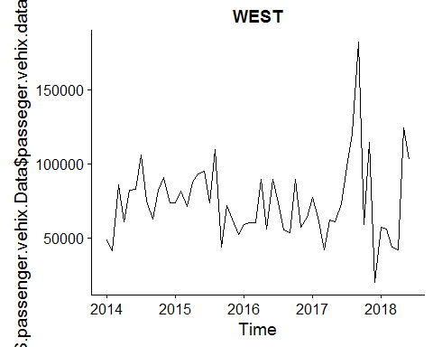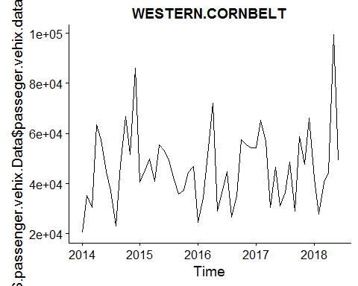

## # A tibble: 16 x 7  
## term CENTRAL.CORNBELT EASTERN EASTERN.CORNBELT SOUTH WEST  
## <chr> <dbl> <dbl> <dbl> <dbl> <dbl>  
## 1 alpha 0.145 2.80e-1 0.395 4.91e-2 1.00e-4  
## 2 b NA NA NA - 6.85e+2 NA   
## 3 beta NA NA NA 4.91e-2 NA   
## 4 gamma NA 1.00e-4 NA NA NA   
## 5 l 73074 2.08e+4 78420 2.62e+4 7.42e+4  
## 6 s0 NA 4.76e-1 NA NA NA   
## 7 s1 NA 9.43e-1 NA NA NA   
## 8 s10 NA 1.21e+0 NA NA NA   
## 9 s2 NA 6.85e-1 NA NA NA   
## 10 s3 NA 5.72e-1 NA NA NA   
## 11 s4 NA 9.77e-1 NA NA NA   
## 12 s5 NA 1.04e+0 NA NA NA   
## 13 s6 NA 1.26e+0 NA NA NA   
## 14 s7 NA 2.28e+0 NA NA NA   
## 15 s8 NA 5.62e-1 NA NA NA   
## 16 s9 NA 8.77e-1 NA NA NA   
## # ... with 1 more variable: WESTERN.CORNBELT <dbl>

## # A tibble: 6 x 13  
## Region.x model.desc sigma logLik AIC BIC ME RMSE MAE  
## <fct> <chr> <dbl> <dbl> <dbl> <dbl> <dbl> <dbl> <dbl>  
## 1 CENTRAL.COR~ ETS(A,N,N) 2.37e+4 -652 1309 1315 -2.02e+3 23694 17144  
## 2 EASTERN ETS(M,N,M) 5.64e-1 -592 1214 1244 -1.49e+3 14603 8713  
## 3 EASTERN.COR~ ETS(A,N,N) 1.83e+4 -638 1282 1288 -9.81e+2 18345 13795  
## 4 SOUTH ETS(A,A,N) 1.32e+4 -620 1250 1260 1.96e+3 13179 7774  
## 5 WEST ETS(A,N,N) 2.62e+4 -657 1320 1326 -3.34e+0 26150 19407  
## 6 WESTERN.COR~ ETS(M,N,N) 3.25e-1 -627 1260 1266 -8.59e-1 15055 11392  
## # ... with 4 more variables: MPE <dbl>, MAPE <dbl>, MASE <dbl>, ACF1 <dbl>

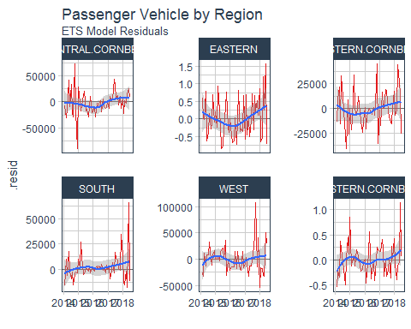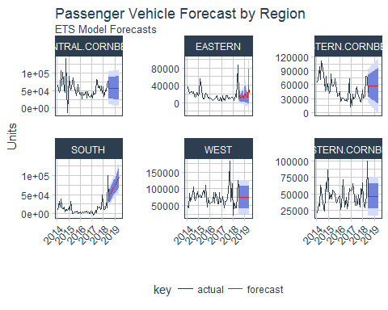

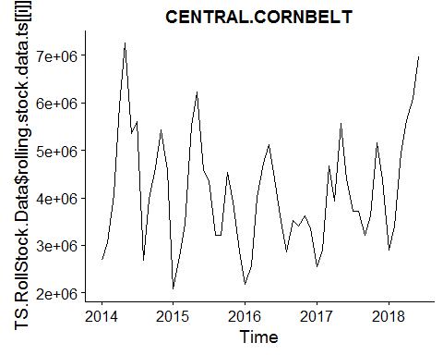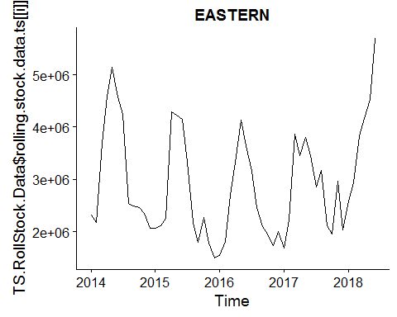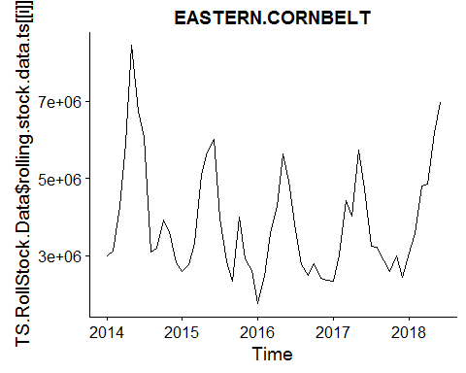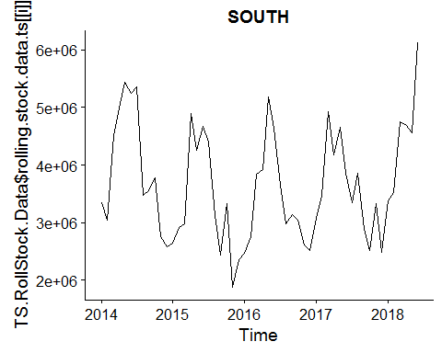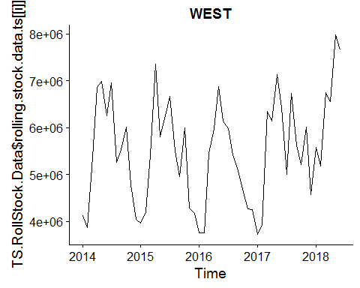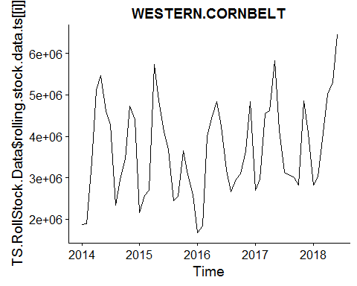

## # A tibble: 16 x 7  
## term CENTRAL.CORNBELT EASTERN EASTERN.CORNBELT SOUTH WEST  
## <chr> <dbl> <dbl> <dbl> <dbl> <dbl>  
## 1 alpha 0.272 2.22e-1 0.249 1.83e-1 5.94e-2  
## 2 b NA NA NA NA -6.67e+3  
## 3 beta NA NA NA NA 5.94e-2  
## 4 gamma 0.000105 5.08e-4 0.000385 1.00e-4 1.01e-4  
## 5 l 4205896 2.92e+6 4060418 3.66e+6 5.52e+6  
## 6 s0 0.925 6.76e-1 0.679 6.77e-1 -1.24e+6  
## 7 s1 1.10 7.88e-1 0.774 7.66e-1 -6.41e+5  
## 8 s10 0.713 7.67e-1 0.788 8.63e-1 -1.33e+6  
## 9 s2 0.994 7.50e-1 0.877 8.68e-1 4.65e+3  
## 10 s3 0.849 7.49e-1 0.717 8.30e-1 -1.55e+5  
## 11 s4 0.803 9.36e-1 0.808 9.20e-1 2.97e+5  
## 12 s5 1.06 1.17e+0 1.13 1.16e+0 7.53e+5  
## 13 s6 1.23 1.48e+0 1.52 1.34e+0 9.27e+5  
## 14 s7 1.46 1.49e+0 1.67 1.33e+0 1.28e+6  
## 15 s8 1.25 1.35e+0 1.26 1.25e+0 1.18e+6  
## 16 s9 1.02 1.15e+0 1.09 1.17e+0 4.20e+5  
## # ... with 1 more variable: WESTERN.CORNBELT <dbl>

## # A tibble: 6 x 13  
## Region.x model.desc sigma logLik AIC BIC ME RMSE MAE MPE  
## <fct> <chr> <dbl> <dbl> <dbl> <dbl> <dbl> <dbl> <dbl> <dbl>  
## 1 CENTRAL~ ETS(M,N,M) 0.128 -817 1664 1694 43624 529450 419860 -0.592  
## 2 EASTERN ETS(M,N,M) 0.139 -802 1634 1664 36438 399938 307088 -0.538  
## 3 EASTERN~ ETS(M,N,M) 0.131 -814 1657 1687 7692 505491 387326 -1.48   
## 4 SOUTH ETS(M,N,M) 0.130 -812 1654 1684 23079 485284 383346 -1.05   
## 5 WEST ETS(M,A,A) 0.0872 -813 1660 1694 34119 500069 382097 0.168  
## 6 WESTERN~ ETS(M,N,A) 0.149 -818 1667 1696 57331 560650 423099 -0.676  
## # ... with 3 more variables: MAPE <dbl>, MASE <dbl>, ACF1 <dbl>

