**CSCE 560**

**Socket Programming Assignment 1**

**TCP Client and Server**

**Fall 18**

**2d Lt James Marvin**

**Assigned: 22 Oct**

**Due: 14 Nov, 1400**

1. Provide a screenshot of the **netstat** results showing a listener at port 12000. 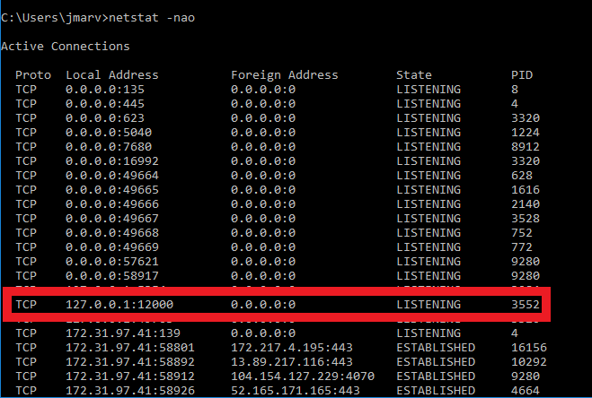
2. Provide screenshots of your server and client Python Shells after the server responds with the capitalized string.

