**CSCE 560**

**Socket Programming Assignment 2**

**2d Lt James Marvin**

**12 November 2018**

1. Hardcopy of complete server code

# Import socket module

from socket import *

# Create a TCP server socket

#(AF_INET is used for IPv4 protocols)

#(SOCK_STREAM is used for TCP)

serverSocket = socket(AF_INET, SOCK_STREAM)

#Prepare a server socket

serverPort = 6969

serverSocket.bind(('',serverPort))

serverSocket.listen(1)

# Server should be up and running and listening to the incoming connections

while True:

print ('Ready to serve...')

# Set up a new connection from the client

connectionSocket, addr = serverSocket.accept()

    # If an exception occurs during the execution of try clause

    # the rest of the clause is skipped

    # If the exception type matches the word after except

    # the except clause is executed

try:

# Receives the request message from the client

message = connectionSocket.recv(1024)#(4096).decode()

# Extract the path of the requested object from the message

# The path is the second part of HTTP header, identified by [1]

filename = message.split()[1]

# Because the extracted path of the HTTP request includes

# a character '/', we read the path from the second character

f = open(filename[1:])

#Store the entire content of the requested file in a temporary buffer

outputdata = f.read()

#Send the HTTP response header line to the connection socket

#Fill in start

response = 'HTTP/1.1 200 OK\n'

contentType = 'Content-Type: text/html\n\n'

connectionSocket.send(response.encode())

connectionSocket.send(contentType.encode())

#connectionSocket.send("\r\n".encode())

#Fill in end

# Send the content of the requested file to the connection socket

for i in range(0, len(outputdata)):

connectionSocket.send(outputdata[i].encode())

connectionSocket.send("\r\n".encode())

# Close the client connection socket

connectionSocket.close()

except IOError:

# Send HTTP response message for file not found

errorResponse = 'HTTP/1.1 404 Not Found\n'

contentType2 = 'Content-Type: text/html\n\n'

connectionSocket.send(errorResponse.encode())

connectionSocket.send(contentType2.encode())

fail = open("fail.html")

faildata=fail.read()

for i in range(0,len(faildata)):

connectionSocket.send(faildata[i].encode())

connectionSocket.send("\r\n".encode())

connectionSocket.close()

serverSocket.close()

2. Screenshot of client browser when you successfully receive a file from the server

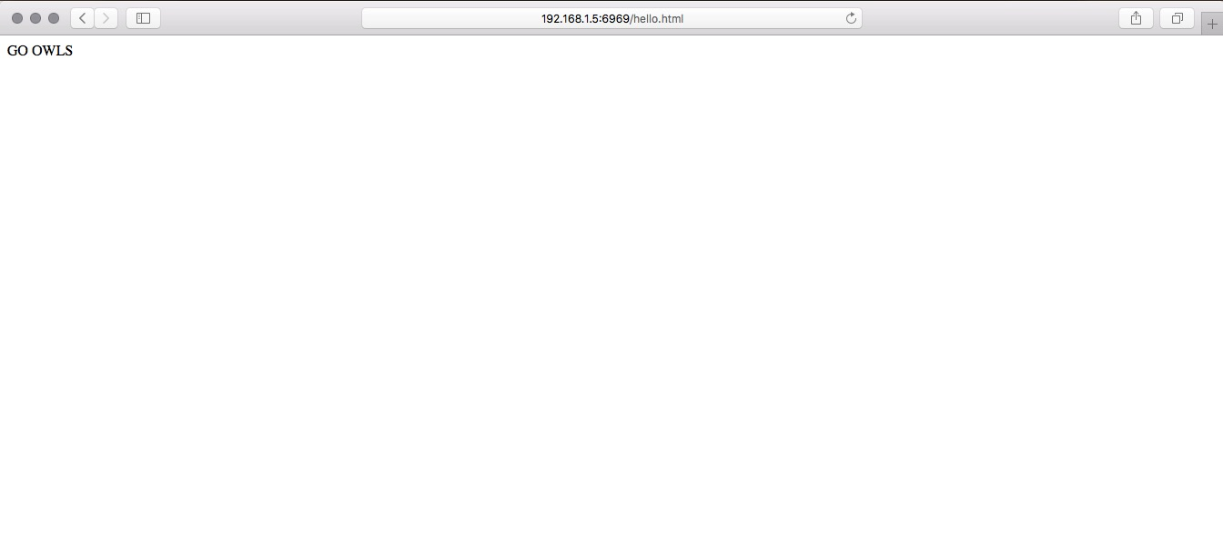

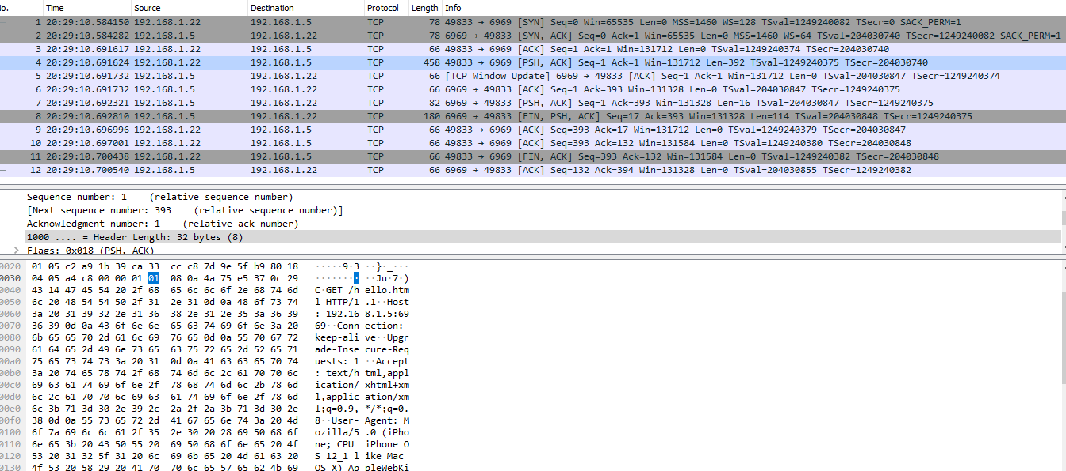3. Screenshot of wireshark when you successfully retrieve file from the server

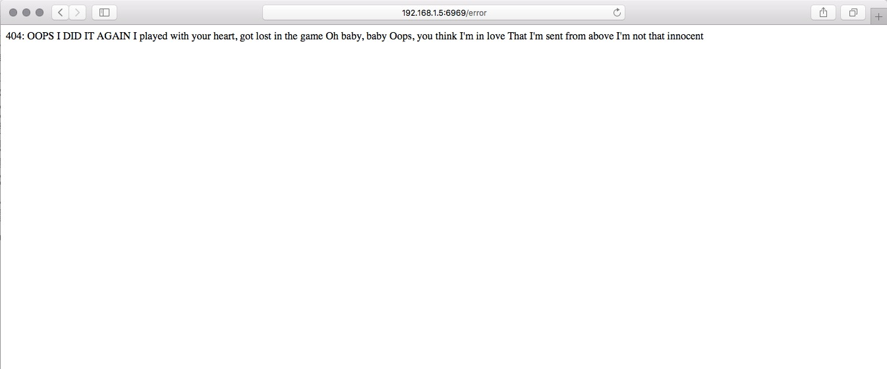4. Screenshot of browser when file is not found

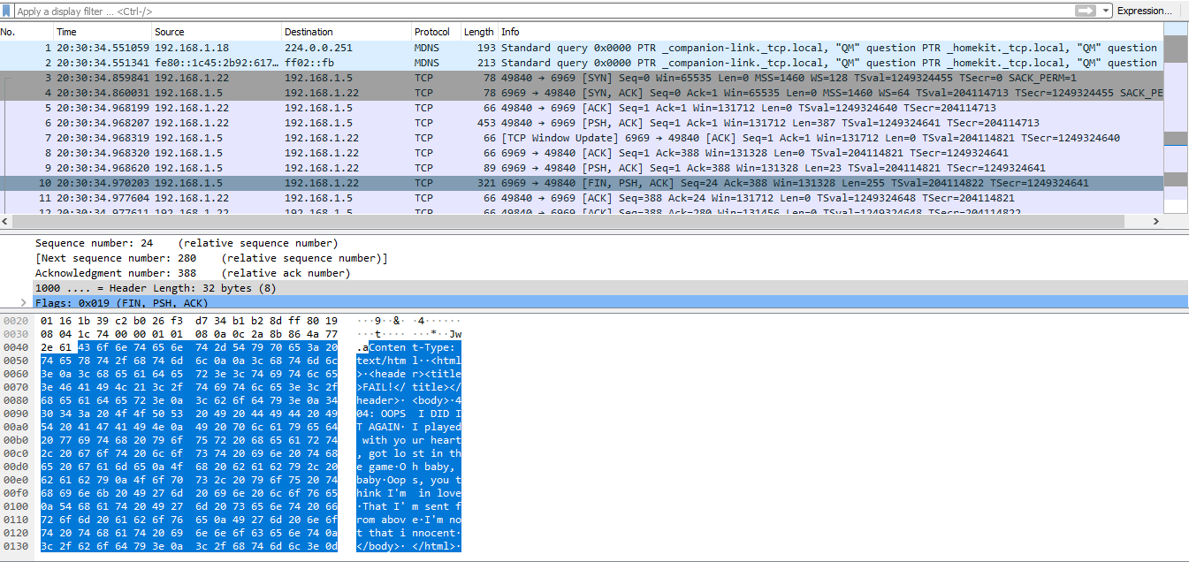5. Screenshot of wireshark when file is not found

6. Include source code of any transferred files

helloworld.html

<html>

<header><title>AFIT is the Best!</title></header>

<body>

GO OWLS

</body>

</html>

fail.html

<html>

<header><title>FAIL!</title></header>

<body>

404: OOPS I DID IT AGAIN

I played with your heart, got lost in the game

Oh baby, baby

Oops, you think I'm in love

That I'm sent from above

I'm not that innocent

</body>

</html>