**Arsenal Report for Brusdar Graterol**  
2019-3-20 to 2019-9-30

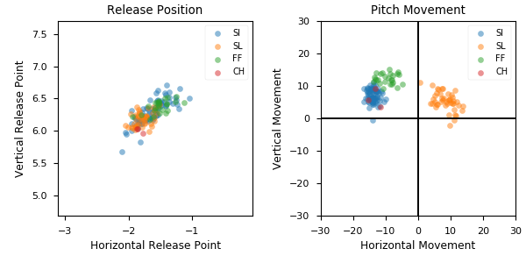

**Aresenal**

|  |  |  |  |  |  |  |  |  |
| --- | --- | --- | --- | --- | --- | --- | --- | --- |
| Pitch Type | % Thrown | Velocity (mph) | Spin Rate (rpm) | Horizontal Break (in) | Vertical Break (in) | xwOBA | wOBA | SwStr% |
| SI | 49.3 | 99.0 | 2003.0 | -13.9 | 7.0 | 0.171 | 0.125 | 8.5 |
| SL | 30.6 | 88.3 | 2408.0 | 8.4 | 5.3 | 0.514 | 0.465 | 15.9 |
| FF | 18.1 | 98.8 | 2098.0 | -9.6 | 12.3 | 0.311 | 0.386 | 0.0 |
| CH | 2.1 | 90.8 | 1674.0 | -13.4 | 6.2 | 0.817 | 1.0 | 0.0 |

* Pitch Type - FF: Four-Seam Fastball, FT: Two-Seam Fastball, SI: Sinkker, FC: Cutter, FS: Splitter, SL: Slider, CU: Curveball, KC: Knuckle-curve, CH: Changeup, FO: Forkball, SC: Screwball, KN: Knuckleball, EP: Eephus
* Velocity - recorded in miles per hour at release.
* Spin Rate - recorded in revolutions per minute at release.
* Horizontal Break - horizontal movement, in inches, of the pitch between the release point and home plate, as compared to a theoretical pitch thrown at the same speed with no spin-induced movement.
* Vertical Break - vertical movement, in inches, of the pitch between the release point and home plate, as compared to a theoretical pitch thrown at the same speed with no spin-induced movement.
* xwOBA - formulated using exit velocity, launch angle and, on certain types of batted balls, Sprint Speed.
* wOBA - a statistic, based on linear weights, designed to measure a player's overall offensive contributions per plate appearance.
* SwStr% - measures swing and miss rate based on pitch type. EX: (FF Swings and Misses)/(Total # of FF Thrown) * 100.