**Arsenal Report for Caleb Smith**  
2019-4-1 to 2019-9-28

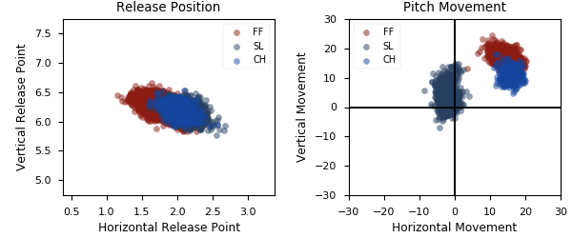

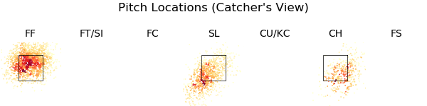

|  |  |  |  |  |  |  |  |  |
| --- | --- | --- | --- | --- | --- | --- | --- | --- |
| Pitch Type | % Thrown | Velocity | Spin Rate | Horizontal Break | Vertical Break | SwStr% | xwOBA | wOBA |
| FF | 53.8 | 91.6 | 2425.0 | 14.6 | 17.0 | 10.3 | 0.423 | 0.338 |
| SL | 31.6 | 83.5 | 2297.0 | -2.1 | 3.8 | 13.8 | 0.376 | 0.3 |
| CH | 14.7 | 82.6 | 1918.0 | 15.9 | 11.1 | 16.2 | 0.33 | 0.352 |

|  |  |  |  |  |  |  |  |  |
| --- | --- | --- | --- | --- | --- | --- | --- | --- |
| Pitch Type | % Thrown | Weak% | Topped% | Under% | Burner% | Solid% | Barrel% | HardHit% |
| FF | 53.8 | 6.8 | 10.9 | 43.2 | 15.6 | 9.9 | 13.5 | 45.3 |
| SL | 31.6 | 5.0 | 27.3 | 33.1 | 17.3 | 7.2 | 10.1 | 32.4 |
| CH | 14.7 | 2.5 | 28.4 | 32.1 | 27.2 | 3.7 | 6.2 | 19.8 |