**Arsenal Report for Gerrit Cole**  
2017-4-2 to 2017-10-1

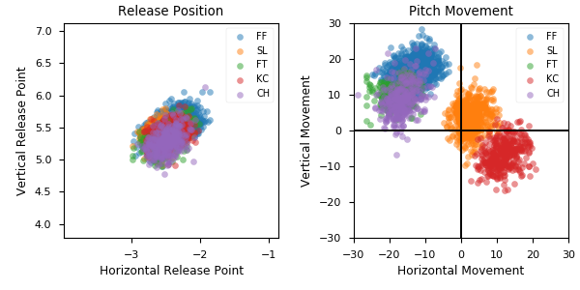

**Aresenal**

|  |  |  |  |  |  |  |  |  |
| --- | --- | --- | --- | --- | --- | --- | --- | --- |
| Pitch Type | % Thrown | Velocity (mph) | Spin Rate (rpm) | Horizontal Break (in) | Vertical Break (in) | xwOBA | wOBA | SwStr% |
| FF | 47.1 | 95.9 | 2164.0 | -13.4 | 16.0 | 0.444 | 0.354 | 7.6 |
| SL | 17.3 | 88.1 | 2417.0 | 2.6 | 3.6 | 0.355 | 0.289 | 14.8 |
| FT | 13.1 | 95.6 | 2096.0 | -17.8 | 10.3 | 0.346 | 0.353 | 4.9 |
| KC | 12.1 | 80.4 | 2667.0 | 11.7 | -6.7 | 0.319 | 0.3 | 6.5 |
| CH | 10.3 | 88.5 | 1633.0 | -16.6 | 8.7 | 0.376 | 0.285 | 10.6 |

* Pitch Type - FF: Four-Seam Fastball, FT: Two-Seam Fastball, SI: Sinkker, FC: Cutter, FS: Splitter, SL: Slider, CU: Curveball, KC: Knuckle-curve, CH: Changeup, FO: Forkball, SC: Screwball, KN: Knuckleball, EP: Eephus
* Velocity - recorded in miles per hour at release.
* Spin Rate - recorded in revolutions per minute at release.
* Horizontal Break - horizontal movement, in inches, of the pitch between the release point and home plate, as compared to a theoretical pitch thrown at the same speed with no spin-induced movement.
* Vertical Break - vertical movement, in inches, of the pitch between the release point and home plate, as compared to a theoretical pitch thrown at the same speed with no spin-induced movement.
* xwOBA - formulated using exit velocity, launch angle and, on certain types of batted balls, Sprint Speed.
* wOBA - a statistic, based on linear weights, designed to measure a player's overall offensive contributions per plate appearance.
* SwStr% - measures swing and miss rate based on pitch type. EX: (FF Swings and Misses)/(Total # of FF Thrown) * 100.