**Aresenal Report for Gerrit Cole**  
2019-7-12 to 2019-9-24

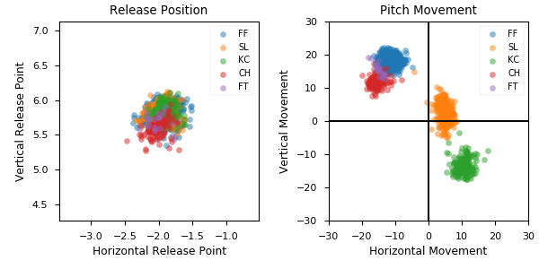

**Aresenal**

|  |  |  |  |  |  |  |  |  |
| --- | --- | --- | --- | --- | --- | --- | --- | --- |
| Pitch Type | % Thrown | Velocity (mph) | Spin Rate (rpm) | Horizontal Break (in) | Vertical Break (in) | Spin Direction (deg) | xwOBA | wOBA |
| FF | 51.5 | 97.5 | 2539.0 | -11.7 | 18.3 | -33.0 | 0.333 | 0.228 |
| SL | 23.2 | 89.5 | 2611.0 | 4.8 | 2.5 | 62.0 | 0.31 | 0.213 |
| KC | 14.0 | 83.6 | 2891.0 | 10.4 | -13.4 | 142.0 | 0.359 | 0.206 |
| CH | 9.6 | 88.8 | 1984.0 | -15.6 | 11.9 | -53.0 | 0.289 | 0.172 |
| FT | 1.6 | 98.1 | 2534.0 | -15.0 | 15.5 | -44.0 | 0.563 | 0.269 |