**Arsenal Report for Gerrit Cole**  
2019-3-30 to 2019-9-30

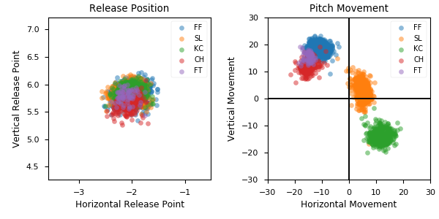

**Aresenal**

|  |  |  |  |  |  |  |  |  |
| --- | --- | --- | --- | --- | --- | --- | --- | --- |
| Pitch Type | % Thrown | Velocity (mph) | Spin Rate (rpm) | Horizontal Break (in) | Vertical Break (in) | xwOBA | wOBA | SwStr% |
| FF | 51.8 | 97.1 | 2530.0 | -11.4 | 18.3 | 0.374 | 0.26 | 17.1 |
| SL | 22.9 | 89.3 | 2622.0 | 4.9 | 3.0 | 0.337 | 0.242 | 19.7 |
| KC | 15.5 | 82.6 | 2899.0 | 11.6 | -14.0 | 0.361 | 0.256 | 8.5 |
| CH | 7.5 | 88.7 | 1873.0 | -15.3 | 11.8 | 0.307 | 0.291 | 18.9 |
| FT | 2.4 | 97.1 | 2506.0 | -15.0 | 15.5 | 0.312 | 0.292 | 6.4 |