**Aresenal Report for Jacob DeGrom**  
2019-9-14 to 2019-9-25

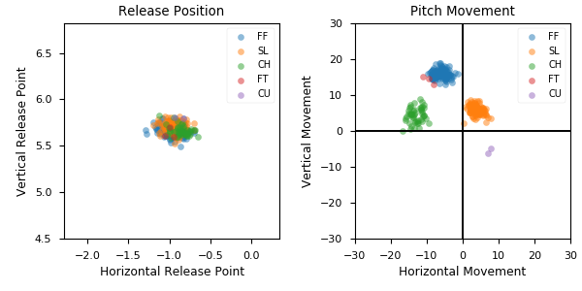

**Aresenal**

|  |  |  |  |  |  |  |  |  |
| --- | --- | --- | --- | --- | --- | --- | --- | --- |
| Pitch Type | % Thrown | Velocity (mph) | Spin Rate (rpm) | Horizontal Break (in) | Vertical Break (in) | Spin Direction (deg) | xwOBA | wOBA |
| FF | 44.5 | 97.4 | 2402.0 | -6.1 | 15.9 | -21.0 | 0.156 | 0.178 |
| SL | 36.6 | 92.2 | 2544.0 | 3.8 | 5.9 | 33.0 | 0.257 | 0.141 |
| CH | 17.1 | 91.3 | 1626.0 | -13.0 | 4.4 | -71.0 | 0.242 | 0.09 |
| FT | 1.0 | 98.9 | 2379.0 | -9.5 | 14.3 | -34.0 | nan | nan |
| CU | 0.7 | 81.8 | nan | 7.4 | -5.5 | 127.0 | nan | nan |