**Arsenal Report for Jacob deGrom**  
2019-3-20 to 2019-9-30

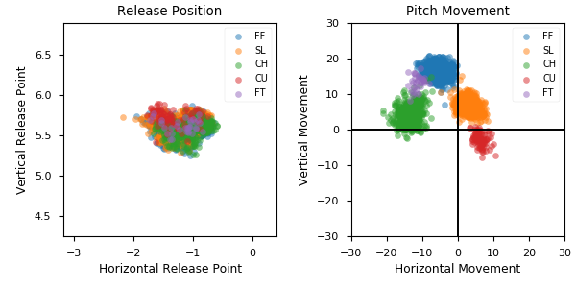

**Aresenal**

|  |  |  |  |  |  |  |  |  |
| --- | --- | --- | --- | --- | --- | --- | --- | --- |
| Pitch Type | % Thrown | Velocity (mph) | Spin Rate (rpm) | Horizontal Break (in) | Vertical Break (in) | xwOBA | wOBA | SwStr% |
| FF | 48.1 | 96.9 | 2388.0 | -5.7 | 16.3 | 0.358 | 0.301 | 12.2 |
| SL | 32.0 | 92.5 | 2454.0 | 3.0 | 6.7 | 0.306 | 0.23 | 18.3 |
| CH | 15.9 | 90.3 | 1703.0 | -13.6 | 4.0 | 0.327 | 0.218 | 20.4 |
| CU | 2.9 | 84.3 | 2567.0 | 6.2 | -2.7 | 0.317 | 0.344 | 11.8 |
| FT | 1.1 | 96.7 | 2281.0 | -11.4 | 13.3 | 0.297 | 0.18 | 0.0 |