**Arsenal Report for Justin Verlander**  
2017-8-1 to 2017-11-1

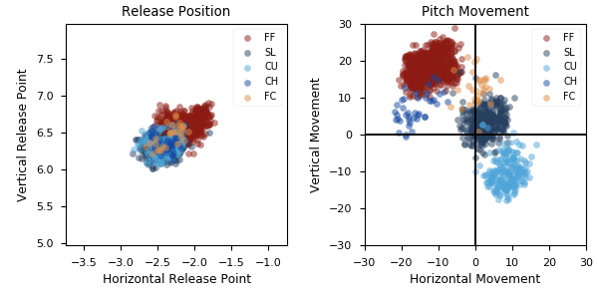

**Aresenal**

|  |  |  |  |  |  |  |  |  |
| --- | --- | --- | --- | --- | --- | --- | --- | --- |
| Pitch Type | % Thrown | Velocity (mph) | Spin Rate (rpm) | Horizontal Break (in) | Vertical Break (in) | xwOBA | wOBA | SwStr% |
| FF | 60.6 | 95.5 | 2569.0 | -12.8 | 18.3 | 0.356 | 0.23 | 10.4 |
| SL | 23.2 | 86.9 | 2615.0 | 2.5 | 3.3 | 0.349 | 0.251 | 21.0 |
| CU | 12.0 | 80.4 | 2832.0 | 8.4 | -10.4 | 0.288 | 0.176 | 8.8 |
| CH | 2.4 | 87.3 | 1776.0 | -16.2 | 7.0 | 0.557 | 0.406 | 12.2 |
| FC | 1.8 | 91.5 | 2529.0 | 0.2 | 12.4 | 0.291 | 0.064 | 3.2 |

* Pitch Type - FF: Four-Seam Fastball, FT: Two-Seam Fastball, SI: Sinkker, FC: Cutter, FS: Splitter, SL: Slider, CU: Curveball, KC: Knuckle-curve, CH: Changeup, FO: Forkball, SC: Screwball, KN: Knuckleball, EP: Eephus
* Velocity - recorded in miles per hour at release.
* Spin Rate - recorded in revolutions per minute at release.
* Horizontal Break - horizontal movement, in inches, of the pitch between the release point and home plate, as compared to a theoretical pitch thrown at the same speed with no spin-induced movement.
* Vertical Break - vertical movement, in inches, of the pitch between the release point and home plate, as compared to a theoretical pitch thrown at the same speed with no spin-induced movement.
* xwOBA - formulated using exit velocity, launch angle and, on certain types of batted balls, Sprint Speed.
* wOBA - a statistic, based on linear weights, designed to measure a player's overall offensive contributions per plate appearance.
* SwStr% - measures swing and miss rate based on pitch type. EX: (FF Swings and Misses)/(Total # of FF Thrown) * 100.