**Arsenal Report for Justin Verlander**  
2017-4-2 to 2017-7-31

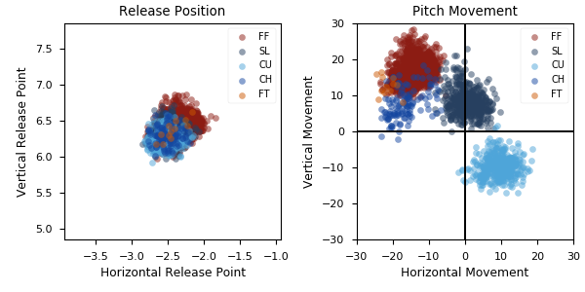

**Aresenal**

|  |  |  |  |  |  |  |  |  |
| --- | --- | --- | --- | --- | --- | --- | --- | --- |
| Pitch Type | % Thrown | Velocity (mph) | Spin Rate (rpm) | Horizontal Break (in) | Vertical Break (in) | xwOBA | wOBA | SwStr% |
| FF | 56.7 | 95.3 | 2538.0 | -14.1 | 17.1 | 0.414 | 0.313 | 7.8 |
| SL | 20.4 | 89.0 | 2498.0 | 0.5 | 8.3 | 0.345 | 0.338 | 14.8 |
| CU | 17.4 | 80.5 | 2797.0 | 9.3 | -9.7 | 0.399 | 0.324 | 6.3 |
| CH | 5.1 | 87.7 | 1833.0 | -16.6 | 7.6 | 0.472 | 0.373 | 9.2 |

* Pitch Type - FF: Four-Seam Fastball, FT: Two-Seam Fastball, SI: Sinkker, FC: Cutter, FS: Splitter, SL: Slider, CU: Curveball, KC: Knuckle-curve, CH: Changeup, FO: Forkball, SC: Screwball, KN: Knuckleball, EP: Eephus
* Velocity - recorded in miles per hour at release.
* Spin Rate - recorded in revolutions per minute at release.
* Horizontal Break - horizontal movement, in inches, of the pitch between the release point and home plate, as compared to a theoretical pitch thrown at the same speed with no spin-induced movement.
* Vertical Break - vertical movement, in inches, of the pitch between the release point and home plate, as compared to a theoretical pitch thrown at the same speed with no spin-induced movement.
* xwOBA - formulated using exit velocity, launch angle and, on certain types of batted balls, Sprint Speed.
* wOBA - a statistic, based on linear weights, designed to measure a player's overall offensive contributions per plate appearance.
* SwStr% - measures swing and miss rate based on pitch type. EX: (FF Swings and Misses)/(Total # of FF Thrown) * 100.