**Aresenal Report for Justin Verlander**  
2019-7-12 to 2019-9-26

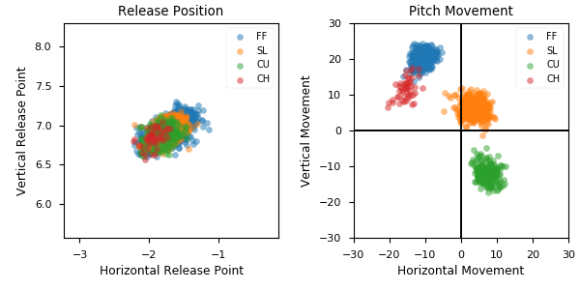

**Aresenal**

|  |  |  |  |  |  |  |  |  |
| --- | --- | --- | --- | --- | --- | --- | --- | --- |
| Pitch Type | % Thrown | Velocity (mph) | Spin Rate (rpm) | Horizontal Break (in) | Vertical Break (in) | Spin Direction (deg) | xwOBA | wOBA |
| FF | 46.8 | 94.6 | 2576.0 | -10.7 | 20.4 | -28.0 | 0.428 | 0.327 |
| SL | 29.6 | 87.4 | 2601.0 | 3.7 | 6.2 | 31.0 | 0.264 | 0.177 |
| CU | 20.1 | 79.4 | 2825.0 | 7.1 | -12.0 | 149.0 | 0.331 | 0.242 |
| CH | 3.6 | 86.3 | 1895.0 | -15.5 | 11.6 | -53.0 | 0.132 | 0.114 |