**Pitch Profile for Justin Verlander**  
2019-3-20 to 2019-9-30

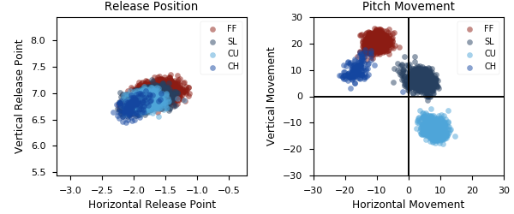

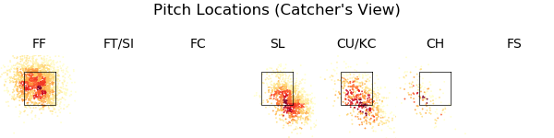

|  |  |  |  |  |  |  |  |  |
| --- | --- | --- | --- | --- | --- | --- | --- | --- |
| Pitch Type | % Thrown | Velocity | Spin Rate | Horizontal Break | Vertical Break | Whiff Rate | xwOBA | wOBA |
| FF | 49.2 | 94.6 | 2577.0 | -10.1 | 20.6 | 27.8 | 0.456 | 0.357 |
| SL | 28.2 | 87.5 | 2612.0 | 4.1 | 6.2 | 35.3 | 0.272 | 0.172 |
| CU | 18.5 | 79.4 | 2821.0 | 7.6 | -12.3 | 21.2 | 0.317 | 0.228 |
| CH | 4.1 | 86.9 | 1866.0 | -16.3 | 10.3 | 29.2 | 0.238 | 0.146 |

|  |  |  |  |  |  |  |  |  |
| --- | --- | --- | --- | --- | --- | --- | --- | --- |
| Pitch Type | % Thrown | Weak% | Topped% | Under% | Burner% | Solid% | Barrel% | HardHit% |
| FF | 49.2 | 1.5 | 13.1 | 39.4 | 21.2 | 9.6 | 15.2 | 49.5 |
| SL | 28.2 | 7.1 | 33.9 | 32.7 | 18.5 | 5.4 | 2.4 | 20.8 |
| CU | 18.5 | 0.0 | 38.6 | 21.7 | 33.7 | 4.8 | 1.2 | 25.3 |
| CH | 4.1 | 0.0 | 34.6 | 46.2 | 15.4 | 0.0 | 3.8 | 11.5 |