**Pitch Profile for Max Scherzer**  
2019-10-1 to 2019-10-15

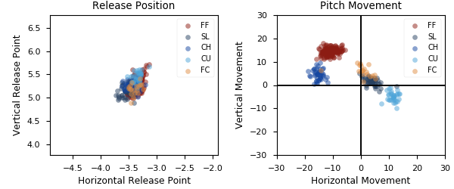

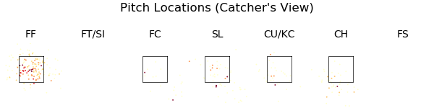

|  |  |  |  |  |  |  |  |  |
| --- | --- | --- | --- | --- | --- | --- | --- | --- |
| Pitch Type | % Thrown | Velocity | Spin Rate | Horizontal Break | Vertical Break | Whiff Rate | xwOBA | wOBA |
| FF | 50.5 | 96.0 | 2523.0 | -10.8 | 14.5 | 21.6 | 0.346 | 0.328 |
| SL | 17.6 | 86.0 | 2471.0 | 3.9 | 1.6 | 41.4 | 0.204 | 0.06 |
| CH | 14.6 | 85.4 | 1528.0 | -15.3 | 4.5 | 52.2 | 0.465 | 0.114 |
| CU | 11.0 | 80.1 | 2782.0 | 11.4 | -5.0 | 28.6 | 0.461 | 0.4 |
| FC | 6.3 | 90.2 | 2369.0 | 0.6 | 6.0 | 55.6 | 0.231 | 0.1 |

|  |  |  |  |  |  |  |  |  |
| --- | --- | --- | --- | --- | --- | --- | --- | --- |
| Pitch Type | % Thrown | Weak% | Topped% | Under% | Burner% | Solid% | Barrel% | HardHit% |
| FF | 50.5 | 4.8 | 14.3 | 52.4 | 14.3 | 4.8 | 9.5 | 38.1 |
| SL | 17.6 | 0.0 | 50.0 | 25.0 | 0.0 | 25.0 | 0.0 | 37.5 |
| CH | 14.6 | 16.7 | 33.3 | 16.7 | 16.7 | 0.0 | 16.7 | 33.3 |
| CU | 11.0 | 0.0 | 50.0 | 0.0 | 25.0 | 0.0 | 25.0 | 50.0 |
| FC | 6.3 | 0.0 | 0.0 | 50.0 | 50.0 | 0.0 | 0.0 | 50.0 |