**Aresenal Report for Randy Dobnak**  
2019-8-9 to 2019-9-25

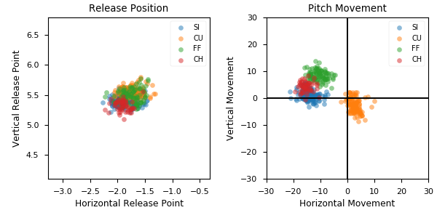

**Aresenal**

|  |  |  |  |  |  |  |  |  |
| --- | --- | --- | --- | --- | --- | --- | --- | --- |
| Pitch Type | % Thrown | Velocity (mph) | Spin Rate (rpm) | Horizontal Break (in) | Vertical Break (in) | Spin Direction (deg) | xwOBA | wOBA |
| SI | 36.5 | 92.2 | 1944.0 | -14.3 | 1.3 | -85.0 | 0.297 | 0.34 |
| CU | 27.9 | 84.1 | 2392.0 | 2.6 | -2.6 | 135.0 | 0.46 | 0.302 |
| FF | 22.7 | 93.4 | 2051.0 | -10.7 | 8.5 | -52.0 | 0.316 | 0.227 |
| CH | 12.9 | 85.7 | 1653.0 | -15.4 | 4.3 | -74.0 | 0.293 | 0.243 |