**Pitch Profile for Stephen Strasburg**  
2019-10-1 to 2019-10-15

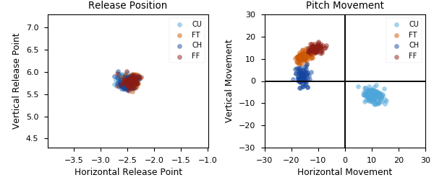

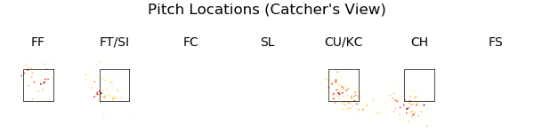

|  |  |  |  |  |  |  |  |  |
| --- | --- | --- | --- | --- | --- | --- | --- | --- |
| Pitch Type | % Thrown | Velocity | Spin Rate | Horizontal Break | Vertical Break | Whiff Rate | xwOBA | wOBA |
| CU | 34.6 | 82.8 | 2777.0 | 10.4 | -6.5 | 31.1 | 0.399 | 0.093 |
| FT | 23.8 | 94.5 | 2181.0 | -15.6 | 11.0 | 11.9 | 0.479 | 0.385 |
| CH | 23.8 | 88.1 | 1724.0 | -16.0 | 2.0 | 36.2 | 0.335 | 0.108 |
| FF | 17.9 | 94.6 | 2204.0 | -11.0 | 14.7 | 20.0 | 0.449 | 0.553 |

|  |  |  |  |  |  |  |  |  |
| --- | --- | --- | --- | --- | --- | --- | --- | --- |
| Pitch Type | % Thrown | Weak% | Topped% | Under% | Burner% | Solid% | Barrel% | HardHit% |
| CU | 34.6 | 0.0 | 36.4 | 18.2 | 27.3 | 9.1 | 9.1 | 45.5 |
| FT | 23.8 | 5.9 | 35.3 | 11.8 | 41.2 | 0.0 | 5.9 | 47.1 |
| CH | 23.8 | 0.0 | 44.4 | 11.1 | 44.4 | 0.0 | 0.0 | 44.4 |
| FF | 17.9 | 0.0 | 15.4 | 23.1 | 30.8 | 15.4 | 15.4 | 53.8 |