**Aresenal Report for Tyler Duffey**  
2019-7-28 to 2019-9-25

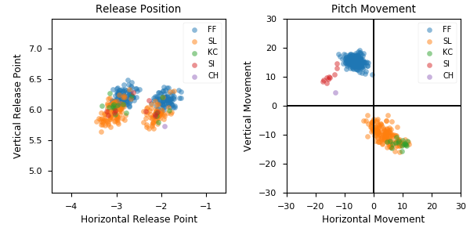

**Aresenal**

|  |  |  |  |  |  |  |  |  |
| --- | --- | --- | --- | --- | --- | --- | --- | --- |
| Pitch Type | % Thrown | Velocity (mph) | Spin Rate (rpm) | Horizontal Break (in) | Vertical Break (in) | Spin Direction (deg) | xwOBA | wOBA |
| FF | 51.1 | 94.3 | 2313.0 | -6.3 | 15.4 | -22.0 | 0.211 | 0.169 |
| SL | 41.2 | 84.1 | 2540.0 | 3.9 | -9.9 | 158.0 | 0.362 | 0.12 |
| KC | 4.7 | 75.0 | 2347.0 | 8.9 | -13.0 | 146.0 | 0.743 | 0.9 |
| SI | 2.8 | 94.4 | 2457.0 | -15.2 | 10.2 | -56.0 | 0.61 | 0.3 |
| CH | 0.3 | 86.3 | 1588.0 | -13.1 | 4.6 | -71.0 | nan | nan |