**Arsenal Report for Tyler Duffey**  
2019-3-20 to 2019-9-30

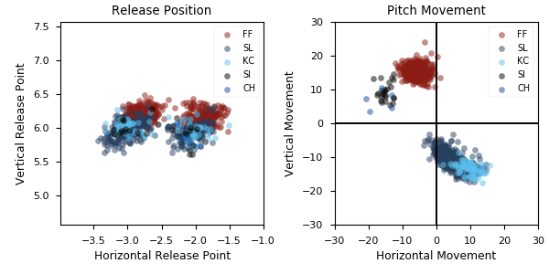

**Aresenal**

|  |  |  |  |  |  |  |  |  |
| --- | --- | --- | --- | --- | --- | --- | --- | --- |
| Pitch Type | % Thrown | Velocity (mph) | Spin Rate (rpm) | Horizontal Break (in) | Vertical Break (in) | xwOBA | wOBA | SwStr% |
| FF | 51.4 | 93.9 | 2305.0 | -5.9 | 15.5 | 0.315 | 0.261 | 15.1 |
| SL | 37.4 | 83.6 | 2550.0 | 5.0 | -11.0 | 0.37 | 0.24 | 14.5 |
| KC | 8.1 | 75.9 | 2385.0 | 9.8 | -13.5 | 0.499 | 0.489 | 8.9 |
| SI | 2.6 | 93.9 | 2430.0 | -15.0 | 9.4 | 0.535 | 0.3 | 16.0 |

* Pitch Type - FF: Four-Seam Fastball, FT: Two-Seam Fastball, SI: Sinkker, FC: Cutter, FS: Splitter, SL: Slider, CU: Curveball, KC: Knuckle-curve, CH: Changeup, FO: Forkball, SC: Screwball, KN: Knuckleball, EP: Eephus
* Velocity - recorded in miles per hour at release.
* Spin Rate - recorded in revolutions per minute at release.
* Horizontal Break - horizontal movement, in inches, of the pitch between the release point and home plate, as compared to a theoretical pitch thrown at the same speed with no spin-induced movement.
* Vertical Break - vertical movement, in inches, of the pitch between the release point and home plate, as compared to a theoretical pitch thrown at the same speed with no spin-induced movement.
* xwOBA - formulated using exit velocity, launch angle and, on certain types of batted balls, Sprint Speed.
* wOBA - a statistic, based on linear weights, designed to measure a player's overall offensive contributions per plate appearance.
* SwStr% - measures swing and miss rate based on pitch type. EX: (FF Swings and Misses)/(Total # of FF Thrown) * 100.