**Arsenal Report for Zach Wheeler**  
2019-3-20 to 2019-9-30

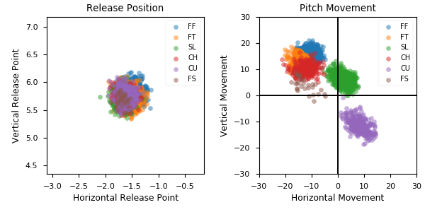

**Aresenal**

|  |  |  |  |  |  |  |  |  |
| --- | --- | --- | --- | --- | --- | --- | --- | --- |
| Pitch Type | % Thrown | Velocity (mph) | Spin Rate (rpm) | Horizontal Break (in) | Vertical Break (in) | xwOBA | wOBA | SwStr% |
| FF | 30.0 | 96.8 | 2341.0 | -10.5 | 15.5 | 0.361 | 0.292 | 11.3 |
| FT | 29.0 | 96.5 | 2256.0 | -13.9 | 12.9 | 0.377 | 0.355 | 7.5 |
| SL | 19.8 | 91.2 | 2386.0 | 2.1 | 6.3 | 0.358 | 0.279 | 11.8 |
| CH | 10.2 | 89.0 | 1771.0 | -12.4 | 10.1 | 0.329 | 0.28 | 11.5 |
| CU | 10.0 | 80.7 | 2647.0 | 8.1 | -11.5 | 0.313 | 0.263 | 9.8 |
| FS | 1.0 | 88.8 | 1383.0 | -12.4 | 4.1 | 0.289 | 0.326 | 15.6 |

* Pitch Type - FF: Four-Seam Fastball, FT: Two-Seam Fastball, SI: Sinkker, FC: Cutter, FS: Splitter, SL: Slider, CU: Curveball, KC: Knuckle-curve, CH: Changeup, FO: Forkball, SC: Screwball, KN: Knuckleball, EP: Eephus
* Velocity - recorded in miles per hour at release.
* Spin Rate - recorded in revolutions per minute at release.
* Horizontal Break - horizontal movement, in inches, of the pitch between the release point and home plate, as compared to a theoretical pitch thrown at the same speed with no spin-induced movement.
* Vertical Break - vertical movement, in inches, of the pitch between the release point and home plate, as compared to a theoretical pitch thrown at the same speed with no spin-induced movement.
* xwOBA - formulated using exit velocity, launch angle and, on certain types of batted balls, Sprint Speed.
* wOBA - a statistic, based on linear weights, designed to measure a player's overall offensive contributions per plate appearance.
* SwStr% - measures swing and miss rate based on pitch type. EX: (FF Swings and Misses)/(Total # of FF Thrown) * 100.