**Arsenal Report for Gerrit Cole**  
2019-3-20 to 2019-9-30

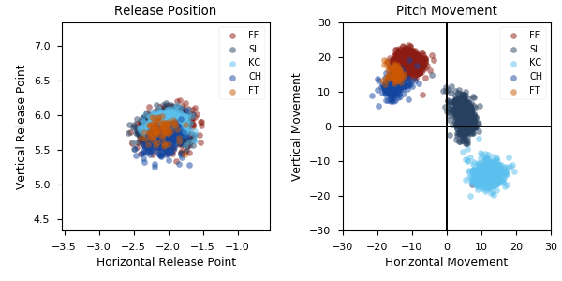

**Aresenal**

|  |  |  |  |  |  |  |  |  |
| --- | --- | --- | --- | --- | --- | --- | --- | --- |
| Pitch Type | % Thrown | Velocity (mph) | Spin Rate (rpm) | Horizontal Break (in) | Vertical Break (in) | xwOBA | wOBA | SwStr% |
| FF | 51.6 | 97.1 | 2530.0 | -11.4 | 18.4 | 0.38 | 0.264 | 17.0 |
| SL | 23.2 | 89.2 | 2622.0 | 4.9 | 3.0 | 0.332 | 0.232 | 20.1 |
| KC | 15.4 | 82.6 | 2901.0 | 11.7 | -14.0 | 0.371 | 0.273 | 8.5 |
| CH | 7.4 | 88.6 | 1870.0 | -15.3 | 11.9 | 0.308 | 0.291 | 18.4 |
| FT | 2.4 | 97.1 | 2508.0 | -15.1 | 15.5 | 0.312 | 0.292 | 6.2 |

* Pitch Type - FF: Four-Seam Fastball, FT: Two-Seam Fastball, SI: Sinkker, FC: Cutter, FS: Splitter, SL: Slider, CU: Curveball, KC: Knuckle-curve, CH: Changeup, FO: Forkball, SC: Screwball, KN: Knuckleball, EP: Eephus
* Velocity - recorded in miles per hour at release.
* Spin Rate - recorded in revolutions per minute at release.
* Horizontal Break - horizontal movement, in inches, of the pitch between the release point and home plate, as compared to a theoretical pitch thrown at the same speed with no spin-induced movement.
* Vertical Break - vertical movement, in inches, of the pitch between the release point and home plate, as compared to a theoretical pitch thrown at the same speed with no spin-induced movement.
* xwOBA - formulated using exit velocity, launch angle and, on certain types of batted balls, Sprint Speed.
* wOBA - a statistic, based on linear weights, designed to measure a player's overall offensive contributions per plate appearance.
* SwStr% - measures swing and miss rate based on pitch type. EX: (FF Swings and Misses)/(Total # of FF Thrown) * 100.