**Arsenal Report for Justin Verlander**  
2019-3-20 to 2019-9-30

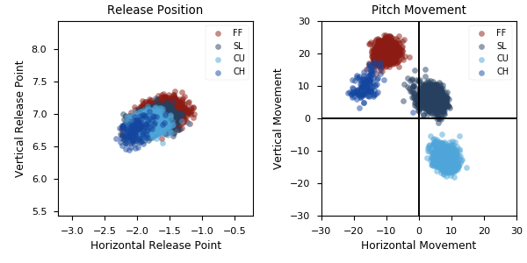

**Aresenal**

|  |  |  |  |  |  |  |  |  |
| --- | --- | --- | --- | --- | --- | --- | --- | --- |
| Pitch Type | % Thrown | Velocity (mph) | Spin Rate (rpm) | Horizontal Break (in) | Vertical Break (in) | xwOBA | wOBA | SwStr% |
| FF | 49.2 | 94.6 | 2577.0 | -10.1 | 20.6 | 0.456 | 0.357 | 14.3 |
| SL | 28.2 | 87.5 | 2612.0 | 4.1 | 6.2 | 0.272 | 0.172 | 22.0 |
| CU | 18.5 | 79.4 | 2821.0 | 7.6 | -12.3 | 0.317 | 0.228 | 7.9 |
| CH | 4.1 | 86.9 | 1866.0 | -16.3 | 10.3 | 0.238 | 0.146 | 14.0 |

* Pitch Type - FF: Four-Seam Fastball, FT: Two-Seam Fastball, SI: Sinkker, FC: Cutter, FS: Splitter, SL: Slider, CU: Curveball, KC: Knuckle-curve, CH: Changeup, FO: Forkball, SC: Screwball, KN: Knuckleball, EP: Eephus
* Velocity - recorded in miles per hour at release.
* Spin Rate - recorded in revolutions per minute at release.
* Horizontal Break - horizontal movement, in inches, of the pitch between the release point and home plate, as compared to a theoretical pitch thrown at the same speed with no spin-induced movement.
* Vertical Break - vertical movement, in inches, of the pitch between the release point and home plate, as compared to a theoretical pitch thrown at the same speed with no spin-induced movement.
* xwOBA - formulated using exit velocity, launch angle and, on certain types of batted balls, Sprint Speed.
* wOBA - a statistic, based on linear weights, designed to measure a player's overall offensive contributions per plate appearance.
* SwStr% - measures swing and miss rate based on pitch type. EX: (FF Swings and Misses)/(Total # of FF Thrown) * 100.