

|  |
| --- |
| Senior Capstone II |
| PitchMetrics Project Summary |
| In Reference to PitchMetrics Project Management Plan |

|  |  |  |  |  |  |
| --- | --- | --- | --- | --- | --- |
| Version | Implemented By: | Revision Date | Approved by: | Approval Date: | Reason: |
| 1.0 | **Jeremy Maschino** | **6/30/2019** |  |  | **Project Summary – Rough Draft** |
| 2.0 | **Jeremy Maschino** | **7/1/2019** |  |  | **Project Summary – Second Draft** |
| 3.0 | **Jeremy Maschino** | **7/4/2019** |  |  | **Project Summary – Final Draf** |

|  |
| --- |
| Jeremy Maschino  7-3-2019 |

**Table of Contents**

**Deliverables Page**

Summary Introduction p. 5

Scope Statement Summary p. 6

Timeline Summary p. 7-8

Week 1 Summary p. 9

Week 2 Summary p. 10

A/B Testing Summary p. 11-13

Week 3 Summary p. 14

Week 4 Summary p. 15

Week 5 Summary p. 16

Linear Regression Summary p. 17-18

Week 6 Summary p. 19-20

Week 7 Summary p. 21-23

DECIDE Framework p. 24-25

Week 8 Summary p. 26

Cost Summary p. 27-28

Work Breakdown Summary p. 29

Network Diagram Summary p. 30

Critical Path Summary p. 31

PERT Summary p. 32

Technology Acceptance Summary p. 33

Quality Metrics Summary p. 34-35

Testing Summary p. 36

Risk Analysis Summary p. 37

Communication Summary p. 38

Stakeholder Summary p. 39

Organizational Chart Summary p. 40

Closure Report p. 41

**Table of Figures and Tables**

**Figure/Table Page**

**Figures**

Figure 1: TI AWR 1642 Radar p. 5

Figure 2: Original Timeline p. 7

Figure 3: Updated Timeline p. 7

Figure 4: Database Visual p. 9

Figure 5: TI AWR 1642 Radar p. 9

Figure 6: Columbia Blue Banner p. 10

Figure 7: Navy Blue Banner p. 10

Figure 8: Web Application Navbar and Banner p. 10

Figure 9: Banner Input Code p. 11

Figure 10: Banner Boxplot and Code p. 11

Figure 11: Banner Means p. 12

Figure 12: perm_fun Code p. 12

Figure 13: Favorability Distribution Histogram and Code p. 12

Figure 14: T-Test p. 12

Figure 15: Small Scale Testing Plot p. 14

Figure 16: Pitch Input Interface p. 15

Figure 17: Orange Right-Handers Dataflow p. 16

Figure 18: Orange Workflow p. 17

Figure 19: Distribution of Pitches by Spin Rate p. 18

Figure 20: Interface Output p. 23

Figure 21: PitchMetrics Presentation p. 26

Figure 22: Cost Estimate vs Actual Cost Chart p. 28

Figure 23: Payback Chart p. 28

Figure 24: Network Diagram p. 30

Figure 25: Critical Path p. 31

Figure 26: Technology Acceptance Model p. 33

Figure 27: Quality Metrics Model p. 34

Figure 28: Organizational Chart p. 40

**Tables**

Table 1: Week 1 Plan p. 7

Table 2: Week 2 Plan p. 8

Table 3: Week 3 Plan p. 12

Table 4: Week 4 Plan p. 13

Table 5: Week 5 Plan p. 14

Table 6: Test Scores of Right Handers 4-Seam Fastball p. 16

Table 7: Week 6 Plan p. 17

Table 8: computeBrake Test p. 17

Table 9: brakeString Test p. 17

Table 10: veloCalc Test p. 17

Table 11: veloString Test p. 17

Table 12: srString Test p. 18

Table 13: aucCalc Test p. 18

Table 14: aucString Test p. 18

Table 15: Week 7 Plan p. 19

Table 16: spinRateCalc Test p. 19-20

Table 17: Database Test p. 21

Table 18: Week 8 Plan p. 26

Table 19: Cost Estimate p. 27

Table 20: Actual Project Cost p. 27

Table 21: PERT (Estimated vs Actual) p. 32

Table 22: Risk Analysis Matrix p. 37

Table 23: Communication Plan p. 38

Table 24: Stakeholder Power-Influence Table p. 39

**PitchMetrics Summary Introduction**

**Created by:** Jeremy Maschino **Date:** 7/2/2019

**Location:** Delano, Minnesota 55328 **Project Number:** PM1

**Introduction:** This summary contains information on the PitchMetrics project from the execution phase to closing phase. Information on previous phases can be found in the PitchMetrics Project Plan, as it will be referenced throughout the summary. This document contains summaries of key points including the scope statement, timeline/weekly progress updates, information on deliverables and how they were achieved, testing information, a cost breakdown, information on how the work breakdown structure was followed, the network diagram/Critical Path/PERT analysis, the technology acceptance model, quality metrics model, risk analysis, communication plan, organizational chart, and closing report.

These documents detail the processes taken to achieve success for the PitchMetrics project (see PitchMetrics Scope Statement Summary). PitchMetrics costed $12,929 to make (including sunk costs like the laptop I had already purchased), and therefor is much cheaper than other pitching analysis systems on the market today. Because of that, PitchMetrics meets its goal of providing a low-cost alternative to other pitching analysis systems.

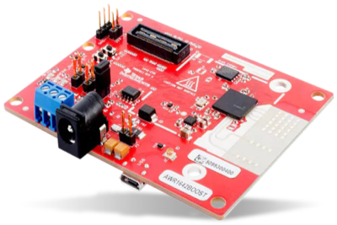

*Figure 1: TI AWR 1642 Radar*

**PitchMetrics Scope Statement Summary**

**Created by:** Jeremy Maschino **Date:** 7/1/2019

**Location:** Delano, Minnesota 55328 **Project Number:** PM1

|  |
| --- |
| Project Justification Accomplishments:  PitchMetrics meets its project justification by proving to be a low cost, alternate to systems Rapsodo and Trackman. PitchMetrics was low cost to create (~$13,000), much lower than the cost to purchase a Trackman system (~$30,000), and can be sold to the public for a lower cost than Rapsodo ($4000 plus $500/year subscription). The main goal of bringing a more cost affordable, pitch tracking system has been met. |
| Product Characteristics and Requirements:   1. User interface to gather pitch information and display pitch data to user – has been tested via DECIDE framework to ensure UI Reliability (p. 24-25). 2. Working server with database that contains pitch information, connected with interface – Tested with database tests to ensure reliability (p. 21-23). 3. Accurate Doppler Radar – Tested using small scale and full-scale tests to ensure reliability (p. 14 and Presentation video). 4. Software that interprets Doppler Radar information – tested via unit tests to ensure reliability (p. 19-20). |
| Summary of Project Deliverables  Product-related deliverables: research reports, design documents, software code, hardware.   1. Working Server – Hosted via Microsoft Azure 2. Fully functional application for end-users – Can be viewed [here](https://pitchmetrics.azurewebsites.net/). 3. Connected and functioning database – Hosted via Microsoft Azure. 4. Collected data reports – Demonstrated by the Pitch Recap Page. |
| How Project Success was Achieved:  The doppler radar implementation was a success, which gave us a good framework to start the user interface. It provides accurate data on pitches thrown, with the help of some C# code to remove noise in the CSV file produced by the radar. We were able to derive the pitch track, and velocity from the radar, following that spin rate was derived using multivariate linear regression on MLB pitch data and implemented into the web application to predict the spin rate of our user’s pitch. Microsoft Azure hosts a very scalable database, and PitchMetrics was thoroughly tested before release. |
| Summary:  PitchMetrics allows for a marketable alternative to other pitch tracking systems. In the write up and presentation that accompanies it. PitchMetrics will demonstrate how the user interface works, how the database handles data, and the tests PitchMetrics underwent before release. |

**PitchMetrics Timeline Summary**

**Created by:** Jeremy Maschino **Date:** 7/1/2019

**Location:** Delano, Minnesota 55328 **Project Number:** PM1

**Original Timeline (1/28/2019):**

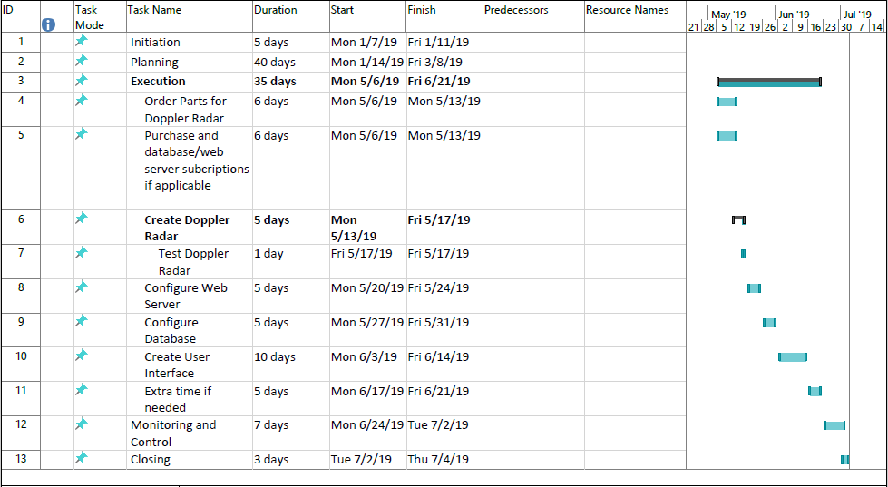

*Figure 2: Original Timeline*

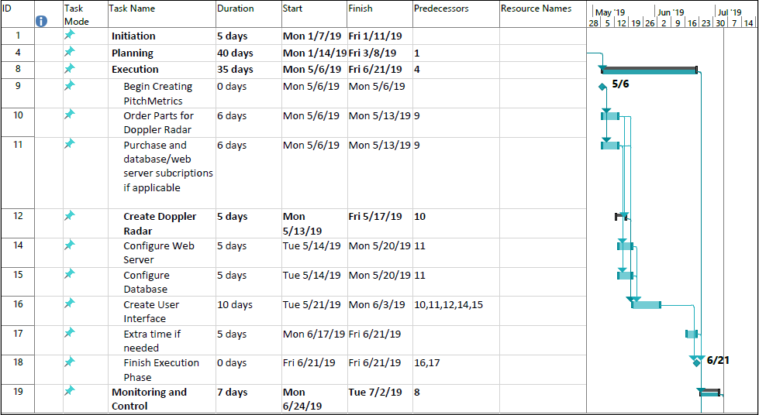**Updated Timeline (2/10/2019):**

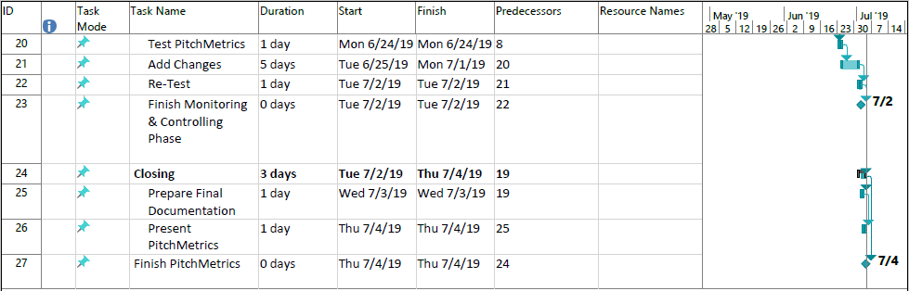

*Figure 3: Updated Timeline*

**Timeline Summary:** The timeline was changed once in project planning stage, mainly to add milestones to be accomplished. Those milestones were Begin creating PitchMetrics (accomplished on 5/13/2019), Finish Execution Phase (accomplished on 6/18/2019), Finish Monitoring and Control Phase (accomplished on 6/30/2019), and Finish PitchMetrics (accomplished on 7/4/2019). Weekly details, changes and deliverables can all be read more in detail in the weekly summaries (p. 9 -26).

**PitchMetrics Week 1 Summary**

**Created by:** Jeremy Maschino **Date:** 6/28/2019

**Location:** Delano, Minnesota 55328 **Project Number:** PM1

**Week 1 Plan:**

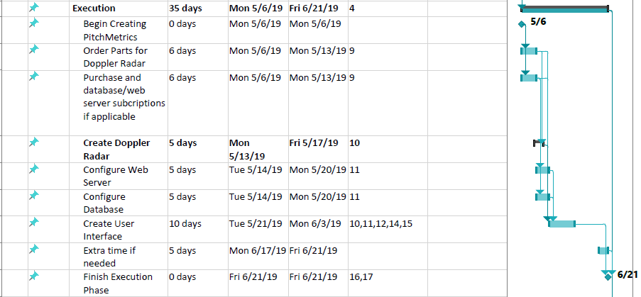

*Table 1: Week 1 Plan*

**Week 1 Summary:** All parts were ordered for Doppler Radar. Device powers on and is configured for computer. Database and web server were purchased (free student use of Microsoft Azure, but will be factored in final cost later) and configured as well. Microsoft Owin Authentication also added some database tables for user Authentication, I will supply what I did though.

**Deliverables:**

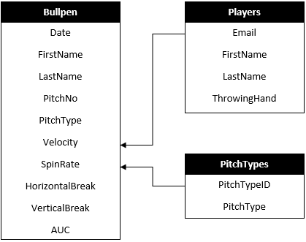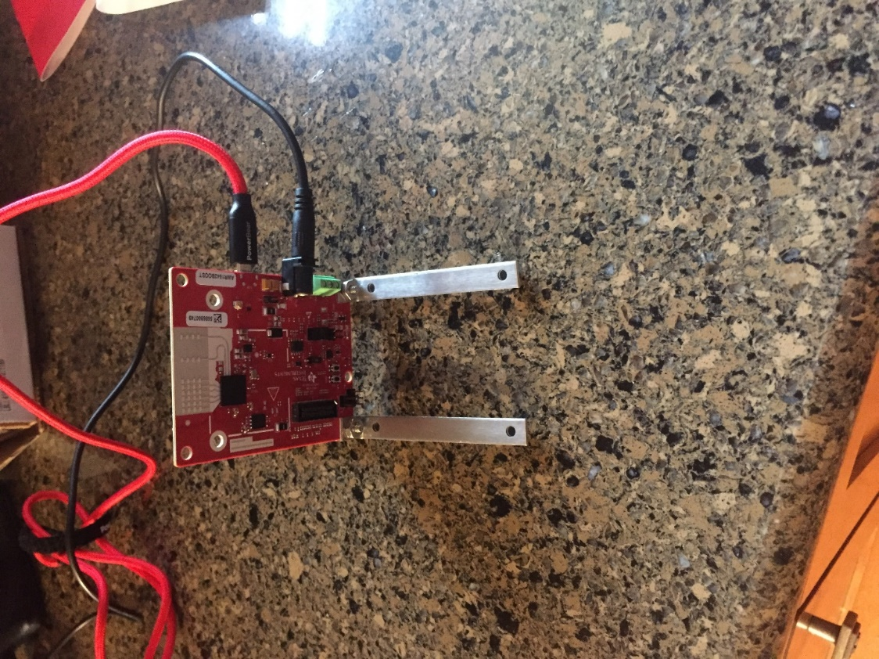

*Figure 5: TI AWR 1642 Radar*

*Figure 4: Database Visual*

**PitchMetrics Week 2 Summary**

**Created by:** Jeremy Maschino **Date:** 6/28/2019

**Location:** Delano, Minnesota 55328 **Project Number:** PM1

**Week 2 Plan:**

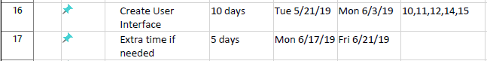

*Table 2: Week 2 Plan*

**Week 2 Summary:** User interface was started. Site.Master was worked on and began working on the home page, about page, and contact page. I did some A/B testing on a couple banners I might use for the website; results will be detailed later.

**Deliverables:**



*Figure 6: Colombia Blue Banner*



*Figure 7: Navy Blue Banner*



*Figure 8: Web Application Navbar and Banner*

*Figure 8: Web Application Navbar and Banner*

The first picture was my first idea of a banner for my user interface, and below is the second idea I had. I ran them through some A/B testing on data I collected and determined that it was statistically smarter for me to go with the navy banner. We can then see the banner implemented in the user interface. It will be displayed on all pages, but the Analysis pages.

**PitchMetrics A/B Testing Summary**

**Created by:** Jeremy Maschino **Date:** 7/2/2019

**Location:** Delano, Minnesota 55328 **Project Number:** PM1

**Overview:** This A/B test was used to decide to stay with my original banner that I had designed, or to go with a columbia blue banner that was suggested that I design. I collected data on a favorability on a scale from 1 to 10. I then used R to do A/B testing to determine if I should stick with my navy-blue banner or go with the columbia blue banner.

**Methods:** The first thing I did was import my data into R and look at it using boxplots.

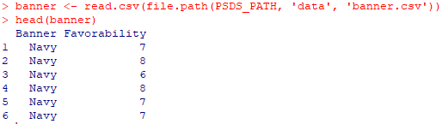

*Figure 9: Banner Input Code*



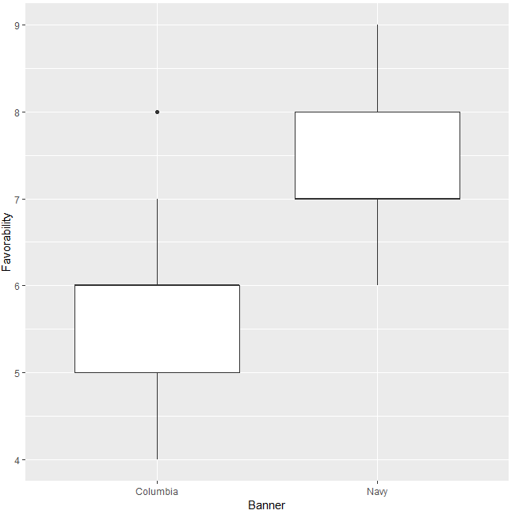

*Figure 10: Banner Boxplot and Code*

Viewing this gave me a good idea that I probably should not change my banner design from navy blue. After that, I viewed the difference in the means.

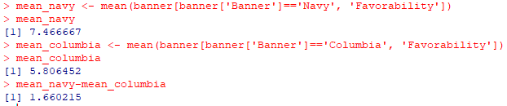

*Figure 11: Banner Means*

I then used the following function.

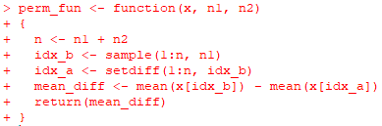

*Figure 12: perm_fun Code*

With that, I was able to produce a histogram of my distribution in differences.

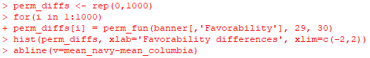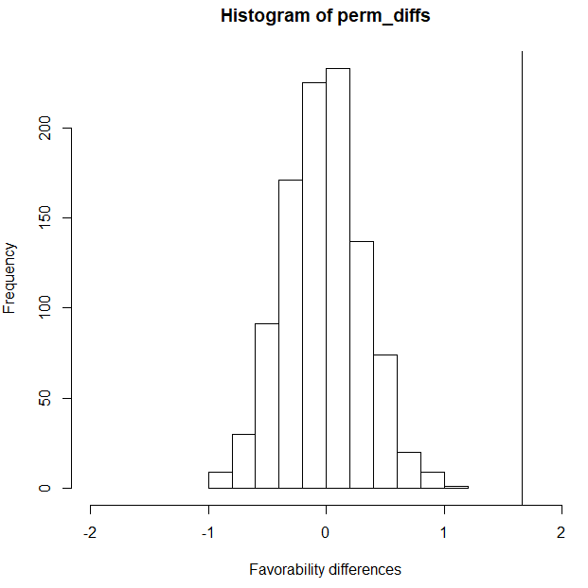

*Figure 13: Favorability Differences Histogram and Code*

*Figure 13: Favorability Differences Histogram and Code*

What I did was call the function 1000 times. The perm_fun function then sampled without replacement. I also had to specify the size of each group, navy or columbia. The line seen is our difference in our means at 1.66. We see no mean differences sampled ever exceed this, so we should use our navy-blue banner.

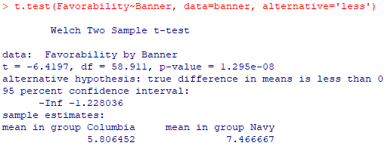

*Figure 14: T-Test*

This t-test also confirms are beliefs as the p-value demonstrates it is highly unlikely that the navy banner would be less favorable than the columbia banner.

**PitchMetrics Week 3 Summary**

**Created by:** Jeremy Maschino **Date:** 6/28/2019

**Location:** Delano, Minnesota 55328 **Project Number:** PM1

**Week 3 Plan:**



*Table 3: Week 3 Plan*

**Week 3 Summary:** The interface is close to complete. The radar was tested on its interface. The user login and register pages were created as well. Since the extra time is more than needed, the Monitoring and Control phase will be started early. Below is sample data from a pool ball on the X-Y plane.

*Figure 15: Small Scale Testing Plot*

Here is some data collected using the radar on a pool ball (roughly the same size as a baseball, much easier to do smaller scale tests). We see that the radar collects a consistent stream of data. And with this data I can create a line using a line of best fit that will represent the baseballs path. I am currently working on configuring the Z axis as well, so we will get a 3D path at the end. Once that is done, I will be able to determine velocity as I know the framerate the radar captures in and an estimated spin rate of the baseball.

**PitchMetrics Week 4 Summary**

**Created by:** Jeremy Maschino **Date:** 6/28/2019

**Location:** Delano, Minnesota 55328 **Project Number:** PM1

**Week 4 Plan:**

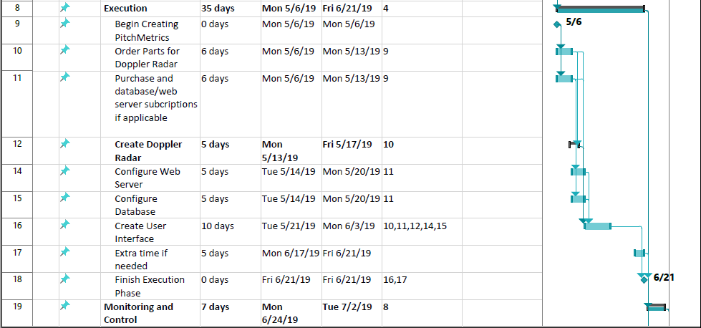

*Table 4: Week 4 Plan*

**Week 4 Summary:** Work on the user interface was done and will start to be wrapped up in the upcoming week. The Data Analysis page was worked on (below) and graphs will be added to complete the page. One more page is to be added, the Pitch Recap page, were users can view their past pitches. I also worked on some code that reads the CSV file data, created by the doppler radar, that should filter out any unwanted noise.

**Deliverables:**

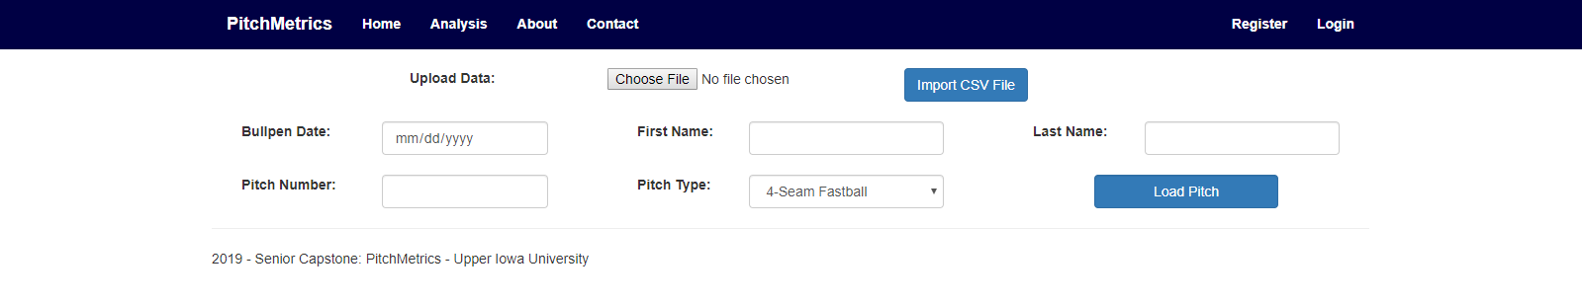

*Figure 16: Pitch Input Interface*

This design would change in the following weeks, as to show AUC, and the graphs.

**PitchMetrics Week 5 Summary**

**Created by:** Jeremy Maschino **Date:** 6/28/2019

**Location:** Delano, Minnesota 55328 **Project Number:** PM1

**Week 5 Plan:**



*Table 5: Week 5 Plan*

**Week 5 Summary:** Everything that needs to be finished is purely cosmetic for the user interface now. Linear regression was used on MLB pitch data to come up with equations to predict spin rates and was implemented into the web application. This will be detailed later in the document. Testing phase will start early.

**Deliverables:**

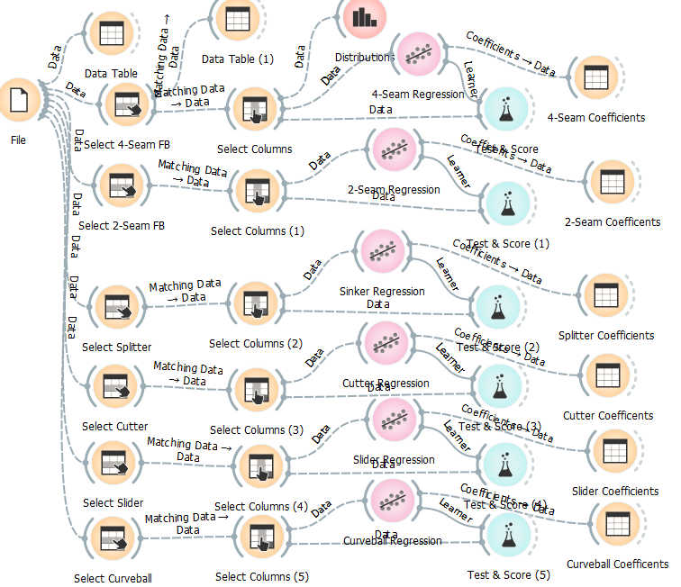

*Figure 17: Orange Right-Handed Dataflow*

Here is the some of the workflow from Orange used to data mine and implement linear regression. I had to do it on two separate files, one for right handers and one for left handers.

**PitchMetrics Linear Regression Summary**

**Created by:** Jeremy Maschino **Date:** 6/28/2019

**Location:** Delano, Minnesota 55328 **Project Number:** PM1

**Overview:** The goal of this project was to mine data on pitches from Baseball Savant, to come up with equation to use to predict the spin rate of a baseball from multivariate linear regression. I then would be implementing these equations into my Senior Capstone, to predict the spin rates of users. I used the Application Orange, as it allowed me to do data preprocessing, many different regressions at once, keep track of my workflow, and keep everything neat and organized. This goes against the grain of what other pitch trackers do as they actually measure the spin rate, but if proven effective, we could cut the cost down on producing such pitch trackers.

**Data and Model:** The data, as stated earlier is from MLB’s Baseball Savant. I actually had a couple different files to work on as the ball moves different ways, depending on what hand you throw it with. For the files, I had to do a few different preprocessing techniques to narrow the data down to what I needed. First, I did a feature reduction (this was done in MS Excel). I selected pitch_name, release_speed, release_pos_x, release_pos_z, plate_x, plate_z, and release_spin_rate. I then cleaned the data of any null values. I did this by removing the rows with null values. This should not hurt me as I have almost 40,000 records to work with for both my right handers data and left handers data. I then performed two feature constructions, by creating horizontal_break by the formula, horizontal_break = release_pos_x – plate_x, and created vertical_break by the formula, vertical_break = release_pos_z – plate_z. Now for right handers, the horizontal break will be negative and for left handers the horizontal_break will be positive. After this, I used orange to do a row selection, to select pitches that are a specific pitch type, then did a feature reduction to select only release_speed, horiztonal_break, and vertical_break to be fed to my linear regression model, with my target release_spin_rate. I selected these features as I was constrained to them due to the outputs of my radar.

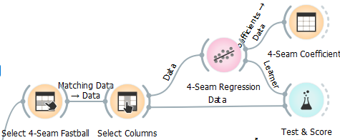

*Figure 18: Orange Workflow Example*

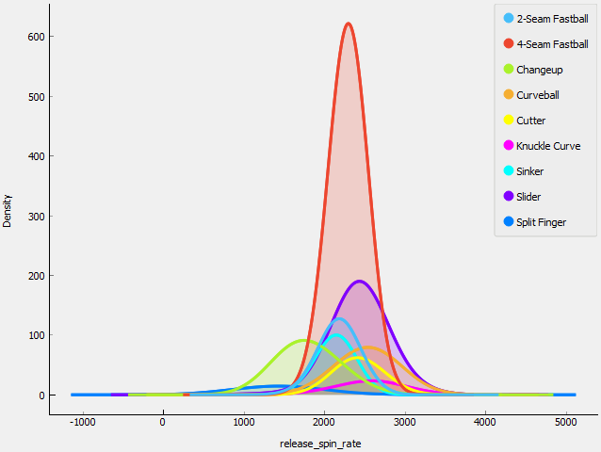

*Figure 19: Distributions of Pitches by Spin Rate*

**Results:** Although, my results aren’t great. They are much better than if I were to use a different algorithm, when testing different algorithms, linear regression always performed better than the others that inputted numeric values.

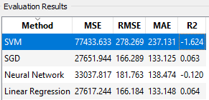

*Table 6: Test Scores of Right-Handed 4-Seam Fastball*

But what I found more helpful, was when I would input similar pitches from different handed pitchers into their respective regression equations, I would get very similar results. For example, a pitch from a right-handed pitcher that has a velocity of 93 mph, a vertical break of 3 feet, and horizontal break of negative half a foot produces around the same spin rate as a left-handed pitcher that has the same velocity, same vertical break and a horizontal break of positive half a foot.

**Conclusion:** Due to the constraints I had to deal with, using regression may not be a viable solution for my current radar. But, if I were to go forward with marketing the radar setup and web app, I would contract someone out to build a custom radar that generates more inputs, similar to Trackman. But, for now it does work as a substitute for producing spin rates.

**PitchMetrics Week 6 Summary**

**Created by:** Jeremy Maschino **Date:** 6/28/2019

**Location:** Delano, Minnesota 55328 **Project Number:** PM1

**Week 6 Plan:**



*Table 7: Week 6 Plan*



**Week 6 Summary:** Execution phase was completed and testing was started early. Some

preliminary unit testing has been done on the web application, with in depth testing following in Week 7. Full implementation of regression-based spin rates into the web application was also completed.

**Deliverables:**

*Table 8: computeBrake Test*

|  |  |  |  |  |
| --- | --- | --- | --- | --- |
| computeBrake tests | |  |  |  |
| Test No. | **List Items** | **Expected Result** | **Result** | **Notes** |
| 1 | 7.0, 4.0 | 36.00 | 36.00 | Vertical Break Either Hand |
| 2 | -1.5, 1.3 | -33.60 | -33.60 | Horizontal Break from Right Hander |
| 3 | 2.0, -0.54 | 30.48 | 30.48 | Horizontal Brake from Left Hander |

*Table 9: brakeString Test*

|  |  |  |  |  |
| --- | --- | --- | --- | --- |
| brakeString tests | |  |  |  |
| Test No. | **brake** | **Expected result** | **Result** | **Notes** |
| 1 | 12.12 | 12.12" | 12.12" | Positive Brake |
| 2 | -24.10 | -24.1" | -24.1" | Negative Brake |

*Table 10: veloCalc Test*

|  |  |  |  |  |  |
| --- | --- | --- | --- | --- | --- |
| veloCalc tests | |  |  |  |  |
| TestNo. | **xPos List** | **fNo List** | **Expected Result** | **Result** | **Notes** |
| 1 | 55.0, 51.3 | 1, 2 | 75.7 | 75.7 | Around high school average test |
| 2 | 55.0, 50.82 | 1, 2 | 85.5 | 85.5 | Around college average test |
| 3 | 55.0, 50.3 | 1, 2 | 96.1 | 96.1 | around pro average test |

*Table 11: veloString Test*

|  |  |  |  |  |
| --- | --- | --- | --- | --- |
| veloString test | |  |  |  |
| Test No. | velo | Expected Result | Result | Notes |
| 1 | 92.3 | 92.3 mph | 92.3 mph | Only need one test as the input (velocity) dictates the result |

*Table 12: veloString Test*

|  |  |  |  |  |
| --- | --- | --- | --- | --- |
| srString test | |  |  |  |
| Test No. | **spin rate** | **Expected Result** | **Result** | **Notes** |
| 1 | 2350 | 2350 rpm | 2350 rpm | Only need one test as the input (velocity) dictates the result |

*Table 13: aucCalc Test*

|  |  |  |  |  |  |
| --- | --- | --- | --- | --- | --- |
| aucCalc test | |  |  |  |  |
| Test No. | **xPos List** | **zPos List** | **Expected Result** | **Result** | **Note** |
| 1 | 55 , 44 , 33, 22, 11, 0 | 7, 6, 5, 4, 3, 2 | 247.5 | 247.5 | Linear auc approx test (trapezoid rule) |
| 2 | 55, 44, 33, 22, 11, 0 | 7, 6.75, 6.25, 5.5, 4.5, 3.25 | 309.38 | 309.38 | Quadradic auc approx test (trapezoid rule of z = -0.001x2 + 0.125x + 3.25) |

*Table 14: aucString Test*

|  |  |  |  |  |
| --- | --- | --- | --- | --- |
| aucString test | |  |  |  |
| Test No. | **AUC** | **Expected Result** | **Result** | **Note** |
| 1 | 310.34 | 310.34 ft^2 | 310.34 ft^2 | Only need one test as the input (velocity) dictates the result |

The function I did not test was the spin rate calculation function. That will be tested with the web application as it takes more than just numerical inputs from the radar, but also database inputs from pitcher hand. The aucCalc function is an integral approximation function which approximates integrals using the trapezoid rule.

**PitchMetrics Week 7 Summary**

**Created by:** Jeremy Maschino **Date:** 6/28/2019

**Location:** Delano, Minnesota 55328 **Project Number:** PM1

**Week 7 Plan:**

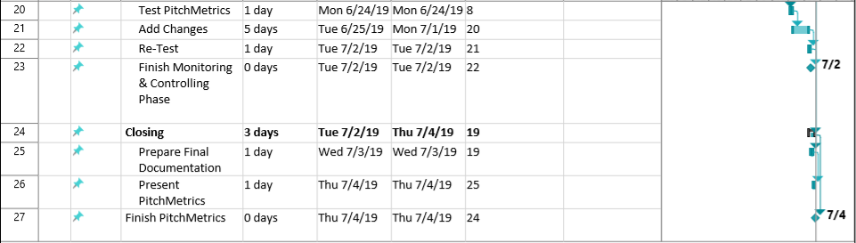

*Table 15: Week 7 Plan*

**Week 7 Summary:** Finished up all testing, making sure the calculations are sent to the spin rate function, and then everything is correctly displayed to the user. Also tested the database to make sure it was receiving the data in the correct formats, and then sending it and having it correctly displayed on the “Pitch Recap” web application page. No major changes/fixes were needed. The DECIDE Framework was to evaluate the user interface. The Monitoring and Control phase has wrapped up a day early, so we will start on the closing phase tomorrow, instead of Tuesday.

**Deliverables:**

Spin Rate Testing:

|  |  |  |  |  |  |  |
| --- | --- | --- | --- | --- | --- | --- |
| Throwing Hand | Pitch Type | Horizontal Break | Vertical Break | Velocity | Expected Spin Rate (Reg.) | Actual Spin Rate (Web App) |
| Right | 4-Seam Fastball | -1.30 | 3.10 | 102.30 | 2428 | 2428 |
| Right | 2-Seam Fastball | -0.05 | 3.19 | 93.70 | 2137 | 2137 |
| Right | Cutter | -1.95 | 2.64 | 93.70 | 2424 | 2424 |
| Right | Sinker | -3.00 | 3.29 | 93.70 | 2208 | 2208 |
| Right | Splitter | -0.35 | 5.07 | 93.70 | 1737 | 1737 |
| Right | Slider | -4.44 | 5.59 | 86.50 | 2446 | 2446 |
| Right | Curveball | -1.62 | 5.55 | 86.50 | 2510 | 2510 |
| Right | Knuckle-Curve | -3.89 | 4.48 | 86.50 | 2684 | 2684 |
| Right | Change-Up | -1.27 | 4.92 | 86.50 | 1772 | 1772 |
| Right | Knuckleball | *** | 5.02 | 80.40 | 935 | 935 |
| Left | 4-Seam Fastball | 1.30 | 3.10 | 102.30 | 2415 | 2415 |
| Left | 2-Seam Fastball | 0.05 | 3.19 | 93.70 | 2144 | 2144 |
| Left | Cutter | 1.95 | 2.64 | 93.70 | 2389 | 2389 |
| Left | Sinker | 3.00 | 3.29 | 93.70 | 2222 | 2222 |
| Left | Splitter | 1.00 | 5.30 | 93.70 | 1755 | 1755 |
| Left | Slider | 4.44 | 5.59 | 86.50 | 2226 | 2226 |
| Left | Curveball | 1.62 | 5.55 | 86.50 | 2475 | 2475 |
| Left | Knuckle-Curve | 3.89 | 4.48 | 86.50 | 2192 | 2192 |
| Left | Change-Up | 1.27 | 4.92 | 86.50 | 1853 | 1853 |
| Left | Knuckleball | *** | 5.02 | 80.40 | 935 | 935 |
|  |  |  |  |  |  |  |
| *** denotes unused attribute | |  |  |  |  |  |

*Table 17: Database Test*

*Table 16: spinRateCalc Test*

|  |  |  |  |  |  |  |  |
| --- | --- | --- | --- | --- | --- | --- | --- |
|  |  | EXPECTED RESULTS | |  |  |  |  |
| Date | Pitch Number | Pitch Type | Velocity | Spin Rate | Horizontal Break | Vertical Break | AUC |
| 6/27/2019 | 1 | 4-Seam Fastball | 102.3 | 2428 | -46.48 | 53.76 | 261.78 |
| 6/27/2019 | 2 | 2-Seam Fastball | 93.7 | 2137 | -0.65 | 38.3 | 294.92 |
| 6/27/2019 | 3 | Cutter | 93.7 | 2424 | -23.4 | 31.68 | 257.4 |
| 6/26/2019 | 1 | 2-Seam Fastball | 93.7 | 2137 | -0.65 | 38.3 | 294.92 |
| 6/26/2019 | 2 | Sinker | 93.7 | 2208 | -36 | 39.48 | 294.92 |
| 6/26/2019 | 3 | Change-Up | 86.5 | 1772 | -15.24 | 59.04 | 249.68 |
| 6/28/2019 | 1 | 2-Seam Fastball | 93.7 | 2137 | -0.65 | 38.3 | 294.92 |
| 6/28/2019 | 2 | Slider | 86.5 | 2208 | -53.26 | 67.08 | 231.25 |
| 6/28/2019 | 3 | Curveball | 86.5 | 2510 | -19.44 | 66.61 | 233.32 |
| 1/1/2018 | 1 | 2-Seam Fastball | 93.7 | 2137 | -0.65 | 38.3 | 294.92 |
| 1/1/2019 | 1 | Knuckleball | 80.4 | 935 | -12 | 60.24 | 247 |
| 1/1/2020 | 1 | Knuckle-Curve | 86.5 | 2684 | -46.68 | 53.76 | 261.78 |

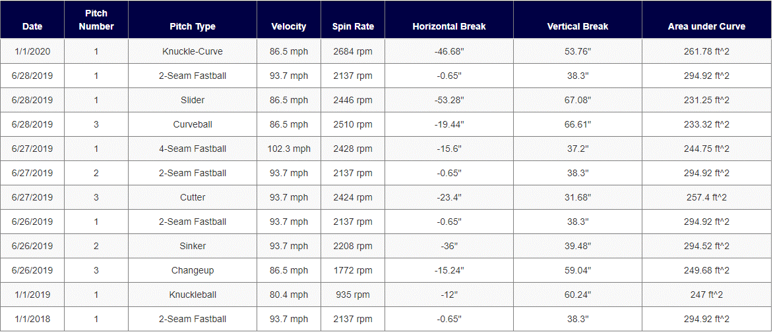

*Figure 20: Interface Output*

For the deliverables, there is two tests. The first is the spin rate testing. The spin rate function would take the velocity, horizontal break, and vertical break from their respective functions, and use the pitchers throwing hand from the Players database table to calculate a spin rate based on the pitch specified by the user. The second test is testing to see if the values were passed correctly from the database to the data table. They are sorted from the latest date, to earliest date, by default.

**DECIDE Framework**

**Created by:** Jeremy Maschino **Date:** 6/28/2019

**Location:** Delano, Minnesota 55328 **Project Number:** PM1

**DECIDE:** (D)etermine the goals, (E)xplore the questions, (C)hoose the evaluation approach and methods, (I)dentify the practical issues, (D)ecide how to deal with the ethical issues, (E)valuate, analyze, interpret and present the data.

**D:** The goal of PitchMetrics is to provide an easy to use Web Application that works with the Radar outputs to display information on pitches tracked. Ease of ease should be at the forefront as many people that will use this application will not be technically savvy. Identifying and upgrading or removing undesirable aspects as well as enhancing/maintaining our desirable aspects should be a major focus. Following this should provide us with a design that users should be accepting to.

**E:** The main question to ask when we evaluate our user experience is, what makes our experience enjoyable compared to other similar models, and how can we build off that. Questions about the software, such as, do users feel PitchMetrics offers an appealing interface and what can PitchMetrics do to improve upon their current design, must be asked.

**C:** We will use the Heuristic Evaluation method to evaluate our user interface. This allows us to evaluate our user interface faster than if we were to gather many users to test PitchMetrics. The Heuristic Evaluation Method gives us a good idea of how our user interface elements effect user experience.

**I:** A practical issue we could run into is cost. If we have to upgrade our radar, we may run the risk of going over budget. Another issue would be time. The project has a hard deadline, so missing milestones and going over soft time constraints could become very costly. Users also pose a practical issue. Going back to the ease of use idea, this user application must be easy enough to use for nontechnical people.

**D:** As for ethical issues, user information, such as name, email, and such must be safely stored in the database, and will not be distributed without their consent.

**E (Heuristic Evaluation):**

**User Control:** PitchMetrics allows the user to feel as they are in control of the application by implementing the use of buttons that control graphs and manipulate/show database contents.

**Human Limitations:** PitchMetrics does not overloud the senses by only usually visuals. All visuals are neatly sorted and are not sporatically placed all over the page as well.

**Aesthetic Integrity:**  PitchMetrics uses charts that use colors that are visually attractive as well as bold fonts where ever emphasis is needed. PitchMetrics is not a web application that uses one specific font type, weight, and size. All font matches well with each other though.

**Simplicity:** PitchMetrics demonstrates simplicity as it only asks for the radar’s CSV file, the pitch type, the date, and the pitch number, although that does auto-increment. All other inputs needed are pulled from a database or hard coded into the Web Application.

**Predictability:** PitchMetrics preforms the same for every single pitch. The only thing that will change is the graphs of each pitch as no two pitches are the same.

**Accuracy:** Per testing, PitchMetrics is an accurate and reliable. Both the Data Analysis and Pitch Recap Page display data the way they are designed to, and that data is accurately displayed from the radar.

**Flexibility:** PitchMetrics offers enough flexibility to where the application feels personal to the user, but does not offer too much flexibility to where the user gets lost.

**Consistency:** PitchMetrics performs the same for every user, and every pitch. The user inputs what is asked, and PitchMetrics outputs velocity, spin rate, horizontal break, vertical break, and area under the curve, as well as graphs of the side view and top view of the pitch.

**Interpretation:** PitchMetrics allows users to interpret their data in many different ways via a sortable data table. Interpretations of current pitch data are easy as the data is displayed the same way every time.

**Fulfillment:** PitchMetrics gives user the opportunity to access pitching analytics at a lower cost to make that similar systems. More people are now able to be marketed to.

**PitchMetrics Week 8 Summary**

**Created by:** Jeremy Maschino **Date:** 7/3/2019

**Location:** Delano, Minnesota 55328 **Project Number:** PM1

**Week 8 Plan:**

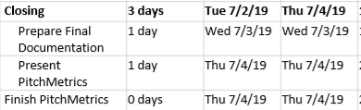

*Table 18: Week 8 Plan*

**Week 8 Summary:** This week all the closing documentation was completed. That includes this document, and the presentation that accompanies this document. No changes were needed this week, and PitchMetrics is completed on time. As of July 4th, the PitchMetrics project will be officially closed as a successful project.

**Deliverables:** This document, presentation, and the [web application](https://pitchmetrics.azurewebsites.net/).



*Figure 21: PitchMetrics Presentation*

**PitchMetrics Cost Summary**

**Created by:** Jeremy Maschino **Date:** 6/30/2019

**Location:** Delano, Minnesota 55328 **Project Number:** PM1

*Table 20: Actual Project Cost*

*Table 19: Cost Estimate*

|  |  |  |  |  |  |
| --- | --- | --- | --- | --- | --- |
|  | # Units/Hrs | Cost/Unit/Hr. | Subtotals | WBS Level 1 Totals | % of Total |
| WBS Items |  |  |  |  |  |
| Project Manager (Jeremy Maschino) | 224 | $35 | $7,840 | **$7,840** | **58.8%** |
| **1. Hardware** |  |  |  | **$1,400** | **10.5%** |
| 1.1 Laptop | 1 | $1,000 | $1,000 |  |  |
| 1.2 Doppler Radar | 1 | $400 | $400 |  |  |
| **2. Software** |  |  |  | **$4,000** | **30.0%** |
| 3.1 PitchMetrics Software Development | 200 | $20 | $4,000 |  |  |
| **3. Testing** |  |  |  | **$100** | **0.7%** |
| 3.1 Live Testing | 10 | $10 | $100 |  |  |
|  |  |  |  |  |  |
| **Total project cost estimate** |  |  |  | **$13,340** |  |

|  |  |  |  |  |  |
| --- | --- | --- | --- | --- | --- |
|  |  |  |  |  |  |
|  | # Units/Hrs | Cost/Unit/Hr | Subtotals | WBS Level 1 Totals | % of Total |
| WBS Items |  |  |  |  |  |
| Project Manager (Jeremy Maschino) | 224 | $35 | $7,840 | **$7,840** | **58.8%** |
| **1. Hardware** |  |  |  | **$1,325** | **9.9%** |
| 1.1 Laptop | 1 | $1,000 | $1,000 |  |  |
| 1.2 Doppler Radar | 1 | $325 | $325 |  |  |
| **2. Software** |  |  |  | **$3,600** | **27.0%** |
| 3.1 PitchMetrics Software Development | 180 | $20 | $3,600 |  |  |
| **3. Testing** |  |  |  | **$120** | **0.9%** |
| 3.1 Live Testing | 12 | $10 | $120 |  |  |
| **4. Hosting** |  |  |  | **$44** | **0.3%** |
| 4.1 Web Application Hosting | 504 | $0.08 | $40 |  |  |
| 4.2 Database Hosting | 504 | $0.008 | $4 |  |  |
| **Total actual project cost** |  |  |  | **$12,929** |  |

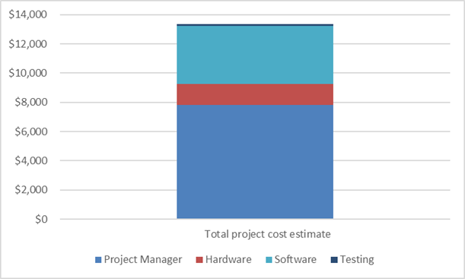 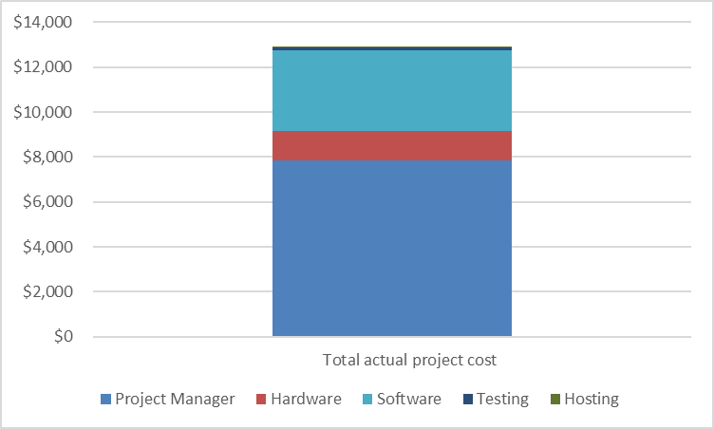

*Figure 22: Cost Estimate vs Actual Cost Chart*

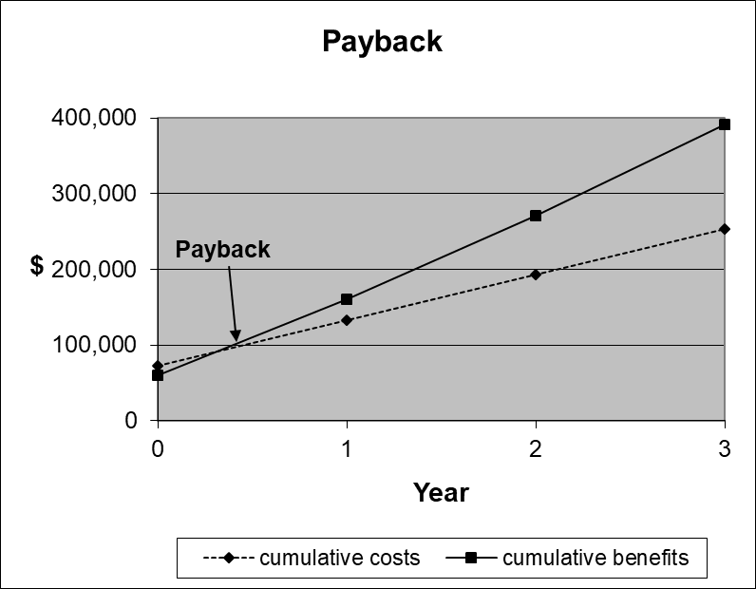

*Figure 23: Payback Chart*

**Summary:** Here is a view of the estimated cost, and the actual cost. Even though Web Application Hosting, and Database hosting were added, the project was still $411 under what was estimated. This is because the software development didn’t take as long and the radar did not cost as much as estimated for. Below is a visual that demonstrates this. I also updated the payback chart, PitchMetrics should make its money before the end of the first year. I factored in cost of creating it, and cost of maintaining it each year.

**PitchMetrics Work Breakdown Summary**

**Created by:** Jeremy Maschino **Date:** 7/1/2019

**Location:** Delano, Minnesota 55328 **Project Number:** PM1

**# WBS Item: Date Accomplished**

1. **Initiation:** Done in Senior Capstone I

**1.1 Introduce PitchMetrics:** Done in Senior Capstone I

1. **Planning:** Done in Senior Capstone I

**2.1 Project planning documentation:** Done in Senior Capstone I

**2.2 Engage stakeholders:** 1/13/2019 – 7/4/2019

1. **Execution:** 5/13/2019 – 6/18/2019

**3.1 Order Parts for Doppler Radar:** 5/13/2019 – 5/17/2019

**3.2 Purchase database/web server subscription if applicable:** 5/14/2019 – 5/16/2019

**3.3 Create Doppler Radar:** 5/18/2019

**3.3.1 Test Doppler Radar:** 5/19/2019 – 5/20/2019

**3.4 Configure Web Server:** 5/17/2019 – 5/20/2019

**3.5 Configure Database:** 5/17/2019 – 5/20/2019

**3.6 Create User Interface:** 5/21/2019 – 6/18/2019

1. **Monitoring and Control:** 6/19/2019 – 6/30/2019

**4.1 Test PitchMetrics:** 6/19/2019 – 6/30/2019

**4.2 Add any changes (if needed):** 6/19/2019 – 6/30/2019

**4.3 Re-Test:** 6/19/2019 – 6/30/2019

1. **Closing:** 7/1/2019 – 7/4/2019

**5.1 Prepare F­inal Documentation:** 7/1/2019 – 7/3/2019

* 1. **Present PitchMetrics:** 7/4/2019

**Summary:** The original WBS followed the Gantt chart created in the project management plan. Here, I provided a detailed view on when everything was done. Most of the 1.0 and 2.0 items were done in Senior Capstone I, but 2.1 was accomplished throughout the project. Most of the WBS items follow each other sequentially, but there were a few outlines. In the Execution phase, I was able to do 3.1 – 3.5 around similar time periods of each other. For the Monitoring and Control phase, testing, adding changes and re-testing was all done sequentially for each test I did, so each item lasted the whole phase.

**PitchMetrics Network Diagram Summary**

**Created by:** Jeremy Maschino **Date:** 7/1/2019

**Location:** Delano, Minnesota 55328 **Project Number:** PM1

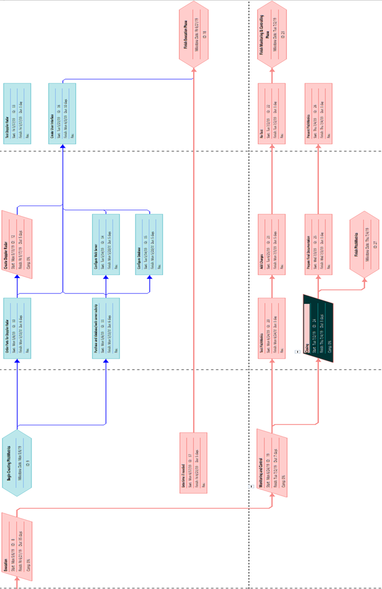

*Figure 24: Network Diagram*

**Summary:** The Network diagram was based off of the Gantt Chart/Timeline and WBS created for the Project Management plan. It was closely followed as, after the first week of ordering and configuring the database, radar, web server, most of the items in the WBS that needed to be completed sequentially.

**PitchMetrics Critical Path Summary**

**Created by:** Jeremy Maschino **Date:** 7/1/2019

**Location:** Delano, Minnesota 55328 **Project Number:** PM1

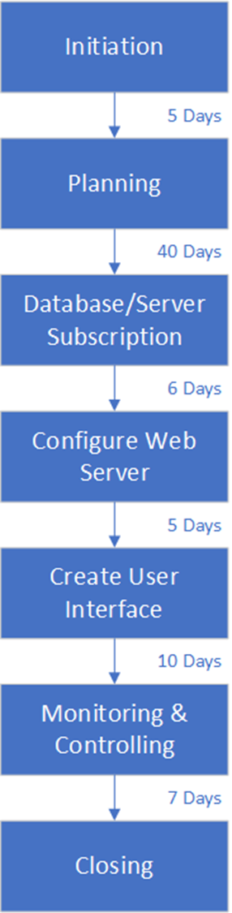**Summary:** Here is the critical path created based off the Network Diagram from the Project Management Plan. We have our critical path and then in the blue font was the estimate time it would take to complete each critical path component. In the red font, is the actual number of days it took to complete the critical path component. Even though I went over time on “Create User Interface” I accomplished the execution phase early as I had extra time built into my schedule. This allowed me to start on my “Monitoring and Controlling” phase and take more time to do that as well. I Also was able to take more time on my “Closing” phase as I was ahead of my actual schedule still. For Senior Capstone II, I started at Database/Server Subscription so my total time estimated to follow my critical path was 28 days and my actual time was 52, but as I had so much extra time built into my project, I still finished the “Execution” and “Monitoring and Controlling” phase early.

4 Days

5 Days

12 Days

28 Days

4 Days

3 Days

40 Days

5 Days

*Figure 25: Critical Path*

**PitchMetrics PERT Analysis Summary**

**Created by:** Jeremy Maschino **Date:** 7/1/2019

**Location:** Delano, Minnesota 55328 **Project Number:** PM1

*Table 21: PERT (Estimated vs Actual)*

|  |  |  |  |  |  |
| --- | --- | --- | --- | --- | --- |
| Task | Optimistic (Days) | Most Likely (Days) | Pessimistic (Days) | Actual (Days) |  |
| Initiation | 3 | 5 | 7 | 5 |  |
| Planning | 33 | 40 | 47 | 40 |  |
| Order Parts for Doppler Radar/Web Subscription | 4 | 6 | 8 | 5 |  |
| Create/Test Doppler Radar | 3 | 5 | 7 | 3 |  |
| Configure Web Server/Database | 3 | 5 | 5 | 4 |  |
| Create User Interface | 8 | 10 | 12 | 28 |  |
| Extra Time | 7 | 5 | 3 | 0 | <- Removed and split between user interface and testing |
| Monitoring and Control | 5 | 7 | 9 | 12 |  |
| Closing | 2 | 3 | 4 | 5 |  |
| Completion | **68** | **86** | **102** | **102** | **Days** |

**Summary:** Even though I ended up around the same number of days as my pessimistic estimation, that is because I used my extra “extra time” to start my testing 4 days early and gave myself another day to work on my closing. If I would have not done that, the amount of days it would have taken me to complete the project would have been 97. Keep in mind, this also factors in work done in Senior Capstone I as well.

**PitchMetrics Technology Acceptance Summary**

**Created by:** Jeremy Maschino **Date:** 7/1/2019

**Location:** Delano, Minnesota 55328 **Project Number:** PM1

*Figure 26: Technology Acceptance Model*

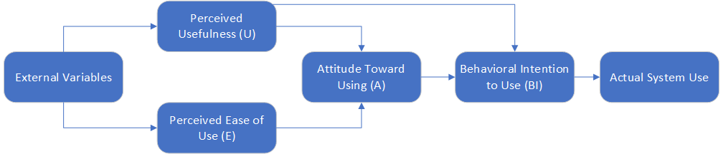**Summary:**  Above is the Technology Acceptance Model created for the Project Management Plan. How each component is achieved will be described. External variables such as the current market are favorable, especially this year. People are willing, now, more than ever to go purchase analytical systems like PitchMetrics. The perceived usefulness is high as PitchMetrics accomplishes implementing pitching analytics though the use of the radar and web application. The ease of use is accomplished, as once the user signs up, they only have to import their pitch CSV files and then select the pitch type for their pitch information to be saved. Then to save the pitch to the database, they just need to enter the date, and the pitch number, if it is different than the auto-incrementing pitch counter. To view past pitches, all they have to do is go to the pitch recap page and it sorts pitches by date. The attitude towards using is exceptional, some of the stakeholders I have talked to here in Delano would like to start trying out the finished product upon completion of Senior Capstone II. The Behavioral Intention to Use is fulfilled as PitchMetrics has been tested and is reliable for its intended purpose. Upon rolling out PitchMetrics, its actual use should be high, it provides ease-of-use, perceived usefulness, a good attitude towards using, behavioral attention to use, all well in a good market to advertise PitchMetrics.

**PitchMetrics Quality Metrics Summary**

**Created by:** Jeremy Maschino **Date:** 7/1/2019

**Location:** Delano, Minnesota 55328 **Project Number:** PM1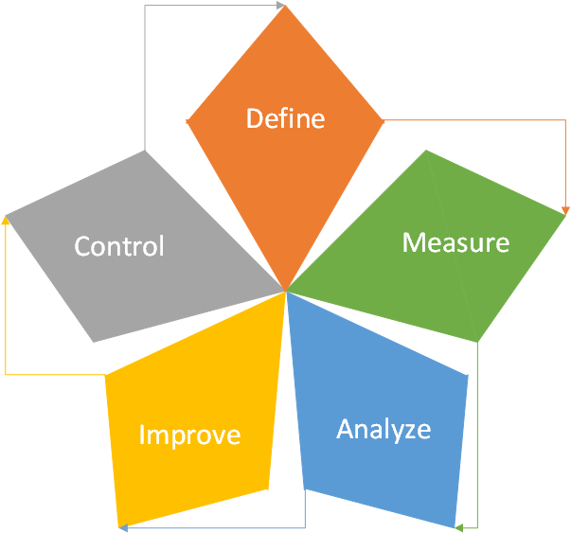

*Figure 27: Quality Metrics Model*

**Summary:** Above is the model I followed to assure the quality of PitchMetrics. I started with Define. The problem I defined was that there was not an affordable pitching analytical system available. I measured this by looking at the cost of current systems (Trackman and Rapsodo), and noticing that only high-budget baseball programs (MLB Baseball Teams, NCAA Division I and some Division II teams) could afford these. These teams do not make up the majority of baseball programs though. With an affordable pitching analysis system, we could reach all levels of baseball competitive baseball, from high school, to professional. Following that I analyzed current pitching analysis systems to see what I would want to implement into PitchMetrics. Following completing the user interface, I improved upon it via testing. I made sure accurate information was being displayed (unit testing/database testing) and the user interface was acceptable (DECIDE Framework). PitchMetrics is now in the controlling phase of quality metrics, where the current solution is being maintained and ready to implement new solutions to problems as they are brought in.

**PitchMetrics Testing Summary**

**Created by:** Jeremy Maschino **Date:** 7/1/2019

**Location:** Delano, Minnesota 55328 **Project Number:** PM1

**Approach:** The approach was slightly altered from the Project Management Plan. Instead of taking the Doppler Radar to a baseball field to test to make sure every single attribute was working, I was able to create pitch recreations like the doppler radar would output and then use those to test PitchMetrics thoroughly.

**Item Pass/Fail:** All items pass their respective tests after testing. No reduction of features needed.

**Deliverables (Below):**

**User-Interface:** Part of the user interface testing was done using the DECIDE Framework (p. 24-25). The other part was done using Microsoft Visual Studio’s unit testing. Those can be seen in the Week 6 Summary (p. 19-20).

**Database/Network:** Database testing was done in Week 7 (p. 21-23).

**Radar:** See Presentation demonstration for end result of radar testing (video).

**Cost:** See PitchMetrics Cost Summary

**Schedule:** See PitchMetrics Timeline Summary or Weekly Summaries

**Risks:** Risks were negated using the PitchMetrics Risk Analysis Plan created for the Project Management plan. Potential problems were avoided.

**PitchMetrics Risk Analysis Summary**

**Created by:** Jeremy Maschino **Date:** 7/1/2019

**Location:** Delano, Minnesota 55328 **Project Number:** PM1

*Table 22: Risk Analysis Matrix*

|  |  |  |  |  |
| --- | --- | --- | --- | --- |
|  | Negligible | Marginal | Critical | Catastrophic |
| Certain |  |  |  |  |
| Likely |  |  |  |  |
| Possible |  | Rain | Light injury (pitcher or catcher) during testing | Doppler radar isn’t accurate enough to work with high-velocity |
| Unlikely | Security Breach |  | Moderate injury (pitcher or catcher) during testing | Baseball hits PitchMetrics system |
| Rare | Preferred test site is unavailable | PitchMetrics is not deemed useful by consumers | Unable to find pitcher or catcher with listed requirements | Severe injury (pitcher or catcher) during testing |

**Summary:** Using the Risk Analysis Matrix (above) created for the Project Management Plan, I was able to mitigate risks, while still test and implement changes during testing. I was able to avoid all injuries during testing as most of my testing was done by simulating pitches. This reduced the number of pitches that actually had to be thrown and I was able to test PitchMetrics myself. It did rain, but that wasn’t an issue as I was able to move my outdoor test to the next day. The doppler radar does work and I was able to avoid having it hit in testing as it can sit behind a screen and still get pitch data. I have not had any security breaches, and am confident in Microsoft Azure that they will protect user integrity as they are hosting my database and web application.

**PitchMetrics Communication Summary**

**Created by:** Jeremy Maschino **Date:** 7/1/2019

**Location:** Delano, Minnesota 55328 **Project Number:** PM1

*Table 23: Communication Plan*

|  |  |  |  |
| --- | --- | --- | --- |
| Communication | Frequency | How it was Accomplished | Owner |
| Project Team |  |  |  |
| Project status report | Weekly | Reviewed weekly status by submitted weekly status report and discussing weekly status with stakeholders. | Project Manager |
| Project review | At milestones | Deliverables are presented weekly with milestone deliverable presented on in closing presentation. | Project Manager |
| Post-project meeting | At end of project | Referred to project closing and presentation | Project Manager |
| Project Sponsor |  |  |  |
| Project status report | Weekly | Reviewed weekly status by submitted weekly status report and discussing weekly status with stakeholders. | Project Manager |
| Project review | At milestones | Deliverables are presented weekly with milestone deliverable presented on in closing presentation. | Project Manager |
| External Stakeholders |  |  |  |
| End User Feedback | After Testing | Provided feedback on PitchMetrics after testing, as well as throughout the whole project process. | Project Manager |
| Post-project meeting | At end of project | Referred to project closing and presentation | Project Manager |

**Summary:** As I am the only one working on the Project, it was my job to simulate each of the communication roles a project would have. I did this though the use of weekly reports, discussions on change, discussions on weekly reports, deliverables, and presentations.

**PitchMetrics Stakeholder Summary**

**Created by:** Jeremy Maschino **Date:** 7/1/2019

**Location:** Delano, Minnesota 55328 **Project Number:** PM1

*Table 24: Stakeholder Power-Influence Table*

|  |  |  |  |
| --- | --- | --- | --- |
| Position Title | Staff Name | Power (1-5) | Interest |
| Project Sponsor | Dr. James Jacobs | 5 | 5 |
| Project Manager | Jeremy Maschino | 5 | 5 |
| Delano Athletics Baseball Club Sponsor | Ryan Hayes | 1 | 2 |
| DYBSA Representative | Dan Rassmusen | 2 | 4 |
| DYBSA Representative | Darren Knight | 1 | 5 |
| DYBSA Representative | J.T. Bruett | 3 | 3 |
| DYBSA Representative | Greg Maschino | 1 | 5 |

**Summary:** Above is a Power-Interest Matrix of my stakeholders for the project. My most powerful and influential stakeholders received weekly updates/changes/deliverables and the most information I could provide them as they are the most important people to PitchMetrics. Stakeholders with higher power and less of an interest (J.T. Bruett) were also keep in a tighter circle of information. Stakeholders with less power were also kept in the loop, but did not require write-ups and such. deliverables at milestones was enough to keep them interested. Then low power, low interest stakeholders were kept in the loop by deliverables or a word-of-mouth summary if deliverables were not available to be presented at the time. All stakeholders will at least see a demonstration of PitchMetrics, and the most powerful ones will also see the presentation as well.

**PitchMetrics Organizational Chart Summary**

**Created by:** Jeremy Maschino **Date:** 7/1/2019

**Location:** Delano, Minnesota 55328 **Project Number:** PM1

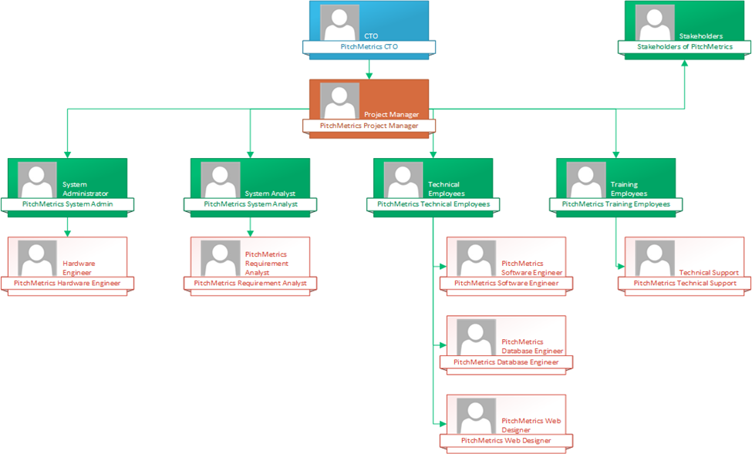

*Figure 28: Organizational Chart*

**Summary:** Going forward, if I were to decide to grow PitchMetrics into something larger, here is the organizational chart I would follow to hire technical employees. I would assume the role of owner and hire a dedicated CTO who would oversee the project manager. The project manager would oversee a System Administrator, System Analyst, Technical Employees, and Technical Support as well as manage stakeholders. The System Administrator would oversee our hardware engineer as we would need to hire someone to create a dedicated radar for PitchMetrics. Our systems analyst would oversee someone who gathers requirements needed and data on what we should implement (Requirements analyst). On the technical side, we would get a software engineer, a database engineer and web developer. We would also hire customer support to deal with problems from PitchMetrics users.

**PitchMetrics Project Closure Report**

**Created by:** Jeremy Maschino **Date:** 7/1/2019

**Location:** Delano, Minnesota 55328 **Project Number:** PM1

**Summary:** PitchMetrics is a pitching analysis system that provides a low-cost solution to users. It implements the use of a radar, to output velocity, horizontal break, vertical break, a regression-based spin rate, area under the curve in the X-Z plane, and two 2D graphs that display the pitch path in the XY and XZ plane. PitchMetrics also saves pitches in a database for to provide a historical view on past pitches.

**Scope Objectives:** The scope statement describes that PitchMetrics will deliver a working server, a fully functional application for end-users, connected and functioning database, and collected data reports. PitchMetrics delivers a working server and connected and functioning database through the use of Microsoft Azure. The fully functioning database can be viewed at [here](https://pitchmetrics.azurewebsites.net/). Collected data reports can be viewed in the pitch recap page for pitches.

**Quality Objectives:** DECIDE Framework was used to evaluate and approve the user interface. Unit testing through Microsoft Visual Studio was done to ensure accurate results. The Define, Measure, Analyze, Improve and Control Quality Metrics Star was used to assure quality during the execution phase, and continue assuring quality after rolling out PitchMetrics.

**Cost Objectives:** In the Project Management Plan, the cost to create PitchMetrics was $13,340, and the actual cost was $12,929. We were able to come in $411 under our estimated cost. If we were to market the solution as is, PitchMetrics would have to pay someone to maintain it as seen in the payback chart, but PitchMetrics should make its money back within a year.

**Lessons Learned:** From the execution phase, to closing phase, PitchMetrics has been an exciting project to work on. I found ways to implement regression into my PitchMetrics, as well as implement integration as well using C#. I learned that following a project plan helps greatly in doing a project, as it helped me stay on track and finish my project in time. This project would have been much more stressful if I did not have a timeline to follow. Overall, I am happy with what I have accomplished throughout the 8 weeks of the Senior Capstone II.

**Going Forward:** Find a company that can build me a radar dedicated to baseball, or look into using high speed cameras as MLB is now shifting to the Hawkeye System (computer vision) in 2020. Currently ball flight data is the only data that is not tracked via cameras in MLB. Depending on the cost of high-speed cameras (240 frames per second, or greater), that may be a route to explore rumors of doppler radars were starting the process of get phased out surfaced around Week 3 of my senior capstone.