This document gives a comprehensive overview of the analysis results for the banking application, utilizing screenshots from SonarQube for code quality and security analysis, and CircleCI for continuous integration and deployment pipelines.

SonarQube Analysis
SonarQube is used to perform static code analysis to detect bugs, vulnerabilities, and code smells in the codebase.

Projects Overview
The initial SonarQube dashboard shows two projects: APDST311_Group_5/secure-bank-api and APDST311_Group_5/secure-bank-client. Both projects have a "Failed" quality gate status.
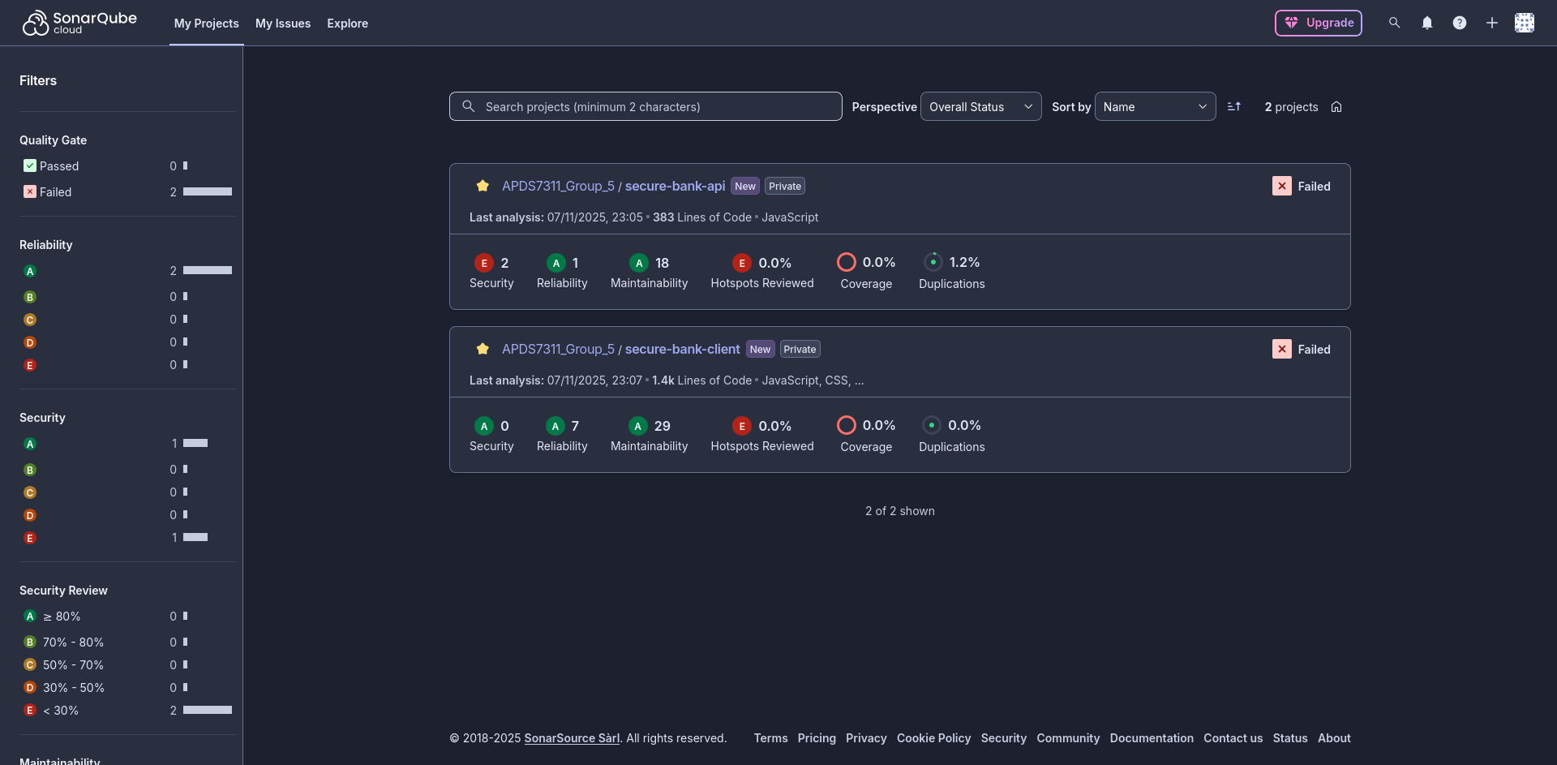

secure-bank-api Analysis

Project Overview
The secure-bank-api project overview indicates that the main branch has failed its quality gate. The primary reason for the failure is "0.0% Coverage on New Code," where the requirement is at least 80.0%.
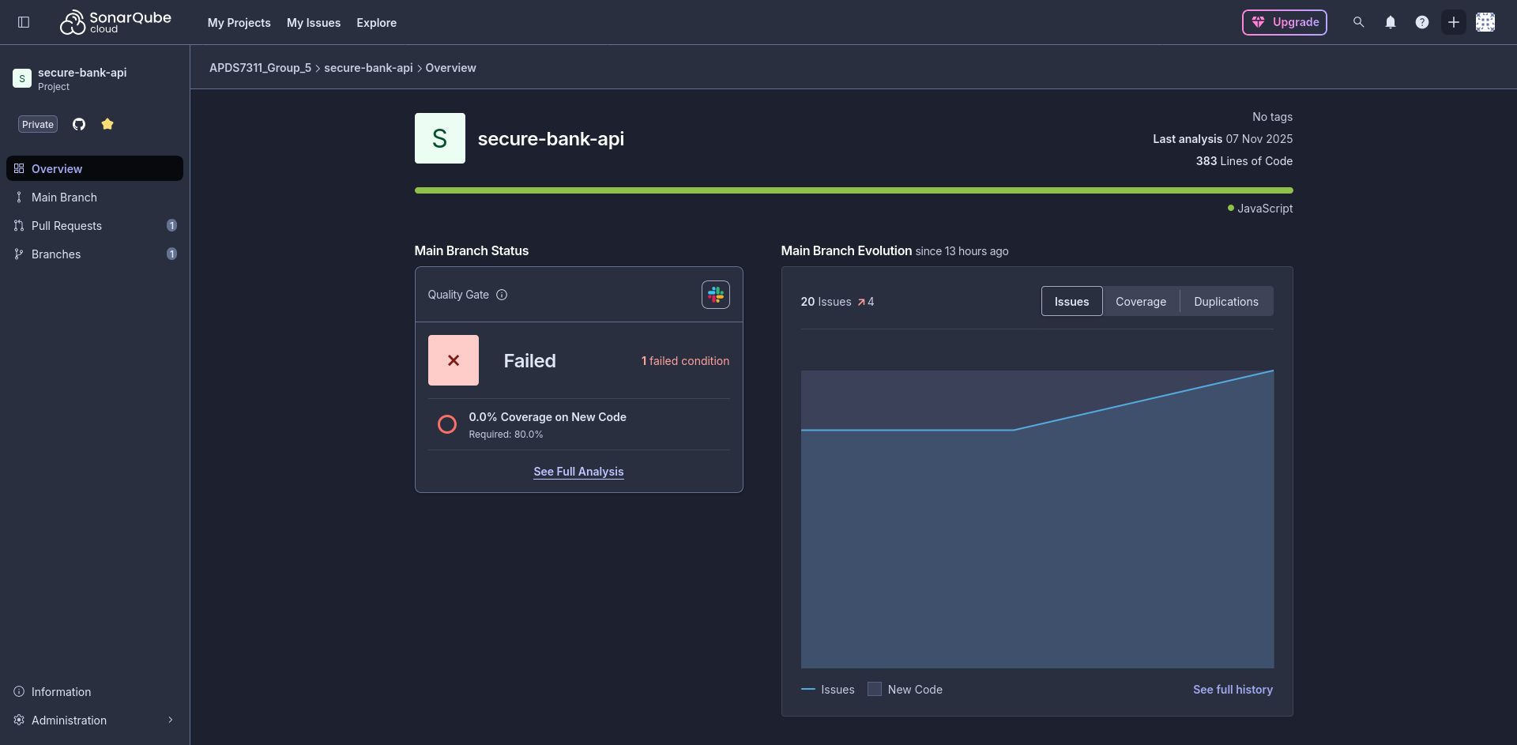

Main Branch Summary
New Code:
The "New Code" tab for the main branch shows one failed condition related to code coverage. There are 5 new issues identified.
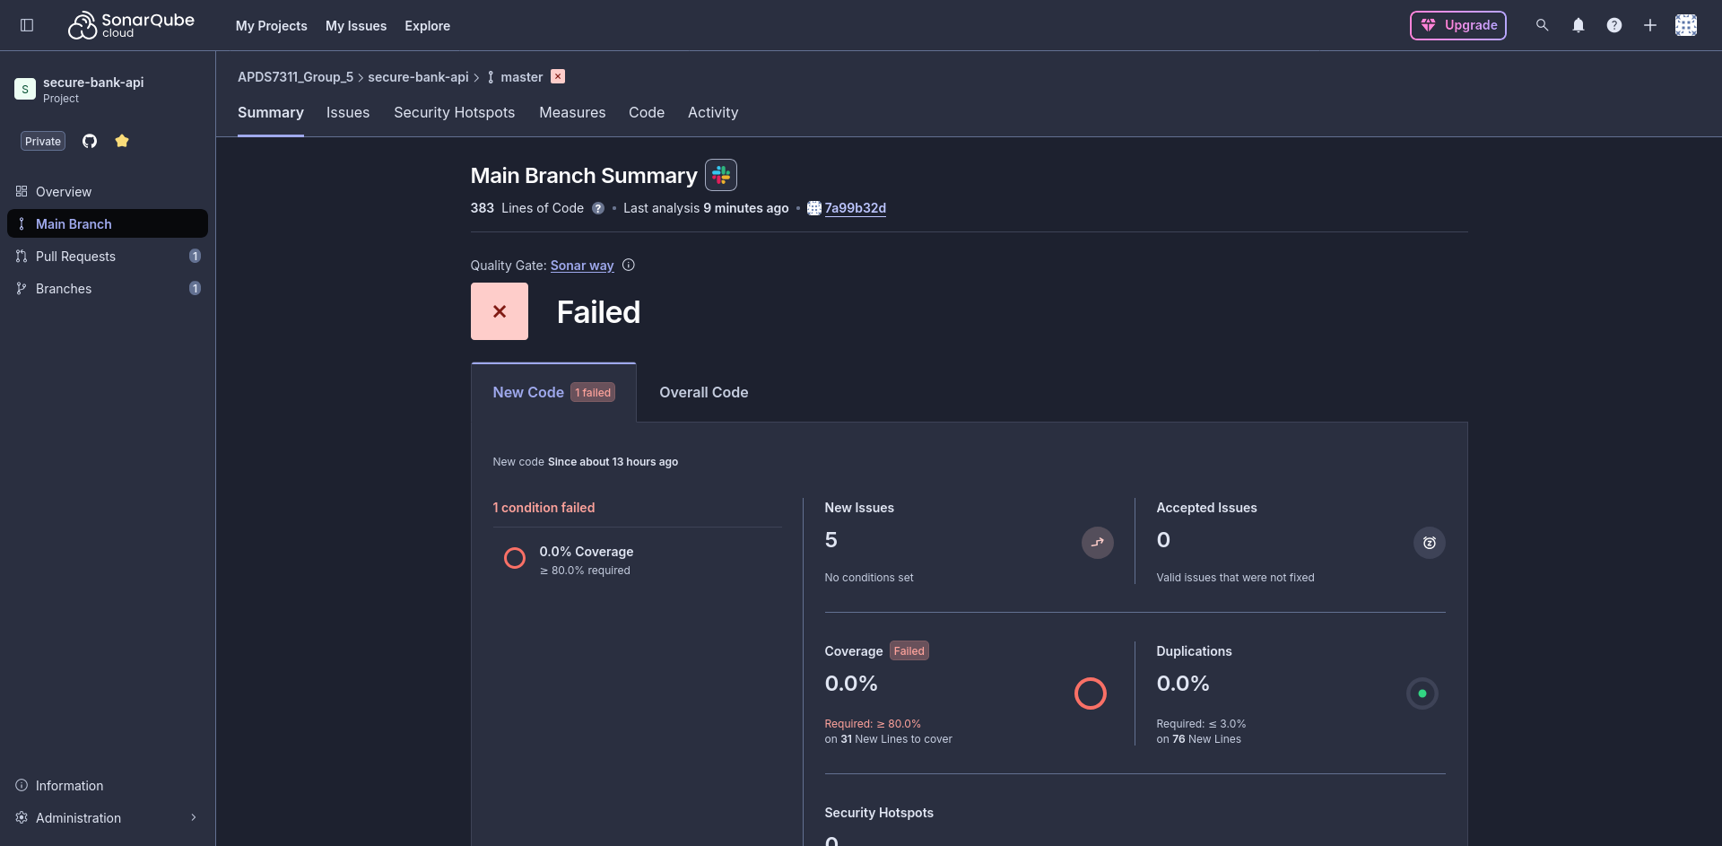

Overall Code:
The "Overall Code" tab reveals 2 open security issues, 1 reliability issue, and 18 maintainability issues. It also highlights 5 security hotspots that require review.
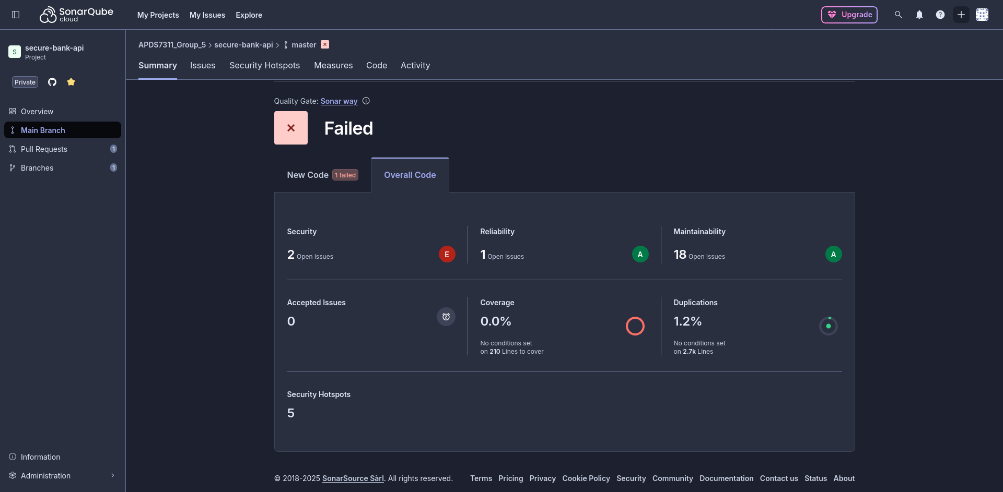

Issues
The detailed "Issues" view lists specific problems found in the code. Notably, there are blocker-level security issues related to private keys (certs/key.pem and certs/server.key) being present in the codebase. Other issues include unhandled exceptions.
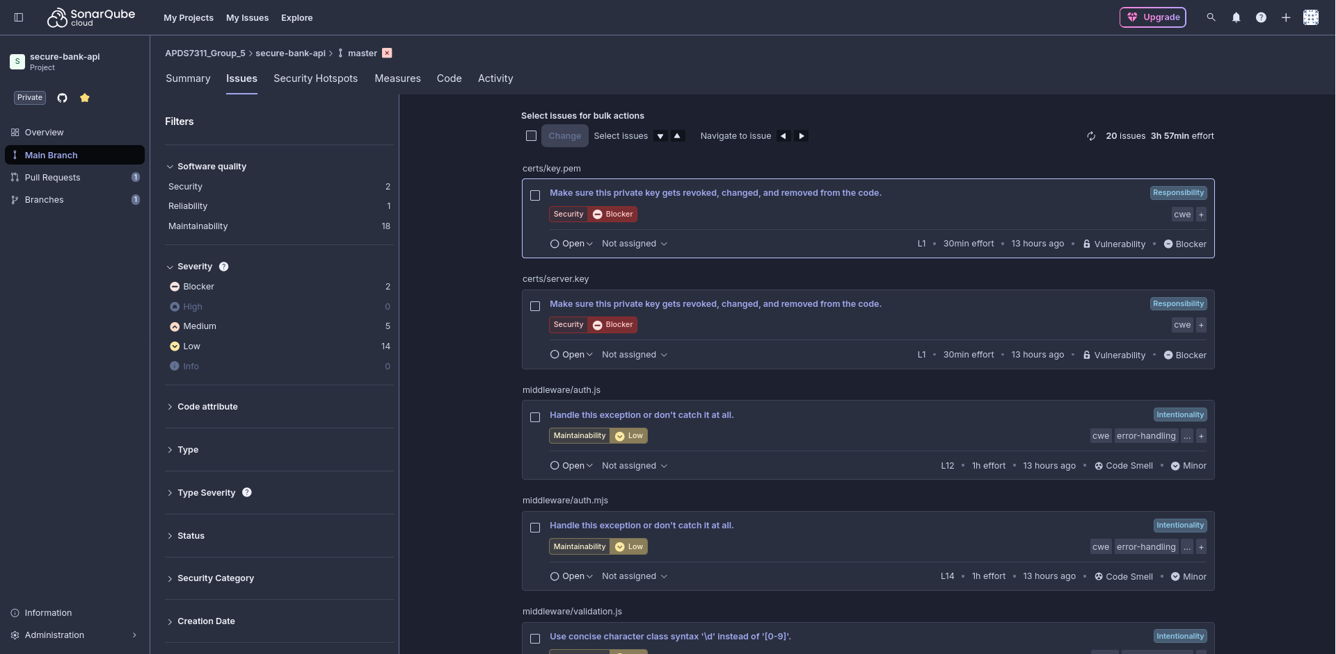

Security Hotspots
The "Security Hotspots" tab points out a low-priority review item concerning Cross-Origin Resource Sharing (CORS) settings in server.js, suggesting to "Make sure that enabling CORS is safe here."
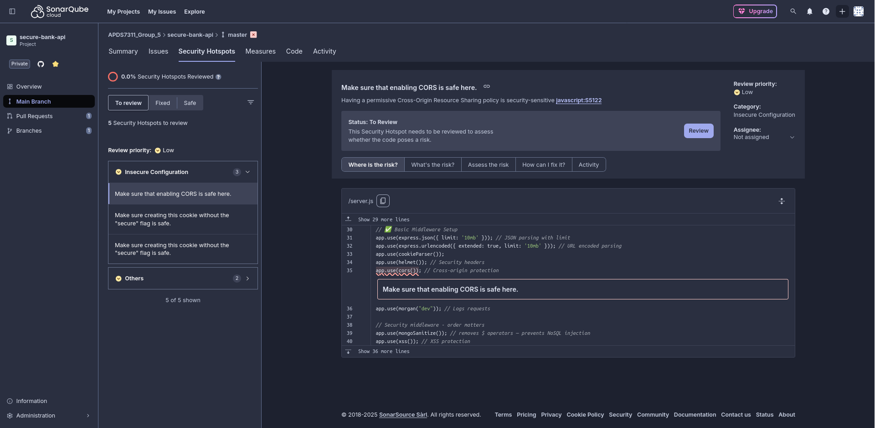

Measures
The "Measures" view provides a graphical representation of the project's health, showing the distribution of issues and technical debt.
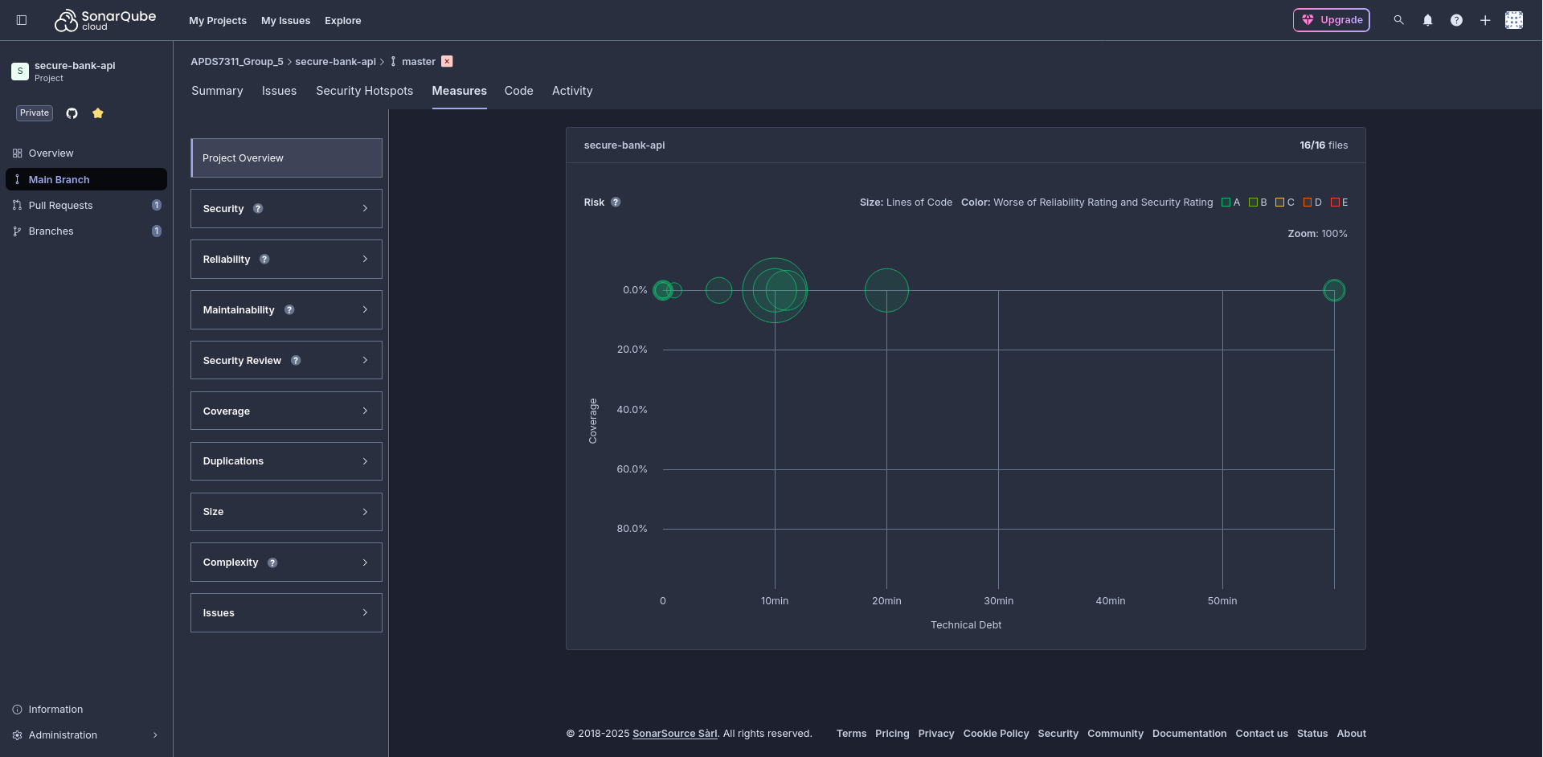

secure-bank-client Analysis

Project Overview
Similar to the API project, the secure-bank-client also has a "Failed" quality gate, with the reason being "0.0% Coverage on New Code" against a required 80.0%.
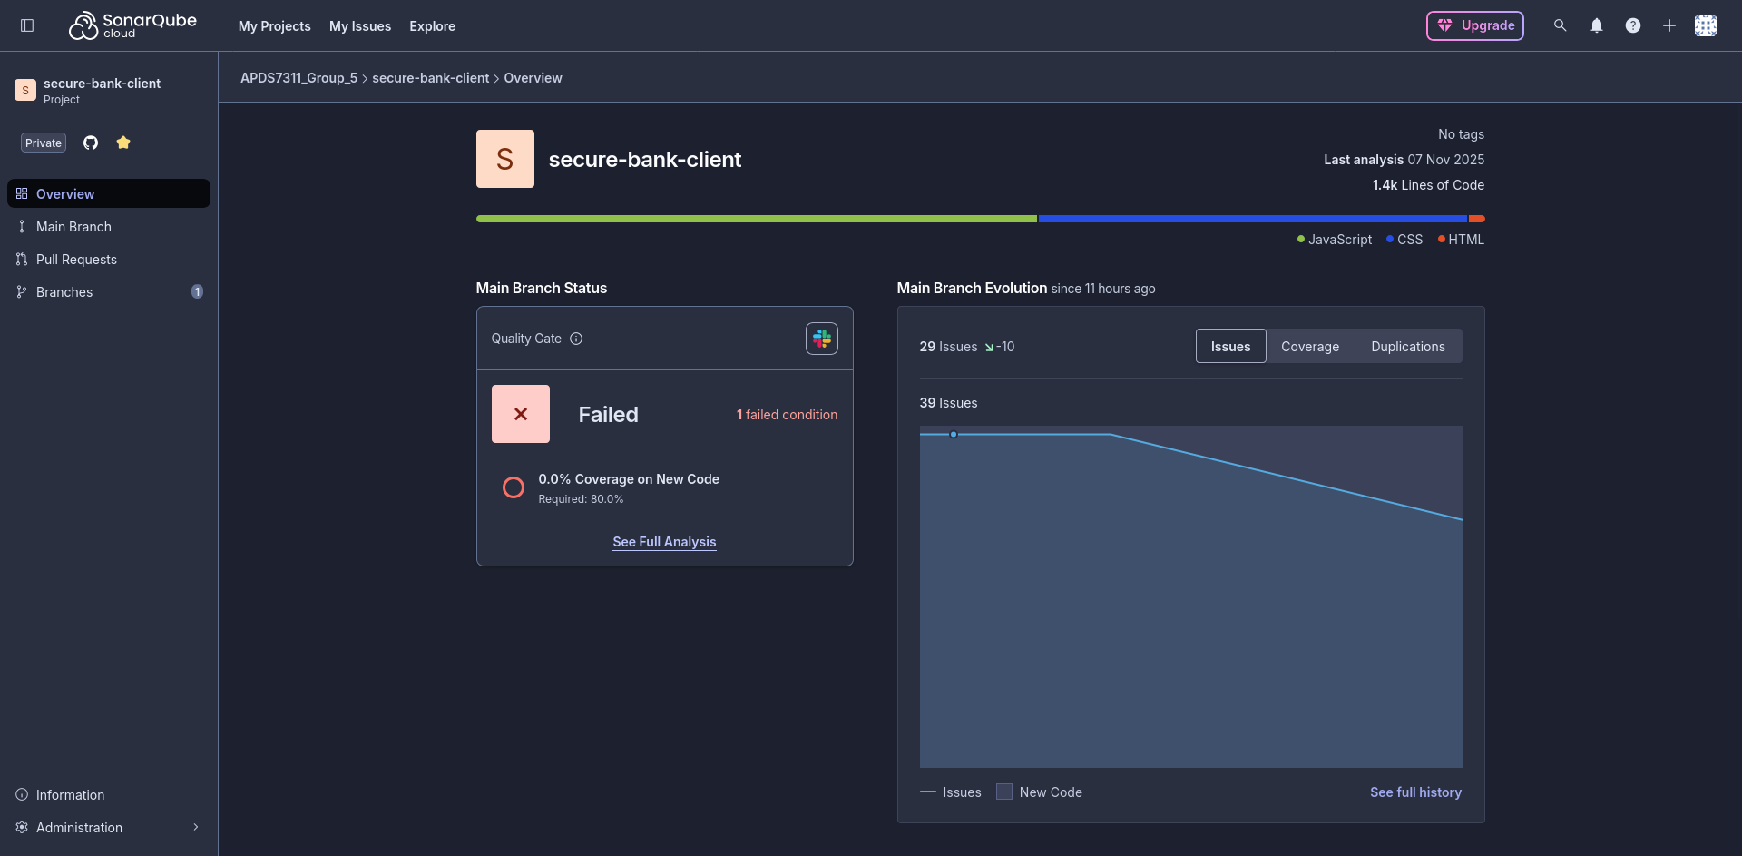

Main Branch Summary
New Code:
The "New Code" summary for the main branch shows one failed condition due to the lack of coverage. There is one new issue reported.
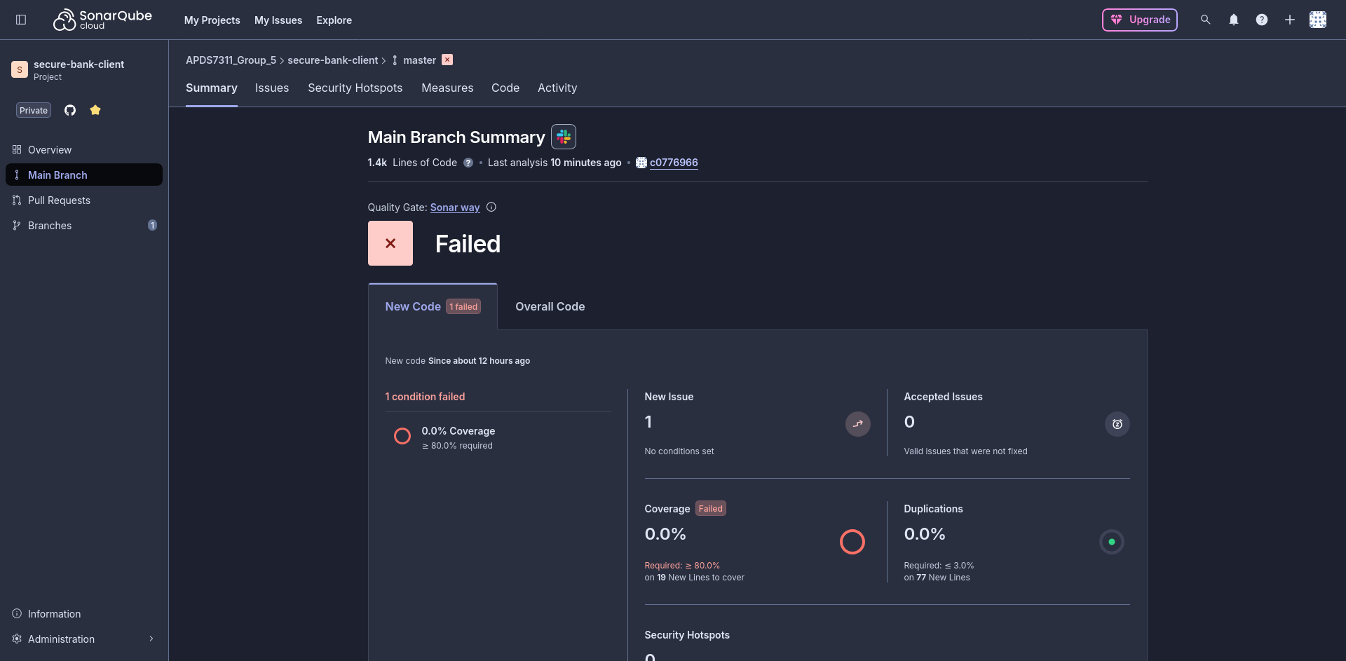

Overall Code:
The "Overall Code" summary indicates 0 security issues but shows 7 open reliability issues and 29 maintainability issues.
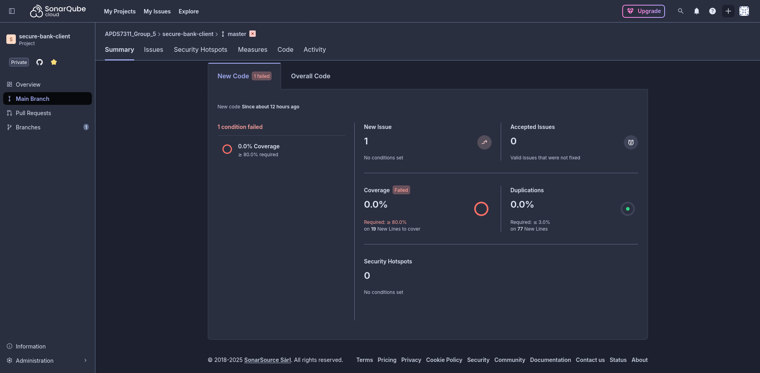

Issues
The "Issues" tab for the client application details several maintainability problems, including multiple instances of "Text does not meet the minimal contrast requirement with its background" in src/app.css.
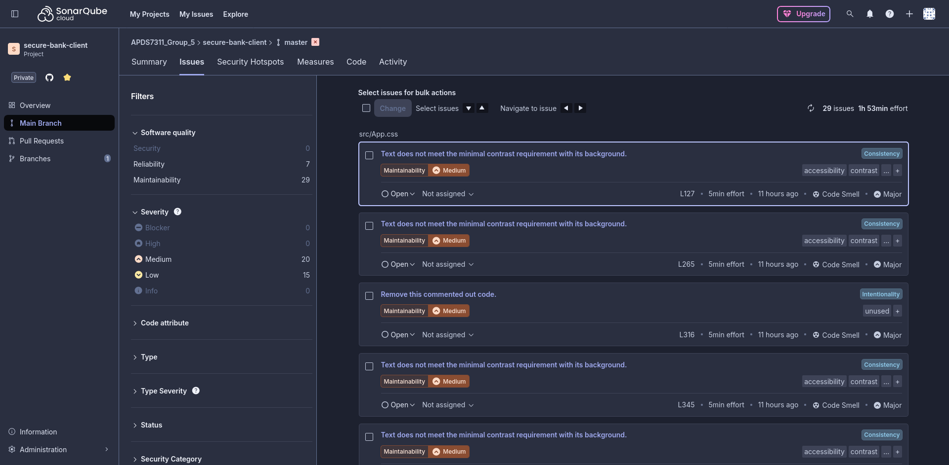

Measures
Security Overview:
The security overview chart shows no vulnerabilities.
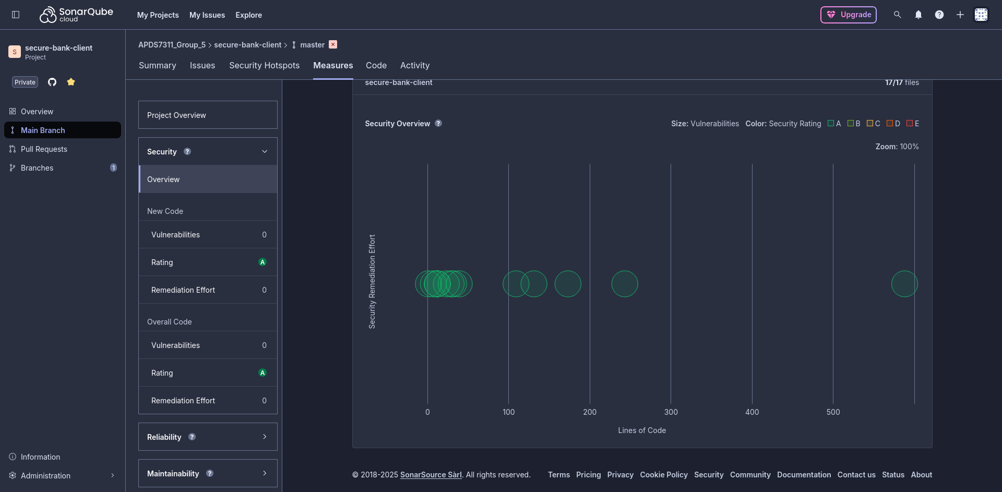
Code Smells:
The measures related to maintainability show 29 code smells with an estimated debt of 1 hour and 53 minutes.
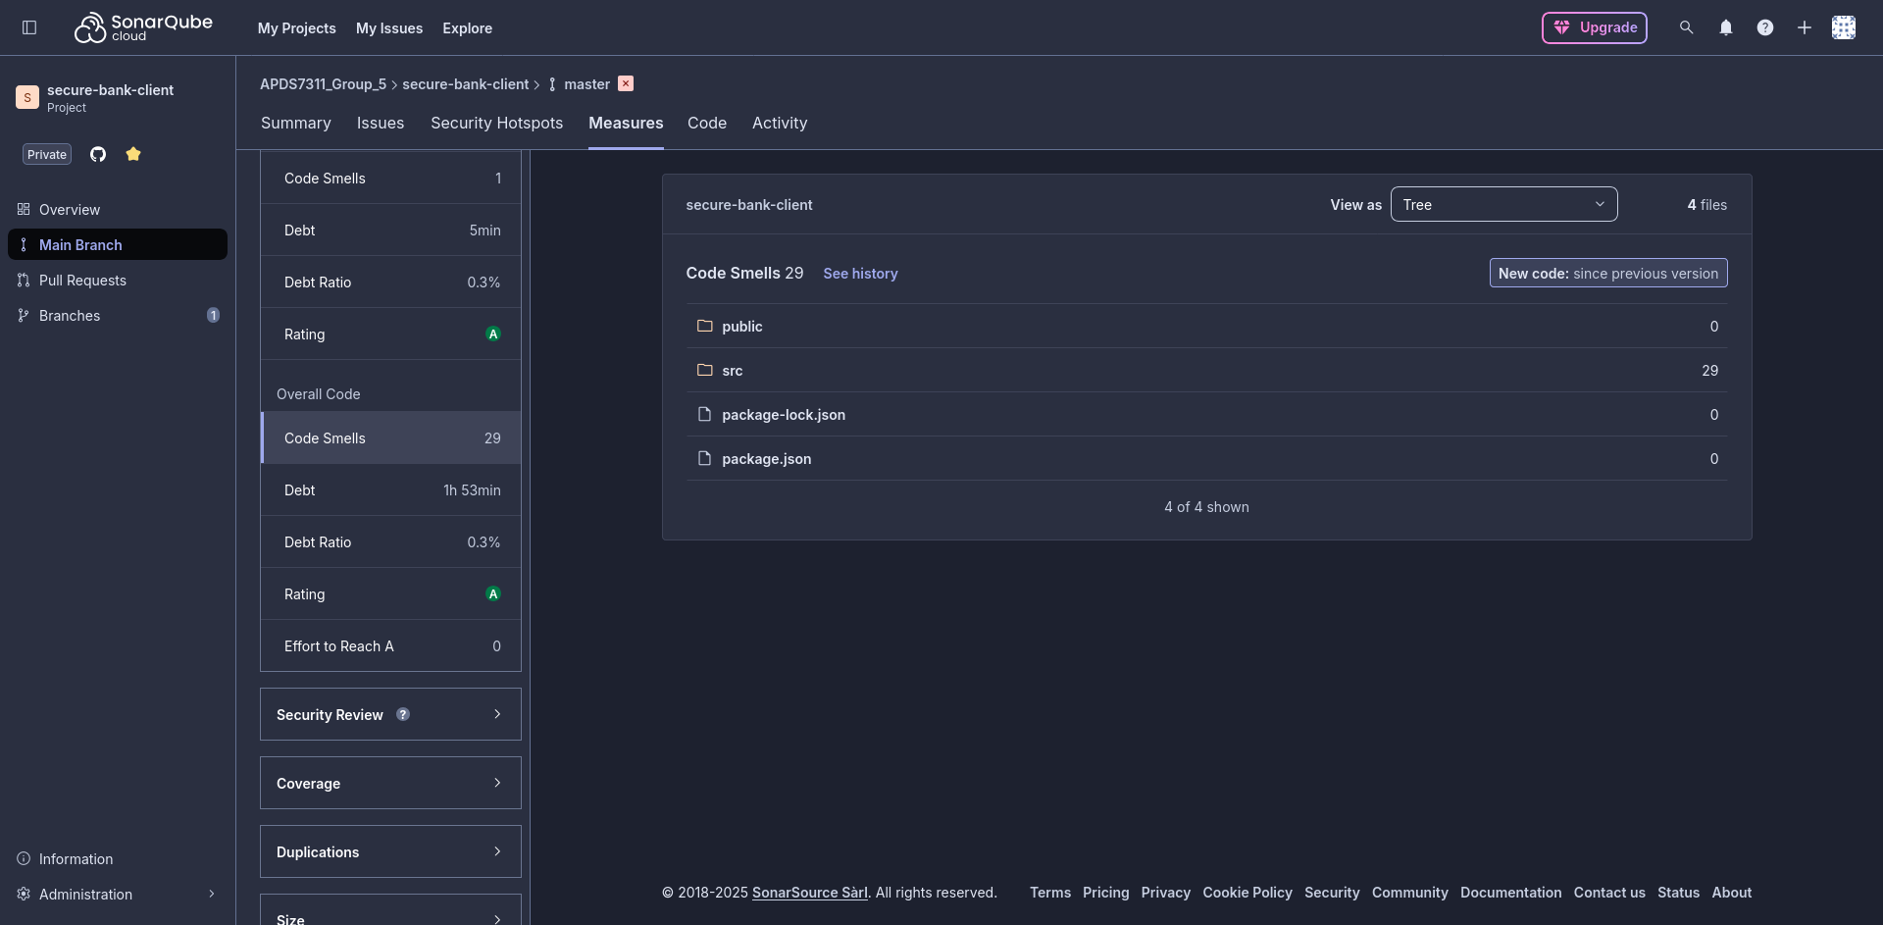

CircleCI Analysis
CircleCI is used for automating the build, test, and deployment processes for both applications.

Organization Home
The CircleCI dashboard for APDST311_Group_5 shows the client and secure-bank-api projects with their last run times.
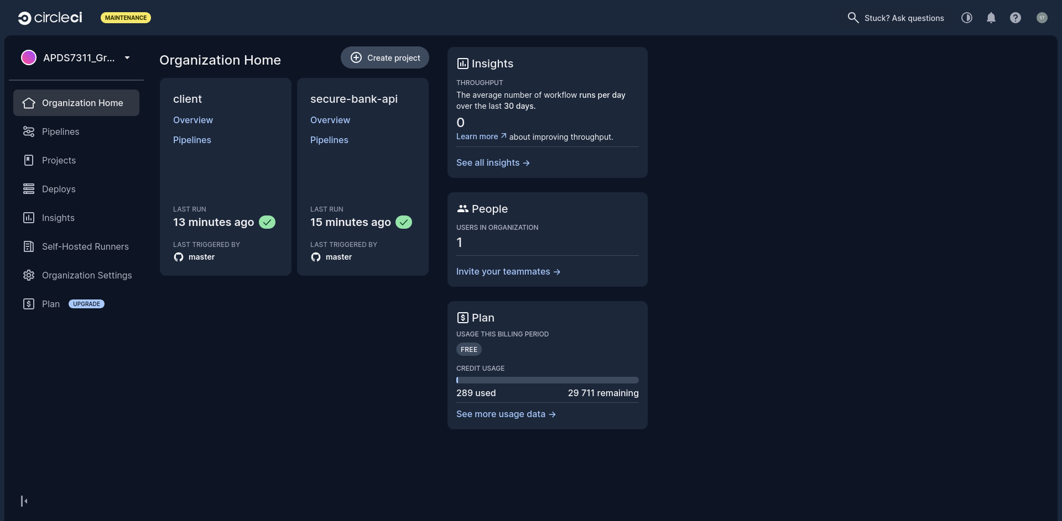

All Pipelines
The "All Pipelines" view provides a history of all the builds for both projects, showing a mix of successful and failed pipeline runs.
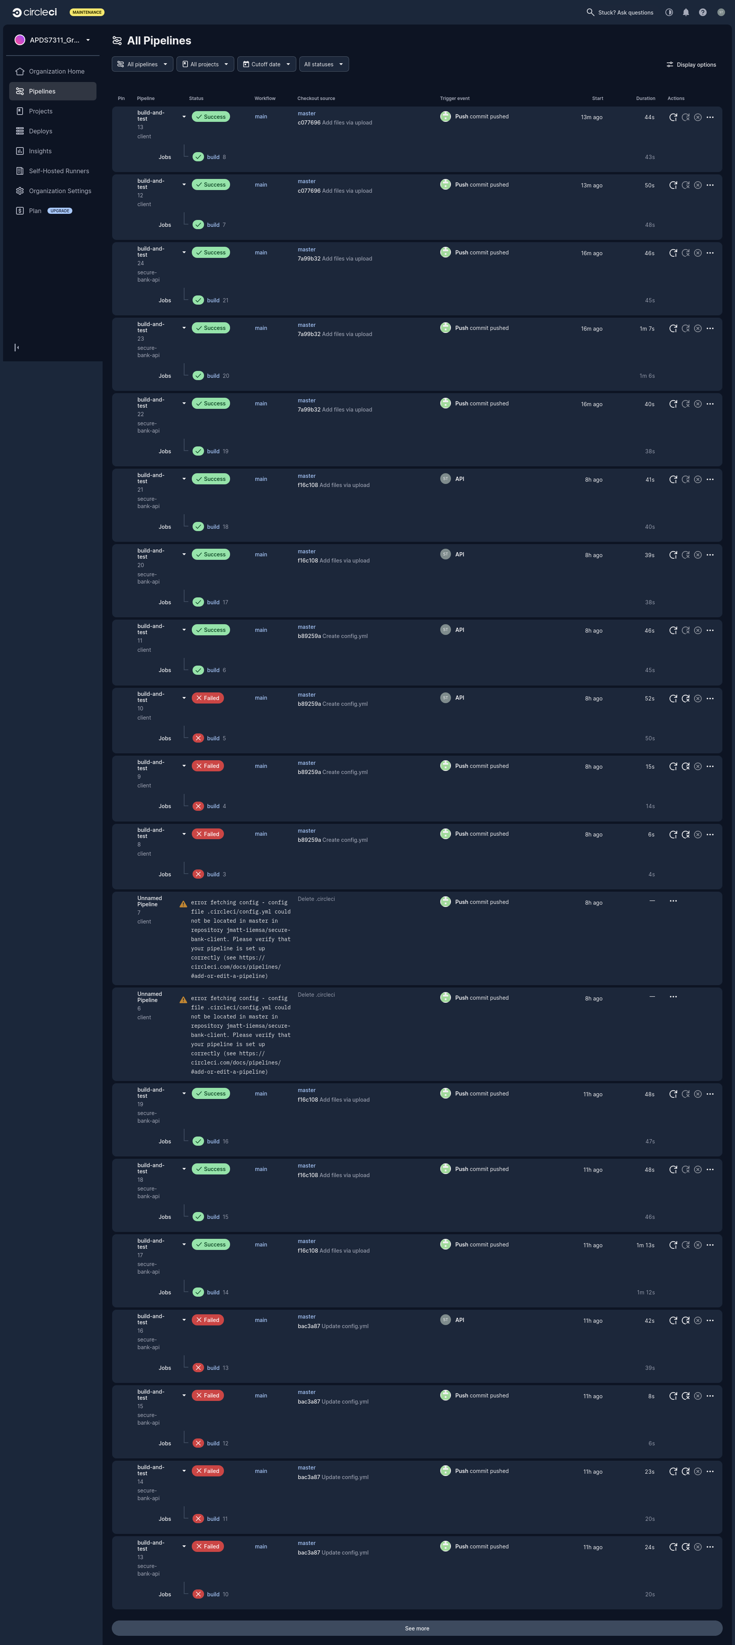

Latest Pipelines
Client:
The latest pipelines for the client project show successful build-and-test runs on the master branch.
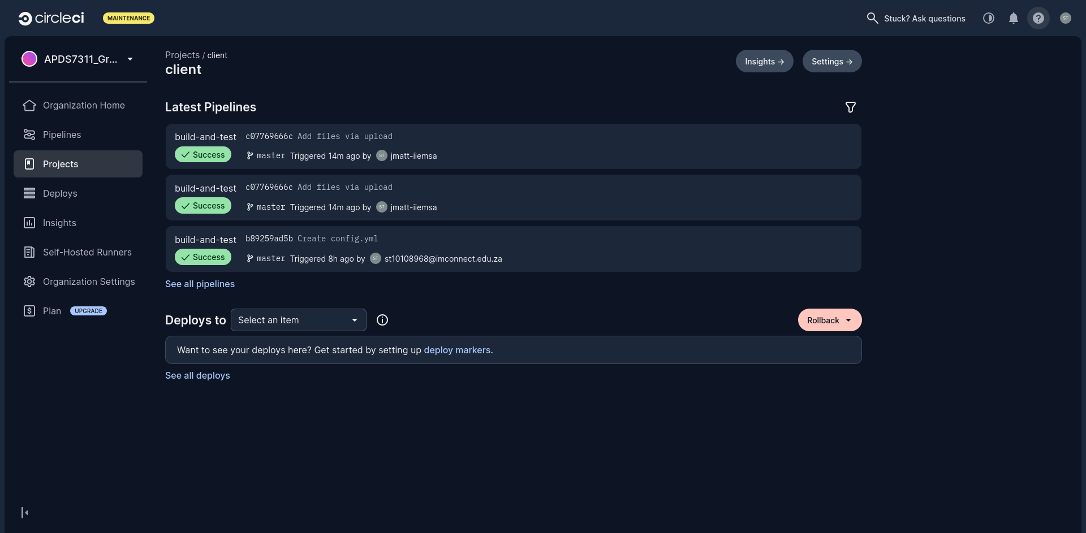
Secure Bank API:
Similarly, the secure-bank-api project also shows successful recent build-and-test pipelines on the master branch.
