**ECE 09495/09595**

**Assessment Quiz Submission for Jacob Matteo**

**Instructions**

1. Allowed Time: 1 week.
2. Maximum points – 100.
3. Submit a single PDF or MS Word file.
4. All questions are from the Textbook (<https://d2l.ai/>).
5. Answer all questions.

**Questions**

1. **Section 2.3 (Linear Algebra) 10 points**
   1. **Show that $L_{1}$ and $L_{2}$ norms are special cases of $L_{p}$ norm**

Because the L­p norm of an array is defined as ${\left\|x\right\|}_{p}= {\left(\sum_{i=1}^{n}{{\left|x_{i}\right|}^{p}}\right)}^{1/p}$, when p=1, this gets rid of the fractional exponent on the outer part of the equation and the integer exponent on the inside of the equation, making the expression ${\left\|x\right\|}_{1}= \sum_{i=1}^{n}{\left|x_{i}\right|}$, or the sum of all the absolute values of all entries in the matrix for L1. L2 is also a special case because the fractional exponent becomes $1/2$, which means the entries in the parenthesis get square-rooted and the exponent on the inside becomes 2, which is a square. This new formula, ${\left\|x\right\|}_{2}= \sqrt{\sum_{i=1}^{n}{{\left|x_{i}\right|}^{2}}}$, is very similar to the Pythagorean Theorem in execution, especially when the matrix only has 2 or 3 entries.

* 1. **Section 2.3.13. Exercise 3**

“Given any square matrix A, is A + AT always symmetric? Why?”

If a matrix A is symmetric with AT, that means the shape A is the same as AT. This makes since because in a square matrix, the length and height of the matrix is the same size. When you transpose a matrix, you are effectively swapping the values of each location in the matrix across the diagonal of the matrix. Also, the number of rows becomes the number of columns and vise versa. However, since NRows = NColumns, when they swap values the N values stay the same and the matrix keeps its symmetry.

1. **Section 2.4.6 (Calculus) Exercises 1 and 4 10 points**
   1. 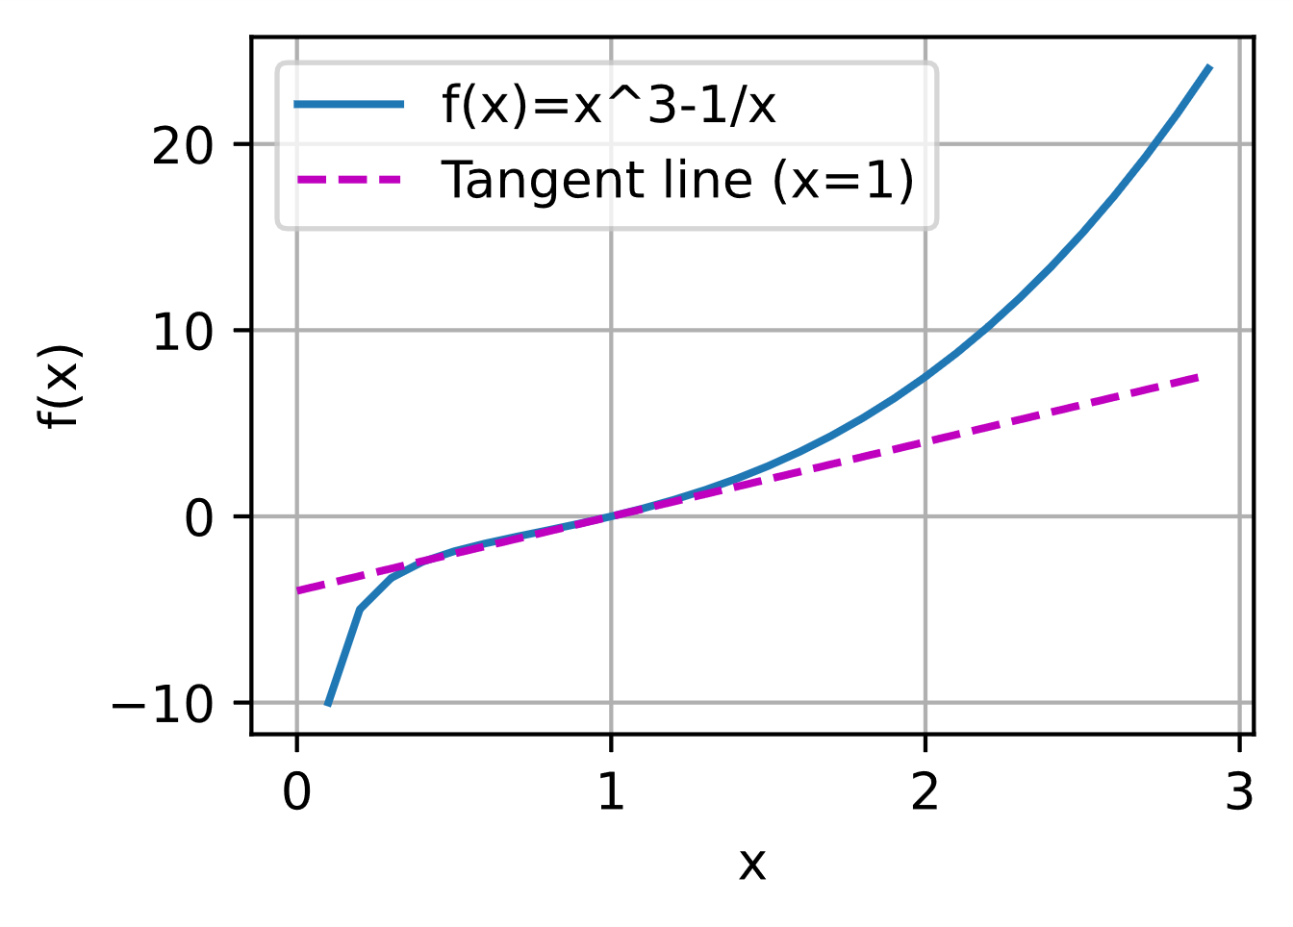
   2. $\frac{∂u}{∂a}=\frac{∂f}{∂x}\frac{∂x}{∂a}+\frac{∂f}{∂y}\frac{∂y}{∂a}+\frac{∂f}{∂z}\frac{∂z}{∂a}$ and $\frac{∂u}{∂b}=\frac{∂f}{∂x}\frac{∂x}{∂b}+\frac{∂f}{∂y}\frac{∂y}{∂b}+\frac{∂f}{∂z}\frac{∂z}{∂b}$
2. **Section 2.5.6 (Automatic Differentiation) Exercise 1 5 points**

To find a second derivative, the first derivative must be found first, then the second. This means that the computer must use its derivation algorithm to find the first derivative, then plug this answer back into the algorithm to find the second. Depending on the equation being derived, this can take twice the time or more to find the second derivative.

1. **Section 2.6.5 (Probability) Exercise 3 5 points**

If there is a sequence of random variables A, B, and C where C relies on B and B relies on A, this can be shortened to C relies on A because in order for C to be true, B needs to be true but if A isn’t true, B is not and C is not. There is not a condition in which C’s Boolean value is true while B’s is false, so the value of B may be skipped in determining the probability of C via A.

1. **Section 18.1.11 (Geometric and Linear Algebraic Operations)**

**Exercises 1 and 7 10 points**

* 1. 0.9078301 rad/s

$\sum_{ii}{a_{ii}^{4}}$

1. **Section 18.2.9 (Eigendecompositions) Exercise 3 5 points**

No, it is not possible for the smallest eigenvalue to be less than 0.5.

1. **Section 18.3.4 (Single Variable Calculus) Exercise 4 5 points**

-0.159768

1. **Section 18.4.9 (Multivariable Calculus) Exercise 3 5 points**

The gradient is $\left[\begin{matrix}\frac{e^{x}}{e^{x}+e^{y}} \\ \frac{e^{y}}{e^{x}+e^{y}}\end{matrix}\right]$ and the sum of its two components is 1.

1. **Section 18.5.8 (Integral Calculus) Exercise 2 5 points**

Using u substitution, make u = x^2 and the solution of the integral comes out to 1.

1. Section 18.6.3 (Random Variables) Exercise 4 10 points
2. Section 18.7.5 (Maximum Likelihood) Exercise 1 5 points
3. Section 18.8.9 (Distributions) Exercise 3 5 points
4. Section 18.10.5 (Statistics) Exercise 1 10 points
5. Section 18.11.7 (Information Theory) Exercise 1 and 5 10 point