Joshua Matthews
Compilers
HW3

1.1
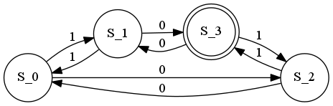

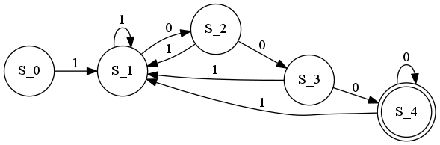
1.2

2.1
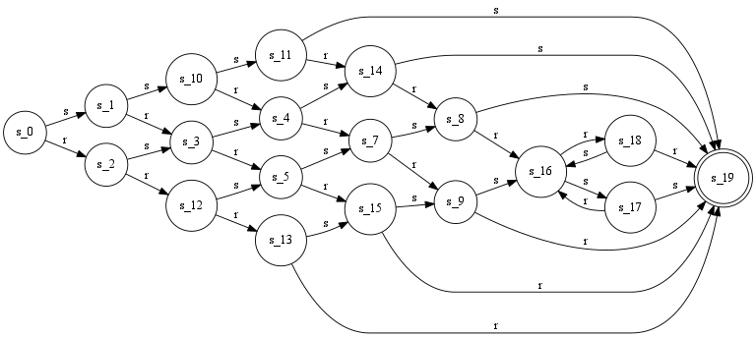

2.2

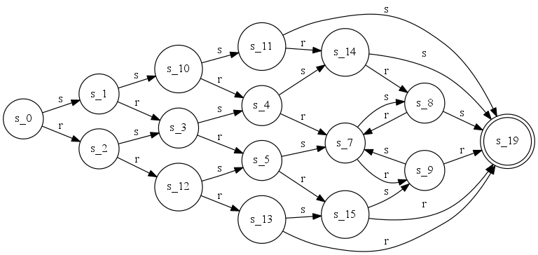
3.1
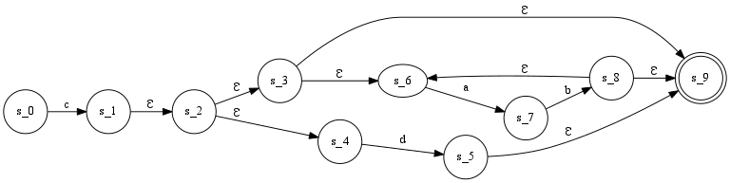
3.2
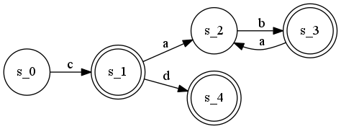

3.3
It is already minimal.

