**Effect Size Cheat Sheet**

# Difference between (Two) Means

|  |  |  |
| --- | --- | --- |
| **Cohen's *d*** |  | **Glass' *Δ*** |
| * Used to compare 2 groups • Standardized:   *Small: d* = .2  *Medium: d* = .5  *Large: d* = .8      𝒅  =    |  𝑴𝒆𝒂𝒏    𝟏  −  𝑴𝒆𝒂𝒏𝟐  |  𝑺𝑫𝒑𝒐𝒐𝒍𝒆𝒅   * How to calculate the pooled SD (SDp):   •      *N* = number of participants,  *SD* = standard deviation     * If the pooled SD cannot be obtained for some reason, and equal variance is assumed, either group SD can be used instead (Chapter 2, Cohen, 1988) | * For comparisons between 2 groups * Uses standard deviation of second group!      * If a control group is part of the study design, the control group should be considered group 2. |

|  |  |
| --- | --- |
|  | **Hedge’s *g*** |
| • | Used to compare 2 groups |
| • | In order to get g, it is necessary to calculate the *pooled standard deviation (SDp)*    *N* = number of participants, *SD* = standard deviation |
| • | The pooled SD can then be used to calculate Hedge’s *g* |

**Variance Explained Effect Sizes**

|  |  |  |
| --- | --- | --- |
| **Pearson’s *r*** |  | ***r²* as correlation coefficient** |
| * Used to assess strength of correlation between variables * **Provides information on whether a correlation is positive or negative** * SPSS provides an easy way to estimate   Pearson’s *r*   * But if you’re interested, the UC Davis has a great explanation of how to calculate it by hand: bit.ly/29Txeil     *Small: r* = .1  *Medium: r* = .3 *Large: r* = .5 | * Pearson’s *r* squared * Estimates percentage of variance shared between variables • Example:   o if *r* = .3, *r²* = .09 which suggests 9% of the variance of variable A is shared with variable B   * Is always positive and thus does not provide information on whether the correlation is positive or negative * Note: R2 = η² |

|  |  |  |
| --- | --- | --- |
| **Eta-squared *η²*** |  | **Cohen's ƒ** |
| * Used to estimate effect size for f-tests * Requires SSbetween and SStotal, which are usually provided by stats-programmes        * Provides a percentage estimate of how much of the observed variance was the   result of the observed variable/treatment • For example:  **η² = .43** → **43% of the observed variance can be accounted for by the observed variable or the treatment under investigaton**   * Note: R2 = η² | * Provides an effect size for *k* population means * This is the formula:      * But it can be easier to just convert it from a different effect size, e.g.:     (taking he square root of *f2*) Standardized:  *Small: f* = .1  *Medium: f* = .25  *Large: f* = .4 |

|  |  |  |
| --- | --- | --- |
| **Partial Eta-squared *ηp²*** |  | **Omega-squared ω2** |
| * If only one predictor variable is present, ηp² = η² * If more than one variable is present: ηp² measure how much of the observed variance can be accounted for by on the variables after excluding variance accounted for by other variables | * Suitable for between-subject analysis with equal numbers of observations in all cells * **Less biased than η2 and therefore preferable**        * Other versions of the formula also suitable for other designs, see Olejnik &   Algina, 2003: bit.ly/29XLLoR |

|  |  |  |
| --- | --- | --- |
| **Cohen's *f²*** |  | **Cohen’s q** |
| • Can be used for multiple regression and F-Tests        *SS = Sum of Squares – most stats*  *programmes will be able to provide this*    *f2* if only one variable is of interest:      *f2* for the overall effect:      *Small: f² = .02*  *Medium: f² = .15 Large: f² = .35* | • Can be used to assess the difference between two correlation coefficients  (i.e. *r*)      *r1 = correlation 1 r2 = correlation 2* • The variance of q can be calculated this way:      *N = number of data points included in correlation* |

**Effect Sizes for Categorical Measurements**

|  |
| --- |
| **Cohen’s *w*** |
| * Used for chi square tests     *p = proportion*  It is easier than the formula might suggest.  Example: let’s imagine a wine tasting    Expected Outcome:   |  |  |  | | --- | --- | --- | |  | ***Red Wine Drinkers*** | ***White Wine Drinkers*** | | ***Women*** | *25%* | *25%* | | ***Men*** | *25%* | *25%* |   Observed Outcome:   |  |  |  | | --- | --- | --- | |  | ***Red Wine Drinkers*** | ***White Wine Drinkers*** | | ***Women*** | *15%* | *45%* | | ***Men*** | *40%* | *10%* | |  |  |  |       𝑤 = √0.542      *Small: w = .1*  *Medium: w = .3*  *Large: w = .5* |

|  |
| --- |
| **Risk Ratio, Risk Difference, & Odds Ratio** |
| * + All three provide an indication of the risks and benefits associated with a treatment.   + They can be used for study designs looking at binary variables   + Risk Difference provides a percentage estimate of how much the two groups/conditions differ   + Risk Ratios 1) estimate the probability of the event under investigation to occur in each group/condition 2) than compare these probabilities to calculate the difference in probability (i.e. the risk ratio)   + Odd Ratio does the same but calculates the odds instead of probability   + Odd Ratio seems to be the preferred effect size in the literature |

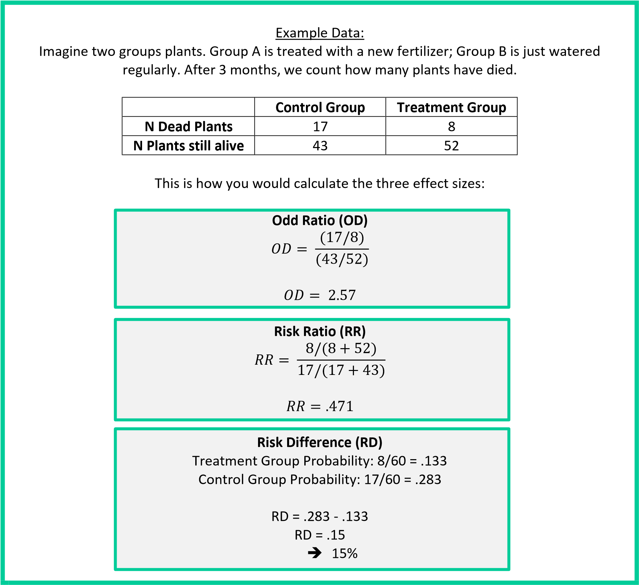

|  |
| --- |
| **Cohen’s *h*** |
| * Used to calculate the differences between proportions         = |𝝋𝟏 − 𝝋𝟐| |
| * **Easiest to look up p-to-**𝝋 **transformations** |
| * For example, 1/3 of group A likes to eat ice-cream & ¾ of group B like to eat ice-cream:   Group A: p = .33 --> 𝜑 = 1.224 Group B: p = .75 --> 𝜑 = 2.094 h = 1.224 – 2.094 h = -.87 |
| * Transformation tables are somewhat old-school but ultimately very easy and quick to use, e.g. Cohen, 1988, p. 183, Table 6.2.2   *Small: h = .2*  *Medium: h = .5*  *Large: h = .8* |

References:

Cohen, J. (1988). *Statistical Power Analysis for the Behavioral Sciences*. Academic Press:

New York