The Effect of Oil Price on Field Production: Evidence from the Norwegian Continental Shelf
Johannes Mauritzen, NHH Norwegian School of Economics, +47 90 56 64 62, johannes.mauritzen@nhh.no

Overview

An increase in oil prices could affect oil production in a particular region in three ways. Higher oil prices could lead to increased exploration, starting production in known but previously uneconomic fields or to changes in production in existing fields. While several studies exist on the effect of oil prices on exploration, few studies exist of the effect of oil price on production in existing fields. This is a particularily important question as many of the worlds largest oil-producing regions, such as the Norwegian Continental Shelf, are maturing and most current oil production is from ageing fields rather than new finds.

I use detailed data on Norwegian oil field production and a semi-parametric additive model to control for the production profile of fields that would otherwise heavily bias the results. I find no significant evidence of a concurrent effect of oil prices on field production, though a slight lagged effect is found of the magnitude of approximately 2 to 4% for a 10 dollar per barrel increase in the real price of oil. These findings are consistent with the idea of producers that do not act strategically to short-term price movements but instead use storage and financial derivatives to hedge oil price changes. Higher oil prices lead to increased investment and an increased total extraction rate, though this effect is modest.

Methods
Parametric linear models have the sizeable advantages of simplicity and interpretability and therefore usually a good starting point for an analysis. However, when attempting to model the effect of price on oil field production, a standard linear model is unable to sufficiently control for the production profile of oil fields. Since the production profiles are correlated across fields and oil prices autocorrelated, a failure to control for field production heavily biases the estimate of the effect of price.

Instead I use a semi-parametric model within the Generalized Additive Model frameworks. Here I estimate a general shape for the production profile of the 77 producing or previously producing oil fields using Thin Plate Spline methods. I simultaneously estimate linear parameters for the effect of the concurrent and lagged oil price.

Results

The figure below shows the results for the estimation of the linear parameters on the oil price variable and its lags in the semi-parametric additive model. A slight effect is estimated on the 4th lag for large fields and on the 6th lag for both small and large oil fields.

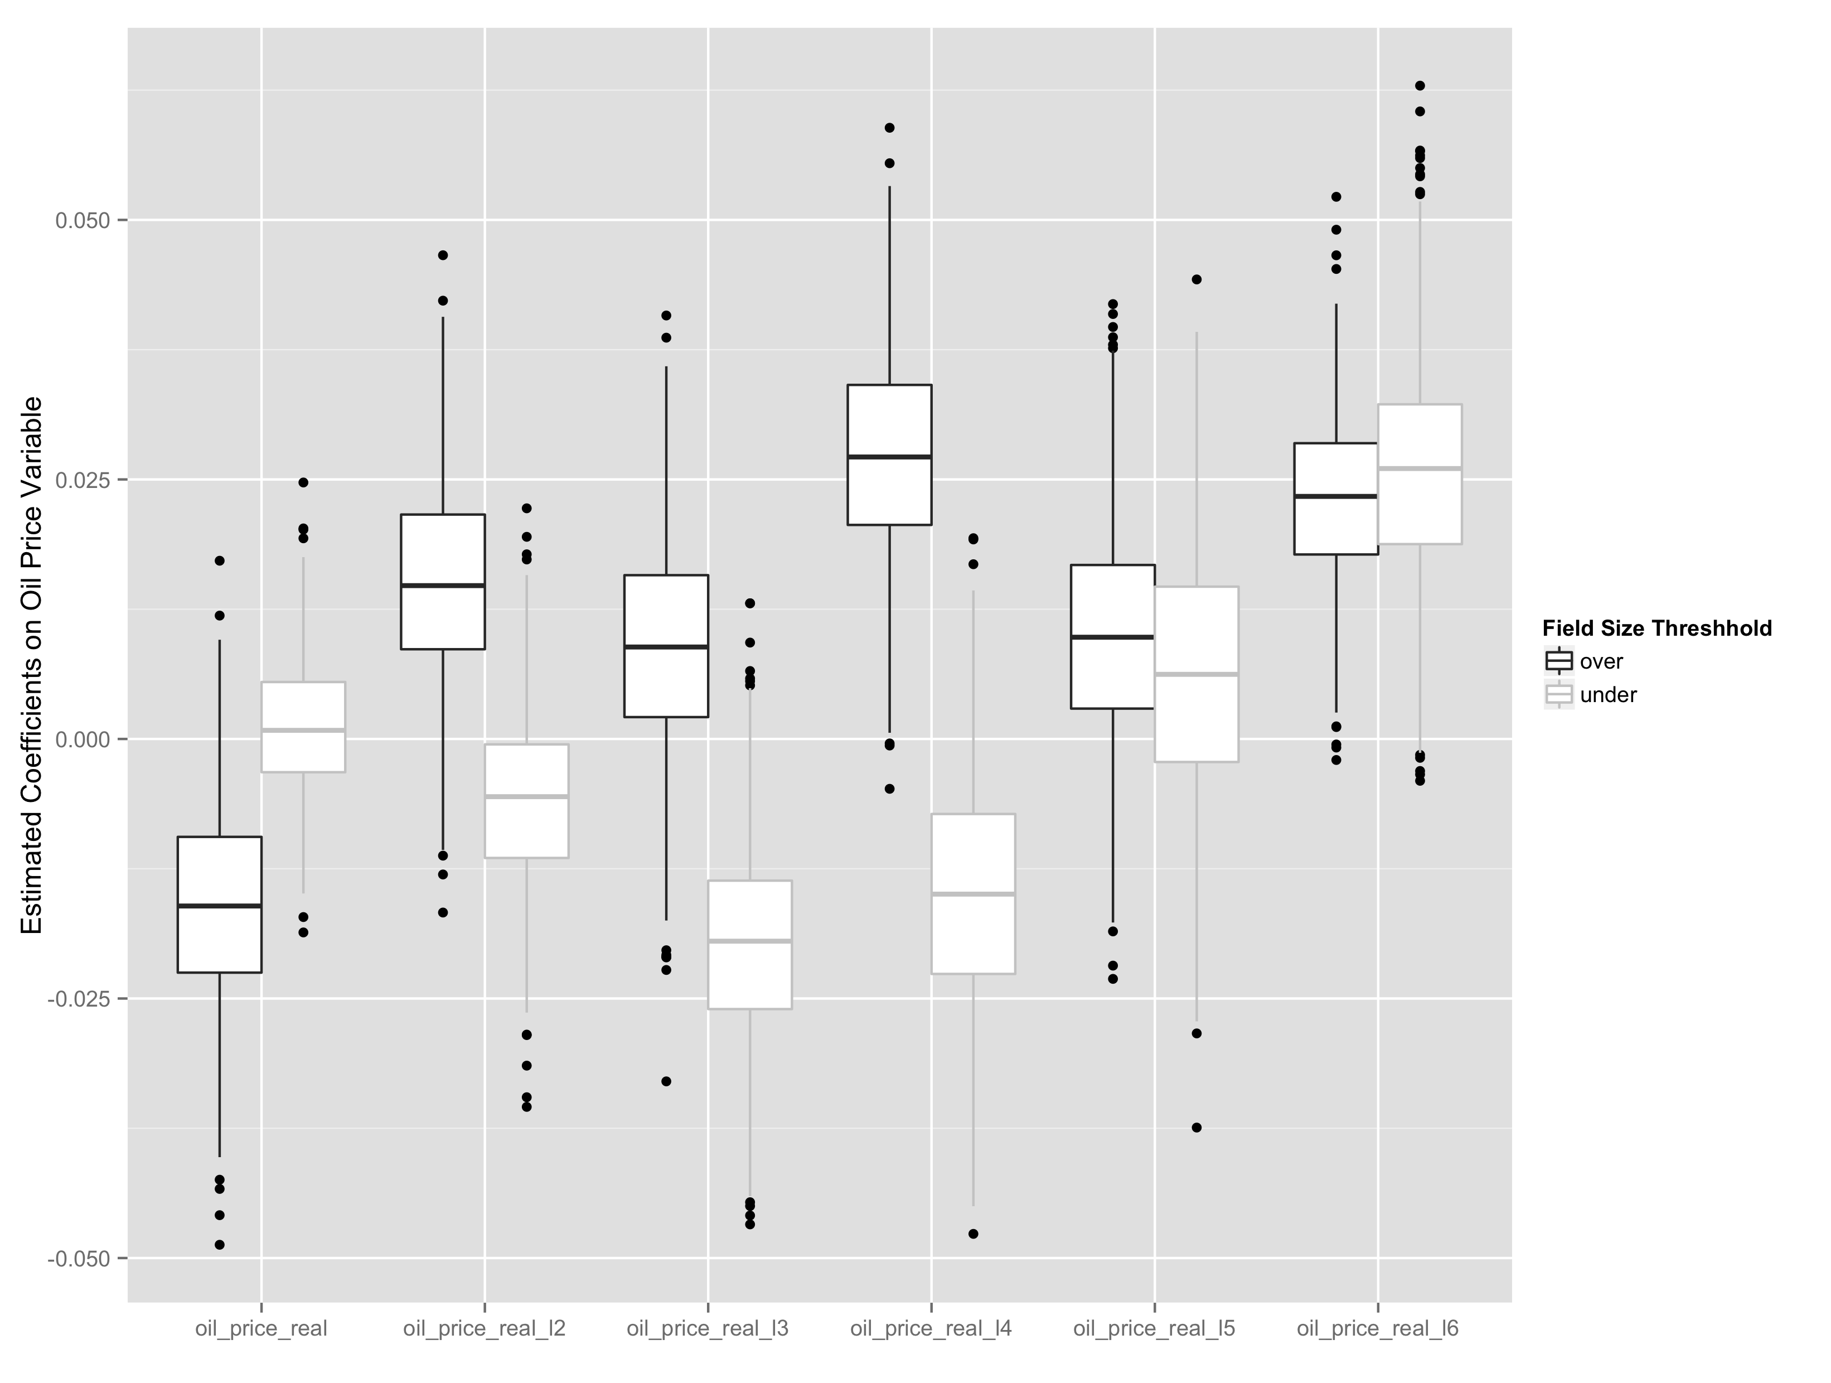

Conclusions
The results of this paper are important in themselves in helping explain and decompose the effects of price on oil production. Production in existing fields has no significant concurrent reaction to higher oil prices while a slight effect is estimated with a lag of between 4 and 6 years. Oil producers do not appear to be behaving strategically in relation to short-term production - increasing or reducing production in response to changes in oil price. Instead they are likely using storage or financial instruments to hedge short-term price movements. Changes in oil prices can rather be seen as a relaxing of a production constraint, justifying increased investment that leads to either a higher total extraction rate or a intertemporal shifting of production.

The modest estimated effect of prices on production adds evidence to the argument that most of the increased supply of oil that comes from higher prices is from expanding the geographic and technological boundaries of oil production. For example exploration of deep-water oil deposits off the coast of Brazil and extraction of oil sands in western Canada.

Beyond the explanatory importance of the results, the Generalized Additive Model methodology, which to my knowledge has not been used in either geo-engineering nor econometric studies of oil production, can also serve a useful function in producing forecasts and scenarios. The major advantage that the methodology has is that by estimating an overall function for the production profile of fields, then production from newer fields can be estimated based on the history of older fields. In this way, forecasts of total oil supply from a region can be built in a bottom-up and relatively simple way that avoids overly restrictive assumptions.

