* Josef Brozovich
* Following Directions
* Open vtk file in paraview
  + On menu bar
    - Filters>Alphabetical>Extract Surface. Apply
    - Filters>Alphabetical>Generate Surface Normals. Apply
    - For any field except “Contact boolean”, Filters>Alphabetical> Cell Data to Point Data. Apply
    - Save Data as “.ply”
    - Check timestamp
    - Check save coloring and alpha
    - Press “Ok”
* Open Blender
  + File>import>Stanford (.ply)
  + Z rendered (Cycles render mode (right side render properties))
  + In “Properties area”
    - Open “Object” tab
    - “Vertex Colors” is “Col”
    - Click on shading tab
    - Select “+new”
    - Open Node Editor
      * Shift+A ”Attribute”, Name :”Col
      * Output Color to Surface
      * FOR EVERY ITERNATION RIGHT NOW
* Work in animation Nodes
  + Download Animation Nodes (if necessary)
  + Save as .blend
  + Pull down new window
  + Select “animation nodes” from symbol in top left corner
  + Select all iterations, Ctrl+a, select “all transforms”, m, move into collections
  + Select new tree
  + In top window, ctrl+a, select “collection info”, select “collections” in drop down window
  + W, “look through all object”
  + Ctrl+a, search, select “object transforms output”
  + Connect “Loop Input” output x to “Object Transform Output” input object
  + Ctrl+a, search, select “compare”
  + Connect “Loop Input” output index to “Compare” input A
  + Ctrl+a, search, select “Time Info”
  + Connect “Time Info” output frame to “Compare” input B
  + Ctrl+a, search, select “Combine Vector”
  + Connect “Compare” output result to “Combine vector” input x,y,z
  + Select “Object Transforms Output” scale x,y,z
  + Connect “Combine vector” output vector to “Object Transform Output” input Scale
  + 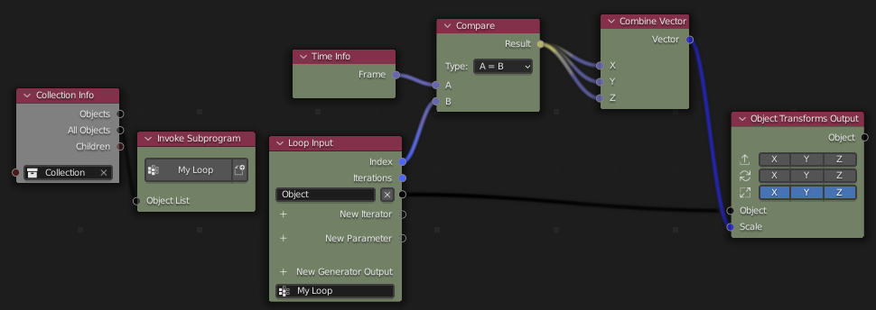
  + Select correct start and stop time in lower left corner
  + Right side “Key frame” menu, “overview”, select “bake to Keyframes”
  + Top left, select “graph editor”, “interpolation”, “key”, “constant”
  + File, export, .glb
  + Right side menu, geometry, select “apply modifiers”
  + Right side menu, animation, animation, unselcect “Group by NLA track” and “always sample animations”