Initial SOAR Monitoring Data Exploration

Jordanna Barley

11/9/2022

## What is in this document:

Because we are still waiting for a fair amount of the data to come in, I picked sites where I knew we had sufficient data that would be good for a presentation. What I have here are very early plots and I would like some feeddback if this is what is needed for the upcoming Builder’s meeting.

### Maryland Monitoring Data

The Maryland monitoring was done by taking a sample of oysters from replicate quadrats, catagorizing them as live or box, and collecting size data. At present, I do not have pre-deployment data. I have computed some simple stats and produced some plots:

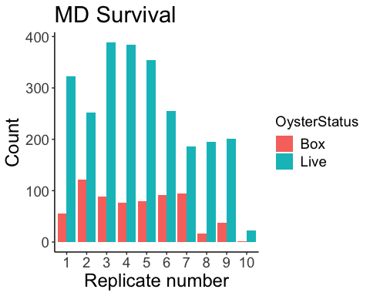

Fig. 1. Counts of box and live oysters from each replicate quadrat.

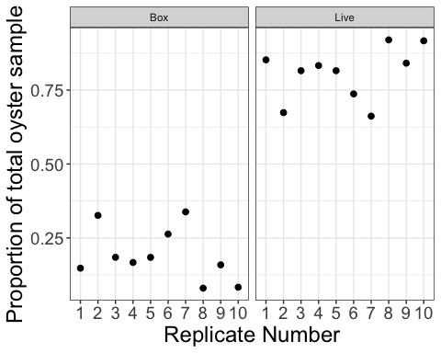

Fig. 2. Proportion of Box and lie oysters from each replicate quadrat.

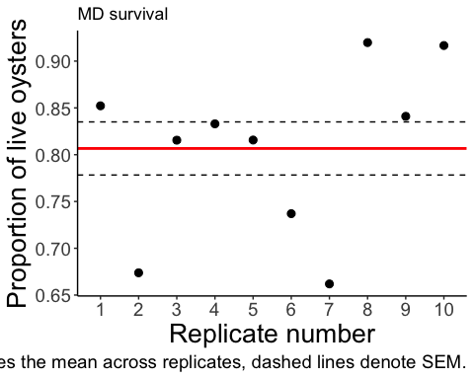

Fig. 3. Red line denotes mean across all replicates. Black dashed lines denote ±SEM.

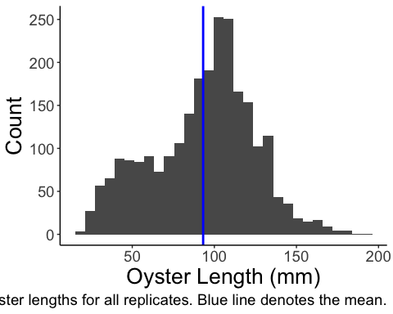

Fig. 4. Histogram of oyster lengths across all replicates. Blue line denotes the mean.

**New York Monitoring Data-Governor’s Island**

The data from this site were collected by taking a subset of 25 oysters from each replicate bag deployed in the water. We have size data for both pre- and post-deployment of the SOAR oysters from Govvernor’s Island. The data do not really suggest significant growth across all replicates. I will compute growth, however I have not gotten there yet and wanted to share what I had so far. I can also compute some statistics to see if there is significant growth, though given the large standard deviations, there does not seem to be much difference in size between the two years.

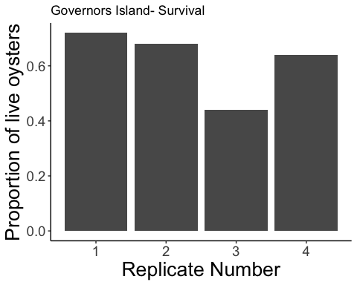

Fig 5. Barplot of the proportion of live oysters from each replicate bag.

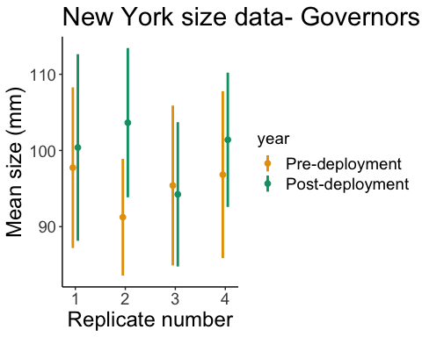

Fig. 6. Mean shell height for both pre- and post-deployment of the SOAR oysters. Error bars denote standard error.