Phenotypic Plasticity Meta-analysis

Jordanna Barley and Morgan Kelly

11/9/2020

**Introduction and Rationale**

The purpose of this document is to detail the exploratory data analysis of the phenotypic plasticity meta-analysis. This work is important because it is not currently known how plasticity varies within speices across latitude. Because different populations of the same species are often locally adapted to their locale, it is important to understand how plasticity varies within species’ population as well as across species and ecosystem.

Plots showing the number of studies per ecosystem and the type of data we get from each:

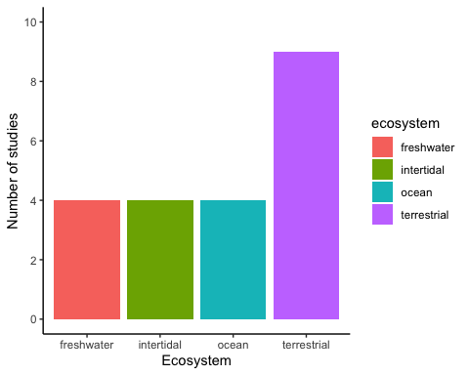

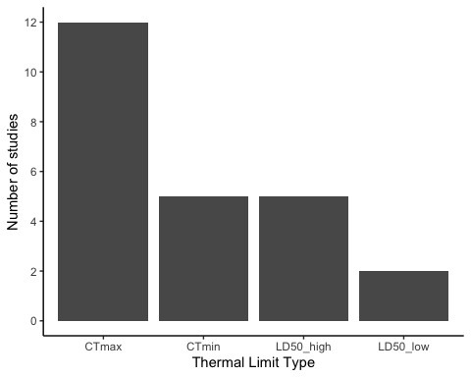

To quantify thermal plasticity, we will be calculating acclimation response ratio (ARR) by taking the different of the limits divided by the difference in acclimation temperature: $\frac{limit2-limit1}{temp2-temp1}$

Here is the distribution of ARR:

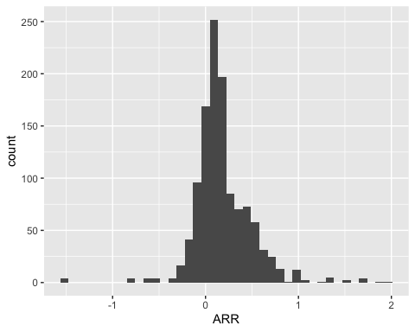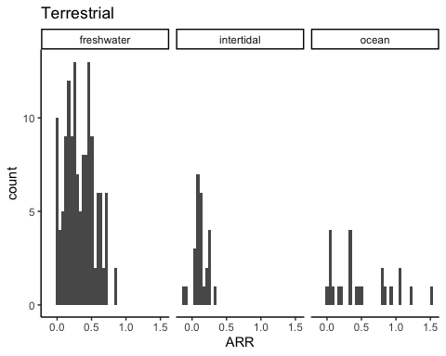

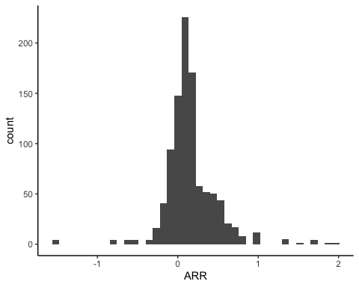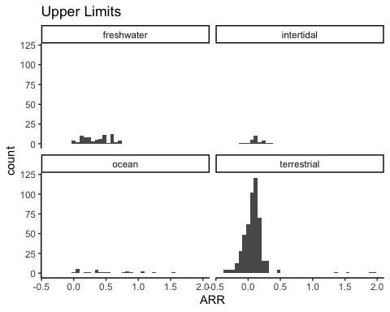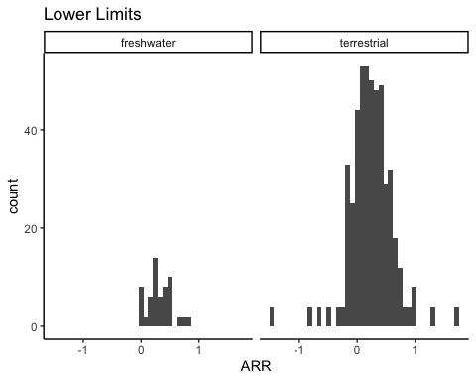

A look at mean ARR across ecosystem:

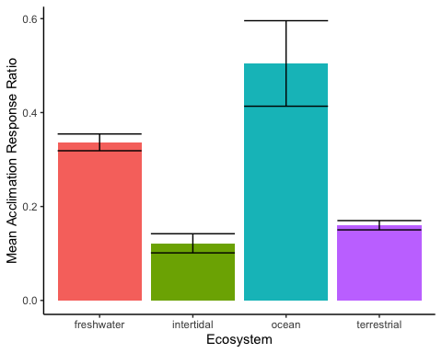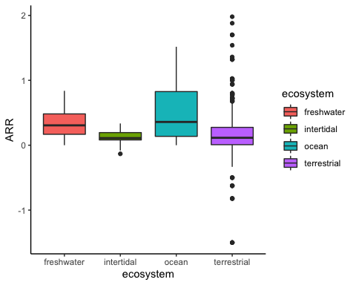

ARR versus latitude:

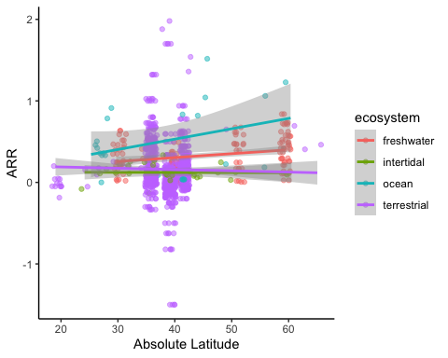

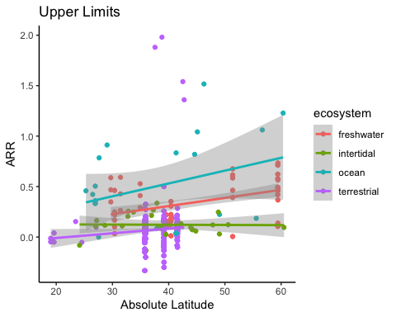

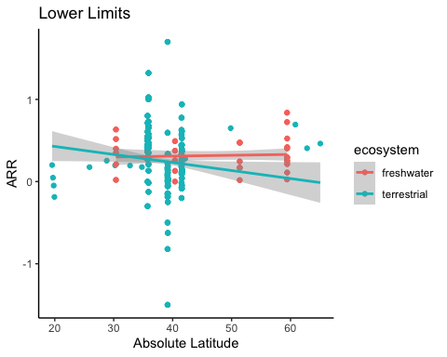

ARR versus thermal limit:

