Plasticity Meta-Analysis

Jordanna Barley, Brian Cheng, and Morgan Kelly

2/18/2021

# Introduction

The purpose of this document is to briefly describe the data extraction and analysis of the plasticity meta-analysis project.

## Criteria for Inclusion

To find studies relevant to this project, we searched Web of Science using this search string:

(Thermal OR temperatures) AND (Lethal OR “Thermal tolerance” OR “Thermal limit” OR CTmax OR CTmin OR LT50 OR “freezing tolerance”) AND ("Local* Adapt*" OR "“Latitud* Var” OR Intraspecific)

Literature searches were conducted on August 24th, 2019 and updated on July 28th, 2020. Also, we added additional studies that we were aware of that may not have met search string criteria.

Studies returned from the literature search were screened based on these criteria:

* Study presents new results (not a review paper)
* Study reports upper thermal tolerance in degrees C
* Study uses critical thermal limit as the measure of thermal tolerance
* Study reports the critical thermal limit metric for at least two populations of the same species, as defined by the study authors
* Studies must have experimentally measured thermal tolerance after acclimating individuals from all populations to 2 or more temperatures for the same amount of time
* Study has a sample size greater than 1 per acclimation temperature and population
* Must be able to determine geographic coordinates of origin for each population
* Study uses whole-organism measurements of thermal limits
* Studies must report sample size and some measure of variance for thermal limit measurements
* Measurements reported cannot come from hybrid lines, cultivars, domesticated species, or later generations of experimental evolution projects
* Populations of the same species cannot be from different ecosystems (marine, terrestrial, intertidal, or freshwater)

## Review of included studies

The main difference between our creiteria for inclusion and that of story #1 is that we limited our data to studies that used CTmax as their thermal limit measure. This is because of both the modeling needs of a meta-analysis as well as the question we are trying to answer. Our search yielded **18 studies**.

|  |  |  |  |  |
| --- | --- | --- | --- | --- |
| Study | Taxon | Populations | Temperatures | Ecosystem |
| Barria_et_al_2017 | Pleurodema_thaul | 2 | 2 | terrestrial |
| Bugg_et_al_2020 | Acipenser fulvescens | 2 | 3 | freshwater |
| Chen_et_al_2001 | Buergeria_japonica | 2 | 2 | terrestrial |
| Darveau_et_al_2012 | Couesius_plumbeus | 3 | 4 | freshwater |
| Diamond_et_al_2018 | Temnothorax_curvispinosus | 3 | 5 | terrestrial |
| Dong_et_al_2015 | Cellana_toreuma | 3 | 2 | marine |
| Fangue_et_al_2006 | Fundulus_heteroclitus | 2 | 7 | marine |
| Fernando_et_al_2016 | Atractosteus_spatula | 3 | 3 | freshwater |
| Healy_et_al_2019 | Tigriopus_californicus | 10 | 2 | marine |
| Jensen_et_al_2019 | Orchesella_cincta | 7 | 2 | terrestrial |
| Kelley_et_al_2011 | Carcinus_maenas | 2 | 2 | marine |
| Manis_and_Claussen_1986 | Rana_sylvatica | 5 | 2 | terrestrial |
| Philips_et_al_2015 | Lampropholis_coggeri | 13 | 2 | terrestrial |
| Tepolt_et_al_2014 | Carcinus_maenas | 7 | 2 | marine |
| Underwood_et_al_2012 | Oncorhynchus_clarkii_pleuriticus | 3 | 3 | freshwater |
| van_heerwaarden_et_al_2017 | Drosophila melanogaster | 2 | 6 | terrestrial |
| Weldon_et_al_2018 | Ceratitis capitata | 8 | 3 | terrestrial |
| Yu_et_al_2018 | Rhynchocypris_oxycephalus | 2 | 4 | freshwater |

**Note: Tepolt et al. 2014 has overall 7 populations, however 5 of them are in the species’ invasive range. Therefore, data from only two of the populations were used in this analysis.

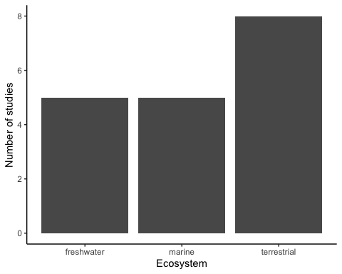

We initially had four ecosystem categories (freshwater, marine, intertidal and terrestrial), however upon closer inspection the studies where the authors said “intertidal” were actually hard to distinguish from marine species. Therefore, we decided to lump oceanic and intertidal studies into the same ‘marine’ category.

## Quick look at ARR (acclimation response ratio)

Acclimation response ratio (ARR) is a measure of thermal tolerance plasticity. We chose to exclude ARR from our modeling, although I am showing it here to illustrate what our data look like. For our analysis, we used a different measure of plasticity which I will get into farther down.

### ARR by latitude

One of the two main hypotheses that we are testing with these data is the latitude hypothesis (or variability hypothesis). This is the idea that plasticity should be higher in populations with more seasonal variability.

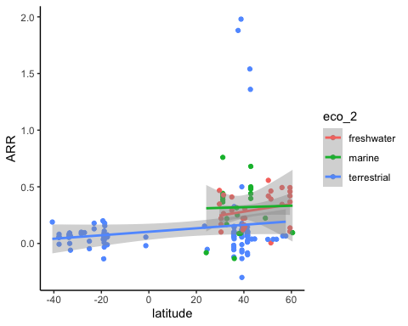

### ARR by thermal limit

The other main hypothesis that we are testing is the trade-off hypothesis. This is the idea that plasticity should be lower in populations that have high thermal tolerance.

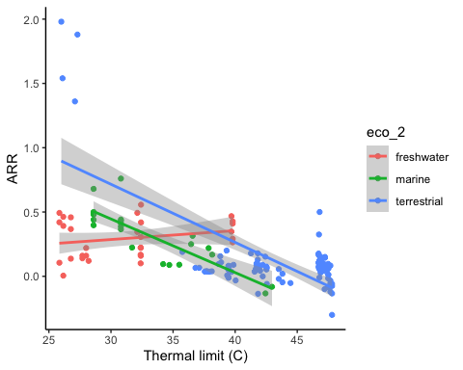

## Analysis

We analyzed these data by calculating an effect size for each study (SMD; standardized mean difference) and using inverse-weighted meta-analytic regression. This model standardizes our effect size (SMD) and weights the data by the variability seen in a particular study. We measured plasticity by computing Hedge’s g (SMD) between the mean thermal tolerance of two acclimation temperatures for each population, where a higher Hedge’s g means higher plasticity. Because the chosen acclimation temperatures could influence plasticity, we included the difference in acclimation temperatures as a covariate in the model. To specifically test which hypothesis has more support (latitude and trade-off hypotheses), we included thermal tolerance and temperature range (range of annual temperatures observed at a given location) as covariates in our model. Because we also were interested in looking at plasticity differences in ecosystem, we included ecosystem as a predictor. To account for non-independence within studies and phylum, we included these variables as random effects.

We used model selection methods to evaluate which covariates were most important in explaining the variability within our data. We centered and scaled the continuous predictors in order to fairly compare each covariate on the same scale. Our data seemed to have some studies that were highly influential in the analysis. However, sensitivity analyses indicated that when these studies were removed, the results were robust. Therefore, we included these studies in our analysis.

Here is a forest plot of all studies, ranked by increasing mean Hedge’s g.

This forest plot shows Hedge’s g as the effect size for each study, with error bars indicating the standard deviation. There is variability in the number of data points per study because the number of populations and acclimation temperatures varied between studies. This plot also shows that as Hedge’s g increases, error also increases. We think this is because large differences in acclimation temperature with study can cause high plasticity, but also contributes to more variability.

For the sake of visualization, I am presenting estimates from our top model. However, we have decided to use model averaging because there are three models that have significant support (using AICc). The results from model averaging and the top model are negligibly different.

### Results

There are a couple of things to point out regarding the model averaging versus the top model. First, our top model only has the difference in acclimation temperature and thermal limit as predictive covariates, and they are both highly significant. In the model averaging, the covariates are weighted by the amount of support they have in all the models tested, however the same predictors are still highly significant. We expected the temperature difference covariate to be important because we already know that this should influence plasticity based on first principles. Because thermal limit shows up as a predictive and highly significant covariate, **there is strong support for the trade-off hypothesis**! Here is a meta-analytic scatter to visualize this trend:

This plot shows the data with a prediction model line from the top model (with upper and lower confidence intervals) overlayed on the effect size data against thermal limit. The predictions were made based on the thermal limit variable with the temperature difference variable held at the mean.

Here is a meta-analytic scatter plot with Hedge’s g plotted against temperature difference, with a prediction model line from the top model (solid line) and upper and lower confidence intervals (dotted lines). This shows that as the difference in acclimation temperatures increases, plasticity increases.

Lastly, here is a meta-analytic scatter plot of Hedge’s g plotted against temperature range. There are no predictions here because this covariate was not in the top model. This plot seems to further show that annual temperature range is not predictive of plasticity.

In meta-analyses, it is common to compute a fail-saife number (FSN), which its basically the number of studies with a null result that would have to be included in your analysis to change your results. Our FSN is very high, however, this number is likely inflated because this is telling us how many studies would have to report a null result of no plasticity for our results to change:

## Fail-safe N: 57135

Therefore, we need to take this number with a grain of salt because this number is not accounting for differences in plasticity across populations. Indeed, we do see strong evidence of phenotypic plasticity in our data, which is to be expected.

This plot is of the estimates for both parameters in the top model (with error bars representing the standard deviation), showing that the effect of thermal limit on plasticity is relatively strong and negative.

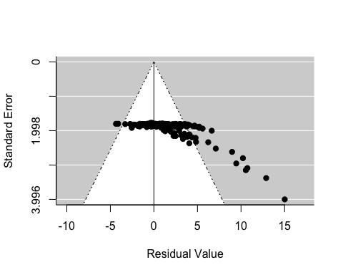Lastly, here is a funnel plot that shows the variation in residuals for the top model (this looks very similar no matter what model you are looking at). Normally, we would expect to see residual data points stay within the white pyramid.

The funnel plot shows that there are several data points that have high residuals (points in the gray area). However, when these data points are taken out of the analysis, other data point replace them. We believe that high residual values arise from large differences in acclimation temperatures, which increases the plasticity effect size. When we constrain the difference in acclimation temperatures to a much smaller number, the variation in residuals does not change much, nor do the results of the model. Therefore, we decided to leave these data points in our analysis.

# Final thoughts

In sum, our data show strong support for the trade-off hypothesis. In the future, we would like to include more studies in this analysis on a wider range of species to see if this trend holds up.