Goals & Objectives

The goal of this program is to accept inputs from a user in the form of integer numbers for the month and year, calculate if the year provided is a leap year, and notify the user of the number of days in the month/year combination provided.

For example, if the user inputs a month of 2 and a year of 2024, the program will respond that February 2024 has 29 days.

Functional Requirements

1. Prompt user input for the month as an integer (eg., 1 for Jan).
2. Prompt user input for the year as an integer (2024).
3. Unique calculation for February for leap years.
4. Output the Month and Year provided, and the number of days in the month.

Pseudocode

Import Scanner Utility

Function Main {

Declare input as New Scanner

Output “Enter a month in the year (e.g., 1 for Jan): “

Input double month

Output “Enter a year (e.g., 2024): “

Input double year

Declare int days as 0.

Use switch on month

Cases 1,3,5,7,8,10,12:

Update days to 31.

Output “[month] [year] has 31 days.”

Break switch

Case 2:

Perform calculation on year to determine leap year; update days to 29 or 28

based on calculation

Output “February [year] has [29 or 28] days.”

Break switch

Cases 4,6,9,11:

Update days to 30.

Output “[month] [year] has 30 days.”

Break switch.

End Switch

End

Flowchart

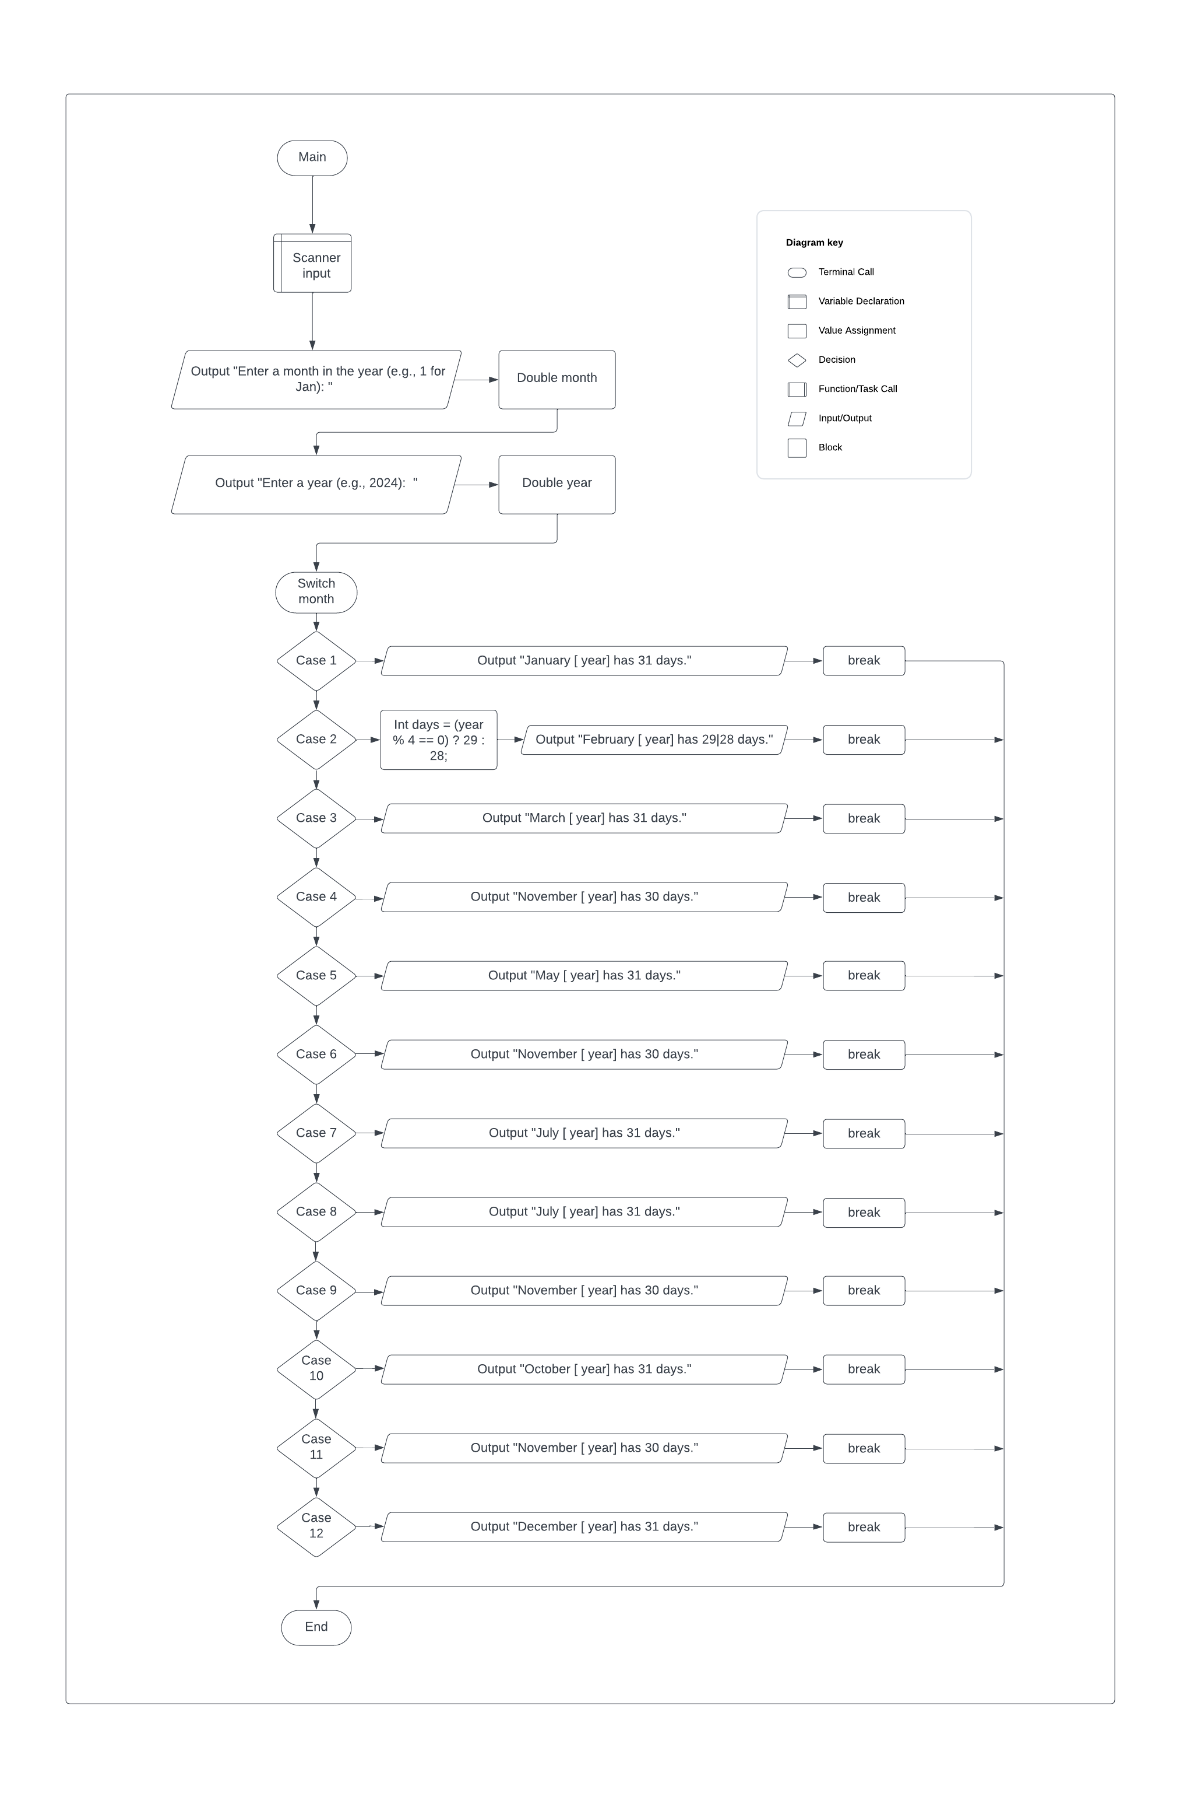

Test Plan

|  |  |  |  |  |
| --- | --- | --- | --- | --- |
| **Test Case** | **Input/Output** | **Expected Result** | **Actual Result** | **Outcome (Pass/Fail)** |
| 1a | User prompted for the month as an integer. | A message prompting the user for an integer number of a month. | “Enter a month in the year (e.g., 1 for Jan): “ | Pass |
| 2a | User prompted for the year | A message prompting the user for an integer number of a year. | “Enter a year (e.g., 2024): “ | Pass |
| 3a | Use month to switch, calculate leap year for February | Switch selects correct case, calculates leap year for February. | Int days = (year % 4 == 0) ? 29 : 28 | Pass |
| 4a | Output month and year, and number of days in the month. | A message that shows the user the month and year followed by the number of days in that month. | e.g., “January 2024 has 31 days.” | Pass |

|  |  |  |  |  |
| --- | --- | --- | --- | --- |
| **Test Case** | **Input/Output** | **Expected Result** | **Actual Result** | **Outcome (Pass/Fail)** |
| 1 | (1a) 2  (2a) 2024 | February 2024 has 29 days. | February 2024 has 29 days. | Pass |
| 2 | (1a) 5  (2a) 1986 | May 1986 has 31 days | May 1986 has 31 days | Pass |
| 3 | (1a) 3  (2a) 1983 | March 1983 has 31 days | March 1983 has 31 days | Pass |
| 4 | (1a) 2  (2a) 2023 | February 2023 has 28 days | February 2023 has 28 days | Pass |

