Goals & Objectives

The goal of this program is to accept inputs from a user in the form of double numbers and determine if the polar coordinates provided are within the boundaries of a rectangle with width of 10 units and a height of .5 units.

Example: A user inputs x y as 4 3, the program outputs that the Point (4,3) is not in the rectangle

Functional Requirements

1. Prompt user for a set of polar coordinates, separated by a space.
2. Declare x and y checks using Boolean logic.
3. Calculate if point x provided is greater than or equal to -5 and less than or equal to 5.
4. Calculate if point y provided is greater than or equal to -2.5 and less than or equal to 2.5.
5. Update x and y checks
6. Output if user supplied points are or are not within the rectangle.

Pseudocode

Import Scanner Utility

Function Main

Declare Scanner input

Output “Please enter a polar coordinate (x, y) as two numbers separated by a space [e.g., 3 5]: “

Double x

Double y

Boolean checkX

Boolean checkY

If x <= 5 AND x >= -5 then

Update checkX as True

If y <= 2.5 AND y >= -2.5 then

Update checkY as True

Else

Update checkY as False

Else

Update checkX as False

If checkX is True AND checkY is True

Output “Point [x,y] is in the rectangle.”

Else

Output “Point [x,y] is not in the rectangle.”

Close input Scanner.

End

Flowchart

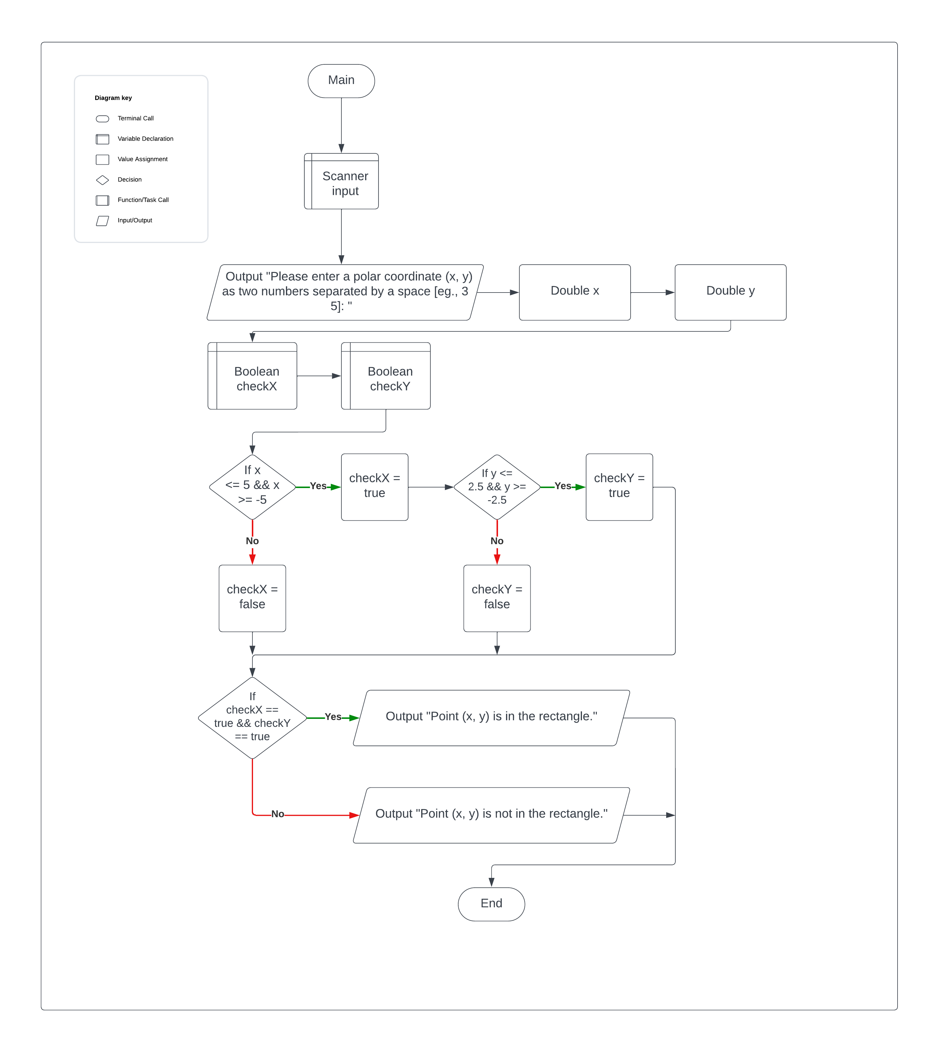

Test Plan

|  |  |  |  |  |
| --- | --- | --- | --- | --- |
| **Test Case** | **Input/Output** | **Expected Result** | **Actual Result** | **Outcome (Pass/Fail)** |
| 1a | User prompted for space separated polar coordinates | A message prompting the user two numbers separated as a space. | "Please enter a polar coordinate (x, y) as two numbers separated by a space [eg., 3 5]: " | Pass |
| 2a | Declare checkX and checkY | Initialize checkX and checkY as Boolean True | Boolean checkX = true  Boolean checkY = true | Pass |
| 3a | Test if provided x is between -5 and 5. | Calculate if user supplied x is greater than or equal to -5 AND less than or equal to 5 | If (x <= 5 && x >= -5) | Pass |
| 4a | Test if provided y is between -2.5 and 2.5. | Calculate if user supplied y is greater than or equal to -25 AND less than or equal to 2.5 | If (y <= 2.5 && y >= -2.5) | Pass |
| 5a | Update checkX and checkY based on tests in 3a and 4a. | Update checkX and checkY based on the results of the tests in steps 3a and 4a. | checkX = true|false  checkY = true|false | Pass |
| 6a | Output whether the provided x,y points are within the rectangle or not. | A message that shows the user if the provided polar coordinates are within the boundaries of the rectangle. | “Point (“ + x + “, “ + y + “) [is, is not] in the rectangle.” | Pass |

|  |  |  |  |  |
| --- | --- | --- | --- | --- |
| **Test Case** | **Input/Output** | **Expected Result** | **Actual Result** | **Outcome (Pass/Fail)** |
| 1 | (1a) -1 -2 | Point (-1,-2) is in the rectangle | Point (-1,-2) is in the rectangle | Pass |
| 2 | (1a) 1.25 1.25 | Point (1.25, 1.25) is in the rectangle | Point (1.25, 1.25) is in the rectangle | Pass |
| 3 | (1a) -1.25 1.25 | Point (-1.25, 1.25) is in the rectangle | Point (-1.25, 1.25) is in the rectangle | Pass |
| 4 | (1a) 6 1.25 | Point (6, 1.25) is not in the rectangle | Point (6, 1.25) is not in the rectangle | Pass |

