Goals & Objectives

The goal of this program is to accept inputs from a user for the number of sides of a polygon and the length of one side. The first is an integer number, the second input being a double, calculate the area of the polygon and output the area back to the user.

Functional Requirements

1. Prompt user input for the number of sides.
2. Prompt user input for the length of one side.
3. Calculate the area of the polygon.
4. Output the area of the polygon to the user..

Pseudocode

Import Scanner Utility

Function Main {

Declare input as New Scanner

Output “Please enter the number of sides: “

Input integer n

Output “Please enter the length of the side: “

Input double s

Declare area as n * s^2 / (4 * tan(pi / n))

Output “The area of the polygon is “ + area

End

Flowchart

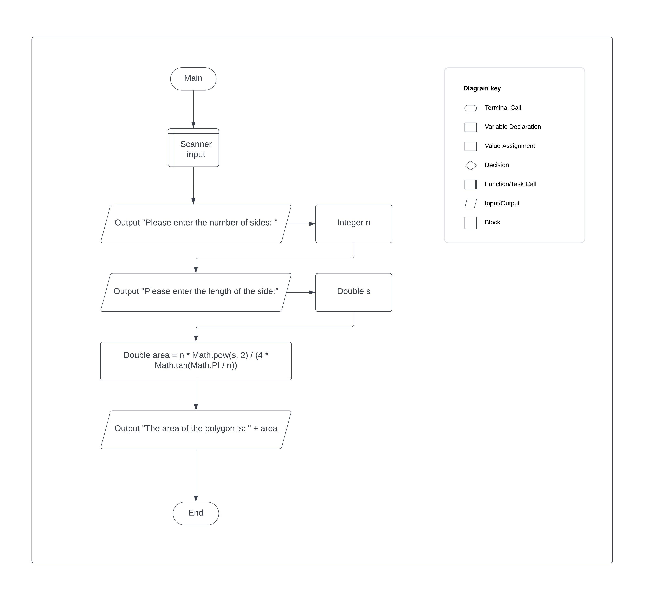

Test Plan

|  |  |  |  |  |
| --- | --- | --- | --- | --- |
| **Test Case** | **Input/Output** | **Expected Result** | **Actual Result** | **Outcome (Pass/Fail)** |
| 1a | User prompted for the number of sides as an integer. | A message prompting the user for an integer number of the number of sides. | “Please enter the number of sides: “ | Pass |
| 2a | User prompted the for length of one side as a Double | A message prompting the user for an double number for the length of one side | “Please enter the length of the side: “ | Pass |
| 3a | Calculate the area of the polygon as a Double | Double area stores calculation for the polygon area | double area = n * Math.pow(s, 2) / (4 * Math.tan(Math.PI / n)) | Pass |
| 4a | Output the area of the polygon. | A message that shows the user area of the polygon. | “The area of the polygon is “ + area | Pass |

|  |  |  |  |  |
| --- | --- | --- | --- | --- |
| **Test Case** | **Input/Output** | **Expected Result** | **Actual Result** | **Outcome (Pass/Fail)** |
| 1 | (1a) 3  (2a) 3.2 | 4.43405 | 4.43405 | Pass |
| 2 | (1a) 5  (2a) 9.86 | 167.2641 | 167.2641 | Pass |
| 3 | (1a) 6  (2a) 9.83 | 251.0492 | 251.0492 | Pass |
| 4 | (1a) 8  (2a) 20.23 | 1976.048 | 1976.0478 | Pass |

