Goals & Objectives

The goal of this program is to accept inputs from a user with a correctly formatted social security number, ensuring a dash (“-“) is located in the 4th (zero base 3rd) and 7th (zero base 6th) digit positions, and output whether or not the social security number is valid.

Functional Requirements

1. Prompt user input for a social security number.
2. Use Boolean logic to ensure SSN contains numbers and dashes in the correct positions.
3. Output SSN validity based on Boolean value.

Pseudocode

Import Scanner Utility

Function Main {

Declare input as New Scanner

Output “Enter a SSN: “

Input String ssn

Declare Boolean isValid as length = 11 && charAt(0) <= 9 && charAt(0) >= 0 && isDigit(0-2) && charAt(3) = ‘-‘ && isDigit(4,5) && charAt(6) = ‘-‘ && isDigit(7-10)

IF (isValid)

Output ssn + “is a valid Social Security Number.”

else

Output ssn + “is an invalid Social Security Number.”

End IF

End

Flowchart

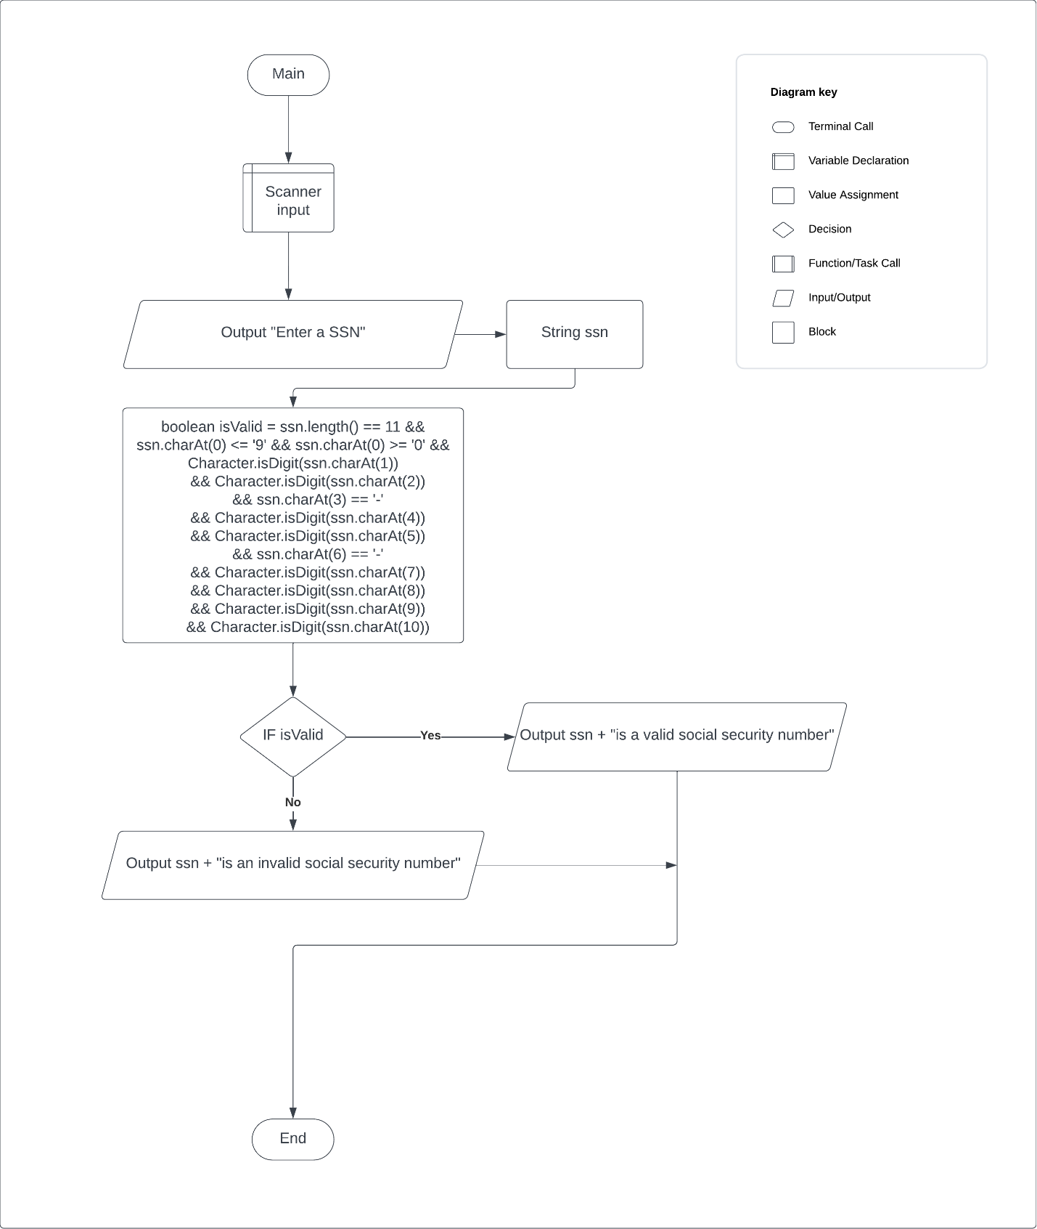

Test Plan

|  |  |  |  |  |
| --- | --- | --- | --- | --- |
| **Test Case** | **Input/Output** | **Expected Result** | **Actual Result** | **Outcome (Pass/Fail)** |
| 1a | User prompted to enter a SSN | A message prompting the user to enter a SSN. | “Enter a SSN: “ | Pass |
| 2a | Characters, length checked as Boolean | Boolean variable isValid checks ssn length, starting characters, digits at 0-2,4,5,7-10 and dashes at 3 and 6 | boolean isValid = ssn.length() == 11 &&  ssn.charAt(0) <= '9' && ssn.charAt(0) >= '0'  && Character.isDigit(ssn.charAt(1))  && Character.isDigit(ssn.charAt(2))  && ssn.charAt(3) == '-'  && Character.isDigit(ssn.charAt(4))  && Character.isDigit(ssn.charAt(5))  && ssn.charAt(6) == '-'  && Character.isDigit(ssn.charAt(7))  && Character.isDigit(ssn.charAt(8))  && Character.isDigit(ssn.charAt(9))  && Character.isDigit(ssn.charAt(10)) | Pass |
| 3a | Output SSN is valid or invalid | IF statement if SSN is Valid | If isValid: ssn + “is a valid social security number”  Else ssn + “is an invalid social security number | Pass |

|  |  |  |  |  |
| --- | --- | --- | --- | --- |
| **Test Case** | **Input/Output** | **Expected Result** | **Actual Result** | **Outcome (Pass/Fail)** |
| 1 | 123-45-6789 | Valid | Valid | Pass |
| 2 | 123-456-789 | Invalid | Invalid | Pass |
| 3 | 12-3456-789 | Invalid | Invalid | Pass |
| 4 | 1234-56-789 | Invalid | Invalid | Pass |

