Goals & Objectives

The goal of this program is to accept a 12-digit input from a user to calculate the full 13-digit number of an ISBN-13 number. The program will check a user input for 12 characters, calculate the checksum, and replace any checksum greater than 9 with 0. If a user input is not 12 characters in length, the program will notify the user of an invalid input and exit. Lastly, the program will output the full ISBN-13 number with the checksum appended to the input number.

Functional Requirements

1. Prompt user input for the first 12 digits of the ISBN-13 number.
2. Check length of the input.
3. Loop through input and add values to sum.
4. Calculate the checksum, replacing a value of 10 with 0.
5. Output the complete ISBN-13 number.

Pseudocode

Import Scanner Utility

Function Main {

Declare input as New Scanner

Output “Please enter the first 12 digits of an ISBN-13 number: “

Declare s as String from input

IF length of s does not equal 12

Output “<String> is an invalid input”

Exit Program

ELSE

Declare int sum as 0

FOR (int i is 0; i is less than length of s – 1; increment i)

IF i % 2 is 0

Add charAt(i) in s – ‘0’ to sum

ELSE

Add 3 * (charAt(i) in s – ‘0’) to sum

END FOR

Declare checksum as (10 – sum % 10);

IF

Checksum is 10, change checksum to 0

Output “The ISBN-13 number is “ s + checksum

Close input

End

Flowchart

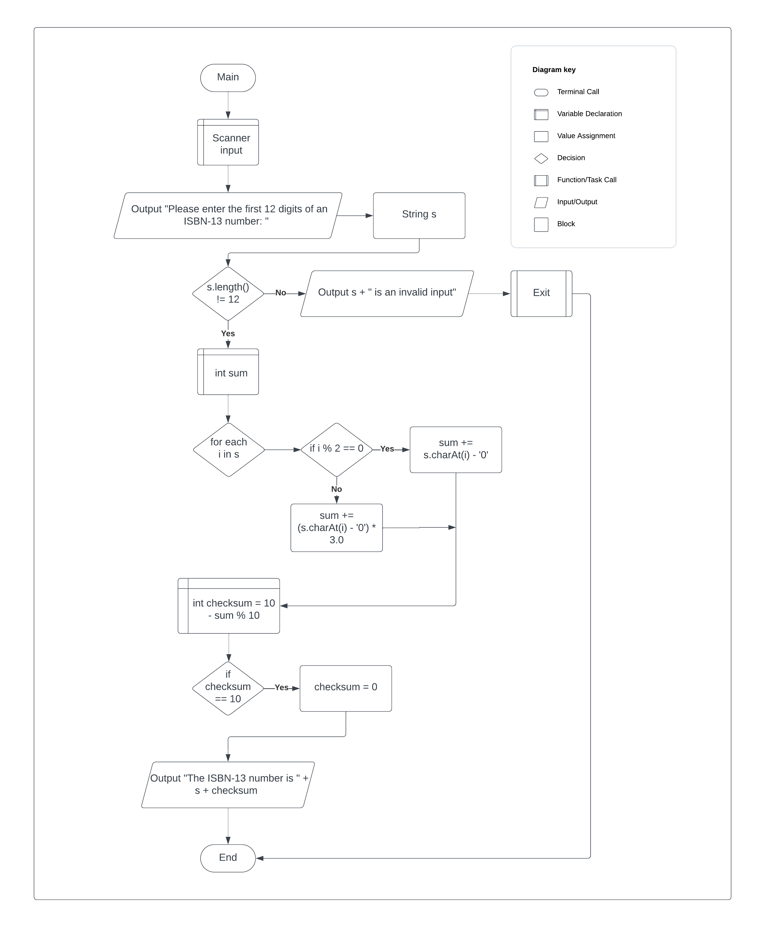

Test Plan

|  |  |  |  |  |
| --- | --- | --- | --- | --- |
| **Test Case** | **Input/Output** | **Expected Result** | **Actual Result** | **Outcome (Pass/Fail)** |
| 1a | Prompt user input for the first 12 digits of the ISBN-13 number | User provides a 12 digit number, stored as a string. | “Please enter the first 12 digits of an ISBN-13 Number | Pass |
| 2a | Check the length of the input | Use .length() to check the input length. | If (s.length != 12) {} | Pass |
| 3a | Loop through input and add to sum | Use a FOR loop to iterate through input, add to sum based on checksum formula | For (int I = 0; I <= s.length() – 1; i++) { sum += s.charAt(i) – ‘0’} | Pass |
| 4a | Calculate the checksum, replace a 10 with 0 | Calculate the checksum, check IF checksum is 10, replace with a 0 if it is | Int checksum = 10 – sum % 10; if (checksum == 10) checksum = 0 | Pass |
| 5a | Output the complete ISBN-13 number | Prompt user with the full ISBN-13 number | “The ISBN-13 number is” + s + checksum | Pass |

|  |  |  |  |  |
| --- | --- | --- | --- | --- |
| **Test Case** | **Input/Output** | **Expected Result** | **Actual Result** | **Outcome (Pass/Fail)** |
| 1 | (1a) 978013156702 | 9780131567023 | The ISBN-13 number is 9780131567023 | Pass |
| 2 | (1a) 9701345 | Invalid | 9701345 is an invalid input | Pass |
| 3 | (1a) 988801346000 |  | The ISBN-13 number is 9888013460001 | Pass |
| 4 | (1a) 973301486789 |  | The ISBN-13 number is 9733014867895 | Pass |

