Goals & Objectives

The goal of this program is to accept inputs from a user in the form of a long integer for a time in milliseconds. The program will use a second method to calculate hours, minutes, and seconds and convert the provided input to a formatted time and output the time to the user.

Functional Requirements

1. Prompt user input a long integer
2. Pass long integer to method convertMillis
3. Convert milliseconds to seconds
4. Convert seconds to minutes, leave remainder
5. Convert minutes to hours leave remainder.
6. Output formatted time

Pseudocode

Import Scanner Utility

Function Main {

Declare input as New Scanner

Output “Please enter time in milliseconds: “

Declare totalMillis as long

Declare output as String from method convertMillis

Output string output

Close input

End

Function convertMillis( requires long millis )

Declare totalSeconds as millis / 1000

Declare seconds as totalSeconds % 60

Declare totalMinutes as totalSeconds / 60

Declare minutes as totalMinutes % 60

Declare totalHours as totalMinutes / 60

Declare hours as totalHours

Declare String total as hours + “:” + minutes + “:” + seconds

Return total

End

Flowchart

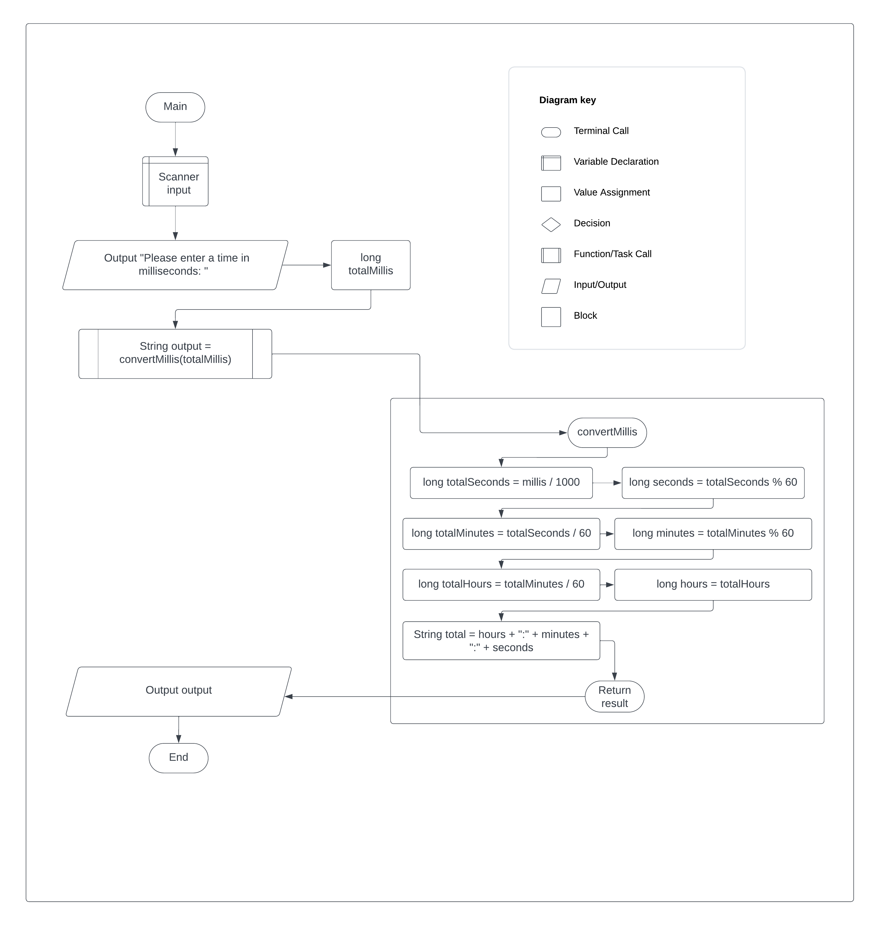

Test Plan

|  |  |  |  |  |
| --- | --- | --- | --- | --- |
| **Test Case** | **Input/Output** | **Expected Result** | **Actual Result** | **Outcome (Pass/Fail)** |
| 1a | Prompt user input for a long integer | User inputs a long integer totalMillis | “Please enter a time in milliseconds: “ | Pass |
| 2a | Pass long integer to method convertMillis | Pass totalMillis to method convertMillis with correct call | String output = convertMillis(totalMillis) | Pass |
| 3a | Convert Millis to seconds | Convert millis to totalSeconds and store only remaining seconds in seconds | Long totalSeconds = millis / 1000  Long seconds = totalSeconds % 60 | Pass |
| 4a | Convert seconds to Minutes | Convert totalSeconds to totalMinutes and store only remaining minutes in minutes | Long totalMinutes = totalSeconds / 60  Long minutes = totalMinutes % 60 | Pass |
| 5a | Convert Minutes to hours | Convert totalMinutes to totalHours | Long totalHours = totalMinutes / 60  Long hours = totalHours | Pass |
| 6a | Output formatted time stamp | Output correctly formatted time stamp | Hours + “:” + minutes + “:” + seconds | Pass |

|  |  |  |  |  |
| --- | --- | --- | --- | --- |
| **Test Case** | **Input/Output** | **Expected Result** | **Actual Result** | **Outcome (Pass/Fail)** |
| 1 | (1a) 512035 | 0:8:32 | 0:8:32 | Pass |
| 2 | (1a) 5500055 | 2:31:40 | 2:31:40 | Pass |
| 3 | (1a) 1400 | 0:0:1 | 0:0:1 | Pass |
| 4 | (1a) 79046 | 0:1:19 | 0:1:19 | Pass |
| 5 | (1a) -79046 | 0:-1:-19 | 0:-1:-19 | Pass |

