Goals & Objectives

The goal of this program is to accept inputs from a user in the form of two integers, one for an integer and one for a width. The program will use the width to pad the integer number provided out the total number of digits the user specified. The program will output the correctly formatted number. For example, if a user inputs the integer 45, and a width of 6, the program will return a value of 000045.

Functional Requirements

1. Prompt user input for an integer
2. Prompt user input for width
3. Pass integer and width to method
4. Use a FOR loop to pad integer with zeros out to width.
5. Output formatted number.

Pseudocode

Import Scanner Utility

Function Main

Declare input as New Scanner

Output “Enter an integer”

Declare number as integer

Output “Enter a width”

Declare width as integer

Declare output as String from Method format

Output “The formatted number is “ + number

Close input

End

Function format (requires integer number, integer width)

Declare result as number + “”

Declare numberOfDigits as integer for length of result

FOR (int i is 1; i less than or equal to width minus numberOfDigits; increment i)

Add “0” to result

Return result

End

Flowchart

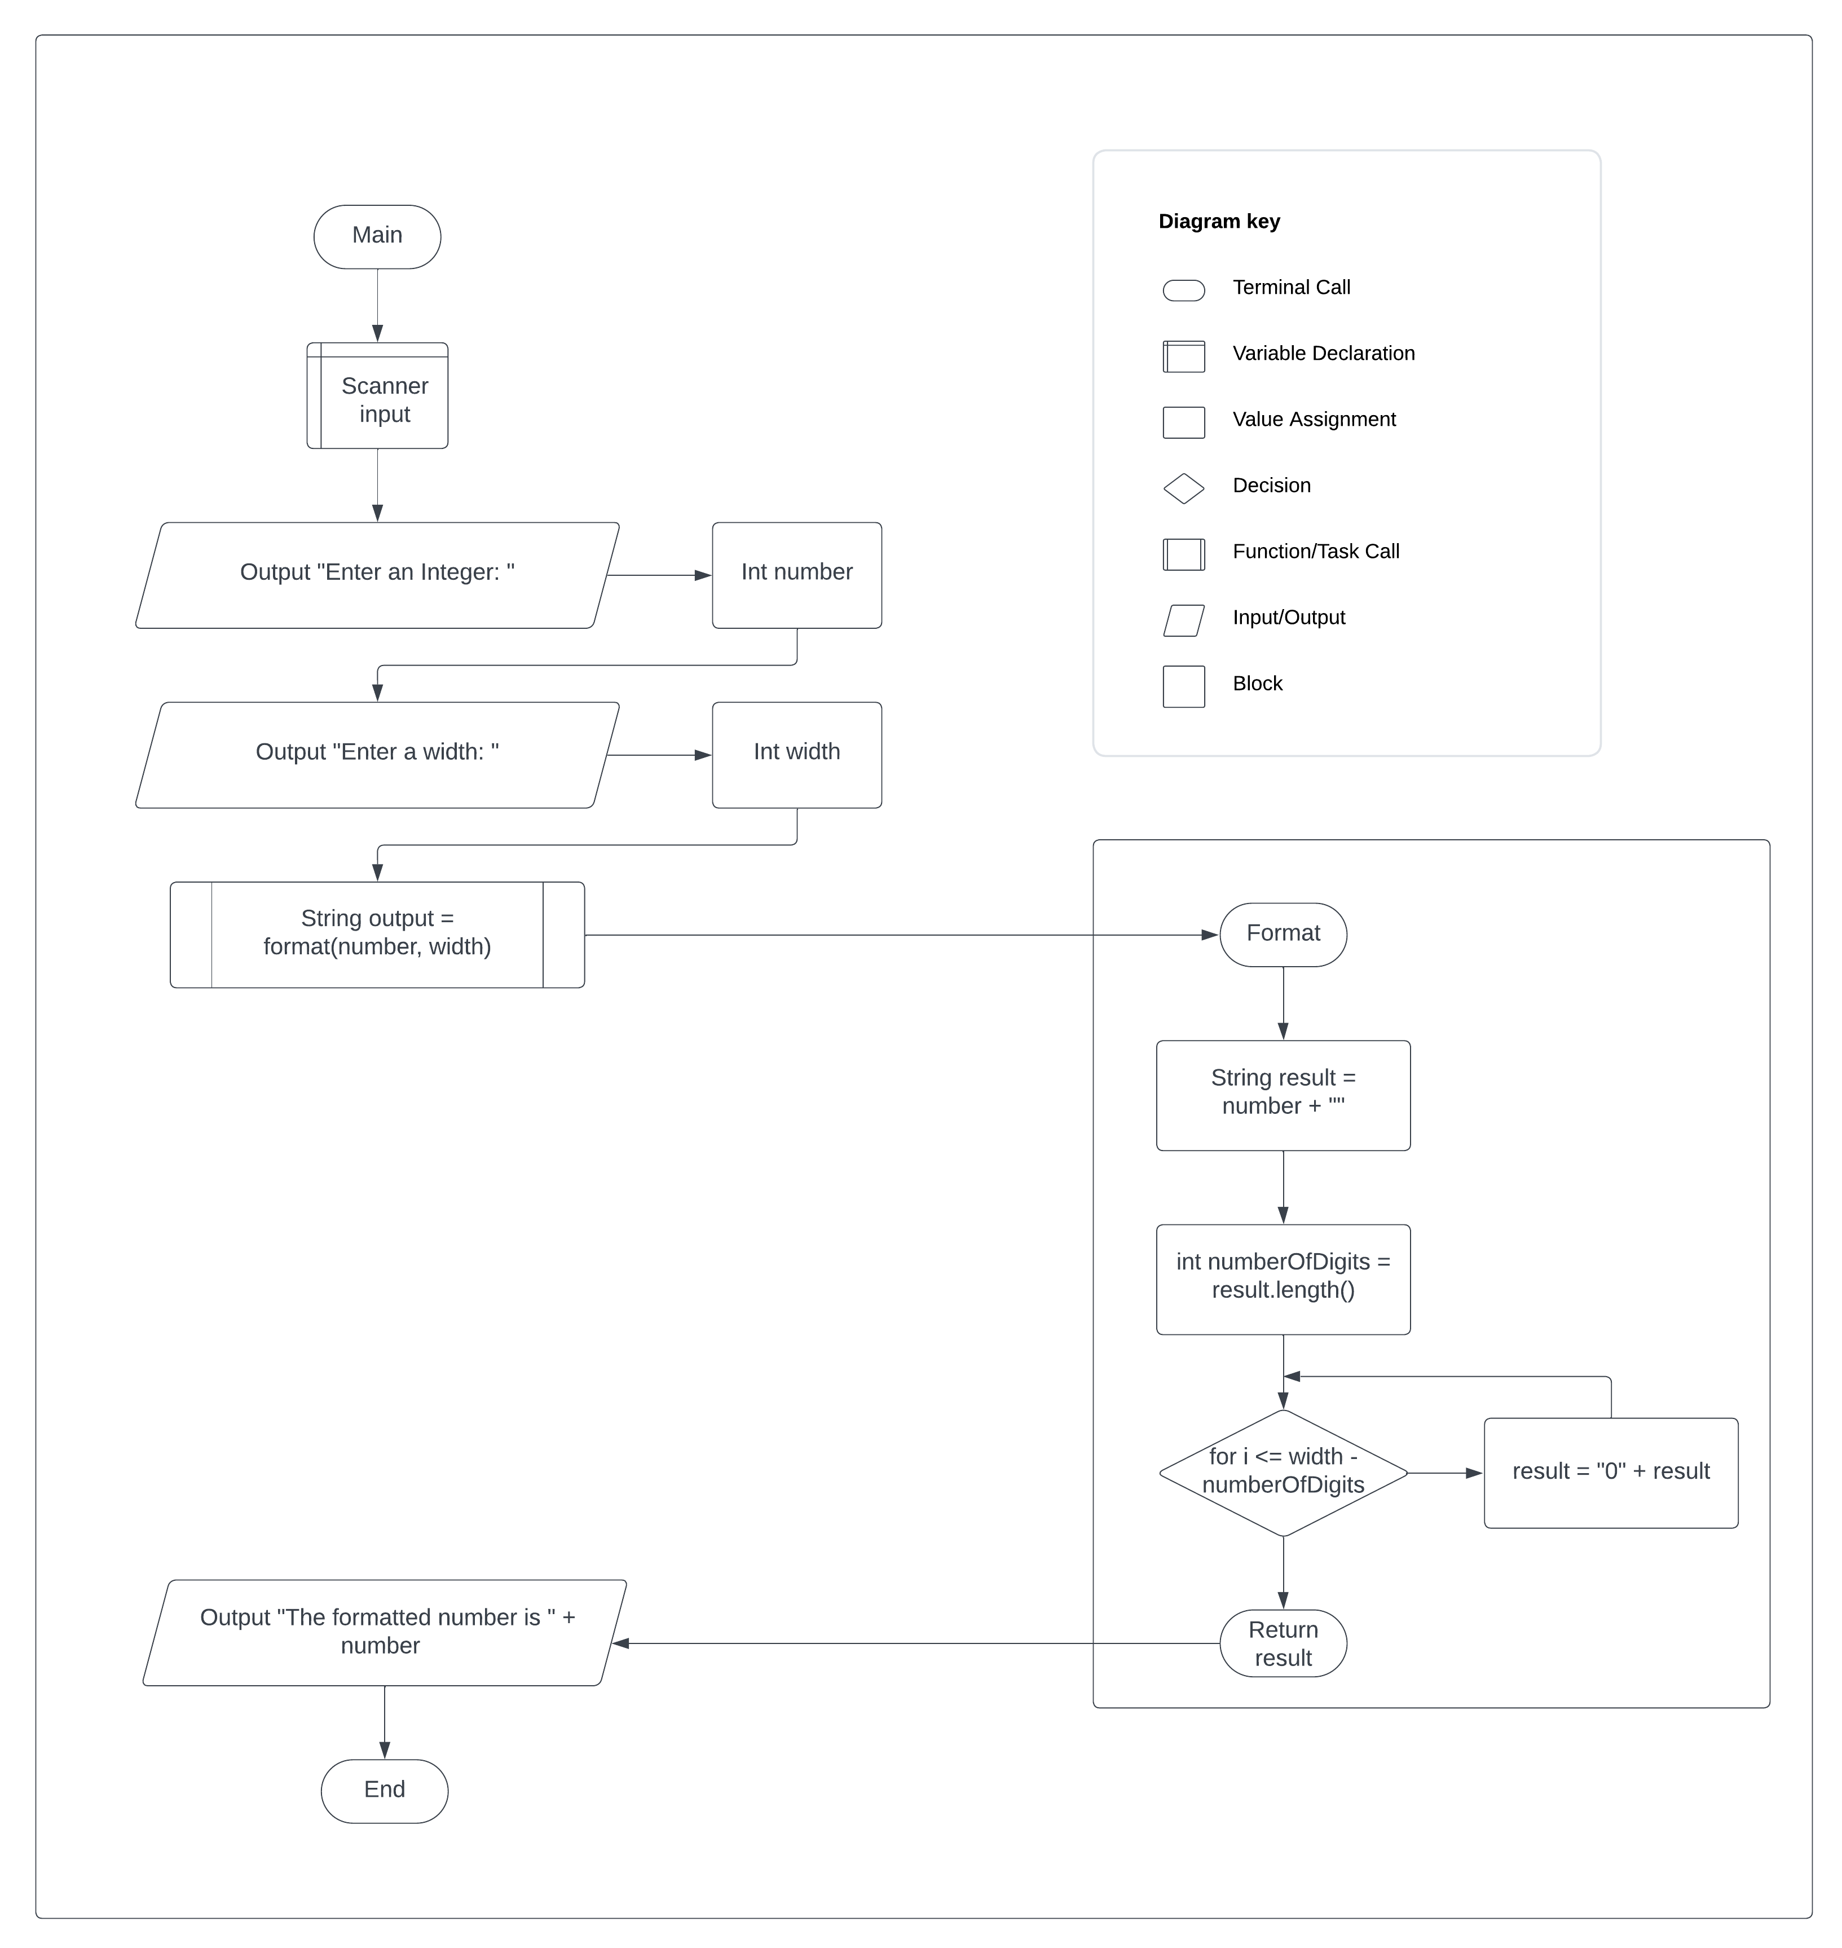

Test Plan

|  |  |  |  |  |
| --- | --- | --- | --- | --- |
| **Test Case** | **Input/Output** | **Expected Result** | **Actual Result** | **Outcome (Pass/Fail)** |
| 1a | Prompt user input for an integer | User inputs an integer number | “Enter an integer:” | Pass |
| 2a | Prompt user input for a width | User inputs an integer width | “Enter a width:” | Pass |
| 3a | Pass number and width to method format() | Pass number and width to Method format with correct call | String output = format(number, width) | Pass |
| 4a | Use FOR loop to pad zeros on to the number out to the width | Use a FOR loop to iterate through length of the result and pad with “0” until length matches width | For (int i = 1; i <= width – numberOfDigits; i++) { result = “0” + result; } | Pass |
| 5a | Output the formatted number | Output correctly formatted number. | “The formatted number is “ + output | Pass |

|  |  |  |  |  |
| --- | --- | --- | --- | --- |
| **Test Case** | **Input/Output** | **Expected Result** | **Actual Result** | **Outcome (Pass/Fail)** |
| 1 | (1a) 45  (2a) 6 | 000045 | 000045 | Pass |
| 2 | (1a) 1520  (2a)4 | 1520 | 1520 | Pass |
| 3 | (1a) 110  (2a) 10 | 0000000110 | 0000000110 | Pass |
| 4 | (1a) 110  (2a) 2 | 110 | 110 | Pass |

