Goals & Objectives

The goal of this program is to accept user input as an integer for number of cities, and polar coordinates for each city, and build a two-dimensional array with inputs as array elements. The program will then iterate through the array and locate the central city, and output the central city and the distance to all other cities back to the user.

Functional Requirements

1. Prompt the user for the number of cities
2. Prompt the user for the polar coordinates of each city
3. Assign each coordinate to an element in an array
4. Compare total distance with minimum distance for each city
5. Output central city polar coordinates
6. Output central city’s total distance to all other cities

Pseudocode

Import Scanner Utility

Function Main {

Declare input as new Scanner

Output “Enter the number of cities:”

Declare numberOfCities as input.nextInt()

Declare double array cities with sizes numberOfCities and 2

FOR each city (row) element

FOR each polar coordinate part (x or y) (column) element

Add input as double

Output “The central city is at (x,y)”

Output “The total distance to all other cities is “ + minTotal

End

Function distance( requires double array c1, and double array c2 )

Return Square Root of (c2[0] – c1[0]) * (c2[0]-c1[0) + (c2[1] – c1[1]) * (c2[1] – c1[1])

End

Function totalDistance (requires double array cities and integer i)

Declare sum as integer 0

For (int x = 0; x <= cities.length – 1; x++)

Sum += return from method distance(cities[i], cities[x])

Return sum

End

Flowchart

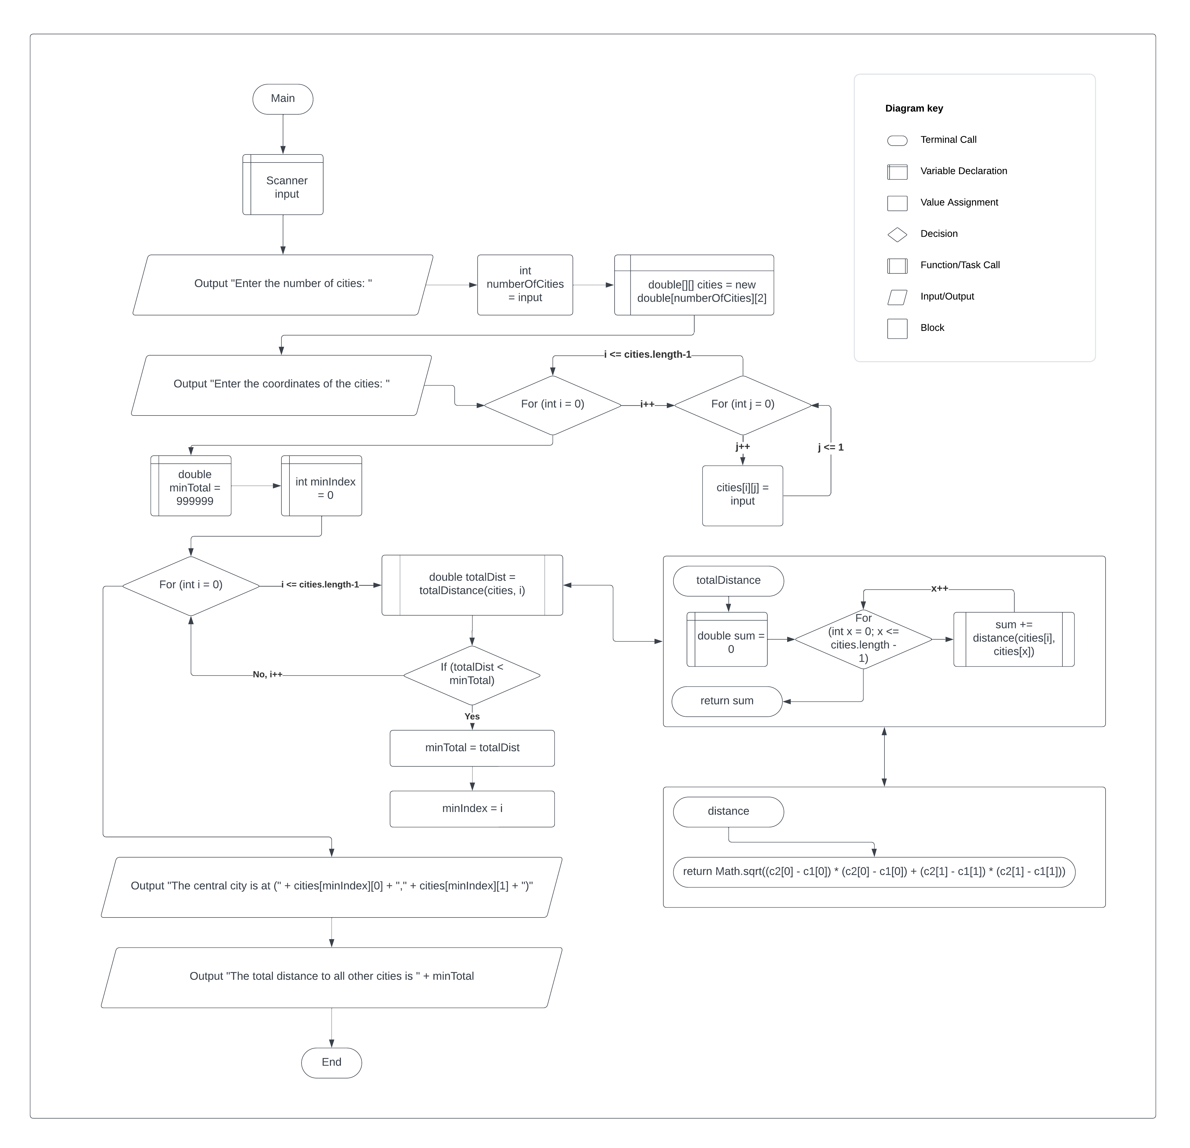

Test Plan

|  |  |  |  |  |
| --- | --- | --- | --- | --- |
| **Test Case** | **Input/Output** | **Expected Result** | **Actual Result** | **Outcome (Pass/Fail)** |
| 1a | Prompt the user for the number of cities | User inputs an integer for the number of cities | “Enter the number of cities:”  Int numberOfCities = input.nextInt() | Pass |
| 2a | Prompt the user for the polar coordinates of each city | User enters x and y coordinates as double | “Enter the coordinates of the cities: “ | Pass |
| 3a | Assign each coordinate to an element in an array | Each x and y coordinate is added as an element of the array cities | For (int I = 0; I <= cities.length – 1; i++) { for (int j = 0; j <= 1; j++) { cities[i][j] = input.nextDouble(); }} | Pass |
| 4a | Compare total distance with minimum distance for each city | Each city’s total distance is compared to the minimum distance total, and the lower is stored as minTotal and i is minIndex is stored | For (int I = 0; I <= cities.length – 1; i++) { double totalDist = totalDistance(cities, i); if (totalDist < minTotal) { minTotal = totalDist; minIndex = I;}} | Pass |
| 5a | Output central city polar coordinates | Outputs the (x,y) coordinates of the central city (cities[minIndex]) | Output “The central city is at(“ + cities[minIndex][0] + “, “ + cities[minIndex][1] + “)” | Pass |
| 6a | Output central city’s total distance to all other cities | Outputs the minTotal of the central city | Output “The total distance to all other cities is “ + minTotal | Pass |

|  |  |  |  |  |
| --- | --- | --- | --- | --- |
| **Test Case** | **Input/Output** | **Expected Result** | **Actual Result** | **Outcome (Pass/Fail)** |
| 1 | (1a) 5  (2a) 2.5 5 5.1 3 1 9 5.4 54 5.5 2.1 | The central city is at (2.5, 5.0)  The total distance to all other cities is 60.81 | The central city is at (2.5, 5.0)  The total distance to all other cities is 60.810516285521615 | Pass |
| 2 | (1a) 3  (2a) 45 65 32 91 12 24 | The central city is at (45, 65)  The total distance to all other cities is 81.70 | The central city is at (45.0, 65.0)  The total distance to all other cities is 81.69967317526033 | Pass |
| 3 | (1a) 4  (2a) 4.5 9 3 2.8 1.2 5 14 3.5 | The central city is at (3.0, 2.8)  The total distance to all other cities is 20.24 | The central city is at (3.0, 2.8)  The total distance to all other cities is 20.243655678215973 | Pass |
| 4 | (1a) 6  (2a) 1 2 3 4 5 6 7 8 9 0 2 9 | The central city is at (5, 6)  The total distance to all other cities is 22.77 | The central city is at (5.0, 6.0)  The total distance to all other cities is 22.767451737032022 | Pass |

