Goals & Objectives

The goal of this program is to take store height and width as double values in the class Rectangle, and output the lengths of the sides, the area, and the perimeter of a given rectangle. The program will use the class Rectangle to compute the area with a method, and compute the perimeter with a method.

Functional Requirements

1. Build two rectangles as Class Rectangle
2. Store height and width of the rectangle
3. Calculate the area of the rectangle
4. Calculate the perimeter of the rectangle
5. Output the width, height, area, and perimeter of each rectangle

Pseudocode

Function Main {

Declare r1 as new class Rectangle

Declare r2 as new class Rectangle

Assign r1.width as 4

Assign r1.height as 40

Assign r2.width as 3.5

Assign r2.height as 35.9

Output “The area of a rectangle with width “ + r1.width + “ and height “ + r1.height + “ is “ + r1.getArea()

Output “The perimeter of the rectangle is “ + r1.getPerimeter()

Output “The area of a rectangle with width “ + r2.width + “ and height “ + r2.height + “ is “ + r2.getArea()

Output “The perimeter of the rectangle is “ + r2.getPerimeter()

End

Class Rectangle {

Declare width as double with default value 1

Declare height as double with default value 1

Function getArea {

Return this.width * this.height

End

Function getPerimeter {

Return this.width * 2 + this.height * 2

End

End

Flowchart

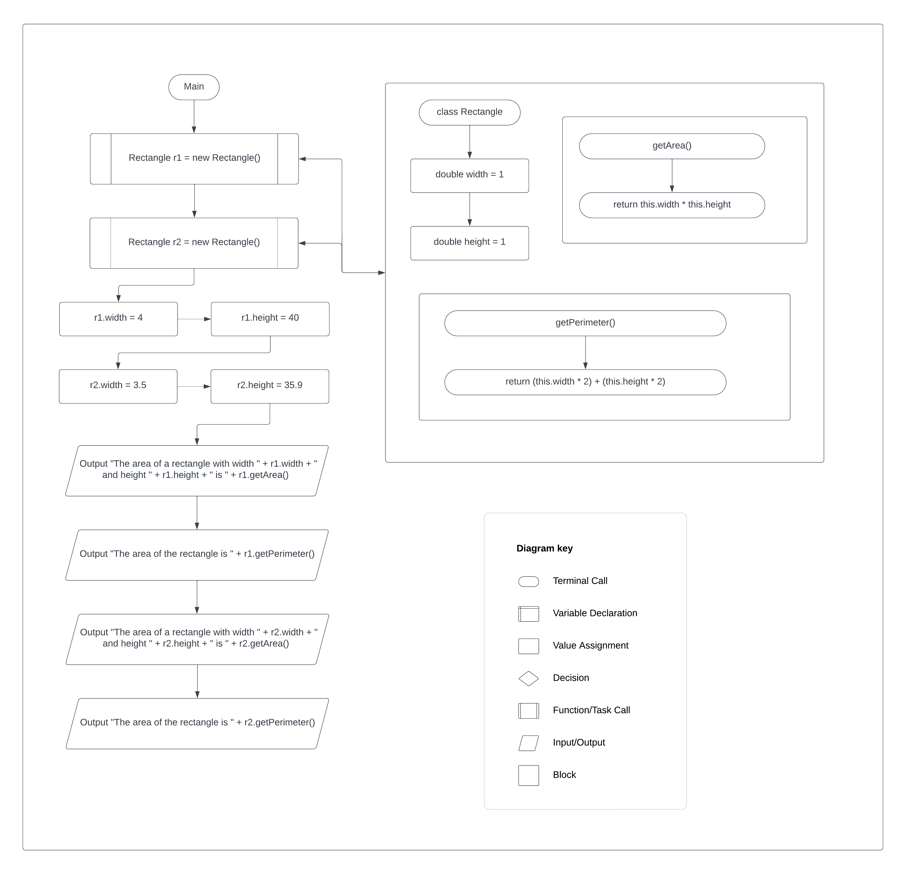

Test Plan

|  |  |  |  |  |
| --- | --- | --- | --- | --- |
| **Test Case** | **Input/Output** | **Expected Result** | **Actual Result** | **Outcome (Pass/Fail)** |
| 1a | Build a rectangle as Class Rectangle | New rectangle is created and default values stored | Rectangle r1 = new Rectangle | Pass |
| 2a | Store height and width of the rectangle | Height and Width values overwrite default values in Rectangle class | R1.width = 4; r1.height = 40; | Pass |
| 3a | Calculate the area of the rectangle | Class method getArea() returns value of width * height | R1.getArea()  Return this.width * this.height | Pass |
| 4a | Calculate the perimeter of the rectangle | Class method getPerimeter() returns value of width * 2 + height * 2 | R1.getPerimeter()  Return (this.width * 2) + (this.height * 2) |  |
| 5a | Output the width, height, area (method), and perimeter (method) of each rectangle | Output the rectangle’s width, height, area, and perimeter to the user | Output “The area of a rectangle with width “ + r1.width + “ and height “ + r1.height + “ is “ + r1.getArea()  Output “The perimeter of the rectangle is “ + r1.getPerimeter() | Pass |

|  |  |  |  |  |
| --- | --- | --- | --- | --- |
| **Test Case** | **Input/Output** | **Expected Result** | **Actual Result** | **Outcome (Pass/Fail)** |
| 1 | (2a) width = 4  Height = 40 | The area of a rectangle with width 4 and height 40 is 160.0  The perimeter of the rectangle is 88.0 | The area of a rectangle with width 4 and height 40 is 160.0  The perimeter of the rectangle is 88.0 | Pass |
| 2 | (2a) width = 3.5  Height = 35.9 | The area of a rectangle with width 3.5 and height 35.9 is 125.65  The perimeter of the rectangle is 78.8 | The area of a rectangle with width 3.5 and height 35.9 is 125.64999999999999  The perimeter of the rectangle is 78.8 | Pass |
| 3 | (2a) width = 6  Height = 16 | The area of a rectangle with width 6 and height 16 is 96.0  The perimeter of the rectangle is 44.0 | The area of a rectangle with width 6.0 and height 16.0 is 96.0  The perimeter of the rectangle is 44.0 | Pass |
| 4 | (2a) width = 2  Height = 92 | The area of a rectangle with width 2 and height 92 is 184.0  The perimeter of the rectangle is 188.00 | The area of a rectangle with width 2.0 and height 92.0 is 184.0  The perimeter of the rectangle is 188.0 | Pass |

