Test 3 Recitation 1

Table of Contents

[CH101-008 UA Fall 2016](/CH101-008/)

[About](/CH101-008/about/)

# Test 3 Recitation 1

Oct 15, 2016

* Consider the molecule below. Determine the molecular geometry at each of the 3 labeled atoms.
  + 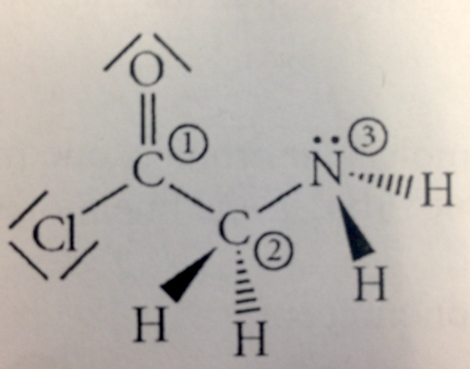
  + 1 = trigonal planar, 2 = tetrahedral, 3 = trigonal pyramidal
  + l = tetrahedral, 2 = tetrahedral, 3 =tetrahedral
  + 1 = trigonal planar, 2 = tetrahedral, 3 = tetrahedral
  + 1 = tetrahedral, 2 = tetrahedral, 3 = trigonal planar
  + 1 = trigonal planar, 2 = trigonal pyramidal, 3 = trigonal pyramidal

The molar mass is in there to confuse you. You just do x*(6.022*10^23)=4.78*10^22

* 2) Place the following in order of increasing F-A-F bond angle, where A represents the central atom in each molecule.
  + PF3 OF2 PF4+
  + PF3 < OF2 < PF4+
  + OF2 < PF3 < PF4+
  + OF2 < PF4+ < PF3
  + PF4+ < OF2 < PF3
  + PF4+ < PF3 < OF2
* 3) How many of the following molecules are polar?
  + BrC13 CS2 SiF4 SO3
  + 1
  + 2
  + 3
  + 4
  + 0
* 4) Give the electron geometry (eg), molecular geometry (mg), and hybridization for XeF4.
  + eg = tetrahedral, mg = tetrahedral, sp3
  + eg = trigonal pyramidal, mg — trigonal pyramidal, sp3
  + eg = octahedral, mg, = square planar, sp3d2
  + eg = octahedral, mg = octahedral, sp3d2
  + eg = trigonal bipyramidal, mg = seesaw, sp3d
* 5) Give the hybridization for the Br in BrF5.
  + sp3d2
  + sp3d
  + sp3
  + sp2
  + sp
* 6) Which of the following statements is true?
  + The total number of molecular orbitals formed doesn’t always equal the number of atomic orbitals in the set.
  + A bond order of 0 represents a stable chemical bond.
  + When two atomic orbitals come together to form two molecular orbitals, one molecular orbital will be lower in energy than the two separate atomic orbitals and one molecular orbital will be higher in energy than the separate atomic orbitals.
  + Electrons placed in antibonding orbitals stabilize the ion/molecule.
  + All of the above are true.
* 7) List the number of sigma bonds and pi bonds in a double bond.
  + 1 sigma, 1 pi
  + 2 sigma, 0 pi
  + 2 sigma, 2 pi
  + 1 sigma, 2 pi
* 8) Draw the Lewis structure for the molecule CH3CH2CCH. How many sigma and pi bonds does it contain?
  + 11 sigma, 0 pi
  + 9 sigma, I pi
  + 8 sigma, 3 pi
  + 9 sigma, 2 pi
  + 8 sigma, 1 pi

Please enable JavaScript to view the [comments powered by Disqus.](https://disqus.com/?ref_noscript)

## CH101-008 UA Fall 2016

* CH101-008 UA Fall 2016
* [jmbeach1@crimson.ua.edu](mailto:jmbeach1@crimson.ua.edu)
* jmbeach
* hey_beach

Notes and study materials for The University of Alabama's Chemistry 101 course offered Fall 2016.