Week 1 - Day 1

Table of Contents

[CH101-008 UA Fall 2016](/CH101-008/)

[About](/CH101-008/about/)

# Week 1 - Day 1

Aug 17, 2016

[Quizlet](https://quizlet.com/_2fb8zs)

Download Word (docx):

## How to Pass CH101: the High School Version

* Pay attention, ask questions, complete your homework

## How to pass the college version

* Do not take it in the summer
* Read ahead
  + You’ll read more new words than when taking a foreign language
  + There is more material than anyone can memorize: you need to understand
  + Seriously compounding: each new topic builds on previous ones
* DO NOT GET BEHIND
* Go back over each days class
  + Reread text book to fix things that were unclear in class
  + It’s up to you to learn the material
  + Correct / amplify notes as needed
* Join a study group
* Do online homework “as we go”
  + Assigned homework is minimum set
  + *10-12 hours a week out of class*
  + Use the practice problems to test yourself
    - If you can’t work the practice problems with the textbook closed, then you won’t necessarily do well on the test
  + Attempt the problems you can’t immediately see how to work
* Do much more than the minimum

## My Labs Plus

* This is where you do your homework and pre-labs
* DO NOT USE THE CODE FOR THE LAB
  + You’ll be given that at your lab time
* University of Alabama Login URL: http://ua.mylabsplus.com
  + Students Username : MyBama ID (all lower case)
  + Students Password : CWID
  + Click on your course under the Fall 2016 tab
  + Accept Terms of Agreement
  + Input Access code (purchased from the bookstore), purchase Access Code, or choose Pay Later to receive 14 days of temporary access
  + Your access code is good for 24 months

## Syllabus overview

* How fast we cover a section depends on how well we perform to some degree
* Tests are not commutative in the sense that future tests will not ask the same exact questions
  + However knowledge of the previous test might be required to answer questions on future tests
* Office hours are Mondays 5-6, Thursdays 4-5
  + Don’t need an appointment

## Test Format

* Some questions will be vocabish “word” questions and have “word answers”
* Some questions ask you if a situation is reasonable

## The textbook

* The second edition

## Labs do not meet this week

## Attendance

* Using your clicker at all gets you half a point
* Using it correctly or luckily gets you the other half

## Tests

* Need to bring an ID
* Labs can’t be programmable

## There will not be recitation this evening

# Chapter 1 - Atoms

## Matter from the Particulate Point of View

* Matter is composed of particles
  + Example: subatomic particles such as neutrons, protons, and electrons, atoms, and molecules
    - “We divide the universe into two types of stuff”
* How the particles come together dictates the physical properties of matter
  + How do things transform
* Matter is defined as anything that has mass and occupies space (e.g., has volume)

## Elements, Molecules, and Mixtures: The Types of Matter

* *Atoms*
  + Basic submicroscopic particles that constitute the fundamental building blocks of ordinary matter
* *Molecules*
  + Substances formed when two or more atoms come together (bond) in specific geometric arrangements
* Atoms and molecules determine how matter behaves
* *Chemistry* is a discipline that seeks to understand matter and its properties, and the transformations that matter undergoes- particularly between molecules.

## The Classification of Matter

* Matter can be classified according to
  + its *state* — its physical form (i.e., solid, liquid, or gas) based on what properties it exhibits;
  + its *composition* or the types of particles
* The state of matter changes from solid to liquid to gas with increasing temperature
* 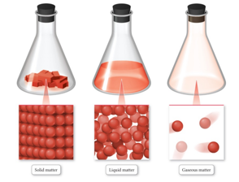

## Solid Matter

* In *solid matter*, atoms or molecules pack close to each other in fixed locations.
* Although the atoms and molecules in a solid vibrate, they do not move around or past each other.
* Consequently, a solid has a fixed volume and rigid shape.
  + Ice, aluminum, and diamond are good examples of solids.

## Liquid Matter

* In *liquid matter*, atoms or molecules pack about as closely as they do in solid matter, but they are free to move relative to each other.
* Liquids have fixed volume but not a fixed shape.
* Liquids’ ability to flow makes them assume the shape of their container.
  + Water, alcohol, and gasoline are all substances that are liquids at room temperature.

## Gaseous Matter

* In gaseous matter, atoms or molecules have a lot of space between them.
* They are free to move relative to one another.
* Fill available space
* These qualities make gases *compressible*.

## Classification of Matter by Components

* Matter can be classified according to its composition: elements, compounds, and mixtures.
* a *pure substance* is made up of only one component, and its composition is invariant
* a *mixture* is a substance composed of two or more components in proportions that can vary from one sample to another
* 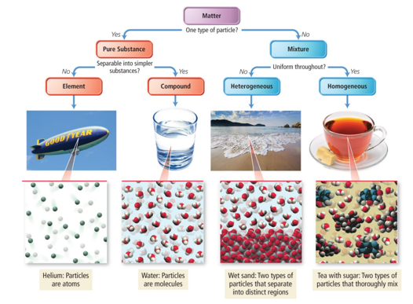

## Vocab

|  |  |
| --- | --- |
| Term | Definition |
| matter | anything that has mass and occupies space (e.g. has volume) |
| atoms | Basic submicroscopic particles that constitute the fundamental building blocks of ordinary matter |
| molecules | Substances formed when two or more atoms come together (bond) in specific geometric arrangements |
| chemistry | a discipline that seeks to understand matter and its properties, and the transformations that matter undergoes- particularly between molecules |
| state | physical form of matter based on what properties it exhibits (i.e. solid, liquid, or gas. Classifies matter) |
| composition | Classifies matter based on the types of particles in it |
| solid matter | atoms and molecules in this type of matter pack close to each other in fixed locations |
| liquid matter | type of matter in which atoms or molecules are packed closely, but they are free to move relative to each other |
| gaseous matter | matter in which atoms or molecules have a lot of space between them |
| compressible | Material which are like gases are said to be… |
| pure substance | made up of only one component and its composition is invariant |
| mixture | substance composed of two or more components in proportions that can vary from one sample to another |

## CH101-008 UA Fall 2016

* CH101-008 UA Fall 2016
* [jmbeach1@crimson.ua.edu](mailto:jmbeach1@crimson.ua.edu)
* jmbeach
* hey_beach

Notes and study materials for The University of Alabama's Chemistry 101 course offered Fall 2016.